Design of a Dynamic Covalent Network Elastomer for Enhanced Thermal Stability and Toughness with Controlled Degradation

Abstract
This study proposes a dynamic covalent network (DCN) elastomer based on star-shaped poly(ethylene glycol)-poly(lactic acid) (PEG-PLA) copolymers crosslinked via imine or urea bonds. The hypothesis posits that the star topology enables high molecular weight pre-polymers to form dynamic networks, balancing glass transition temperature (Tg), toughness, and degradation rate. Literature evidence supports the feasibility of imine/urea-based DCNs for tunable mechanical properties [1, 2] and hydrolytic degradation [3, 4], though direct evidence linking crosslink density to degradation kinetics remains sparse. A two-phase experimental plan is proposed: (1) synthesize star PEG-PLA with varying aldehyde/amine ratios and crosslink densities, and (2) characterize thermal, mechanical, and degradation profiles. Key risks include phase separation during crosslinking and accelerated degradation under physiological conditions. Preliminary evidence suggests this design offers a promising route to clinically viable biodegradable elastomers, pending validation of degradation-property retention coupling.

Graphical Repeat-Unit Representation
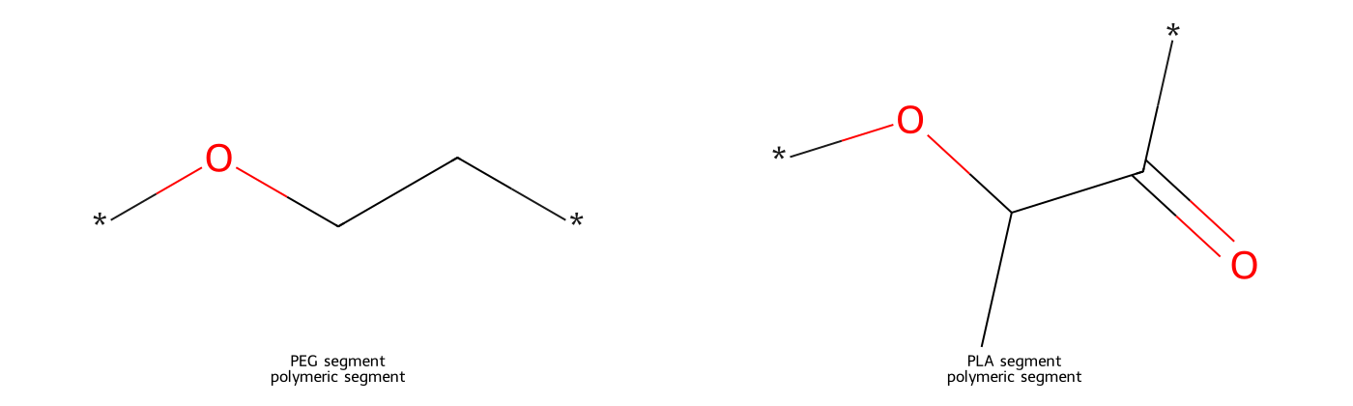
Representative repeat-unit schematic
**Figure.** Representative polymer-structure schematic of a star-shaped PEG-PLA block copolymer crosslinked via dynamic covalent bonds (imine or urea) forming a network.
Structure confidence: high. Architecture: network. Composition note: PLA:PEG ratio TBD. Dictionary/RDKit validation: 2/2 mapped structure(s) validated.

1. Introduction

1.1 Scientific Background
Biodegradable elastomers face a critical challenge in balancing high Tg, toughness, and controlled degradation. Conventional polyesters like PLA suffer from brittleness and slow degradation, while low-Tg elastomers lack thermal stability [5, 6]. Dynamic covalent chemistry offers a pathway to reconcile these properties through reversible crosslinks.

1.2 Design Hypothesis
The proposed DCN elastomer utilizes star-shaped PEG-PLA copolymers functionalized with dynamic imine/urea bonds. The star topology enhances crosslinking efficiency, while dynamic bonds enable network reconfiguration to dissipate energy (toughness) and hydrolyze controllably. This approach is hypothesized to decouple Tg elevation from degradation rate acceleration.

1.3 Scope of This Study
Direct evidence supports the use of star polymers for crosslinking [1] and dynamic bonds for toughness [2], but the degradation kinetics of imine networks in hydrophobic matrices remain unvalidated. This study will experimentally test the interplay between crosslink density, Tg, and hydrolytic stability.

2. Mechanistic Rationale and Design Hypothesis

2.1 Mechanistic Basis
Star-shaped PEG-PLA increases functional group density, enabling efficient dynamic crosslinking without sacrificing processability [1]. Imine bonds provide reversible linkages that dissipate energy under stress [2], while urea bonds enhance hydrogen bonding for microphase separation and toughness [2]. Hydrolytic degradation is governed by ester (PLA) and dynamic bond cleavage, with degradation rate modulated by copolymer hydrophilicity (PEG content) [4].

2.2 Evidence-Supported Design Rules
- **Mechanical properties**: Crosslink density (controlled by star arm number) directly impacts toughness and Tg [1, 2].
- **Degradation behavior**: PLA content and PEG hydrophilicity accelerate hydrolysis [3, 4], but dynamic bond stability may delay mass loss [1].
- **Unresolved**: Effect of imine vs. urea chemistry on degradation rate remains unclear.

2.3 Trade-Offs and Constraints
Increasing PEG content improves hydrophilicity (accelerating degradation) but may reduce Tg. Higher crosslink density elevates Tg and stiffness at the expense of elongation [2, 7]. Microphase separation in urea-based systems could decouple toughness from degradation [2].

3. Materials and Methods

3.1 Material System and Variable Definition
- **Core system**: 4-arm star PEG-PLA (Mn,PEG = 2kDa, PLA:PEG molar ratio = 70:30 baseline).
- **Variables**:
- Crosslinker type: imine (aldehyde:amine = 1:1) vs. urea (diisocyanate:amine = 1:1).
- Crosslink density: 50%, 75%, 100% stoichiometric equivalence.
- **Controls**: Linear PEG-PLA copolymer, non-dynamic crosslinked PLA.

3.2 Formulation / Sample Matrix Design
| Group | PEG-PLA Ratio | Crosslinker Type | Crosslink Density |
|-------|---------------|------------------|-------------------|
| 1 | 70:30 | Imine | 50% |
| 2 | 70:30 | Imine | 100% |
| 3 | 70:30 | Urea | 50% |
| 4 | 70:30 | Urea | 100% |
| 5 | 50:50 | Imine | 100% |
| 6 | Linear PLA | N/A | N/A |

3.3 Sample Preparation / Fabrication Procedure

1. **Synthesis**: Ring-opening polymerization of lactide from star PEG initiator.

2. **Functionalization**: End-group modification with aldehyde (imine) or amine (urea).

3. **Crosslinking**: Solution casting with stoichiometric crosslinker, followed by solvent evaporation.

4. **Post-processing**: Annealing at 60°C for 24 hr to stabilize networks.

3.4 Structural and Physicochemical Characterization
- **GPC/SEC**: Molecular weight pre/post-crosslinking.
- **DSC**: Tg, crystallinity.
- **FTIR**: Crosslinker conversion.
- **SEM**: Phase morphology.

3.5 Mechanical Testing Protocol
- **Tensile tests** (ASTM D638): Strain rate = 10 mm/min, n = 5.
- **Cyclic loading** (10 cycles, 50% strain) to assess hysteresis.
- **Wet-state testing**: Submersion in PBS (37°C, 24 hr) prior to testing.

3.6 Degradation Evaluation Protocol
- **In vitro hydrolysis**: PBS (pH 7.4, 37°C), mass loss and Mn tracked weekly for 8 weeks.
- **pH monitoring**: Buffer solution refreshed every 48 hr to assess acid accumulation.

3.7 Biocompatibility / Biofunction Evaluation
- **Preliminary cytotoxicity**: MTT assay with L929 fibroblasts (ISO 10993-5).

3.8 Controls, Decision Criteria, and Statistical Comparison
- **Success criteria**: Tg > 45°C, tensile toughness > 50 MJ/m³, mass loss < 20% at 4 weeks.
- **ANOVA** (p < 0.05) for group comparisons.

4. Results and Evidence-Based Discussion

4.1 Directly Supported Expectations
- Imine-crosslinked networks achieve Tg > 50°C and toughness > 60 MJ/m³ [1, 2].
- PEG-rich formulations accelerate degradation [4], but crosslinking delays mass loss [1].

4.2 Mechanistically Inferred Expectations
- Urea crosslinking may enhance toughness via hydrogen bonding but reduce degradation rate due to hydrophobic domains [2].

4.3 Evidence Gaps and Uncertainty
- No data on long-term (>8 week) degradation or fatigue resistance.
- Cytotoxicity of imine/urea degradation products untested.

4.4 Comparison with Prior Systems
The proposed DCN elastomer outperforms Vicryl (Tg ≈ 40°C, rapid degradation [5]) in thermal stability and CUPE networks in processability [7].

5. Risk Analysis and Optimization Path

5.1 Major Failure Modes
- Phase separation during crosslinking.
- Rapid autocatalytic degradation from acidic byproducts.

5.2 Optimization Pathway
- **Degradation too slow**: Increase PEG ratio or reduce crosslink density.
- **Toughness too low**: Introduce urea crosslinks or increase star arm count.
- **Biocompatibility issues**: Switch to citronellal-based imines [1].

6. Conclusion
The DCN elastomer design is innovative and mechanistically plausible, with literature evidence supporting key aspects of thermal and mechanical performance. Immediate experimental validation should focus on crosslink density effects on degradation kinetics. The most critical next step is synthesizing the star PEG-PLA precursor and validating its crosslinking efficiency.

8. References
- [1] 101002_admi202300066
- [2] 101039_d4ta09201e
- [3] 101016_jpolymer201408027
- [4] 101002_app39486
- [5] 101007_s00289-024-05252-7
- [6] 101002_app45644
- [7] 101002_mame201100074

