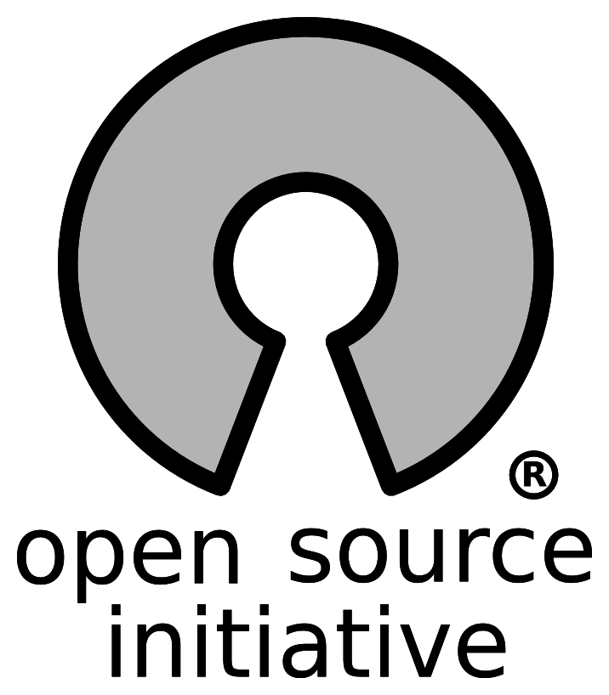

Check us out on Facebook if you want to join or have questions. https://goo.gl/jLp7O3

Interest Meeting: NSC 227, 6:00pm January 29th

To promote, support, and create open source software.

Open Source Club

Interest Meeting: NSC 227, 6:00pm January 29th

To promote, support, and create open source software.



Check us out on Facebook if you want to join or have questions. https://goo.gl/jLp7O3

Check us out on Facebook if you want to join or have questions. https://goo.gl/jLp7O3

Interest Meeting: NSC 227, 6:00pm January 29th

To promote, support, and create open source software.

Open Source Club

Open Source Club