VULNERABILITY ASSESSMENT &
PENETRATION TESTING (VAPT) REPORT
Comprehensive Security Assessment & Technical Findings

TARGET ORGANIZATION: UFOSI Group
DATE OF ASSESSMENT: June 07, 2026
REPORT VERSION: v1.0 (Final)
PREPARED BY: IT Sec UFOSI

1. Executive Summary
During the deployment period, SecOps Global performed a strict Vulnerability Assessment and Penetration Testing (VAPT) engagement targeting the perimeter routers, public-facing applications, and corporate directory networks of Enterprise Infrastructure Solutions Inc. The objective of this evaluation was to proactively discover infrastructure weaknesses, evaluate existing security configuration compliance, and simulate realistic advanced adversary vectors.
CRITICAL RISK SUMMARY: Multiple high-severity exposures were uncovered, including unauthenticated remote code execution paths on legacy internal staging assets and misconfigured multi-tenant boundary routes allowing lateral tenant pivoting.
1.1 Risk Breakdown Metrics
Severity Level | Identified Occurrences | Action Requirement Window
Critical | 1 | Immediate Mitigation (24 Hours)
High | 2 | Urgent Resolution (7 Days)
Medium | 4 | Scheduled Remediation (30 Days)
Low | 7 | General Lifecycle Patching

2. Project Scope & Assessment Boundaries
The scope of this comprehensive testing deployment was strictly constrained to the explicit CIDR blocks, fully qualified domain names (FQDNs), and physical server environments detailed in the architecture mapping below.
Asset Identifier / Target | Asset Type | Assessment Type Constraints
192.168.23.72 | Internal LAN Core | Internal Vulnerability & Pivot Testing
https://portal.enterpriseinfra.io | Web Application | OWASP Top 10 Application Assessment

3. Methodology Framework
The engagement strictly utilized industry-standard technical validation frameworks, ensuring a complete and systematic discovery lifecycle. The process follows four key operational phases:
- Reconnaissance & Passive OSINT: Gathering public data records, DNS mapping, sub-domain discovery, and historical leak inspection.
- Active Scanning & Enumeration: Port mapping, protocol version querying, operating system identification, and defensive configuration assessment.
- Exploitation Phase: Controlled delivery of proof-of-concept exploits to validate true vulnerability status without impacting business availability.
- Analysis & Reporting: Structuring tactical remediation steps, risk severity quantification, and building administrative paths.

4. Detailed Technical Findings
This section outlines individual discoveries made during the technical execution phase. Each vulnerability includes metadata, operational impact explanations, and actionable code/configuration fixes.
4.1 Using Outdated/Vulnerable Dependency
STANDARD/REFERENCE ID | - CVE-2026-4800  - CVE-2025-13465  - CVE-2026-2950 | Severity Level | CRITICAL
Affected Asset | in frontend application:  - node_modules/next/dist/compiled/jsonwebtoken/index.js  - node_modules/next/dist/compiled/babel-packages/packages-bundle.js | Remediation Status | Pending Action
Description & Impact Analysis
- The fix for CVE-2021-23337 (https://github.com/advisories/GHSA-35jh-r3h4-6jhm) added validation for the variable option in _.template but did not apply the same validation to options.imports key names. Both paths flow into the same Function() constructor sink. When an application passes untrusted input as options.imports key names, an attacker can inject default-parameter expressions that execute arbitrary code at template compilation time. Additionally, _.template uses assignInWith to merge imports, which enumerates inherited properties via for..in. If Object.prototype has been polluted by any other vector, the polluted keys are copied into the imports object and passed to Function(). Patches: Users should upgrade to version 4.18.0. Workarounds: Do not pass untrusted input as key names in options.imports. Only use developer-controlled, static key names.
- Lodash versions 4.0.0 through 4.17.22 are vulnerable to prototype pollution in the _.unset and _.omit functions. An attacker can pass crafted paths which cause Lodash to delete methods from global prototypes. The issue permits deletion of properties but does not allow overwriting their original behavior. This issue is patched on 4.17.23
- Lodash versions 4.17.23 and earlier are vulnerable to prototype pollution in the _.unset and _.omit functions. The fix for CVE-2025-13465: https://github.com/lodash/lodash/security/advisories/GHSA-xxjr-mmjv-4gpg
only guards against string key members, so an attacker can bypass the check by passing array-wrapped path segments. This allows deletion of properties from built-in prototypes such as Object.prototype, Number.prototype, and String.prototype. The issue permits deletion of prototype properties but does not allow overwriting their original behavior. Patches: This issue is patched in 4.18.0. Workarounds: None. Upgrade to the patched version.
Proof of Concept (PoC)

Proof of Concept (PoC)
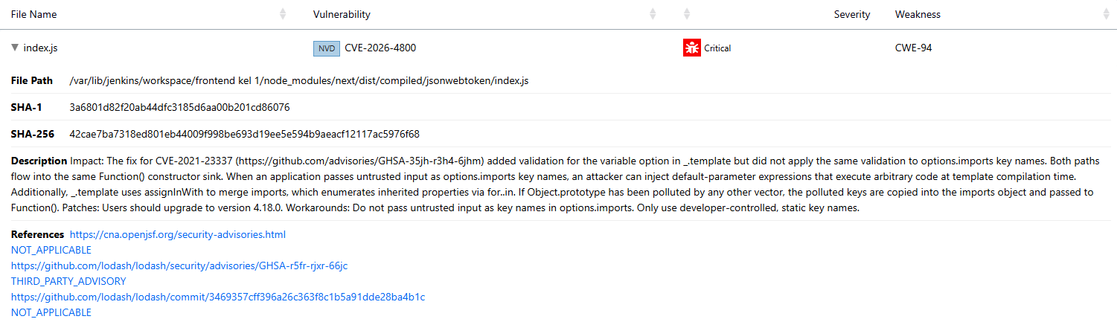
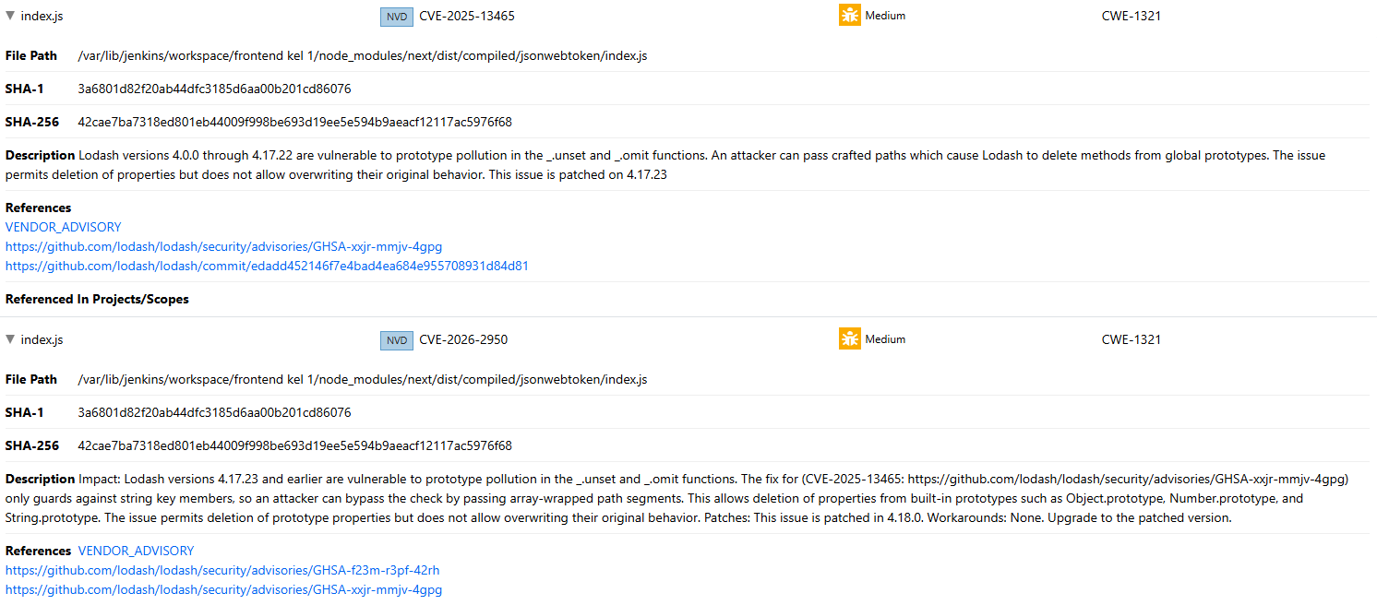

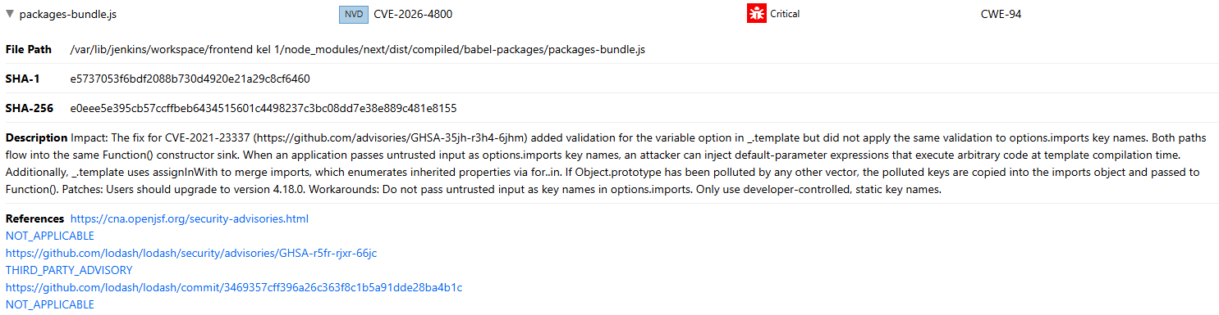
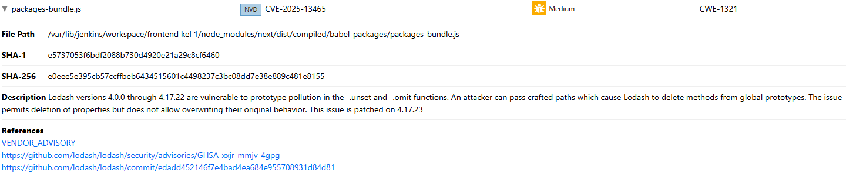
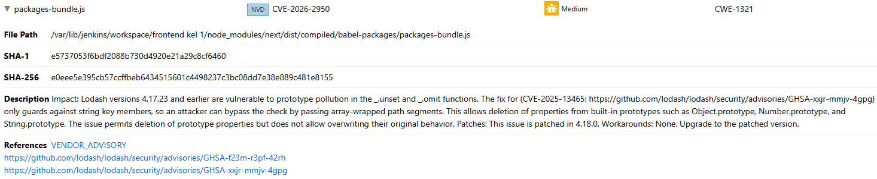
Remediation Strategy
Upgrade to the patched version.
4.2 Critical Memory Management and Remote Code Execution Vulnerabilities in libssl3 (OpenSSL) Library
STANDARD/REFERENCE ID | CVE-2026-31789, CVE-2025-15467, CVE-2025-69421 , CVE-2026-28387, CVE-2026-28388, CVE-2026-28389  CVE-2026-28390, CVE-2025-69419, CVE-2025-9230, CVE-2025-9231, CVE-2026-31790, CVE-2025-15468  CVE-2025-66199, CVE-2025-68160, CVE-2025-69418, CVE-2025-69420, CVE-2025-9232, CVE-2026-22795  CVE-2026-22796 | Severity Level | CRITICAL
Affected Asset | in back-end application  - libcrypto3  - libssl3 | Remediation Status | Pending Action
Description & Impact Analysis
Multiple severe vulnerabilities, ranging from Medium to Critical severity, have been detected in the libssl3 core package (OpenSSL framework) across installed versions 3.3.5-r0, 3.3.6-r0, and 3.3.7-r0. The most severe finding is tracked under CVE-2026-31789 (CRITICAL), which involves a heap buffer overflow condition triggered on 32-bit architecture systems when parsing excessively large or malformed X.509 digital certificates.
Additionally, the audit highlights CVE-2025-15467 (HIGH), representing a Remote Code Execution (RCE) threat via oversized internal initialization parameters, alongside CVE-2026-28387, which isolates a dangerous Use-After-Free (UAF) memory state within the DANE TLSA secure authentication handshake pipeline. The remaining nested findings (such as CVE-2025-69421 and CVE-2026-28389) primarily induce immediate Null Pointer Dereferences during PKCS#12 file extraction and CMS data processing structures.
Proof of Concept (PoC)
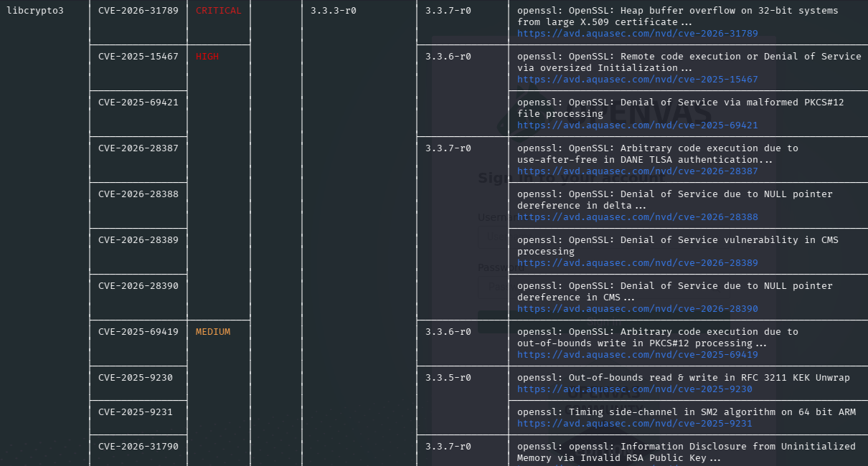
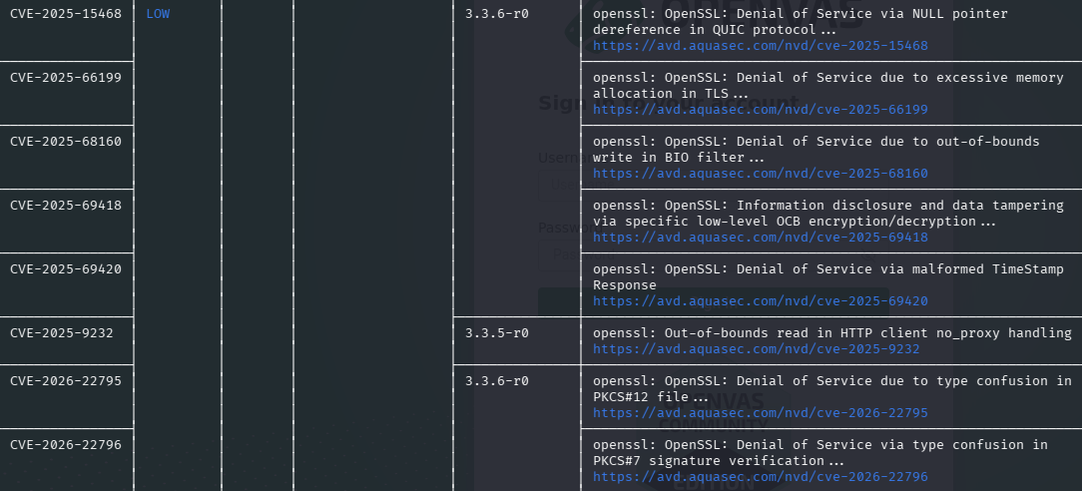
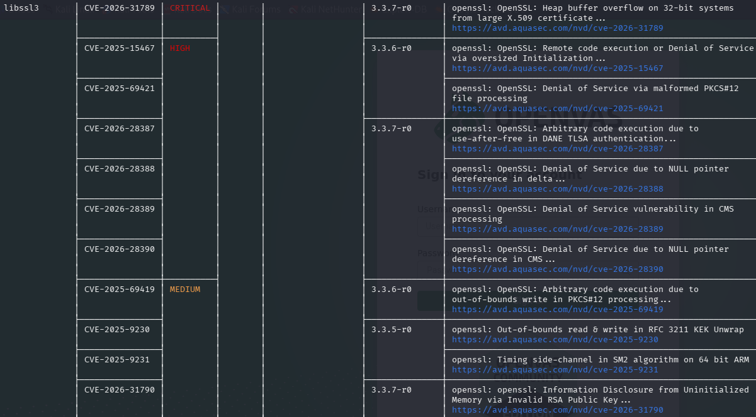
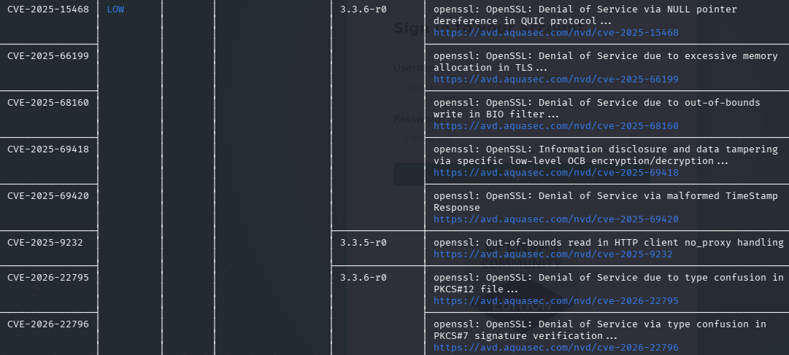
Remediation Strategy
Upgrade to the patched version.

4.3 Sensitive Data Exposure via Recursive Copy
STANDARD/REFERENCE ID | - CVE-2026-45149 | Severity Level | HIGH
Affected Asset | in frontend application:  backend/package-lock.json | Remediation Status | Pending Action

Description & Impact Analysis
The brace-expansion library generates arbitrary strings containing a common prefix and suffix. From 5.0.0 to before 5.0.6, the max option was being applied too late. When expanding a single large numeric range like {1..10000000}, the sequence generation loop generates all 10 million intermediate elements before the max limit is applied With max=10, the output is correctly limited to 10 items, but the process still allocates ~505 MB and spends ~800ms building the full intermediate array. This vulnerability is fixed in 5.0.6.
Proof of Concept (PoC)
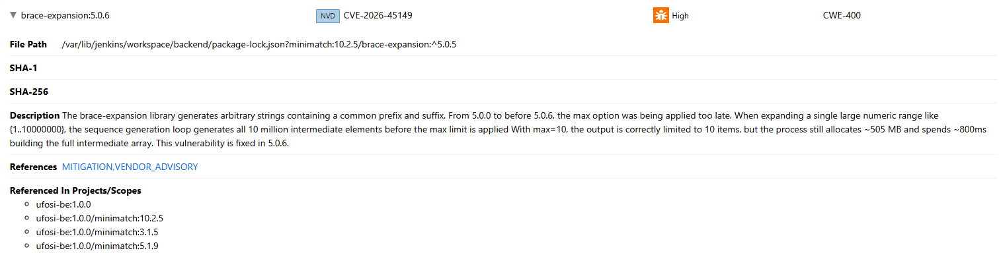
Remediation Strategy
Ensure the string to be expanded doesn't contain more values than the desired max item count.
4.4 Insecure File Permissions on Copied Resources
STANDARD/REFERENCE ID | CWE-732 - Incorrect Permission Assignment for Critical Resource | Severity Level | HIGH
Affected Asset | Dockerfile in front-end application | Remediation Status | Pending Action
Description & Impact Analysis
Ownership or write permissions for a file or directory copied to the Docker image have been assigned to a user other than root.
Write permissions enable malicious actors, who have a foothold on the container, to tamper with the resource and thus potentially manipulate the container’s expected behavior.
Manipulating files could disrupt services or aid in escalating privileges inside the container.
This also breaches the container immutability principle as it facilitates container changes during its life. Immutability, a container best practice, allows for a more reliable and reproducible behavior of Docker containers. If a user is given ownership on a file but no write permissions, the user can still modify it by using his ownership to change the file permissions first. This is why both ownership and write permissions should be avoided.
Proof of Concept (PoC)
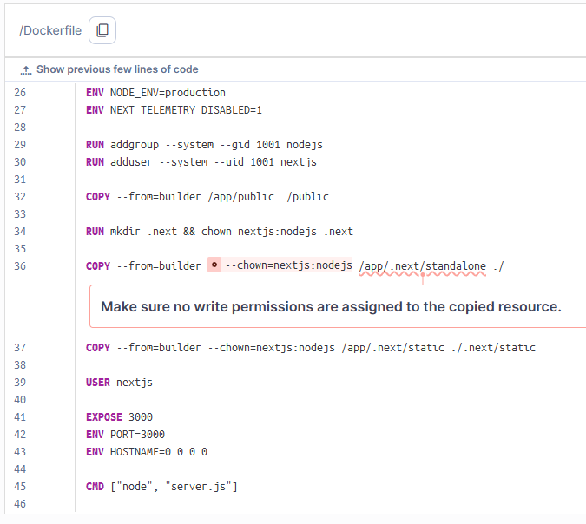
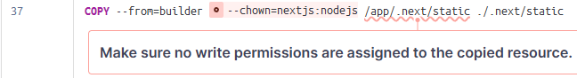
Remediation Strategy
- Use --chmod to change the permissions so that only root users can write to files.
- Use --chown to change the file/directory owner to a root user.
- Be mindful of the container immutability principle.
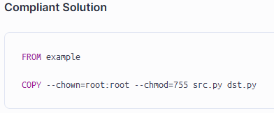
4.5 Vulnerabilities in musl libc
STANDARD/REFERENCE ID | - CVE-2026-40200  - CVE-2026-6042 | Severity Level | HIGH
Affected Asset | in back-tend application:  musl  musl-utils | Remediation Status | Pending Action

Description & Impact Analysis
Two security vulnerabilities, including one High-severity and one Medium-severity flaw, have been detected affecting both the musl core library and musl-utils package, specifically targeting installed version 1.2.5-r9.
These vulnerabilities are tracked under CVE-2026-40200 (High) and CVE-2026-6042 (Medium). Technically, CVE-2026-40200 involves a critical stack-based buffer overflow risk within the core libc framework. Meanwhile, CVE-2026-6042 stems from an algorithmic inefficiency within the GB18030 4-byte character decoder component, leading to resource exhaustion during specific text or string parsing routines.
Proof of Concept (PoC)
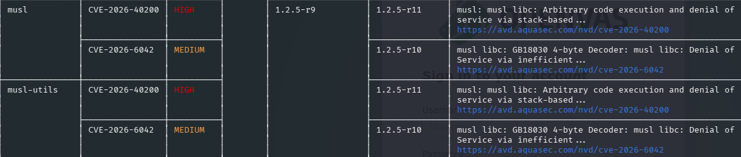
Remediation Strategy
Upgrade to the patched version.
4.6 Vulnerabilities in zlib Library
STANDARD/REFERENCE ID | - CVE-2026-22184  - CVE-2026-27171 | Severity Level | HIGH
Affected Asset | in back-tend application:  zlib | Remediation Status | Pending Action

Description & Impact Analysis
Two security vulnerabilities, including one High-severity and one Medium-severity flaw, have been identified in the zlib data compression library, specifically affecting package version 1.3.1-r2.

These findings are tracked under CVE-2026-22184 (High) and CVE-2026-27171 (Medium). Technically, CVE-2026-22184 involves a critical buffer overflow vulnerability within the library's untgz utility component. Meanwhile, CVE-2026-27171 stems from a logic flaw within the CRC32 checksum combination functions, which triggers an uncontrolled recursive execution or freezing condition."
Proof of Concept (PoC)

Remediation Strategy
Upgrade to the patched version.
4.7 Vulnerabilities in ssl_client BusyBox Core Utilities
STANDARD/REFERENCE ID | CVE-2024-58251  CVE-2025-46394 | Severity Level | MEDIUM
Affected Asset | ssl_client in back-end application | Remediation Status | Pending Action
Description & Impact Analysis
Two Low-severity vulnerabilities have been identified in the ssl_client component embedded within BusyBox, specifically affecting package version 1.37.0-r12. The findings are tracked under CVE-2024-58251 and CVE-2025-46394. Technically, these flaws exist within BusyBox's core applet utilities through version 1.37.0. CVE-2024-58251 involves a flaw in how the netstat utility manages networking parameters, while CVE-2025-46394 pertains to improper handling or truncation of long or malformed filenames inside a TAR archive processed by the tar utility.
Proof of Concept (PoC)
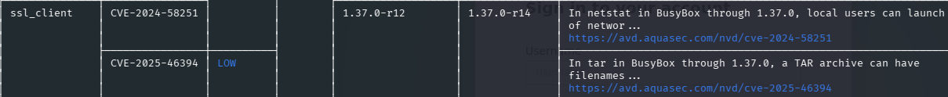
Remediation Strategy
Upgrade to the patched version.
4.8 Sensitive Data Exposure via Glob Copy Pattern
STANDARD/REFERENCE ID | CWE-668 - Exposure of Resource to Wrong Sphere  CWE-497 - Exposure of Sensitive System Information to an Unauthorized Control Sphere | Severity Level | MEDIUM
Affected Asset | Dockerfile in front-end application  Dockerfile in back-end application | Remediation Status | Pending Action
Description & Impact Analysis
When building a Docker image from a Dockerfile, a context directory is used and sent to the Docker daemon before the actual build starts. This context directory usually contains the Dockerfile itself, along with all the files that will be necessary for the build to succeed. This generally includes:
- the source code of applications to set up in the container.
- configuration files for other software components.
- other necessary packages or components.
The COPY and ADD directives in the Dockerfiles are then used to actually copy content from the context directory to the image file system. When COPY or ADD are used to recursively copy entire top-level directories or multiple items whose names are determined at build-time, unexpected files might get copied to the image filesystem. It could affect their confidentiality.
Proof of Concept (PoC)
Front-end
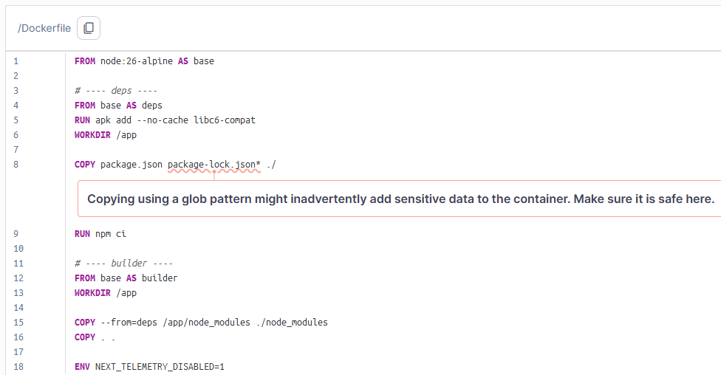
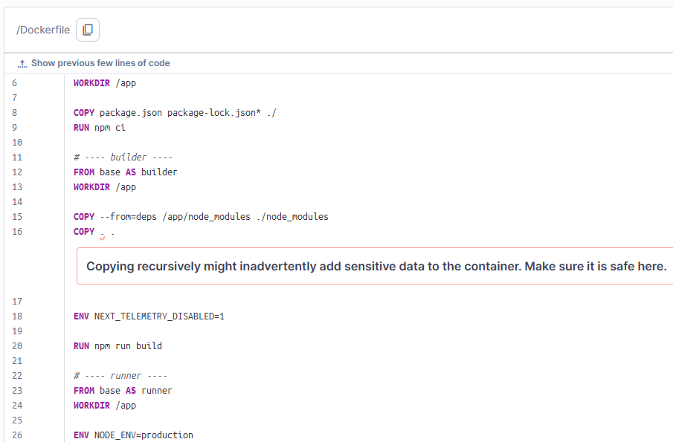
Back-end
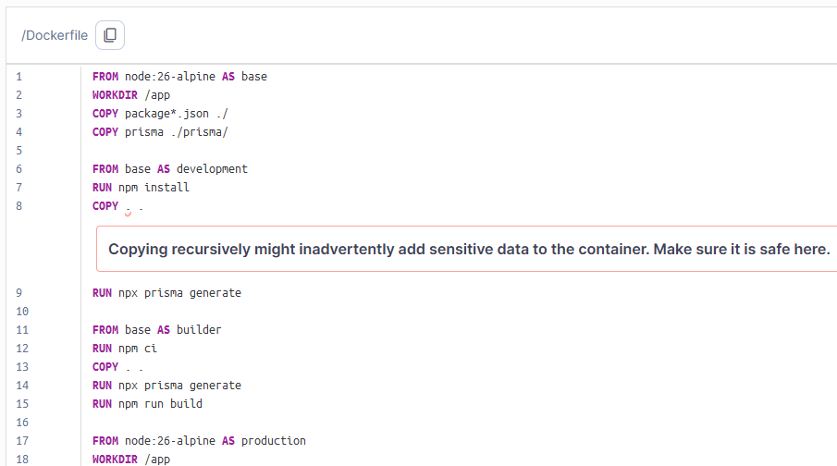
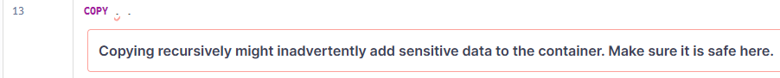
Remediation Strategy
- Limit the usage of globbing in the COPY and ADD sources definition.
- Avoid copying the entire context directory to the image filesystem.
- Prefer providing an explicit list of files and directories that are required for the image to properly run.
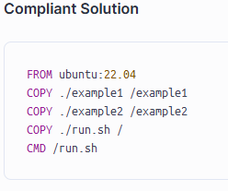
4.9 Sensitive Data Exposure via Recursive Copy
STANDARD/REFERENCE ID | OWASP - Secure Random Number Generation Cheat Sheet  OWASP - Top 10 2021 Category A2 - Cryptographic Failures  OWASP - Top 10 2017 Category A3 - Sensitive Data Exposure  CWE-338 - Use of Cryptographically Weak Pseudo-Random Number Generator (PRNG)  CWE-330 - Use of Insufficiently Random Values  CWE - CWE-326 - Inadequate Encryption Strength  CWE-1241 - Use of Predictable Algorithm in Random Number Generator | Severity Level | MEDIUM
Affected Asset | in front-end application  src/app/(dashboard)/analytics/page.tsx  src/app/(dashboard)/document-vault/page.tsx  src/app/(dashboard)/fraud-analytics/page.tsx  src/hooks/useOcrFinancing.ts  in back-end application  src/utils/upload.util.ts | Remediation Status | Pending Action
Description & Impact Analysis
PRNGs are algorithms that produce sequences of numbers that only approximate true randomness. While they are suitable for applications like simulations or modeling, they are not appropriate for security-sensitive contexts because their outputs can be predictable if the internal state is known.
As the Math.random() function relies on a weak pseudorandom number generator, this function should not be used for security-critical applications or for protecting sensitive data. In such a context, a cryptographically strong pseudorandom number generator (CSPRNG) should be used instead.
Proof of Concept (PoC)
Front-end
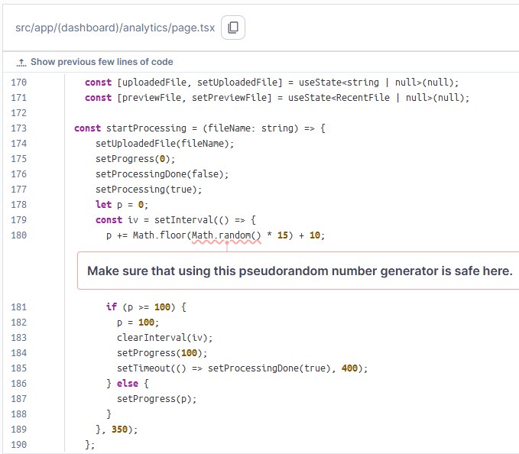
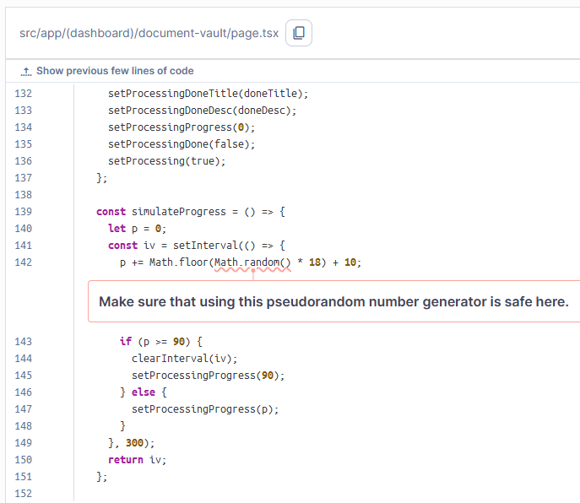
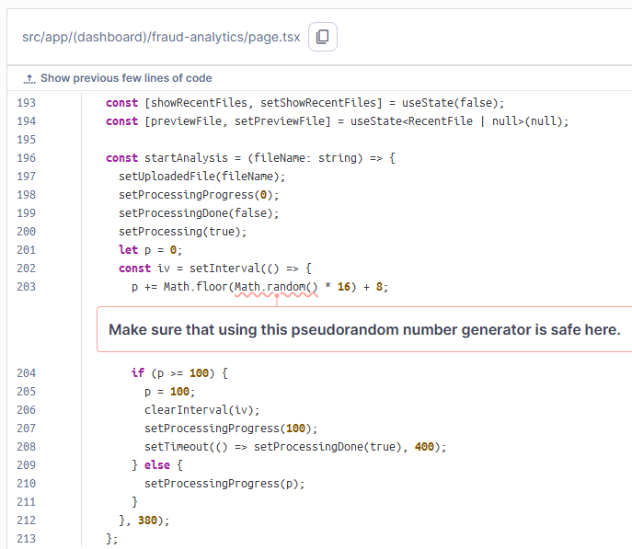
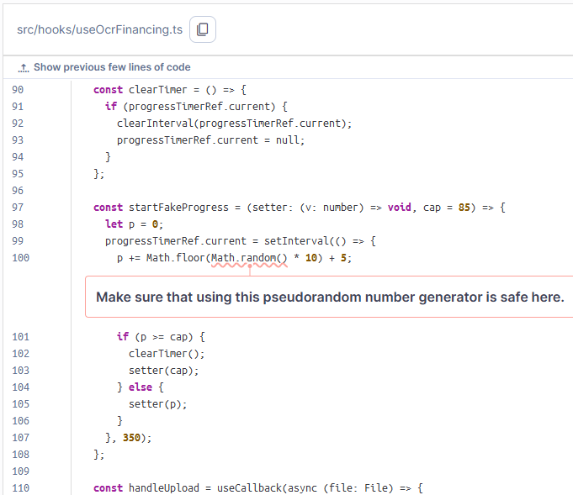
Back-end
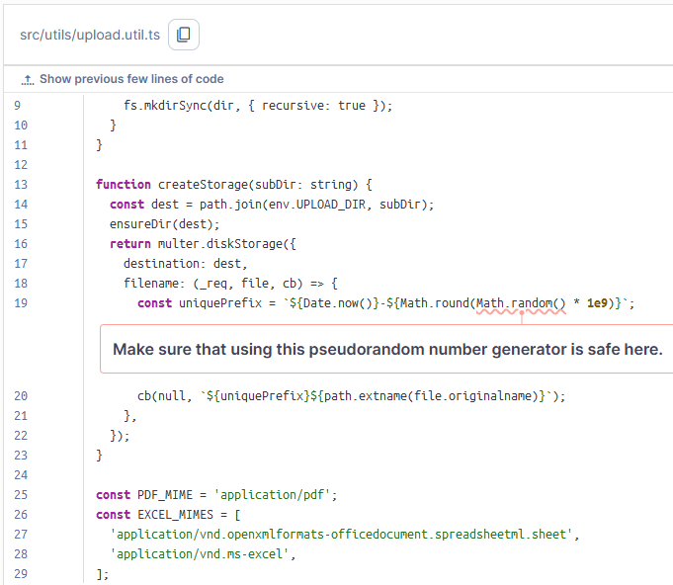
Remediation Strategy
- Use a cryptographically secure pseudorandom number generator (CSPRNG) like crypto.getRandomValues().
- Use the generated random values only once.
- You should not expose the generated random value. If you have to store it, make sure that the database or file is secure.
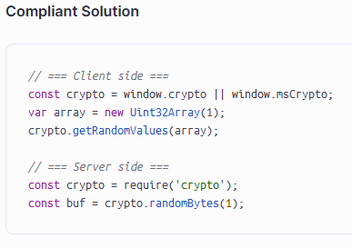
4.10 The "node" image runs with "root" as the default user
STANDARD/REFERENCE ID | CWE - CWE-284 - Improper Access Control | Severity Level | MEDIUM
Affected Asset | Dockerfile in back-end application | Remediation Status | Pending Action

Description & Impact Analysis
Running containers as a privileged user weakens their runtime security, allowing any user whose code runs on the container to perform administrative actions.
In Linux containers, the privileged user is usually named root. In Windows containers, the equivalent is ContainerAdministrator.
A malicious user can run code on a system either thanks to actions that could be deemed legitimate - depending on internal business logic or operational management shells - or thanks to malicious actions. For example, with arbitrary code execution after exploiting a service that the container hosts.
Suppose the container is not hardened to prevent using a shell, interpreter, or Linux capabilities. In this case, the malicious user can read and exfiltrate any file (including Docker volumes), open new network connections, install malicious software, or, worse, break out of the container’s isolation context by exploiting other components.
This means giving the possibility to attackers to steal important infrastructure files, intellectual property, or personal data.
Depending on the infrastructure’s resilience, attackers may then extend their attack to other services, such as Kubernetes clusters or cloud providers, in order to maximize their reach.
Proof of Concept (PoC)
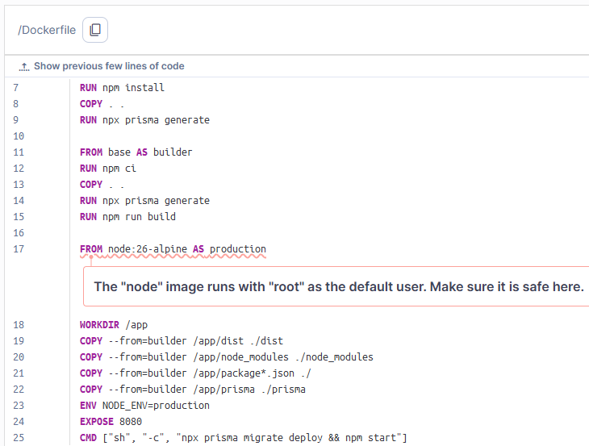
Remediation Strategy
In the Dockerfile:
- Create a new default user and use it with the USER statement.
- Some container maintainers create a specific user to be used without explicitly setting it as default, such as postgresql or zookeeper. It is recommended to use these users instead of root.
On Windows containers, the ContainerUser is available for this purpose.
Or, at launch time:
- Use the user argument when calling Docker or in the docker-compose file.
- Add fine-grained Linux capabilities to perform specific actions that require root privileges.
If this image is already explicitly set to launch with a non-privileged user, you can add it to the safe images list rule property of your SonarQube instance, without the tag.
4.11 Missing Linux Kernel mitigations for 'Register File Data Sampling (RFDS)' hardware vulnerability (INTEL-SA-00898)
STANDARD/REFERENCE ID | CVE-2023-28746 | Severity Level | MEDIUM
Affected Asset | Server Ubuntu with ip 127.0.0.1:9392 | Remediation Status | Pending Action

Description & Impact Analysis
The Linux Kernel on the remote host is missing the mitigation for the "reg_file_data_sampling" hardware vulnerability as reported by the sysfs interface:
sysfs file checked | Linux Kernel status (SSH response) -------------------------------------------------------------------------------------------------/sys/devices/system/cpu/vulnerabilities/reg_file_data_sampling | Vulnerable: No microcode
Notes on the "Linux Kernel status (SSH response)" column:
- sysfs file missing: The sysfs interface is available but the sysfs file for this specific vulnerability is missing. This means the current Linux Kernel doesn't know this vulnerability yet. Based on this it is assumed that it doesn't provide any mitigation and that the target system is vulnerable.
- Strings including "Mitigation:", "Not affected" or "Vulnerable" are reported directly by the Linux Kernel.
- All other strings are responses to various SSH commands.
Proof of Concept (PoC)
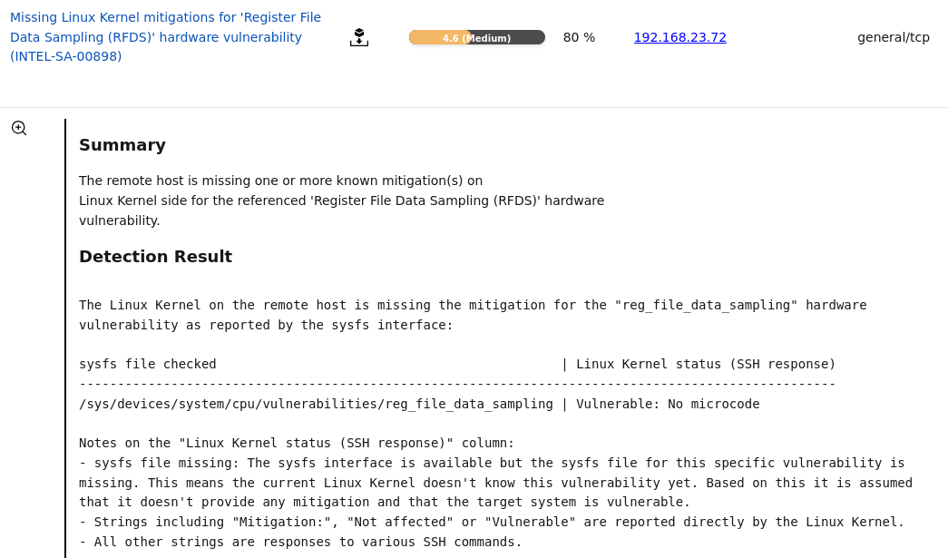
Remediation Strategy
The following solutions exist:
- Update to a more recent Linux Kernel to receive mitigations on Kernel level and info about the mitigation status from it
- Enable the mitigation(s) in the Linux Kernel (might be disabled depending on the configuration)

Additional possible mitigations (if provided by the vendor) are to:
- Install a Microcode update
- Update the BIOS of the Mainboard

Note: Please create an override for this result if one of the following applies:
- The sysfs file is not available but other mitigations like a Microcode update is already in place
- The sysfs file is not available but the CPU of the host is not affected
- The reporting of the Linux Kernel is not correct (this is out of the control of this VT)

4.12 PostCSS: Cross-Site Scripting (XSS) via improper escaping of style closing tags
STANDARD/REFERENCE ID | CVE-2026-41305 | Severity Level | MEDIUM
Affected Asset | postcss (package.json) | Remediation Status | Pending Action

Description & Impact Analysis
A Medium-severity security vulnerability has been detected in the frontend build-tool component PostCSS (v8.4.31), identified within the project's package.json dependency file under CVE-2026-41305.
This flaw is categorized as a Cross-Site Scripting (XSS) vulnerability. It occurs due to the library's failure to perform proper sanitization or encoding (improper escaping) of characters within style closing tags. Consequently, the system can be manipulated if malicious actors inject arbitrary code via corrupted CSS syntax or visual styles processed by this specific component.
Proof of Concept (PoC)
Remediation Strategy
Upgrade to the patched version from 8.4.31 to 8.5.10
4.13 Vulnerabilities in BusyBox
STANDARD/REFERENCE ID | CVE-2024-58251  CVE-2025-46394 | Severity Level | MEDIUM
Affected Asset | in back-end application  - busybox  - busybox-binsh | Remediation Status | Pending Action

Description & Impact Analysis
Multiple security vulnerabilities, consisting of one Medium-severity and one Low-severity flaw, have been detected within the foundational busybox and busybox-binsh core system packages, specifically impacting version 1.37.0-r12.
These flaws are tracked under CVE-2024-58251 (Medium) and CVE-2025-46394 (Low). Technically, CVE-2024-58251 involves a logic vulnerability within the netstat applet through BusyBox version 1.37.0, which handles network monitoring structures poorly. Meanwhile, CVE-2025-46394 points to an improper processing and validation workflow of long or malformed filenames within compressed TAR archives handled by the tar applet utility.
Proof of Concept (PoC)
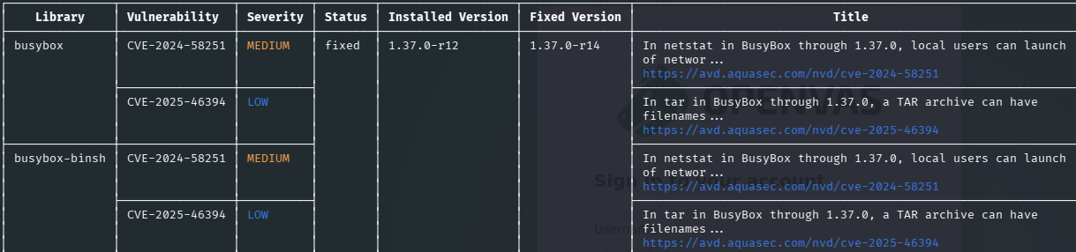
Remediation Strategy
Upgrade to the patched version from 1.37.0-r12 to 1.37.0-r14

4.14 Information Disclosure via Outdated Next.js Version Exposure
Affected Asset | Next.js version | Remediation Status | Pending Action
Description & Impact Analysis
An Information Disclosure vulnerability has been identified on the application front-facing interface host (192.168.23.72:30080). Passive technological fingerprinting via Wappalyzer successfully detected that the web framework is running an outdated version of Next.js (v15.5.19).
This exposure occurs because the framework's default production headers, source maps, or specific JSON data structures (such as _next/static paths) are actively broadcasting exact software build metrics to the public network, failing to obfuscate infrastructure properties.
Proof of Concept (PoC)
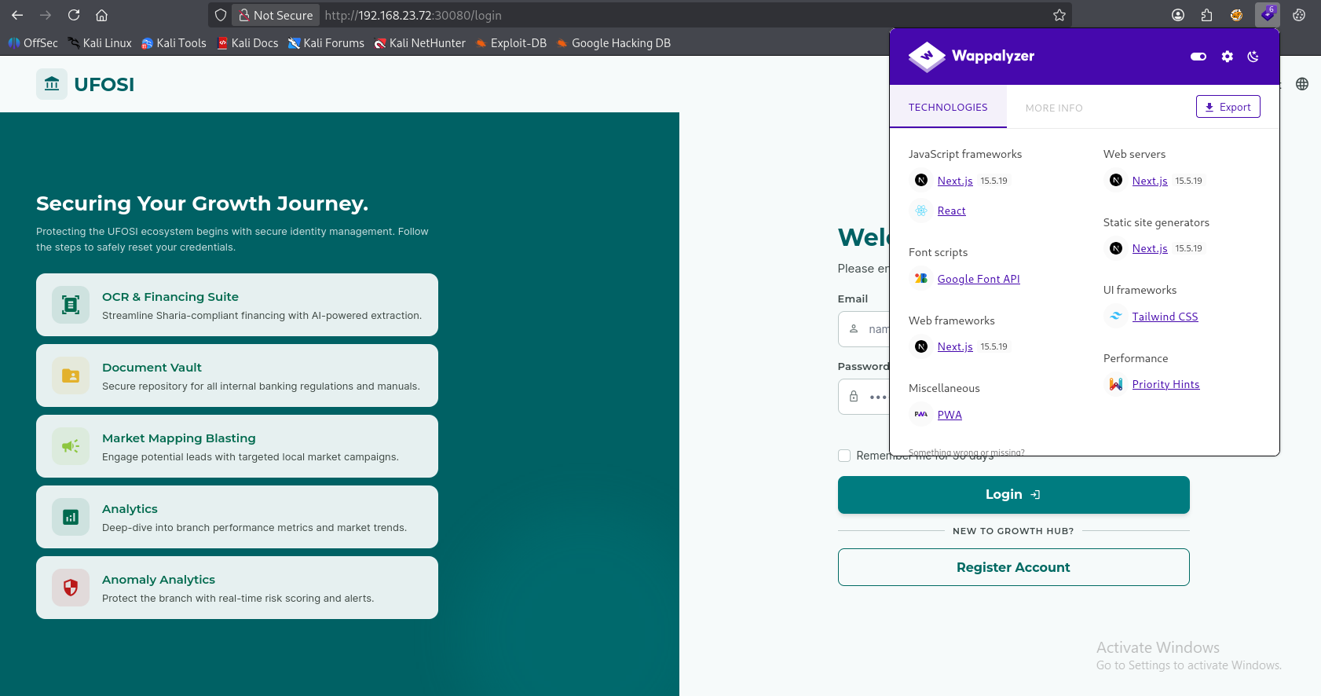
Remediation Strategy
Actionable steps for the development team to hide or fix the issue.
- Immediate Framework Obfuscation: Disable the x-powered-by header generation within your Next.js configuration to stop broadcasting framework information.
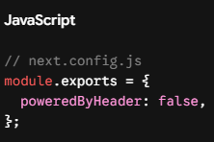
- Security Patch Maintenance: Ensure the deployment pipeline continuously monitors Next.js core releases and updates the application dependencies to the latest stable, hardened production release to invalidate any potential target exploits.
4.15 Sensitive Data Exposure via Recursive Copy
STANDARD/REFERENCE ID | - OWASP - Top 10 2021 Category A8 - Software and Data Integrity Failures  - CWE-353 - Missing Support for Integrity Check  - OWASP - Top 10 2017 Category A6 - Security Misconfiguration | Severity Level | LOW
Affected Asset | in frontend application:  - referensi/anomaly-prediction.html  - referensi/document.vault.html  - referensi/home.html  - referensi/market-mapping-blasting.html  - referensi/ocr-financing-suite.html  - referensi/raw-analytics.html | Remediation Status | Pending Action

Description & Impact Analysis
When building a Docker image from a Dockerfile, a context directory is used and sent to the Docker daemon before the actual build starts. This context directory usually contains the Dockerfile itself, along with all the files that will be necessary for the build to succeed. This generally includes:
- the source code of applications to set up in the container.
- configuration files for other software components.
- other necessary packages or components.
The COPY and ADD directives in the Dockerfiles are then used to actually copy content from the context directory to the image file system. When COPY or ADD are used to recursively copy entire top-level directories or multiple items whose names are determined at build-time, unexpected files might get copied to the image filesystem. It could affect their confidentiality.

Proof of Concept (PoC)
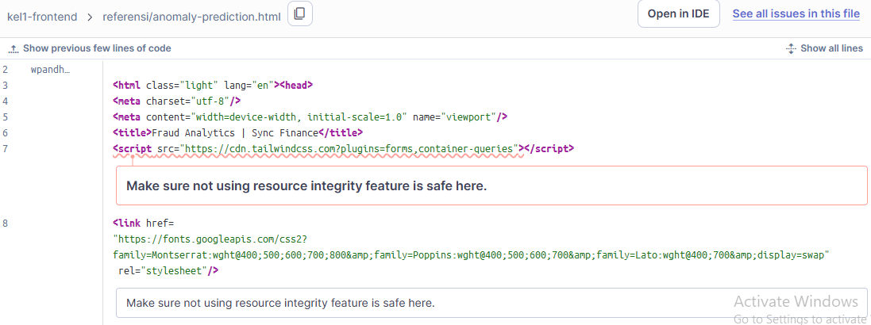
Remediation Strategy
The following code does not include an integrity check, which means any change to the remote artifact — whether by its author or an attacker — will execute unverified in the application. It also loads the resource from a mutable URL, so an integrity hash alone is not enough: the URL must be pinned to a specific version.

4.16 Weak MAC Algorithm(s) Supported (SSH)Sensitive Data Exposure via Recursive Copy
STANDARD/REFERENCE ID | - OWASP - Top 10 2021 Category A8 - Software and Data Integrity Failures  - CWE-353 - Missing Support for Integrity Check  - OWASP - Top 10 2017 Category A6 - Security Misconfiguration | Severity Level | LOW
Affected Asset | in frontend application:  Server Ubuntu with ip 127.0.0.1:9392 | Remediation Status | Pending Action

Description & Impact Analysis
The remote SSH server supports the following weak client-to-server MAC algorithm(s):
umac-64-etm@openssh.com
umac-64@openssh.com
The remote SSH server supports the following weak server-to-client MAC algorithm(s):
umac-64-etm@openssh.com
umac-64@openssh.com
Proof of Concept (PoC)
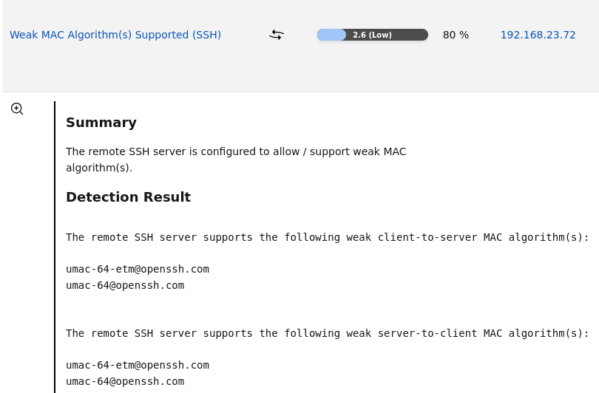
Remediation Strategy
Mitigation, disable the reported weak MAC algorithm(s).

