RULES OF ENGAGEMENT (ROE)
Cybersecurity Assessment Framework & Authorization Protocol
Date: 04 Juni 2026
Target Organization: OFUSI Group
Assessment Team: IT Security
1. ROE Objective
This document defines the operational boundaries, testing authority, and authorized guidelines for the security assessment conducted on behalf of the Target Organization. The primary objective is to evaluate defensive controls, identify technical vulnerabilities, and safely validate the organization's security posture under a strict, controlled framework.
2. Operational Timeline & Scheduling Constraints
Testing maneuvers must strictly align with the execution windows defined below. Unauthorized off-hours traffic will be treated as non-compliant.
- Daily Debrieﬁng Frequency : Twice a day
- Daily Debrieﬁng Time/Location : Offline 08.00 WIB and 19.00 WIB at Yogya Room
- Start Date of Penetration Test : 05 Juni 2026
- End Date of Penetration Test : 09 Juni 2026
- Type of Test : White box
- Testing Occurs at Following Times : 24/7 Full Testing
- Tests Relate to : Web Application
3. Explicit Technical Restrictions
To ensure infrastructure stability and business continuity, the following operational bounds are heavily enforced:
- Denial of Service (DoS): Interruption of business functions or crash-testing production loops is strictly barred. DoS scripts, stress-testing utilities, or heavy resource-exhaustion actions are forbidden.
- Destructive Exploitation: Operators must not execute commands that permanently delete, modify, or format system data, active databases, or operating system code integrity.
- Malware Deployment: Persistent ransomware strings, self-propagating worm modules, or unauthorized third-party tooling binaries are strictly barred from deployment on target hosts.

4. Scope & Targeted Environments
The operational assessment is strictly constrained to the assets defined below. Interaction with any asset not explicitly declared in-scope constitutes a violation of this agreement.
What is the official name of the application, its target URL(s), and all associated IP address ranges or CIDR blocks? | Application Name: UFOSI  Target URL(s):  - https://github.com/UFOSI-Project/ufosi-fe (Front-end)  - https://github.com/UFOSI-Project/ufosi-be (Back-end)  IP Address / CIDR Blocks: 192.168.23.72 dan 192.168.23.73
What type of environment is being tested? | Development (Dev) / Testing (UAT) Environment
Is the infrastructure hosted on-premises, via a cloud provider, or within a containerized environment? | On-Premises via VMware workstation, Docker, Kubernetes, GNS3, grafana, terraform, and prometheus
What specific Operating Systems are running on the target servers/hosts? | Ubuntu Server
Is the application hosted on a shared platform with other internal/external sites, and is it behind a load balancer or reverse proxy? | It runs within a Kubernetes cluster deployed on VMware infrastructure, which operates as a shared platform (multi-tenant environment) where other internal services or microservices may reside.
What core programming language(s) is the application written in and what frameworks are utilized? | Node.js, python, Express.js, Next.js, Flask
What database systems are integrated with the application, and is direct testing of the database backend in-scope? | PostgreSQL
Does the application enforce multiple user roles, and is explicit privilege escalation/role-based cross-testing required? | Yes, ordinary user and admin user.
What is the application login credentials, if required? (Please provide login and password of all roles which should be tested, administrator, editor, user, customer etc.) | Provide login with user and password for testing
Are deep, authenticated host-level infrastructure scans required? (If yes, please provide the necessary SSH keys or administrative service account access). | Yes. Provide SSH or administrative service account access.  Note: The necessary SSH or administrative service accounts will be provided securely through the designated credential sharing channel before the testing starts.
Will supplementary documentation be provided to the testing team? | API Documentation, system diagram, code documentation
5. Statement of Acknowledgement
By signing below, I formally acknowledge that I have read, understood, and agree to comply with the terms, policies, and guidelines established for this program/document. I verify that all information provided in this form is accurate, complete, and true to the best of my knowledge. I understand that any willful misrepresentation or breach of the terms outlined herein may result in the revocation of access, termination of agreements, or further formal action as required.
✓ | I agree and accept the terms and conditions outlined above.

6. Formal Cross-Departmental Sign-Off
By establishing signatures below, all three distinct corporate departments validate and acknowledge the operational boundaries, safety parameters, and timeline agreements governing this assessment.
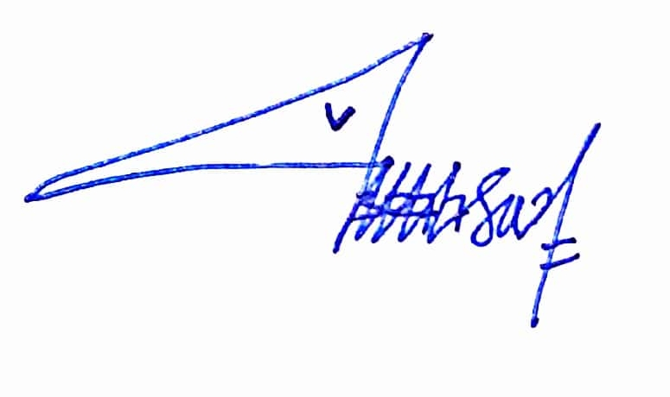 |  |  |  | 
IT Security Team Approval |  | IT Developer Team Approval |  | IT Operation Team Approval
Annisa Nursafitri  Date: 04 June 2026 |  | Ghifari Maaliki Syafa Syuhada  Date: 04 June 2026 |  | Nindya Dwi Larasati  Date: 04 June 2026

