Revision History
Revision | Changes Description | Release Date
A | New Document | 12-Aug-2026

Purpose
Detailed assembly instructions, guiding the production technician to assemble the Nova Power Supply Sub-Assembly (55-00007 Rev.A), in accordance with the company's quality and safety standards.

Scope
Applies to all production technicians on the assembly workstations.

Safety Equipment
Item | Internal PN
TBD | TBD

Hazards
Hazard Type | Hazard Description
TBD | TBD

Tools & Equipment
Internal PN | Description
2 | PH2 - #2 Phillips screwdriver or drill bit | 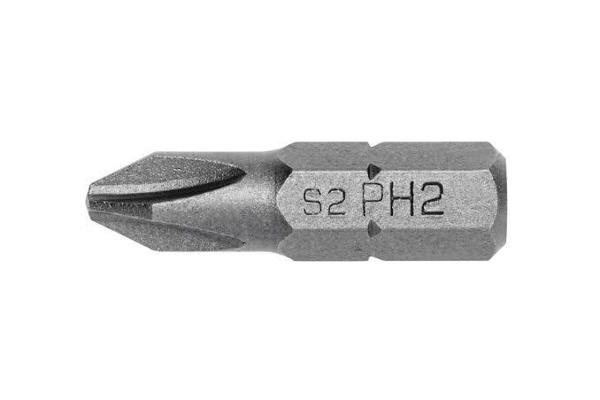
3 | PH2 - #2 Phillips screwdriver or drill bit | 
4 | PH2 - #2 Phillips screwdriver or drill bit | 
5 | PH2 - #2 Phillips screwdriver or drill bit | 
8 | PH2 - #2 Phillips screwdriver or drill bit | 
9 | PH2 - #2 Phillips screwdriver or drill bit | 
10 | PH2 - #2 Phillips screwdriver or drill bit | 

Software & Firmware
Internal PN | Description
N/A | N/A

Part list
Internal PN | Description

Instructions
# | Description | Reference
1

