1. Customers: list all customers sorted by customer name.

* Display the following fields: Customer Name, Contact First Name, Contact Last Name, Phone Number and Country.

SELECT customerName, contactFirstName, contactLastName, phone, country

FROM customers;

2. Employees: list all employees sorted by last name, first name

* Display the following fields: First Name, Last Name, Extension, email, office location, name of manager, job Title
* Note: this will require an inner join between the employees table and the offices table as well as a self join on the employees table to get the name of the manager (reportsTo)

SELECT e.firstName, e.lastName, concat(m.firstName, ‘ ‘, m.lastName ) As ReportsTo, e.extension, e.email, e.jobTitle, e.officeCode, offices.city, offices.state, offices.postalCode

FROM employees e

INNER JOIN offices

ON e.officeCode = offices.officeCode

INNER JOIN

employees m

ON m.employeeNumber = e.reportsto

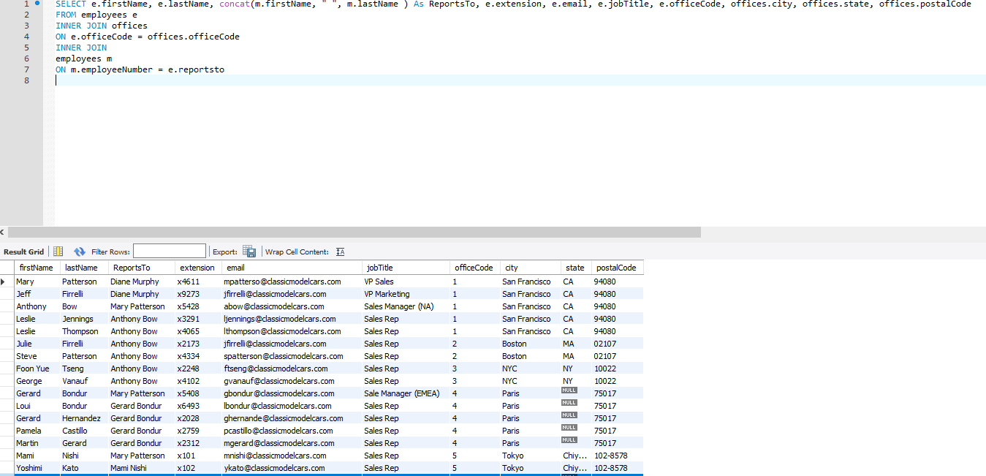

3. Products: list all products ordered by product line. On the same page, list all the product lines and their descriptions.

* Display Product Name, Product Line, Quantity, Price and MSRP. Display amounts formatted properly.

SELECT productName, quantityInStock, buyPrice, MSRP, products.productLine, productLines.textDescription, productLines.htmlDescription, productLines.image

FROM products

INNER JOIN productlines

ON productlines.productLine = products.productLine

ORDER BY productLine;

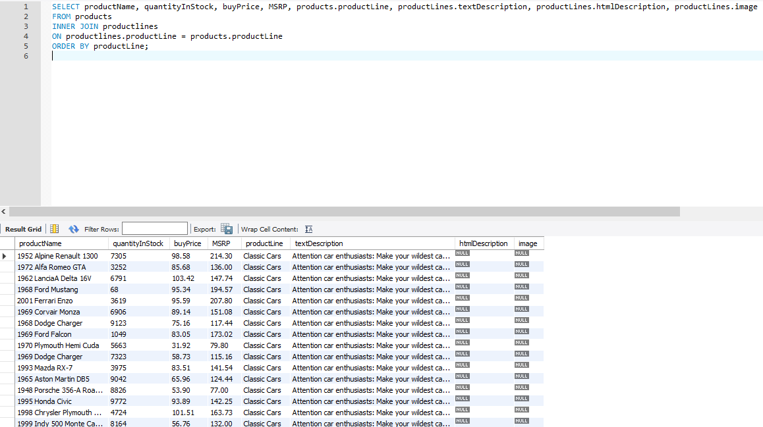

4. Orders: display all products ordered by order date in descending order.

* Display the following fields: order date, order status, customer name, shipped date, products ordered for each order (product name, price), order total
* Note: this will require joining a bunch of fields

SELECT orders.orderDate, orders.status, customerName, orders.shippedDate, products.productName, orderdetails.priceEach, orderdetails.quantityOrdered, Sum(orderdetails.priceEach \* orderdetails.quantityOrdered) As Total

FROM customers

INNER JOIN orders

ON orders.customerNumber = customers.customerNumber

INNER JOIN orderdetails

ON orders.orderNumber = orderdetails.orderNumber

INNER JOIN products

ON products.productCode = orderdetails.productCode

GROUP BY orders.orderDate, orders.status, customerName, orders.shippedDate, products.productName, orderdetails.priceEach ORDER BY orders.orderDate DESC;

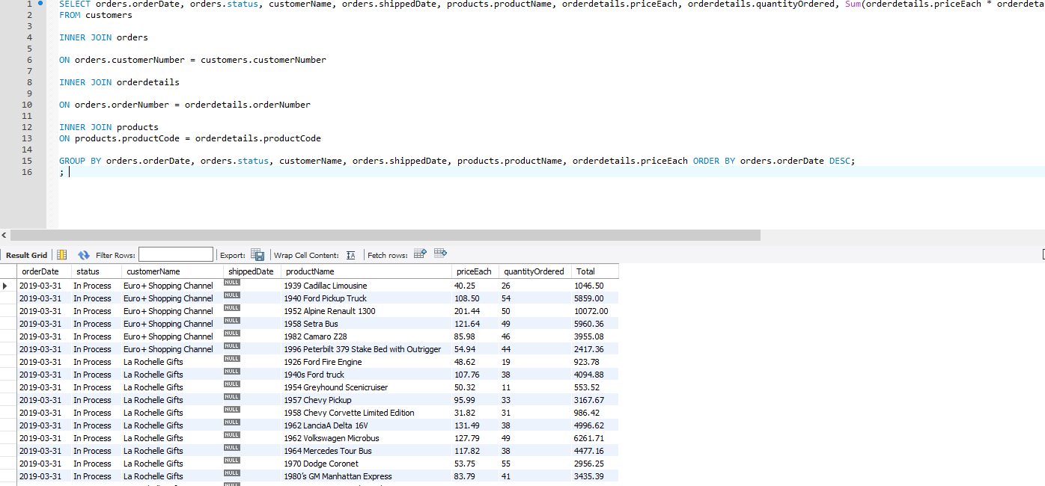

5. Top Customers: list the top ten customers in terms of amount spent.

* Display the following fields: Customer Name, Contact First Name, Contact Last Name, Phone Number and Country, Amount spent, date of their last order

SELECT customers.customerName, customers.contactFirstName, customers.contactLastName, customers.phone, customers.country, Sum(orderdetails.priceEach \* orderdetails.quantityOrdered) As Total , customers.customerNumber, MAX(orderDate) AS MostRecentOrder

FROM customers

INNER JOIN orders

ON orders.customerNumber = customers.customerNumber

INNER JOIN orderdetails

ON orders.orderNumber = orderdetails.orderNumber

GROUP BY customers.customerNumber

ORDER BY Total

DESC

LIMIT 10;

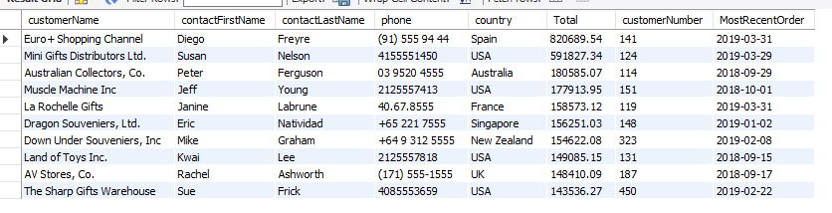

6. Useless customers: list all customers who have never placed an order

* Display the following fields: Customer Name, Contact First Name, Contact Last Name, Phone Number and Country

SELECT customers.customerName, customers.contactFirstName, customers.contactLastName, customers.phone, customers.country

FROM customers

LEFT JOIN orders

ON orders.customerNumber = customers.customerNumber

WHERE orders.customerNumber IS NULL;

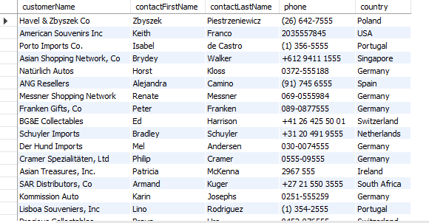

7. Customer by country: display all country names, along with the number of customers in each country and the total amount spent by customers in that country. Order by country name.

SELECT customers.country, count( distinct customers.customerNumber) as numberOfCustomers ,Sum(orderdetails.priceEach \* orderdetails.quantityOrdered) As Total , customers.customerNumber

FROM customers

INNER JOIN orders

ON orders.customerNumber = customers.customerNumber

INNER JOIN orderdetails

ON orders.orderNumber = orderdetails.orderNumber

GROUP BY customers.country

ORDER BY customers.country;

