# CHAPTER 3: RESEARCH AND METHODOLOGY

# 3.0 SYSTEM DEVELOPMENT METHODOLOGY

## 3.1 INTRODUCTION

A software developer or development team must implement a development strategy that covers the procedure, techniques, and tool layers as well as general stages. This approach is frequently referred to as a software development paradigm or a process model. The selection of the software development process model is dependent on the type of project and application, the tools and procedures to be employed, the necessary controls, and the deliverables. Every software development process may be defined as a loop of problem-solving where several stages are experienced. No matter whether process model is selected for a software project, every stage occurs concurrently at some level of specificity. The system development methodology is a structure that is used to plan, organize, and regulate the process of creating a system (Tatva Soft, 2020). I am This kind of advancement strategy is merely concerned with the process of system development; thus, it does not involve any specialist parts. Instead, it is concerned with the proper preparation for system development. This section will cover a few different techniques, including waterfall, fast application development, and agile. A comparison of these approaches will be made, and the appropriate methodology to employ for the new system (Tatva Soft 2020) will be justified. Each system offers both definite and indivisible advantages.

**3.2 PROJECT WORKFLOW**

Project workflow refers to the series of steps or activities that are followed in a project from initiation to completion. It outlines the sequence of tasks, the dependencies between them, and the overall flow of work. A project workflow provides a structured framework for managing and executing project activities in an organized and efficient manner.

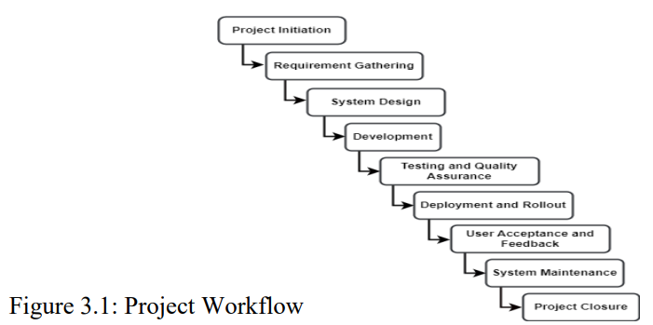

**3.3 METHODOLOGY**

The system development methodology is a structure that is used to plan, organize, and regulate the process of creating a system (Tatva Soft, 2020). The selection of the software development process model is dependent on the type of project and application, the tools and procedures to be employed, the necessary controls, and the deliverables

### 3.4 SELECTED METHODOLOGY

Agile technique has been chosen as the approach for the suggested system. the entire system in a brief amount of time, it's critical to establish brief routes for iterations and make sure that there isn't an excessive use of resources, both mentally and physically.

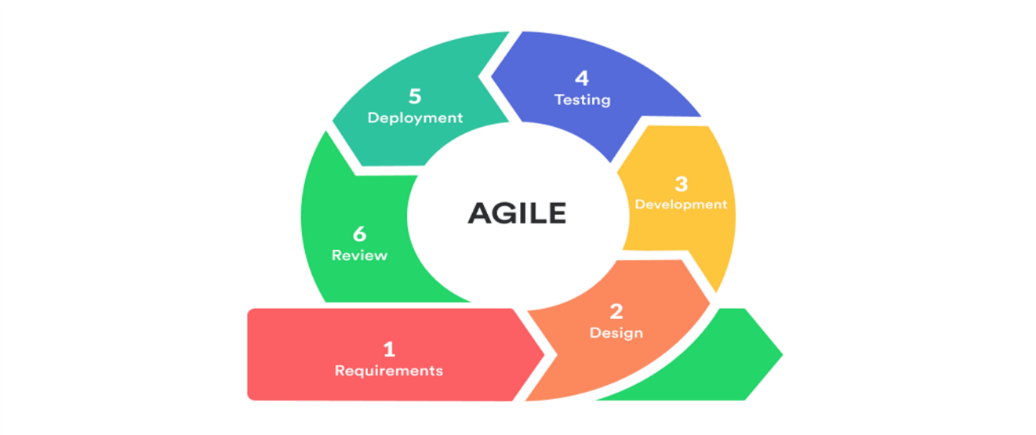

Figure 34: Agile methodology stages (Pawan Pawar, 2019)

## 3.4.1 AGILE METHODOLOGY

The art of software development is unique and somewhat distinct from other types of engineering projects, as many who work in or around the industry know (Dinniei Muslihat, 2018). It needs the care and attention of a staff that is flexible and adaptive, as well as individuals who are ready to react fast to changes and who won't bat an eyelid at a client's requests made overnight. Conventional development models were predicated on a timeline approach, in which development proceeded step by step and the finished product was not disclosed to clients until the very last stage. This allowed a small space for flexibility when it comes to progress evaluations and modifications. Therefore, at the time the current application was completed, it was quite probable that the initial aims of the project were altered in terms of needs and systems.

|  |  |
| --- | --- |
| **Advantage** | **Disadvantage** |
| People and interactions are emphasized rather than process and tools. Customers, developers and testers constantly interact with each other | In case of some software deliverables, especially the large ones, it is difficult to assess the effort required at the beginning of the software development life cycle. |
| Even late changes in requirements are welcomed | The project can easily get taken off track if the customer representative is not clear what outcome that they want. |
| Continuous attention to technical excellence and good design. | There is lack of emphasis on necessary designing and documentation. |

###### 3.4.1.1. REQUIREMENTS

###### In this phase, the application's prospective needs are carefully examined and documented to determine what is required to finish the project. Usually, the result is requirements report that describes what the program should do but not how it should accomplish it.

**REQUIREMENT DEFINITION**

1. **Functional Requirements:**

Functional requirements describe what the software must do to validate the system They are called product features:

1. **System Admin Functionalities**
2. coordinator shall login to the system.
3. coordinator can manage (add/delete) lecturers or students.
4. coordinator can allocate lecturers to the students
5. coordinator shall manage the system.
6. coordinator shall view the list of students or lecturer and has the right to delete and hide the details of one.
7. coordinator shall manage the pages of the website.
8. coordinator shall view request received from students. Admin can also update their profile, change password and recover password.
9. **Registered lecturer(supervisor) Functionalities**
10. lecturer can login to the system
11. Lecturer can view the list of students allocated to him
12. Lecturer can accept student if allocated
13. Lecturer can edit projects
14. Lecturer can check/upload project to the main repository
15. Lecturer can update their profiles, change password, profile picture login detils.

**4.Registerd Students Functionality**

1. Students can login
2. Can view the allocated lecturer
3. Can send message to the coordinator

**5.Non-Functional Requirements:**

The non-functional requirements are restrictions, quality based on the solutions that will meet the functional requirements. In essence, it is concerned with how well the system performs. The security, usability, accessibility, reliability and accuracy, flexibility and also how user-friendly. A non-functional requirement also deals with both hardware and software specifications of the system.

* **User friendly:** The system shall be easy to use and understand.
* **Performance:** The system shall respond quickly to user requests.
* **Reusability:** The system will provide a means to reuse some of its features like the diagrams and codes.
* **Maintainability:** The system will be easy to maintain as changes can be implemented easily.

**REQUIREMENT ANALYSIS**

**SOFTWARE REQUIREMENTS**

|  |  |
| --- | --- |
| **SOFTWARE** | **DESCRIPTION** |
| Microsoft Word 2019 | A report writing software |
| Microsoft Explorer | A report writing software |
| X.A.M.P.P. | It assists a local host or server in performing website testing. |
| MySQL ( Workbench ) | A software to create databases, tables & E.R.D. diagram |
| Sublime Text | Make PHP code programs with it. |
| UMLStar | A software for drawing use-case diagrams, activity diagram, system flowchart etc. |

**HARDWARE REQUIREMENTS**

|  |  |
| --- | --- |
| **HARDWARE** | **DESCRIPTION** |
| System | Laptop or Desktop |
| Processor | Intel core i5 |
| Memory (RAM) | Minimum of 2GB |

###### 3.4.1.2. DESIGN

This stage contains a lot of technical needs, including programming language, data layers, services, and so on. A design specification is usually developed that specifies how precisely the business logic contained in the study will be executed technically.

**System Architecture**

Figures 1 and 2 provide a basic overview of the system's operation. Figure 2 depicts the interaction between the client and server using a use case diagram, whereas Figure 1 describes the architecture of a three-tier client/server. In summary, the system's flow may be summed up as follows. The browser sends a request to the web server to obtain an HTML page or run a PHP function when a user inputs the URL to access FYP Online Management System. The FYP Online Management System database tables are accessed by a PHP script using SQL queries, and dynamically created HTML pages are returned to the client's browser. Among the strong arguments in favor of creating FYP Online Management The system's goal is to manage every participant and project in an easy-to-use online environment. Dulal C. Kar et al., (2020). The four components that make up the system are as follows:

1. Client side

2. Server side

3. Database back-end and web-based administration tool

4. Graphical front-end

**Client-Side Architecture**

The purpose of the FYP Online Management System is to facilitate information sharing among supervisors, students, and the FYP committee. The technology will allow students to examine every project subject and supervisor that is available, with the option to pick the one they want. Students may see the progress of their submissions as well as the supervisor's profile. This system facilitates the work of uploading projects and student allocations for lecturers, supervisors, and examiners. There won't be any more paper forms to fill out and mail in. Everything will be done online. Additionally, this group has the ability to see student profiles and provide grades. The intended functionality of the system is to enable professors to observe the entries made online by pupils. Dulal C. Kar et al., (2020). Complete access to this system will be provided to the FYP coordinators so they may appoint the examiners and manage the titles and allocations. The committee will post any significant news and may view the marks. The administrators will oversee the system. The system administrator is responsible for keeping an eye on everything, adjusting user access levels, and managing site configurations. The FYP Online Management System is an online program that communicates with users using any web browser. Therefore, web browsers (such as Internet Explorer, Mozilla Firefox, Google Chrome, etc.) are a crucial client-side component. Following the completion of the back-end procedure, JavaScript will validate user input and HTML will be utilized to create dynamic web pages Dulal C. Kar et al., (2020). HTML is the scripting language used here, and JavaScript is enabled to guarantee server-side compatibility. Architecture on the Server Side In terms of the server, the FYP Online The management system will have several database tables that house all of the information and data, in addition to a few dynamically created tables created in a Linux environment utilizing the MySQL database. The queries to access the database are written in MySQL. PHP scripts containing embedded queries will be used by the server to communicate with the database.

**Three-Tier Client/Server Architecture**

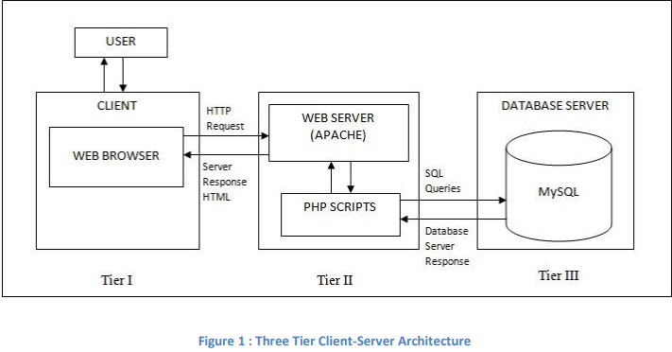

The user interface in the client browser, the Web server, and the database server comprises the three tiers of the FYP Online Management System architecture shown in Figure 1. The following is a functional description of every system tier:

• Interface at the First Tier HTML pages with Java Script support are used to generate the interface when viewed through the client's web browser.

• Web Server, Second Tier The third-tier back ends of this system are supported by the PHP module running on an Apache web server. After the user input is processed by the PHP scripts, the Apache server compiles and runs the resulting SQL queries to access the database, resulting in dynamically created HTML pages.

• Database server is the third tier. At the third division, the second layer will send requests for SQL queries to be executed to the MySQL database server. After retrieving the data that has been saved, the server delivers the requested data back via database file access.

**Use Case Illustration:**

A use case diagram is a visual aid for illustrating a system's dynamic elements. Actors, use cases, and their relationships make up this. Use case diagrams show how users will communicate with the suggested system. It is employed to compile the system's needs and determine the internal and external variables that will affect it swee-Lien Chan et al., (2019). The interactions and functions are shown by sketching the figure swee-Lien Chan et al., (2019). The three players in Figure 2 stand in for the three user groups of the FYP Online Management System: FYP Coordinators, Lecturers/Supervisors/Examiners, and Students. The requirements that each group has for the system are in the middle.

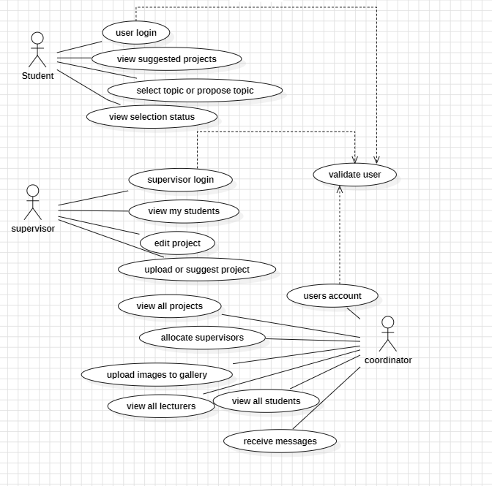

Use-case illustration of the system

**Use-case specification**

|  |  |
| --- | --- |
| Description | All the users of the systems admin, student and lecturer have to login using their details to have access to the system to do their tasks. |
| Actor | Admin, lecturer / supervisor, coordinator and student |
| Triggers | All the users must be registered in the system. |
| Condition | Users have to enter his correct details. |
| Priority | Critical |

Change password specification table

**Class diagram representation**

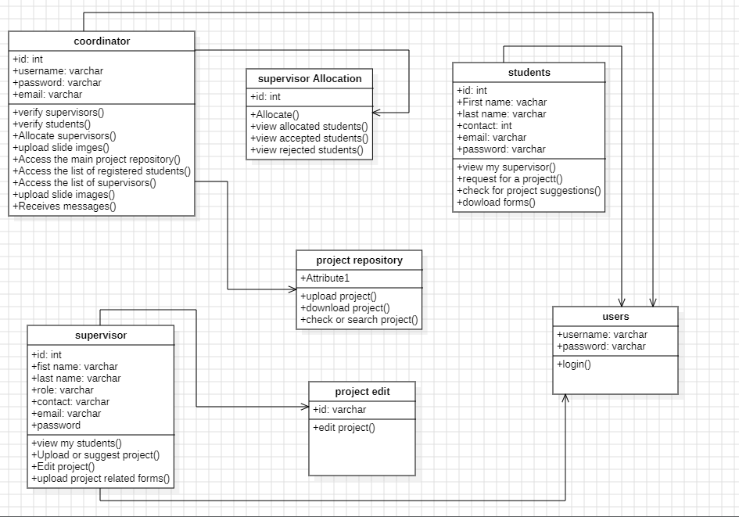

Class diagram of the system

**class diagram specifications**

|  |  |
| --- | --- |
| Descriptions | All the users of the systems admin, student and lecturer have to login using their details to have access to the system to do their tasks. |
| Classes | coordinators, supervisors and students |
| Triggers | All users must register to the system |
| Condition | All users must be verified by coordinator(admin) and must use their valid login details for them to access their respective profiles |
| Priority | Critical |

**Login Activity diagram**

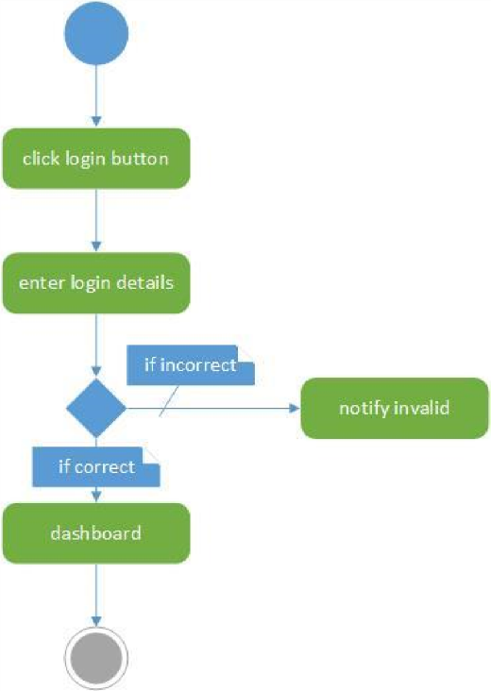

Login activity diagram

**i3.4.1.2:IDEVELOPMENTI** Asisooniasiyouifinishiscopingitheiprojectiyouicanistartidevelopment.iDesignersiandideveloperi williworkiintimatelyiwithicustomersitoimakeiandienhanceiuponiworkingiprototypesiuntilithei finaliproductiisiready.

## TOOLS USED

## PROGRAMMING LANGUAGE CHOSEN

The chosen programming language is JavaScript and Larabel. Larabel is a server-side scripting language. It is used for developing Static Web site, Dynamic Web site and Web application. Larabel is an open-source PHP framework, which had been standing for personal homepage so far. JavaScript is a Web programming language. This is one of the most dominant and highly demanding skills in the current employment market. JavaScript not only adds effective collaboration to websites, it also establishes commonly used libraries (such as jQuery) and frameworks (such as AngularJS, ReactJS, NodeJS). As a web developer, it is fundamental that you understand this flexible language strongly. Both programming languages are reasonable to build applications. This programming language, chosen by the developer, is flexible when users use the application.

#### Laravel

#### The open-source Laravel PHP framework is dependable and simple to use. It adheres to the model-view-controller architecture paradigm. Laravel facilitates the creation of web applications by reusing pre-existing components from several frameworks. (Tabassum, Sairai 2020). As a result, the web application is more logically organized. Combining the fundamental features of PHP frameworks such as Yii and CodeIgniter with those of other programming languages like Ruby on Rails, Laravel provides an extensive range of functionality. Web development will go more quickly thanks to the advantages that Laravel offers. Laravel may simplify your work if you know both basic and advanced PHP.It saves a great deal of time if you intend to create a website from the ground up. Additionally, a Laravel-built website is improved security and shielded against several threats. (Backe,i 2017).

#### JavaScript

According to Ethan Scully (2019),i JavaScript has curly-bracket syntax,i dynamic typing,i and first-class functions.i Iti alsoi isn’t made to be run outside of ai browser,i and although there are some powerful non-browser applications that use it,i those applicationsi arei mostlyi web-based.i JavaScript standsi with HTML and CSSi as one of thei core technologiesi of thei internet.i Iti enables interactivity in web pages,i and it’s thei default language for web applications.

* IDE (Interactive Development Environment)

The interactive development environment that has been chosen for the project will be on Microsoft vs. Code. With VsCode, you can work with huge projects more quickly and effectively while navigating your code.The IDE offers smart code completion, syntax highlighting, flexible code formatting configuration, on-the-fly error checking, code folding, and jump to any method. It also defines functions or variables with only one click.Supports several language combinations and more.Automated refactoring that handles your code with care, assisting in the simple and safe creation of global project settings.Hundreds of code inspections are performed to confirm that your code is written exactly as you intended and to check the whole project for any problems.

### Or the code smells. Most inspections can be quickly fixed, making it simple to fix or instantly improve the code.me

### APIs/libraries chosen / Tools chosen

Programming is an accumulation of precompiled schedules that are available to programs in a library. Routines, which are often referred to as modules, are kept in object format. Libraries are very helpful for keeping track of procedures that are used frequently since they don't need to be explicitly interfaced with every application that utilizes them. As a result, searched libraries for procedures that I could not find elsewhere. Within the MS-Windows system, the DLL extension is used by the library of records (Webopedia.com, 2017). The selectedi library is created by Taylor Otwelli and is Laravel,i ai free open source PHPi web framework for developing web applicationsi according to thei model view controller (MVC)i architecture pattern.i Laravel is suitable for developing applicationsi for thei properties it makes up

### Database Management System chosen

#### MySQL

In the current big data environment, MySQL is one of the most well-known technologies, according to Stacey McDaniel (2019). Often referred to as the most popular database, MySQL is today found in many industries and is widely and effectively used. It is evident that anybody working with business data or general IT should at the very least strive to become familiar with the fundamentals of MySQL. MySQL enables the creation of quick, robust, and secure data storage systems even for those who are new to relational databases. PHP is an object-oriented scripting language, and MySQL is a relational database management system. According to Stacey McDaniel (2019), MySQL's programmatic syntax and interfaces are also ideal entry points into the vast world of other well-known query languages and structured data stores. PHP is occasionally substituted with Perl or Python.

**PostgreSQL**

#### A robust, open-source object-relational database system, PostgreSQL extends the SQL language and utilizes it to store and scale even the most complex data demands with a plethora of capabilities. PostgreSQL comes with a plethora of capabilities designed to assist developers in creating applications, administrators in safeguarding data integrity and creating fault-tolerant settings, and you in managing your data regardless of the size of the dataset.PostgreSQL is not only open source and free, but it is also very extendable.For instance, you may create new functions, establish your own data types, and write code in several programming languages without having to recompile your database.PostgreSQL attempts to comply with the SQL standard; nevertheless, this compliance does not conflict with conventional features or may result in subpar design choices.Numerousi ofi3.5.4.3 Selected Database management system All capabilities mandated by the SQL standard are implemented, but occasionally with somewhat different syntax or functionality. Over time, more progress toward conformity might be anticipated.

DBMS is software that enables you to create, define and manipulate databases. A DBMS is actually a tool used to perform all kinds of operations on data in a database. DBMS also provides database protection and security. Maintains data integrity for multiple users. (Studytonight.com, 2017). The selected DBMS is MySQL and is an open-source relational database management system (RDBMS) using SQL (Structured Query Language). SQL is the most common language for adding, accessing, and managing content in a database. This is most noticed for rapid processing, proven reliability, ease of use, and flexibility. MySQLi provides customers with flexible operations when using applications.

### OPERATING SYSTEM CHOSEN

Windows is the operating system that has been chosen.Windows is a structured operating system developed by Microsoft Corporation.Similar to previous operating systems, Windows simplifies the PC foundation by providing a graphical user interface and organizing data so that it may be accessed efficiently.The working framework makes use of symbols and tools to simplify the confusing operations that PCs do.Assessments suggest that 90%i ofi PCsi utilizei thei Windowsi

working structure. With the introduction of the first graphical user interface (GUI) for IBM-compatible PCs, the Windows operating system quickly came to dominate the PC industry. Roughly 90% of PCs are running some version of Windows (David Hemmendinger, 2020). Following the release of Windows XP in 2001, Microsoft brought together all of its Windows products under one roof, providing a variety of editions for developers, enterprises, consumers, and multimedia specialists, among others. Microsoft launched Windows 7 in 2009, Windows 8 in 2012, and a start screen with apps displaying as tiles on a grid. Users could also synchronize their preferences so they could log in to another Windows 8 system and utilize their preferred settings. Microsoft introduced Windows 10 in 2015, along with Cortana, a digital personal assistant similar to Apple's Siri, and Microsoft Edge, a web browser that took the role of web browser Explorer. Microsoft Additionally, said that Windows 10 would be the last version of the operating system. This meant that customers would continue to get updates to the OS but that no further significant changes would be made (David Hemmendinger, 2020).

### WEB SERVER & WEB BROWSER CHOSEN

* selected web server, Homestead is an official "box" that comes pre-packaged. Achieve a remarkable state of development without installing server software on your local computer, such as PHP, HHVM, or Web server. Your operating system is broken by it. Homestead is a Windows, Mac, and Linux framework developer that also includes an agency to create incredible apps using PHP 5.6, MySQL, Postgres, Redis, Memcached, and Nginx web server. Yes, it is. The World Wide Web (WWW) has a variety of items and information that can be found, searched for, and shown using a web browser. These include files, videos, photos, and web pages. The platform may be used in the following ways with any web browser.
* Internet Explorer
* Chrome and ETC

### SUMMARY

From this chapter we understand the important of using a suitable IDE, programming language, database and operation system for the proposed, the new system need to have some new feature and availability in order to eliminate all the issues from the old system and similar system by using the right software’s the developer we will be able the develop a system that will do so and provide all user needs. Developer have quickly talked about all the necessary software that an online examination system needs to gain target fulfillment while managing their system to save, shared or conduct examination for it to be very effective and efficient system helps target users and makes it simpler for them.

**➢ Testing:**

During this stage, a, beta analyzers,iandieveryisingleiotherianalyzerideliberatelyifindiandireporti issuesiinsideitheiapplicationithatishouldibeisettled.iItiisn'tiextraordinaryiforithisistageitoicausei ani"essentialirehash"iofitheipasticodingistage,iallitogetheriforiuncoveredibugitoibeiappropriately crushed.

###### ➢ Deployment

Thisistageibeforeitheicompletedisystemigoesitoilunch.iItiincludes information transformation and user training.

###### ➢ Review

Inithisistage,iprototypesiandibetaisystemiareichangedioveriintoiworkingimodels.ideveloperiatith atipointiaccumulateifeedbackifromiusersitoichangeiandiimproveiprototypeiandimakeitheimost-iidealiproduct.

**JUSTIFICATION**

Agile is usually a great option for large, expensive systems. As the requirements of the proposed system are satisfied, the developers will employ the agile process, which enables them to assess and construct a prototype for the system. Users will evaluate and provide feedback. This will provide users with information so they can understand what they need and organize a system improvement group to put together the right solution for them. Most customers don't have a clear understanding of what they need (system features) until they interact with the prototype and have a top-to-bottom understanding of the actual system they need. In any instance, the system may be developed and communicated to its users in a brief amount of time. The ideal strategy for the Online final year project management system is the agile methodology. For organizing and creating the system.

## 3.5 SUMMARY

## The developer noticed that this would be one of the greatest ways for him to get all the information on what the target user wanted in the new system, so he chose the proper data collecting methodology. Through the use of questionnaires and interviews, the developer is able to determine the precise requirements for the target. The research methodology is also carried out in this chapter, which enables the author to obtain a comprehensive understanding of the needs of the suggested system. The developer selects the most effective and reliable fact-finding methodology, shares a questionnaire with users for assessment, and provides crucial feedback on what needs to be installed in the suggested system, the "Online Examination System. “The interview will be done with students, instructors, and administrators of the respective institutions. The exploration technique is further focused on this particular section by enabling the developers to determine the characteristics required for the suggested solution.