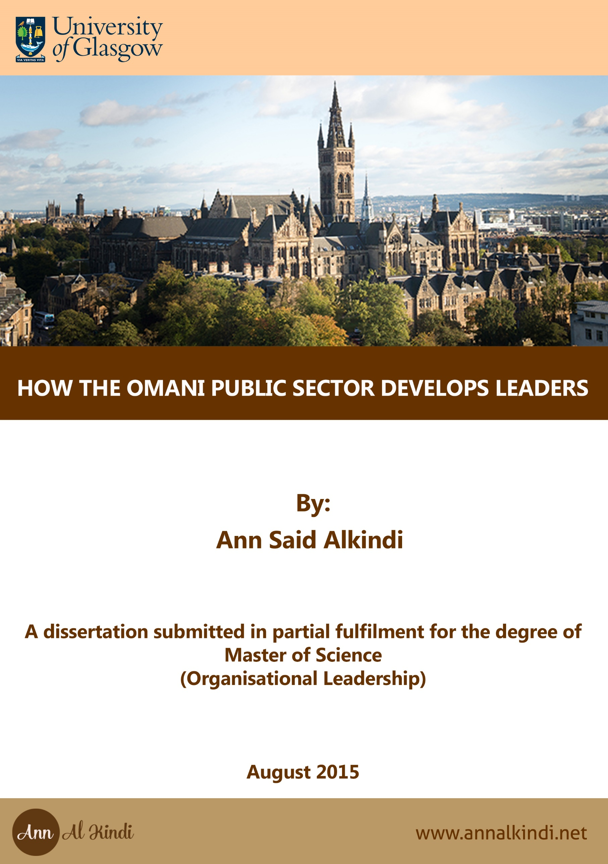



HOW THE OMANI PUBLIC SECTOR DEVELOPS LEADERS

**By:**

**Ann Said Alkindi**

**2062181A**

**A dissertation submitted in partial fulfilment for the degree of**

**Master of Science**

**(Organizational Leadership)**

**August 2015**

# 

# CHAPTER SIX

# Conclusions and Recommendations

Oman had a great chance to make many important changes after the social and political turning point in 2011, which was a crisis that increased the urgency level to the extreme and created valuable momentum for change (Kotter, 1996). Yet there were successful political solutions to contain the demonstrations without an adequate level of structural change in the Omani public sector. These short-term solutions will have long-run repercussions (al-Jamali, 2014).

There are many existing forms of co-operation between Oman and Singapore, as reported in the media from time to time (Government, 2014; Oman, 2014; Yousuf, 2015). There is even a Free Trade Agreement between the two countries signed in 2007 (Perry, 2007). However no tangible results have yet been felt in the area of learning from the Singaporean example of Public Service excellence. As Quah (Ensuring Good Governance in Singapore, 2013) says, the Singaporen experiences cannot be directly copied in other Asian countries, because of the absence of political willingness and insufficient proper governance. Nevertheless Singpaoer sucessful story from thrid to frsit world is worth adopting human development strategy and approchies.

There are number of deep structural reforms that are needed in the Omani public sector, including a culture and mind-set shift program. Oman needs leaders with a greater sense of urgency, as the time factor does not seem to be important in the Omani public sector.

It may be difficult to change the situation by fighting the existing reality. “To change something; build a new model that makes the existing model obsolete” (Buckminster Fuller, 1975). This applies to many things. Firstly the scattered effort of developing leadership and spending money on training people in leading position without clear strategy, as it was shown earlier in this research. It would be more effective to improve and develop the Oman Institute of Public Administration and merge it with Competence Development Institute (Observer, 2015).

An immediate action the Oman Government could do in order to increase the effectiveness of Oman leadership training, is to take into account what Sheik Mohammed said “Some leadership traits that were useful in the past might not be so today” (Maktoum, 2012). This is one of the reason why Dubai can be a learning experience. Oman and Dubai share many similarities such as culture, religion and most importantly both have less oil reserve compared to other Gulf counties.

The Omani public sector has been slow to make changes, for example there are Managers and Director Generals that have been in the same positions for more than 20 years. Statistical information on how long senior people remain in their positions is however not made public or published.

It is important that new (healthy) leadership blood is injected into the Omani public sector. In addition, an emphasis on practising the tools of anti-corruption policy must be put in place. Performance appraisal, reward systems and meritocracy must be practise as the base for selecting candidates to full leadership positions. Without setting a clear mandate to build good governance in the public sector, the latter will continue to operate at high costs and ineffectiveness. Furthermore, it will continue to tread the path of inability to build an advanced economy that moves away from dependency on oil and one that creates jobs for the Omani youth (al-Jamali, 2014). There continues to be a need to develop leaders to handle the future challenges in Oman. A transformational leadership style would be helpful in addressing these challenges. This style is appropriate in the process of changing and transforming people (Northouse, 2013). Leaders are required who believe in the urgency of change, in order to make change with in the Omani public sector.

In order to introduce an effective leadership development program, it is important initially to establish a “learning culture” as it is called in Singapore or “knowledge share culture” as it is referred to in Dubai. As the research and the interviews showed, on-job training has developed leaders in the Oman public or private sector. A leadership development program is only a part of a comprehensive program based first on job training. On-job experience means that people in the leading positions have to understand the importance of developing the second and the third tier of leaders by involving, empowering and trusting them.

As a result of the analysis of the interviewees’ comments and experiences, this dissertation recommends that selection criteria for candidates nominated for leading positions must match the job requirements. Reengineering the public sector organizational structure to increase its effectiveness is the way forward. It is a necessary step to pay competitive salaries to the public services employees. However, there is a very high existing number of employees on the public payroll: a total of 211 thousands in the civil services, 30 thousands in the Royal Court, and 13 thousands in other public organizations for a population of 4 million, according to official statistics (Information, 2014).

If the roles and responsibilities within the public sector are not clear, then there will be conflict within one organization that has many roles such strategic planning, regulations, policy making and execution. An example of the common structure within the Omani Public Sector is the Ministry of Transportation and Communication (Communications, 2015). In this case the ministry role is regulatory for transportation, and yet it executes roads and other infrastructure construction through tendering out to other companies. It is a clear example of mixing roles of regulating, planning, execution and monitoring. Further research on the roles, structure, and manpower policies of the Oman Government ministries is needed.

The Oman public sector needs a revolutionary change which is dramatic and radical (Jones, 2009) along the same lines that Singapore and Dubai followed. Traditional solutions are highly unlikely to be effective in changing a traditional problem in the public sector, therefore it is highly recommended to adopt and not copy a program like Dubai Excellence Program. Executing such a program cannot be successful without good leadership and such fact will enforce it self. It is a common challenge for all the countries in the world, of how to have an effective public sector. Experts claim that India is not catching up with China’s huge development due to bureaucracy and bad governance (Kamma, 2008). The FDI (foreign direct investment) and domestic investment in India were affected by general inefficiency within the government and a governance deficit (Stuart, 2013).

Oman has all the potential to be in the first world, as it has the financial resources, political stability and a perfect geographic location. Proper governance will lead to the creation of a healthy working environment conducive to enabling the right leaders whose mission match their vision. A crucial step to take amidst a financial crisis so as to create a path for the necessary changes required to face declining oil prices and rising unemployment.

References:

al-Jamali, C. A. (2014). *Elusive Employment Development Planning and Labour Market Trends in Oman.* London: Chatham House.

Buckminster Fuller, R. (1975). *Synergetics.* New York, NY: Macmillan Publishing Co.

Communications, M. o. (2015). *Ministry of Transportation and Communications*. Retrieved July 8, 2015, from http://www.motc.gov.om/DefaultEn.aspx?PageID=6k7dEN8q%2fJKStDIYmttGAQ%3d%3d&typeID=w3AIvDiWY%2bI9USuWXvvcJQ%3d%3d

Government, I. S. (2014, April 9). *Singapore Signs Agreement with Oman to Deliver Innovative Digital Services for the Sultanate’s Ministry of Manpower.* Retrieved July 1, 2015, from https://www.ida.gov.sg/About-Us/Newsroom/Media-Releases/2014/Singapore-Signs-Agreement-with-Oman-to-Deliver-Innovative-Digital-Services-for-the-Sultanates-Ministry-of-Manpower

Information, N. C. (2014). *National Center for Statistic and Information*. Retrieved June 30, 2015, from http://www.ncsi.gov.om/NCSI_website/book/SYB2014/4-Government.pdf

Jones, G. (2009). *Basic Challenges of Organisational Design, Organisational Theory, Design and Change* (6th ed.). London, UK: Pearson.

Kamma, T. (2008, October 13). *Global Entrepreneurship: The Contrasting Cases of China and India.* Retrieved July 12, 2015, from http://www.hbs.edu/centennial/businesssummit/global-business/global-entrepreneurship-the-contrasting-cases-of-china-and-india.html

Kotter, J. P. (1996). *Leading Change* (frist ed.). USA: Harvard Business Review Press.

Maktoum, H. S. (2012). *My Vision, Challenges in the Race for Excellence* (1st ed.). Dubai, UAE: Motivate.

Mark Busine, I. T.-L. (2011). *Leading Singapore: a snapshot of leadership readiness.* Singapore: Development Dimensions International Inc.

Northouse, P. G. (2013). *Leadership Theory and Practice* (6th ed.). Thousand Oaks: Sage.

Observer, O. (2015). *Competence Development Institute opens*. Retrieved July 5, 2015, from http://omanobserver.om/competence-development-institute-opens/

Oman, T. o. (2014, April 7). Oman, Singapore join hands for e-services. *Times of Oman*.

Perry, M. (2007). *Singapore, Oman agree to boost bilateral investments*. Retrieved June 25, 2015, from http://www.bilaterals.org/?singapore-oman-agree-to-boost

Quah, J. S. (2013). Ensuring Good Governance in Singapore. *International Journal of Public Sector Management, Vol.26*(Emerald Group Publication Limited), 401-420.

Stuart, S. (2013). *Accelerating India’s Growth*. Retrieved June 30, 2015, from https://www.spencerstuart.com/~/media/pdf%20files/research%20and%20insight%20pdfs/accelerating-indias-growth_18mar2013.pdf

Yousuf, K. (2015, April 01). Oman, Singapore all set to enhance bilateral ties. *Oman Daily Observer*.

