120

The Transition to a Knowledge-Based Arab Society and Economy: Can Knowledge Enhance Arab Competitiveness?

Atif Kubursi

Intellectual Capital, Knowledge and Competitiveness

Figure 1: The House Metaphor

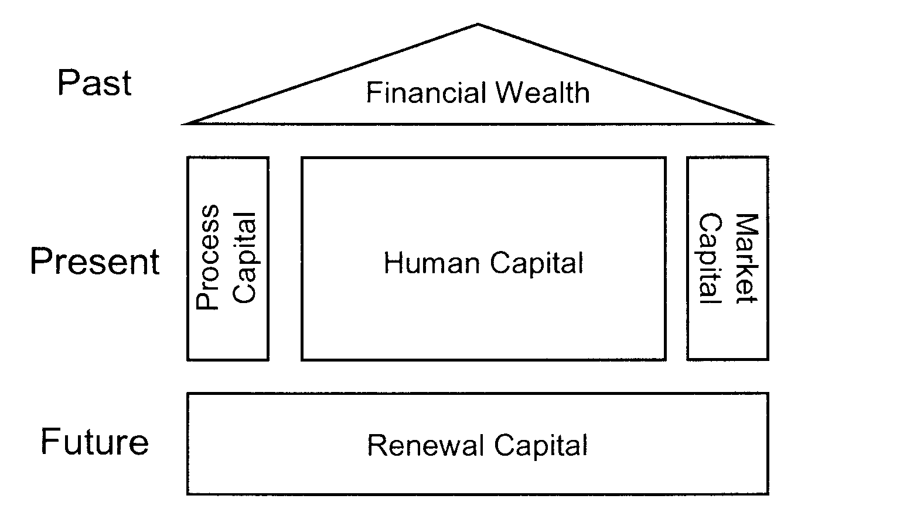

This organization can also be represented as a tree (Figure 2) or a value chain. The wealth of the nation is no longer restricted to its natural resources or financial assets; the true wealth is the intellectual capital of its people. It includes more than human capital as it also encompasses structural capital. The definition of the various components is provided in details below.

Human Capital

This includes knowledge, expertise, wisdom, intuition, and the ability of the individual to realize his/her full potential and national tasks. This includes also the philosophy of the society, cultural norms and narratives.

Social capital

This includes the cultural and value systems that provide both social cohesion and continuity through long period of time across multiple generations. These systems often change slower than the speed of change of the mode of production and therefore can present formidable challenge to the transition of the economy and society to knowledge-based systems. Hence these systems often offer resistance to social and economic change ⎯ often referred to as “resistance to change”. If the resistance is stronger than the forces of change, a breakdown in the process of change results and the proponents of change either flee (such as brain drain) or resign their efforts to introduce new ideas and create new knowledge

Structural Capital

This is the set of organizational and market skills, managerial systems and organizational leadership that guides and controls the efficient utilization leverage its effects into market advantages and highly productive and efficient performance.

Market Capital

These are the embedded relationships between customers, clients and users and the organization. For a nation these pertain primarily to knowledge, familiarity and strategic contacts in international markets and the networks established with partners and stakeholders.

Process Capital

The flow of knowledge requires cooperation and structural intellectual assets such as hardware, software, databases, information systems, organizational and management structures. These structures can amplify and sustain human capital development and its efficient use.

Renewal and Development Capital

This relates to the organization/nation’s capabilities and actual investments in renewal projects and programs to amplify of competitive strengths in future markets and assure future growth. These include investments in R&D, technological incubators, business incubators, trademarks, and patents.

Figure 2: The Expanded Skandia Model of Intellectual Capital System

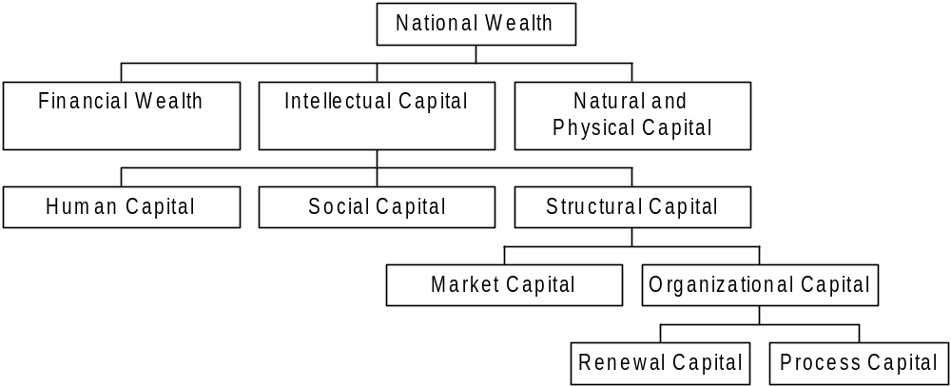

The framework above provides a useful vehicle for identifying core competencies, i.e. the values both visible and hidden, tangibles and intangibles that give a nation its comparative advantage in future global markets. The Skandia balance sheets provides a set of indicators that can be gauged for defining the relative position of the nation in the global market, the inhibitors and facilitators of its failure and success to compete and prosper. These indicators will be quantified and assessed in the way they apply to Arab current and future performance. But before we delve into this evaluative process, it is necessary that we present some alternative transition strategies that have been used and tried elsewhere and some account of success stories that can also set a benchmark against which Arab performance can be analyzed.

Alternative Transition Strategies to the Knowledge-Based Economy

If transition to the global economy is no longer a choice, it is fortunate that economies have a number of options and alternatives that can be adopted to make the transition smoother and more appropriate to their conditions. As the Arabs ponder their options for transition to the New Globalized Economy, there appears to be three fundamental systems. These include the National Innovation System adopted by Japan, Malaysia and other South East Asian countries, the sectoral-lead transition that typifies the Brazilian experiment or the entrepreneurial-lead transition that the US has generally adopted.

The Malaysian Experience

Malaysia has embarked on a major social project that would see the country transformed into a major technological powerhouse in Asia by 2020. The project is rooted in the limited success of bottom-up approach (the US model). Malaysia is set on providing a top-down leadership that is capable of building a bottom-up technology push.

A dedicated and determined program that involves all Malaysians in the IT revolution is the hallmark of the initiative. The plan is to change small ripple effects into tidal waves of global, regional and national changes that would be lead by Malaysians. At the heart of this plan is the democratization of the policy making process, the engagement of key players and stakeholders in national agenda building, and transforming Malaysia into a center of excellence in multimedia and content building. The Center of Excellence is planned to leverage the transformation of the entire country.

A triangular view is at the foundation of this social project. It aims at creating value, quantitative transformation and improving access and equity. It brings together people through education, skill development and acculturation to develop a highly efficient infostructure rooted in supporting laws and regulations, networks and clusters of firms and in developing affordable applications. The latter will comprise indigenous content development, interactivity and information systems, edutainment and infocommunication. The building of the infostructure means building broadband network technology, mobile computing technology, every house/premise must be linked to the network, and every new road/building must have conduit ready structure.

The preparation of people involves the provision of smart learning for all. Every school will be totally and completely connected to the Internet. A multimedia university will be established and basic computer literacy program for all Malaysians will be implemented as well as electronic distance education for all.

Skill development will target the development of decision support systems to aid workers and managers alike, business re-engineering knowledge and tools, and the promulgation of a knowledge-intensification skills’ development program.

Acculturation will be promoted through the comprehensive education system, and through on-line information services, networked electronic communities, IT appreciation through the media and strengthening traditional values.

The Malaysian project is a special application of a national innovation system that is particularly relevant for the Arabs in so far as another Third World Muslim country has made major strides into the New Economy and advanced technology.
Figure 6
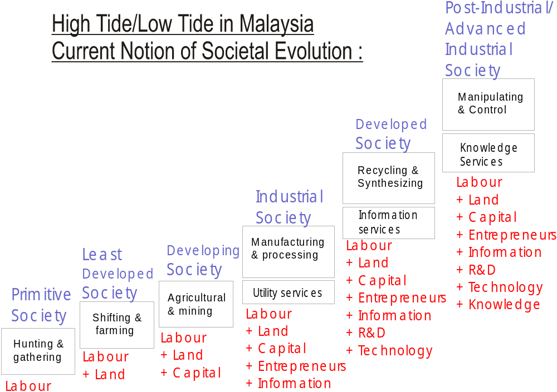
Figure 7
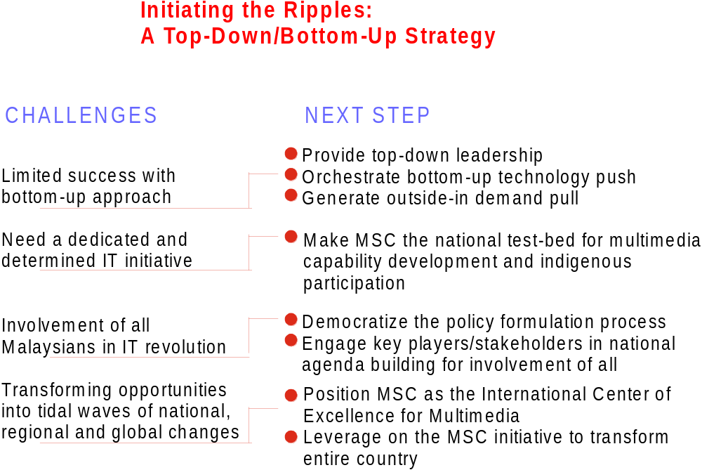
Figure 8
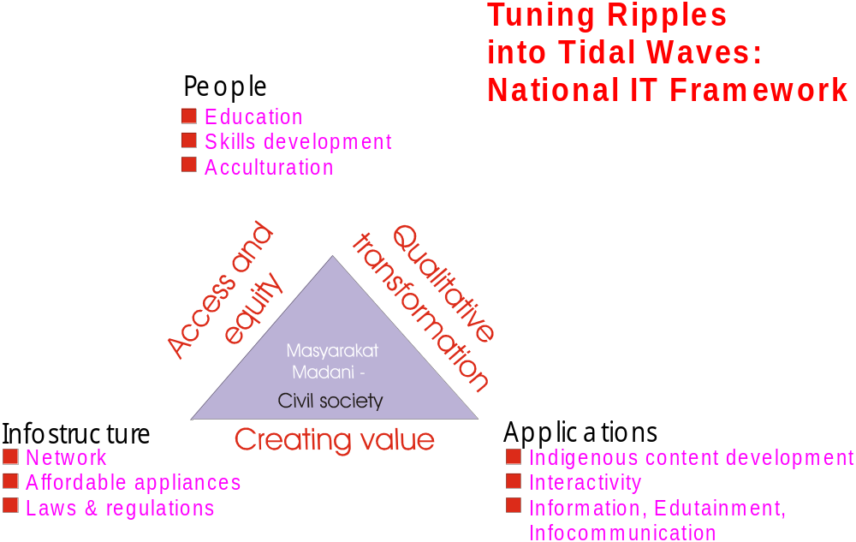

Figure 9
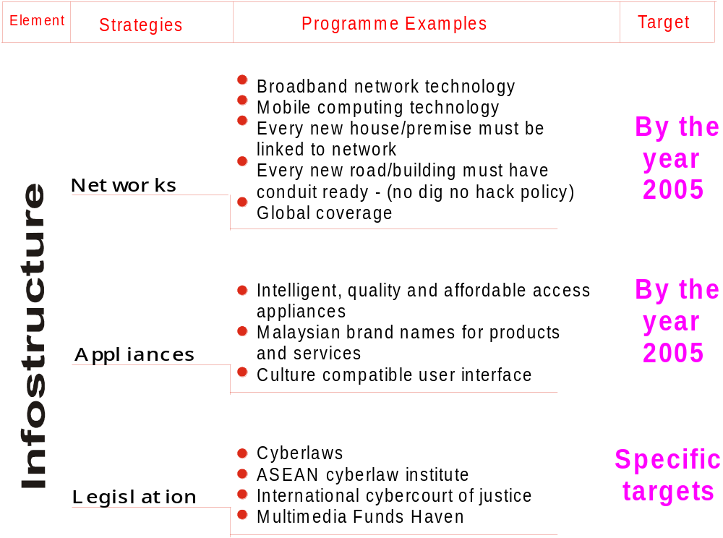
Figure 10
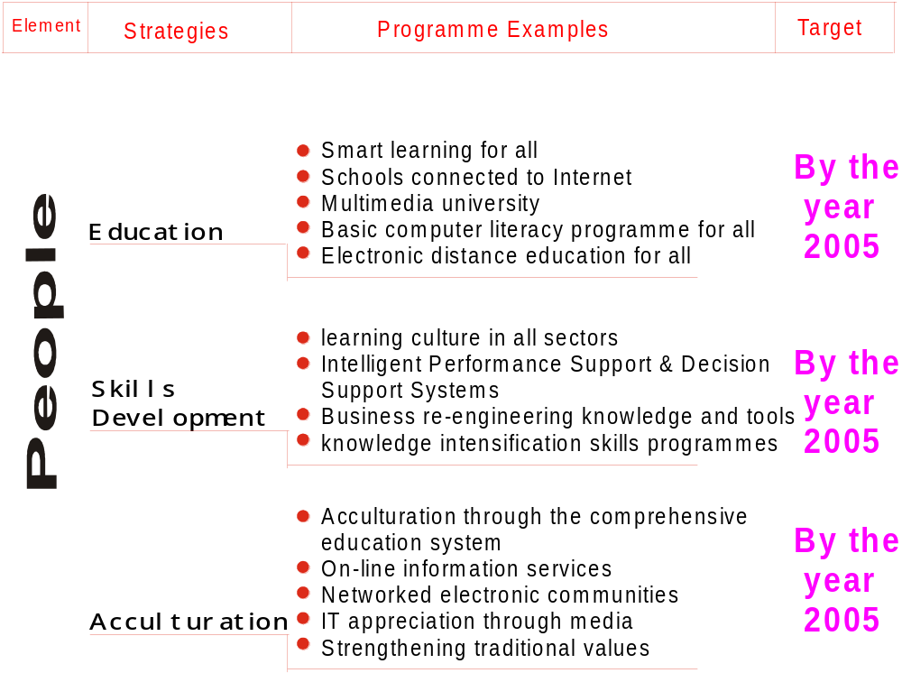
The main objectives of this strategy are many but particularly here we concentrate on those measures that would strengthen Arab competitiveness, increase Arab productivity and diversify the sources of Arab income and employment. Reducing the knowledge deficit is the primary plank of this strategy. It involves a multidimensional set of measures to accelerate the process of knowledge creation, distribution, diffusion, leveraging, and feedback. The full account of the measures needed to realize this objective includes the following:

1. Accelerate creation and acquisition of new knowledge:
- Develop, allow and encourage the formation and open discourse of Communities of Knowledge within the Arab states, across the Arab region and across the whole world.
- Protect and preserve the integrity of research and academic freedom;
- Accord full protection for the rights to publish, freedom of expression, freedom of the press, freedom to publish without fear; and free and independent press.
- An important social form for accelerating the creation of knowledge is Knowledge Communities where like-minded people in the Region come together to have an open discourse about any topic. There could be many Knowledge Communities even for the same topic.
- Improve the quality of tertiary education (better qualified professors, libraries, laboratories, research subventions, publications incentives and lower student per professor ratios) and academic research centers.
- Raise the budgetary allocations for education but primarily for higher academic institutions with publication records and embedded research centers.
- Create networks of consulting houses and knowledge centers.
- Establish national and regional research funding institutions with adequate resources and meritorious criteria.
- Reward innovation and creativity and protect local intellectual properties. There are many ways to reward creativity, among them creating national, sector-based, and organizational prizes to recognize knowledge based contributions: Great books; high impact studies; great Films, photographs, plays, and music; discoveries; inventions; social analysis; etc.
- Encourage and reward the production of local content in the ICT field.
- Promote the translation of important contributions to knowledge from their original languages into Arabic.
- Facilitate and develop continuing education and virtual learning centers at all levels and in all fields and locations.
- Develop and support programs for improving language skills in the region.
2. Accelerate knowledge distribution and diffusion
- Develop the infostructure and broadband connectivity on the broadest possible geographical scale. Intellectual capital and growth potential increases as long as the information and computer infrastructure continue to expand the more it is used.
- Leverage ICT technology rapidly and broadly; use it in learning centers, at home, at businesses, and at government organizations; ensure significant and reliable connectivity
- Use e-mails, web sites, and electronic means of information distribution widely without “security interventions”.
- Provide for and widely establish without restriction libraries and information services.
- Enable and support freedom of expression and freedom of assembly to allow for knowledge exchange and distribution.
- Expand the circulation of specialized publications and the use of communication media in knowledge sharing.
- Encourage and support international conferences at home and the full participation of local producers of knowledge in these conferences abroad.
- Accelerate consumption of knowledge

- Knowledge consumption and use is primarily accelerated through creating a safe environment free from fear, capable of forgiveness of errors, conducive to the elimination of the fear of experimentation, generous in rewarding new ideas, and has the capacity to establish a merit based system in the work place.
- Public debate and open discourses is another mechanism to encourage knowledge consumption.
- Protection of copyright and intellectual capital right is not only a strong way to encourage knowledge creation, including innovations, but also necessary to encourage the proper and higher impact use of knowledge. Respects to the value of Intellectual Property create market mechanisms to distribute leverage, and promote new knowledge.
- Encourage feedback mechanisms

- There are a rich number of feedback channels: critiques, book reviews, commentary, letters to authors and manufacturers, open forum discussions, debates, web publishing of counter views, bodies that specialize in reviews of products or intellectual outputs, testing organizations for standards and products, labs for testing products and materials etc.
- The legal framework has to protect and provide safety to all those engaged in a feedback capacity.
- The legal system has to provide for and facilitate measures to counter claim and challenge providers of feedback when it is unfair and unfounded. Also, the same system should encourage protection of intellectual property rights.
- Encourage and provide safety and connectivity for communities of knowledge to have freedom of discourse, of publishing their results, and for dialoguing with other communities. This is a very powerful mechanism for encouraging knowledge creation, knowledge sharing, and feedback mechanism.
- Improve management of knowledge

- Develop and implement the processes, methods, systems, and techniques to manage and expand the available knowledge in such a way as to make it available and easy to distribute.
- Design and implement technological (ICT) systems to encourage collaboration; sharing; access to information and knowledge; and, acceleration of the process of distribution of new knowledge.
- Create the processes, methods, and rules to retire and archive currently not useful knowledge and to continue the process of refining knowledge by adding feedback directly to existing knowledge assets from experience.
- Leverage Positive Social Capital:

Leverage factors in the culture and society that facilitate the process of sharing, innovations, and the privileging of knowledge. Slowly, but consciously and resolutely transform the constraints and social inhibitors either by removing them, changing them, or transforming them to knowledge facilitators. Included in these factors is Otherness⎯ i.e. acceptance of the other, transparency in all public matters, tolerance of difference, and renunciation of violence as a means to resolve policy, political, and social differences, reducing or eliminating gender biases, patriarchal structures, rout education, submission to irrational ideologies, etc.

- Formation and development of knowledge workers and knowledge services.

The region needs to increase the ratio of knowledge workers in the labor force, their quality and their employability. A knowledge worker is a person that generates more value out of their knowledge than using their muscle. ‘By 2006 almost half the U.S. workforce will be employed by industries that are either major producers or intensive users of information technology products and services.’ New jobs are knowledge jobs⎯ and so are old jobs. I think, therefore I earn..” The number of knowledge workers in the Arab world is small and could and should be increased through formation (by the education system) and through training and on the job training.

Another phenomenon that evolved on the margin of the industrial economy is that of selling knowledge-based services. Such services existed as far back as the middle of the 1800s. There relative contribution to the total economic activities remained small until the 1960s. As the name implies knowledge-based services leverage knowledge workers to deliver service to their clients. The two phenomenons are intertwined and need to be developed simultaneously. The Arabs need to raise the contributions of the knowledge-based services in the Arab economy through the development and contributions of knowledge workers. The share of these knowledge-services is now dominant in economically advanced societies. The Arab region should strive to raise their ratios in the labor force to comparable ones in the advanced countries very quickly. A Leapfrogging Strategy is no longer an option for the Arabs, it is a survival necessity in the increasingly competitive globalized international economy.

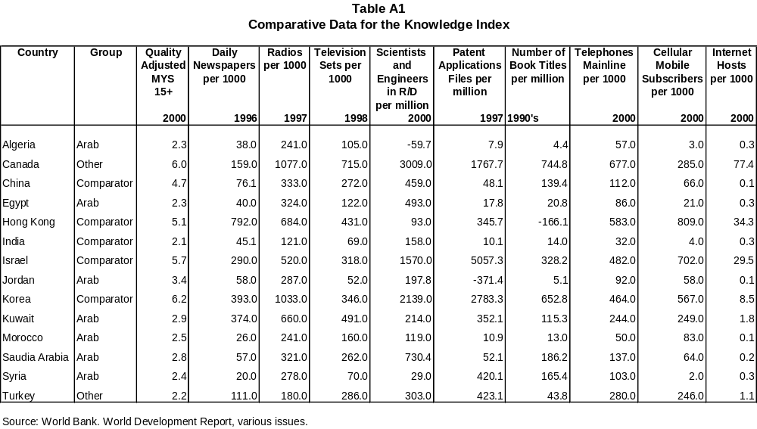

This section builds on the original contributions of Sami Albanna in a contribution to the UNDP. Arab Human Development Report 2003 on the Conceptual Framework. November 22, 2002.
T.A.Stewart. (2001) The Wealth of Knowledge: Intellectual Capital and the Twenty First Century Organization. First ed. New York, NY: A Currency Book: Doubleday; A division of Random House, Inc.

