**Exercise 1: Control Structures**

Scenario 1: The bank wants to apply a discount to loan interest rates for customers above 60 years old.

Question: Write a PL/SQL block that loops through all customers, checks their age, and if they are above 60, apply a 1% discount to their current loan interest rates.

**Schema to be created:**

CREATE TABLE Customers (

CustomerID NUMBER PRIMARY KEY,

Name VARCHAR2(100),

DOB DATE,

Balance NUMBER,

LastModified DATE

);

CREATE TABLE Accounts (

AccountID NUMBER PRIMARY KEY,

CustomerID NUMBER,

AccountType VARCHAR2(20),

Balance NUMBER,

LastModified DATE,

FOREIGN KEY (CustomerID) REFERENCES Customers(CustomerID)

);

CREATE TABLE Transactions (

TransactionID NUMBER PRIMARY KEY,

AccountID NUMBER,

TransactionDate DATE,

Amount NUMBER,

TransactionType VARCHAR2(10),

FOREIGN KEY (AccountID) REFERENCES Accounts(AccountID)

);

CREATE TABLE Loans (

LoanID NUMBER PRIMARY KEY,

CustomerID NUMBER,

LoanAmount NUMBER,

InterestRate NUMBER,

StartDate DATE,

EndDate DATE,

FOREIGN KEY (CustomerID) REFERENCES Customers(CustomerID)

);

CREATE TABLE Employees (

EmployeeID NUMBER PRIMARY KEY,

Name VARCHAR2(100),

Position VARCHAR2(50),

Salary NUMBER,

Department VARCHAR2(50),

HireDate DATE

);

Example Scripts for Sample Data Insertion

INSERT INTO Customers (CustomerID, Name, DOB, Balance, LastModified)

VALUES (1, 'John Doe', TO_DATE('1985-05-15', 'YYYY-MM-DD'), 1000, SYSDATE);

INSERT INTO Customers (CustomerID, Name, DOB, Balance, LastModified)

VALUES (2, 'Jane Smith', TO_DATE('1990-07-20', 'YYYY-MM-DD'), 1500, SYSDATE);

INSERT INTO Accounts (AccountID, CustomerID, AccountType, Balance, LastModified)

VALUES (1, 1, 'Savings', 1000, SYSDATE);

INSERT INTO Accounts (AccountID, CustomerID, AccountType, Balance, LastModified)

VALUES (2, 2, 'Checking', 1500, SYSDATE);

INSERT INTO Transactions (TransactionID, AccountID, TransactionDate, Amount, TransactionType)

VALUES (1, 1, SYSDATE, 200, 'Deposit');

INSERT INTO Transactions (TransactionID, AccountID, TransactionDate, Amount, TransactionType)

VALUES (2, 2, SYSDATE, 300, 'Withdrawal');

INSERT INTO Loans (LoanID, CustomerID, LoanAmount, InterestRate, StartDate, EndDate)

VALUES (1, 1, 5000, 5, SYSDATE, ADD_MONTHS(SYSDATE, 60));

INSERT INTO Employees (EmployeeID, Name, Position, Salary, Department, HireDate)

VALUES (1, 'Alice Johnson', 'Manager', 70000, 'HR', TO_DATE('2015-06-15', 'YYYY-MM-DD'));

INSERT INTO Employees (EmployeeID, Name, Position, Salary, Department, HireDate)

VALUES (2, 'Bob Brown', 'Developer', 60000, 'IT', TO_DATE('2017-03-20', 'YYYY-MM-DD'));

**Program:**

SET SERVEROUTPUT ON;

DECLARE

v_age NUMBER;

v_name Customers.Name%TYPE;

v_loan_count NUMBER;

v_updated BOOLEAN := FALSE;

BEGIN

FOR cust IN (SELECT CustomerID, Name, DOB FROM Customers) LOOP

-- Calculate age

v_age := TRUNC(MONTHS_BETWEEN(SYSDATE, cust.DOB) / 12);

IF v_age > 60 THEN

-- Count loans for the customer

SELECT COUNT(*) INTO v_loan_count

FROM Loans

WHERE CustomerID = cust.CustomerID;

IF v_loan_count > 0 THEN

-- Apply 1% discount to interest rate

UPDATE Loans

SET InterestRate = InterestRate - 1

WHERE CustomerID = cust.CustomerID;

-- Show output

DBMS_OUTPUT.PUT_LINE('Customer "' || cust.Name || '" (Age: ' || v_age || ') received a 1% interest rate discount.');

v_updated := TRUE;

END IF;

END IF;

END LOOP;

IF NOT v_updated THEN

DBMS_OUTPUT.PUT_LINE('No customers over 60 with active loans found.');

END IF;

COMMIT;

END;

/

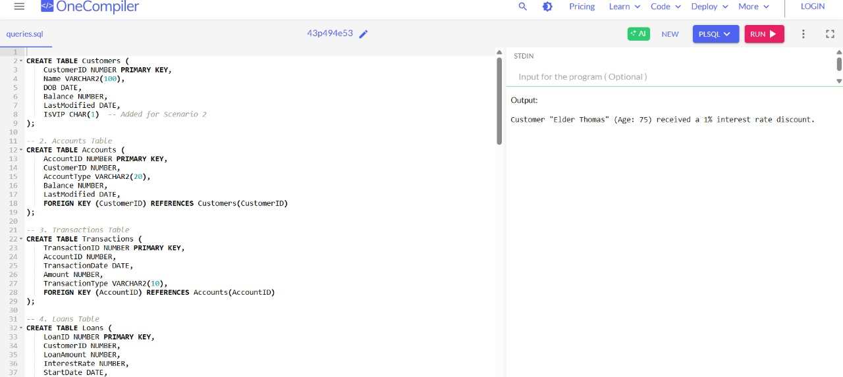

Scenario 2: A customer can be promoted to VIP status based on their balance.

Question: Write a PL/SQL block that iterates through all customers and sets a flag IsVIP to TRUE for those with a balance over $10,000.

**Program:**

SET SERVEROUTPUT ON;

BEGIN

FOR cust IN (SELECT CustomerID, Name, Balance FROM Customers) LOOP

IF cust.Balance > 10000 THEN

UPDATE Customers

SET IsVIP = 'Y'

WHERE CustomerID = cust.CustomerID;

DBMS_OUTPUT.PUT_LINE('Customer "' || cust.Name || '" marked as VIP.');

END IF;

END LOOP;

COMMIT;

END;

/

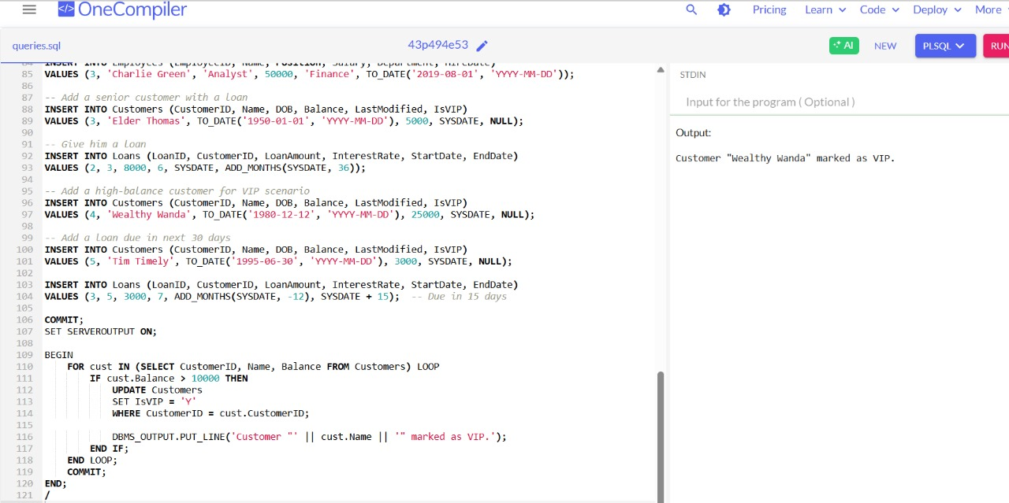

Scenario 3: The bank wants to send reminders to customers whose loans are due within the next 30 days.

Question: Write a PL/SQL block that fetches all loans due in the next 30 days and prints a reminder message for each customer.

**Program:**

SET SERVEROUTPUT ON;

BEGIN

FOR loan IN (

SELECT L.LoanID, C.Name, L.EndDate

FROM Loans L

JOIN Customers C ON C.CustomerID = L.CustomerID

WHERE L.EndDate BETWEEN SYSDATE AND SYSDATE + 30

) LOOP

DBMS_OUTPUT.PUT_LINE('Reminder: Loan #' || loan.LoanID || ' for customer "' || loan.Name ||

'" is due on ' || TO_CHAR(loan.EndDate, 'YYYY-MM-DD') || '.');

END LOOP;

END;

/

