**Exercise 4: Creating and Configuring a Maven Project**

Scenario:

You need to set up a new Maven project for the library management application and add Spring dependencies.

Steps:

Create a New Maven Project:

Create a new Maven project named LibraryManagement.

Add Spring Dependencies in pom.xml:

Include dependencies for Spring Context, Spring AOP, and Spring WebMVC.

Configure Maven Plugins:

Configure the Maven Compiler Plugin for Java version 1.8 in the pom.xml file.

**Program:**

**Dependencies Pom.xml:**

<project xmlns="http://maven.apache.org/POM/4.0.0"

xmlns:xsi="http://www.w3.org/2001/XMLSchema-instance"

xsi:schemaLocation="http://maven.apache.org/POM/4.0.0

http://maven.apache.org/xsd/maven-4.0.0.xsd">

<modelVersion>4.0.0</modelVersion>

<groupId>com.library</groupId>

<artifactId>librarymanagement</artifactId>

<version>1.0.0</version>

<packaging>jar</packaging>

<name>Library Management</name>

<description>Spring Boot Library Management Project</description>

<parent>

<groupId>org.springframework.boot</groupId>

<artifactId>spring-boot-starter-parent</artifactId>

<version>3.2.5</version>

<relativePath/> <!-- lookup parent from repository -->

</parent>

<properties>

<java.version>17</java.version>

</properties>

<dependencies>

<!-- Spring Boot Starter Web -->

<dependency>

<groupId>org.springframework.boot</groupId>

<artifactId>spring-boot-starter-web</artifactId>

</dependency>

<!-- Spring Boot Starter JPA -->

<dependency>

<groupId>org.springframework.boot</groupId>

<artifactId>spring-boot-starter-data-jpa</artifactId>

</dependency>

<!-- H2 Database (in-memory DB for development) -->

<dependency>

<groupId>com.h2database</groupId>

<artifactId>h2</artifactId>

<scope>runtime</scope>

</dependency>

<!-- Spring Boot DevTools -->

<dependency>

<groupId>org.springframework.boot</groupId>

<artifactId>spring-boot-devtools</artifactId>

<scope>runtime</scope>

</dependency>

<!-- Spring Boot Starter Test -->

<dependency>

<groupId>org.springframework.boot</groupId>

<artifactId>spring-boot-starter-test</artifactId>

<scope>test</scope>

</dependency>

</dependencies>

<build>

<plugins>

<plugin>

<groupId>org.springframework.boot</groupId>

<artifactId>spring-boot-maven-plugin</artifactId>

</plugin>

</plugins>

</build>

</project>

**LibraryManagement.java:**

@SpringBootApplication

public class LibrarymanagementApplication {

public static void main(String[] args) {

SpringApplication.run(LibrarymanagementApplication.class, args);

}

}

**Output:**

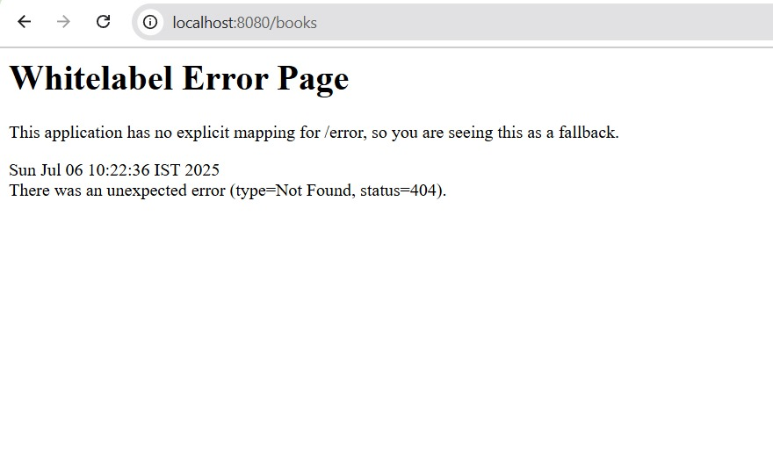

If no controller exists, you’ll see the Whitelabel error page