## **Objectives**

* Explain React components
* Identify the differences between components and JavaScript functions
* Identify the types of components
* Explain class component
* Explain function component
* Define component constructor
* Define render() function

In this hands-on lab, you will learn how to:

* Create a function component
* Apply style to components
* Render a component

## **Prerequisites**

The following is required to complete this hands-on lab:

* Node.js
* NPM
* Visual Studio Code

## **Notes**

Estimated time to complete this lab: **30 minutes.**

Create a react app for Student Management Portal named scorecalculatorapp and create a function component named “CalculateScore” which will accept Name, School, Total and goal in order to calculate the average score of a student and display the same.

1. Create a React project named “scorecalculatorapp” type the following command in terminal of Visual studio:



1. Create a new folder under Src folder with the name “Components”. Add a new file named “CalculateScore.js”
2. Type the following code in CalculateScore.js

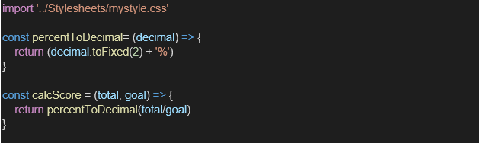

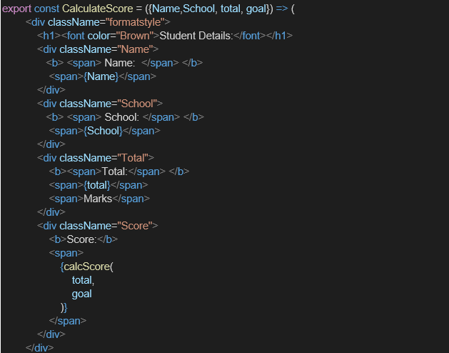

1. Create a Folder named Stylesheets and add a file named “mystyle.css” in order to add some styles to the components:

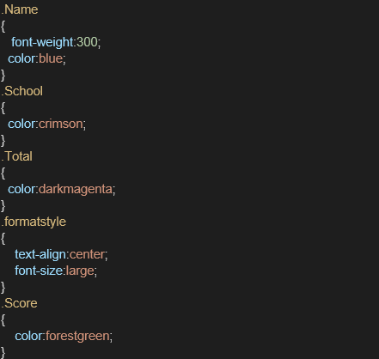

1. Edit the App.js to invoke the CalculateScore functional component as follows:

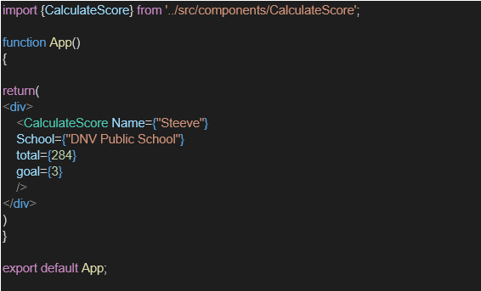

1. In command Prompt, navigate into scorecalculatorapp and execute the code by typing the following command:



1. Open browser and type “localhost:3000” in the address bar:

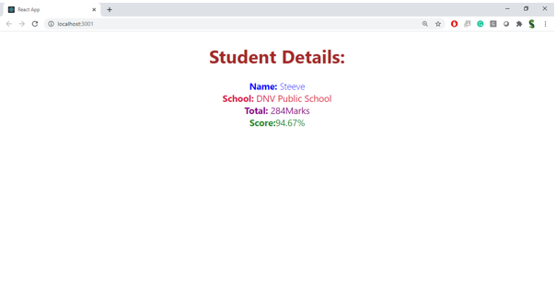

**Program:**

**CalculateScore.js:**

import React from 'react';

import '../Stylesheets/mystyle.css';

function CalculateScore(props) {

const average = props.total / props.goal;

return (

<div className="score-card">

<h2>Student Score Report</h2>

<p><strong>Name:</strong> {props.name}</p>

<p><strong>School:</strong> {props.school}</p>

<p><strong>Total Marks:</strong> {props.total}</p>

<p><strong>Goal:</strong> {props.goal}</p>

<p><strong>Average Score:</strong> {average.toFixed(2)}</p>

</div>

);

}

export default CalculateScore;

**mystyle.css:**

.score-card {

background-color: #f0f8ff;

border: 2px solid #008cba;

padding: 20px;

margin: 20px auto;

width: 300px;

border-radius: 10px;

font-family: Arial, sans-serif;

box-shadow: 2px 2px 10px rgba(0,0,0,0.1);

}

.score-card h2 {

color: #333;

text-align: center;

}

.score-card p {

font-size: 16px;

margin: 8px 0;

}

**App.js:**

import React from 'react';

import CalculateScore from './Components/CalculateScore';

function App() {

return (

<div>

<h1 style={{ textAlign: 'center' }}>Score Calculator App</h1>

<CalculateScore

name="John Doe"

school="Greenwood High"

total={450}

goal={5}

/>

</div>

);

} export default App;

