## **Objectives**

* Explain various ways of conditional rendering
* Explain how to render multiple components
* Define list component
* Explain about keys in React applications
* Explain how to extract components with keys
* Explain React Map, map() function

In this hands-on lab, you will learn how to:

* Implement conditional rendering in React applications

## **Prerequisites**

The following is required to complete this hands-on lab:

* Node.js
* NPM
* Visual Studio Code

## **Notes**

Estimated time to complete this lab: **60 minutes.**

Create a React App named “bloggerapp” in with 3 components.

1. Book Details
2. Blog Details
3. Course Details

Implement this with as many ways possible of Conditional Rendering.

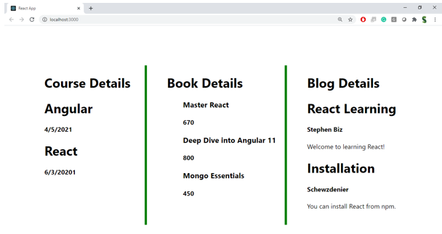

**Hint:**

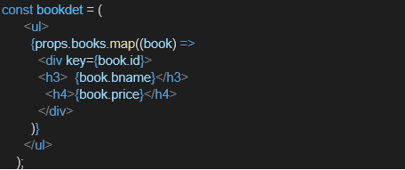

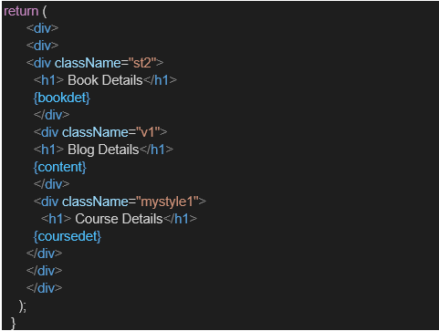

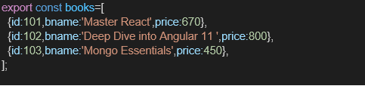

**Program:**

**BookDetails.js :**

import React from 'react';

function BookDetails() {

return (

<div>

<h2> Book Details</h2>

<ul>

<li>Title: React for Beginners</li>

<li>Author: Dan Abramov</li>

<li>Pages: 250</li>

</ul>

</div>

);

}

export default BookDetails;

**BlogDetails.js :**

import React from 'react';

function BlogDetails() {

return (

<div>

<h2>Blog Details</h2>

<p>Blog Title: Learning React</p>

<p>Published: July 2025</p>

</div>

);

}

export default BlogDetails;

**CourseDetails.js :**

import React from 'react';

function CourseDetails() {

const courses = [

{ id: 1, name: "React Basics" },

{ id: 2, name: "Advanced React" },

{ id: 3, name: "React with TypeScript" }

];

return (

<div>

<h2> Course Details</h2>

<ul>

{courses.map(course => (

<li key={course.id}>{course.name}</li>

))}

</ul>

</div>

);

}

export default CourseDetails;

**MainPage.js :**

import React, { useState } from 'react';

import BookDetails from './BookDetails';

import BlogDetails from './BlogDetails';

import CourseDetails from './CourseDetails';

function MainPage() {

const [selected, setSelected] = useState('book');

const [show, setShow] = useState(true);

// Using If-Else

let componentToRender;

if (selected === 'book') {

componentToRender = <BookDetails />;

} else if (selected === 'blog') {

componentToRender = <BlogDetails />;

} else {

componentToRender = <CourseDetails />;

}

return (

<div style={{ textAlign: 'center' }}>

<h1>Welcome to BloggerApp</h1>

<div style={{ margin: '20px' }}>

<button onClick={() => setSelected('book')}>Show Book</button>

<button onClick={() => setSelected('blog')}>Show Blog</button>

<button onClick={() => setSelected('course')}>Show Course</button>

<button onClick={() => setShow(!show)}>

{show ? "Hide Component" : "Show Component"}

</button>

</div>

{/* Using Ternary */}

{show ? componentToRender : <p>Component is hidden.</p>}

{/* Using && Operator */}

{selected === 'blog' && <p>Showing blog info using && operator!</p>}

</div>

);

}

export default MainPage;

**App.js :**

import React from 'react';

import MainPage from './components/MainPage';

function App() {

return (

<div>

<MainPage />

</div>

);

}

export default App;

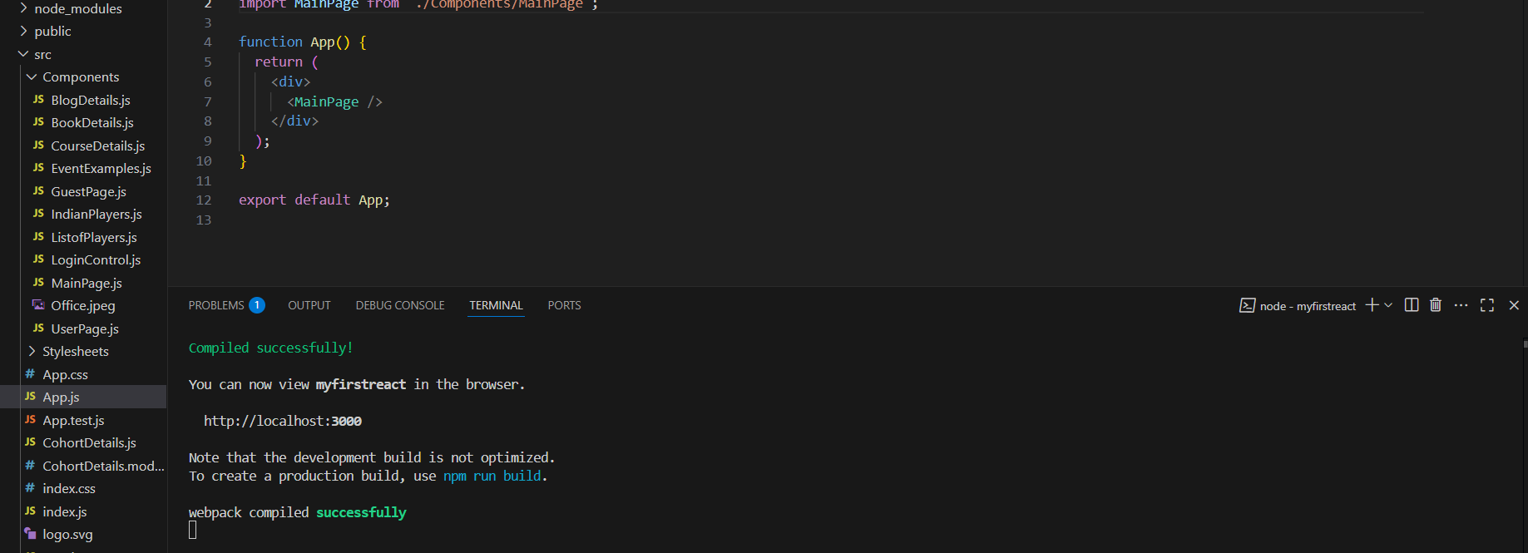

**Output:**

