

**ECE 5397/6397: Intro to Robotics**

**HW 4, Due March 3** The manipulator Jacobian

1. Calculate the manipulator Jacobian of the anthropomorphic manipulator at the position *zc.*
   1. Write out the *J* matrix in terms of *zi* and *oi*.
   2. Write out the *zi* and *oi* values.
   3. Write out the *J* values. Calculate the cross products. You may use your previous calculations for the A and T matrices.

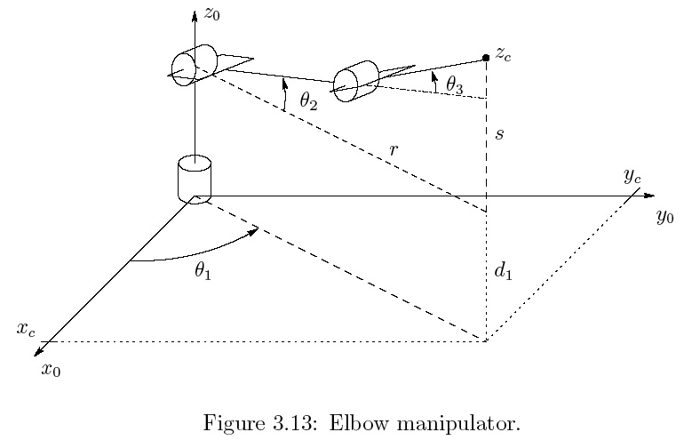

2. Calculate the manipulator Jacobian of the cylindrical robot with spherical wrist manipulator at the position *z6.*

1. Write out the J matrix in terms of zi and oi.
2. Write out the zi and oi values.
3. Calculate the cross products. You may use your previous calculations for the A and T matrices.

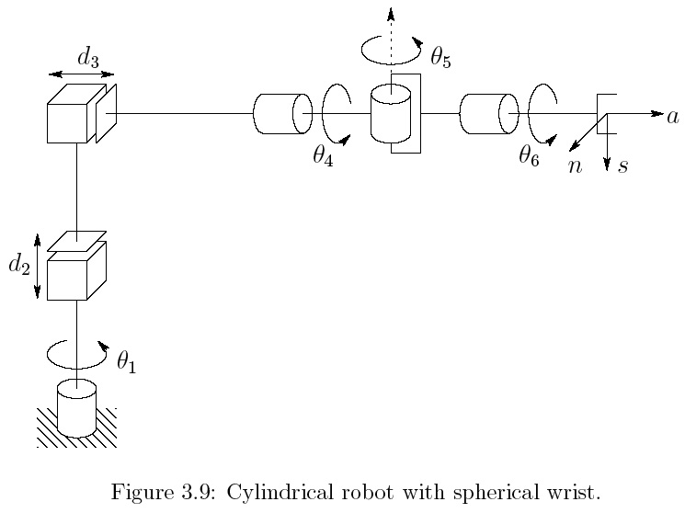

$$T_{1}^{0}=\left[\text{⁠}\begin{matrix}c_{1} & -s_{1} & 0 & 0 \\ s_{1} & c_{1} & 0 & 0 \\ 0 & 0 & 1 & d_{1} \\ 0 & 0 & 0 & 1\end{matrix}\right]$$

$$T_{2}^{0}=\left[\text{⁠⁠⁠}\begin{matrix}c_{1} & 0 & -s_{1} & 0 \\ s_{1} & 0 & c_{1} & 0 \\ 0 & -1 & 0 & d_{1}+q_{2} \\ 0 & 0 & 0 & 1\end{matrix}\right]$$

$$T_{3}^{0}=\left[\text{⁠⁠⁠}\begin{matrix}c_{1} & 0 & -s_{1} & -q_{3}s_{1} \\ s_{1} & 0 & c_{1} & q_{3}c_{1} \\ 0 & -1 & 0 & d_{1}+q_{2} \\ 0 & 0 & 0 & 1\end{matrix}\right]$$

$$T_{4}^{0}=\left[\text{⁠⁠⁠}\begin{matrix}c_{1}c_{4} & s_{1} & -c_{1}s_{4} & -q_{3}s_{1} \\ c_{4}s_{1} & -c_{1} & -s_{1}s_{4} & q_{3}c_{1} \\ -s_{4} & 0 & -c_{4} & d_{1}+q_{2} \\ 0 & 0 & 0 & 1\end{matrix}\right]$$

$$T_{5}^{0}=\left[\text{⁠⁠⁠}\begin{matrix}c_{1}c_{4}c_{5}+s_{1}s_{5} & -c_{1}s_{4} & -c_{5}s_{1}+c_{1}c_{4}s_{5} & -q_{3}s_{1} \\ c_{4}c_{5}s_{1}-c_{1}s_{5} & -s_{1}s_{4} & c_{1}c_{5}+c_{4}s_{1}s_{5} & q_{3}c_{1} \\ -c_{5}s_{4} & -c_{4} & -s_{4}s_{5} & d_{1}+q_{2} \\ 0 & 0 & 0 & 1\end{matrix}\right]$$

$$T_{6}^{0}=\left[\text{⁠⁠⁠}\begin{matrix}c_{6}s_{1}s_{5}+c_{1}(c_{4}c_{5}c_{6}-s_{4}s_{6}) & -s_{1}s_{5}s_{6}-c_{1}(c_{6}s_{4}+c_{4}c_{5}s_{6}) & -c_{5}s_{1}+c_{1}c_{4}s_{5} & -q_{3}s_{1} \\ c_{4}c_{5}c_{6}s_{1}-c_{1}c_{6}s_{5}-s_{1}s_{4}s_{6} & -c_{6}s_{1}s_{4}+(-c_{4}c_{5}s_{1}+c_{1}s_{5})s_{6} & c_{1}c_{5}+c_{4}s_{1}s_{5} & q_{3}c_{1} \\ -c_{5}c_{6}s_{4}-c_{4}s_{6} & -c_{4}c_{6}+c_{5}s_{4}s_{6} & -s_{4}s_{5} & d_{1}+q_{2} \\ 0 & 0 & 0 & 1\end{matrix}\right]$$

$$J=\left[\text{⁠⁠}\begin{matrix}z_{0}×\left(o_{c}-o_{0}\right) & z_{1} & z_{2} & z_{3}×\left(o_{c}-o_{3}\right) & z_{4}×\left(o_{c}-o_{4}\right) & z_{5}×\left(o_{c}-o_{5}\right) \\ z_{0} & 0 & 0 & z_{3} & z_{4} & z_{5}\end{matrix}\right]$$

$$z_{0}=\left[\begin{matrix}0 \\ 0 \\ 1\end{matrix}\right],z_{1}=z_{2}=z_{3}=\left[\begin{matrix}{-s}_{1} \\ c_{1} \\ 0\end{matrix}\right],z_{4}=\left[\begin{matrix}-c_{1}s_{4} \\ -s_{1}s_{4} \\ -c_{4}\end{matrix}\right],z_{5}=\left[\begin{matrix}-c_{5}s_{1}+c_{1}c_{4}s_{5} \\ c_{1}c_{5}+c_{4}s_{1}s_{5} \\ -s_{4}s_{5}\end{matrix}\right],$$

$$o_{0}=\left[\begin{matrix}0 \\ 0 \\ 0\end{matrix}\right],o_{1}=\left[\begin{matrix}0 \\ 0 \\ d_{1}\end{matrix}\right],o_{2}=\left[\begin{matrix}0 \\ 0 \\ d_{1}+q_{2}\end{matrix}\right],o_{3}=o_{4}=o_{5}=o_{c}=\left[\begin{matrix}-q_{3}s_{1} \\ q_{3}c_{1} \\ d_{1}+q_{2}\end{matrix}\right]$$

$$J=\left[\text{⁠⁠}\begin{matrix}-c_{1}q_{3} & {-s}_{1} & {-s}_{1} & 0 & 0 & 0 \\ -s_{1}q_{3} & c_{1} & c_{1} & 0 & 0 & 0 \\ 0 & 0 & 0 & 0 & 0 & 0 \\ 0 & 0 & 0 & {-s}_{1} & -c_{1}s_{4} & -c_{5}s_{1}+c_{1}c_{4}s_{5} \\ 0 & 0 & 0 & c_{1} & -s_{1}s_{4} & c_{1}c_{5}+c_{4}s_{1}s_{5} \\ 1 & 0 & 0 & 0 & -c_{4} & -s_{4}s_{5} \end{matrix}\right]$$

With non zero *d6*

,,