Midterm Exam 1, Ver.a

March 31, 2016, Intro to Robotics

Name: __________________________________________________

PeopleSoft ID: __________________________________________________

|  |  |  |
| --- | --- | --- |
| Problem | Score | Possible |
| 1 |  | 5 |
| 2 |  | 5 |
| 3 |  | 5 |
| 4 |  | 5 |
| 5 |  | 5 |
| 6 |  | 5 |
| Totals |  | 30 |

You may have on your desk:

* Your student ID card
* 1 handwritten 8.5”x11” double-sided crib sheet
* this exam (provided by Professor)

Grading: (problem difficulty)

Concepts: Covers chapters 1-4, 11.1--11.2

*Rotations & transformations*

* Composition of rotations about world or current frame
* Construct a homogenous transform

*Kinematics*

* Assign DH parameters
* Given DH parameters, construct A matrix
* Given two A matrices, construct T matrix

*Inverse Kinematics*

* Two-argument arc tangent function
* Solve inverse position kinematics for a 3-link arm

*Jacobian*

* Construct Jacobian given sketch and T matrices

*Computer Vision*

* Move from camera frame to world frame

Problem 1: ______/5

1. Write the matrix product that will give the resulting rotation matrix (do not perform the matrix multiplications:
   1. Rotate by *Φ* about the current *y*-axis
   2. Rotate by *θ* about the world *x*-axis
   3. Rotate by *ψ* about the current *y*-axis
   4. Rotate by *α* about the world *z*-axis
   5. Rotate by *β* about the current *y*-axis

1. Suppose the three coordinate frames

, , and are given, and suppose

, .

Find the matrix



3. Consider the diagram at right. Robot is 1 meter from a table. The tabletop is 1 m high and 1 m square. A frame is fixed to the side of the table as shown. A cube measuring 20 cm on a side is placed in the center of the table with frame established at the center of the cube as shown. A camera is situated directly above the center of the block 2 meters above the table top with frame attached as shown.

Find the **homogenous transform** relating the frame to the camera frame.

Problem 2: ______/5 Rotation matrices

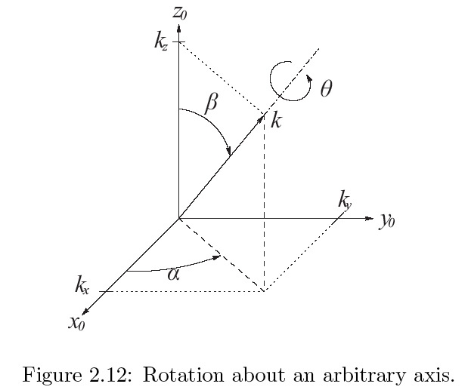**Axis/Angle Representation:**

Define axis as unit vector in .

1. Rotate world *z*-axis to align with vector *k*:
   1. Rotate about world z-axis.
   2. then about current *y-*axis

Matrix Identification. +1 for each correctly listed, -1 for each incorrectly listed, score is **max**(0, sum points)

a.) , b.) c.), d.,

e.)

Which are valid so(*k*)? ______________

Which are valid SE(3)? _______________

Which are a valid SO(3) _________________

Problem 3: ______/5, Forward Kinematics

a.) For the 3-link robot below, draw the z and x-axis according to the DH convention

b.) Give the DH parameters for this PRP planar robot.

* indicates variable

|  |  |  |  |  |
| --- | --- | --- | --- | --- |
| Link |  |  |  |  |
| 1 |  |  |  |  |
| 2 |  |  |  |  |
| 3 |  |  |  |  |

c.) Compute the transformation matrix *A2* and *A4* using the DH parameters:

|  |  |  |  |  |
| --- | --- | --- | --- | --- |
| Link |  |  |  |  |
| 1 | 0 |  |  |  |
| 2 | 0 |  |  |  |
| 3 | 10 |  |  |  |
| 4 | 3 |  | 0 |  |

* indicates variable

*A2* =, *A4* =

Problem 4: ______/5 Inverse kinematics

, **solve for**

Already did spherical robot and articulated manipulator

Do cylindrical robot

Planar PRP for inverse kinematics.

Problem 5: ______/5 Jacobian

1. Calculate the manipulator Jacobian of the anthropomorphic manipulator at the position o3= oc.
   1. Write out the *J* matrix in terms of *zi* and *oi*.
   2. Write out the *zi* and *oi* values.
   3. Write out the *J* values. Calculate the cross products. You may use your previous calculations for the *A* and *T* matrices.

Problem 6: ______/5 Computer Vision

1. **Two frames**  and are related by the homogenous transformation

A particle has velocity relative to frame . What is the velocity of the particle in frame ?

1. For a camera with focal length , find the image plane coordinates for the 3D points whole coordinates in the camera frame are given below. Indicate which points will not be visible to a physical camera.

Transformation:

* 1. (5,5,15)c 🡪 (*u,v*) =

* 1. (-25,-25,50)c 🡪 (*u,v*) =

* 1. (5,5,-5)c 🡪 (*u,v*) =

* 1. (15,10,25)c 🡪 (*u,v*) =

1. The robot has two parallel laser beams located at [-0.2,0,0], [0.2,0,0], and pointing in the direction [0,0,1]. They are used to measure the distance to approaching cars. If the car on the image is of width 5, the camera has focal length , and the laser beams are located at [-1,0,0], [1,0,0].

How far is the car from the camera?

How big is the car?