

**ECE 5397/6397: Intro to Robotics**

**Class Worksheet – Lecture 1**

1. What type of manipulator would be best suited? Worst Suited? Justify your answers: articulated

*arc welding packing*

You May Skip this one

*grinding,*

*parts inspection,*

*small parts assembly,*

*cleaning/spraying,*

*spot welding,*

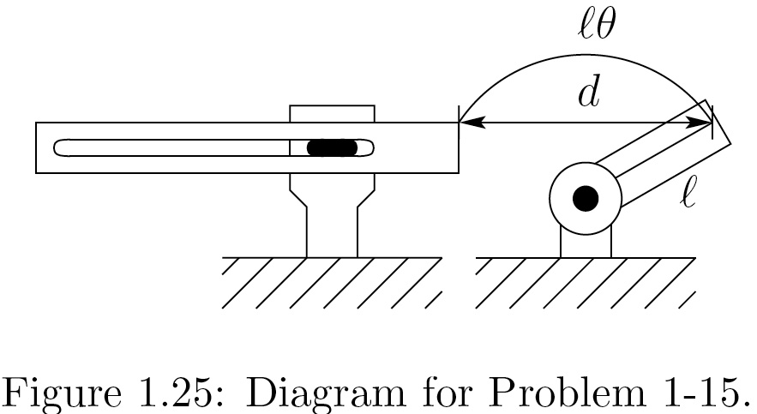

*painting*

2. Suppose that the tip of a single link travels a distance *d* between two points. A linear axis would travel the distance *d* while a rotational link would travel through an arc length $lθ$ as shown. Use the law of cosines [triangle with sides a,b,c,, side c opposite angle θc,: ] to determine *d.*

3. *Grad students*: suppose we could close every factory today and reopen them tomorrow fully automated with robots. What would be some of the economic and social consequences of such a development?

*Undergrads*: Suppose a law were passed banning all future use of industrial robots. What would be some of the economic and social consequences of such an act?

­­­You May Skip this one



**ECE 5397/6397: Intro to Robotics**

**Class Worksheet – Preparation for Lecture 2**

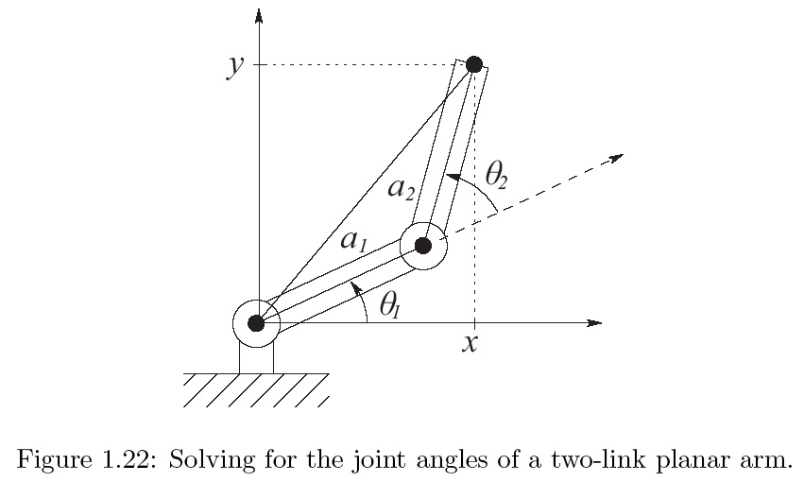

4. Derive inverse equation for the two-link manipulator at right:

5. [use a calculator or computer] For the two-link manipulator, suppose $a_{1}=a_{2}=1$.

* Find coordinates of the tool when $θ_{1}=\frac{7}{6}π,θ_{2}=\frac{3}{2}π$
* If joint velocities are constant at ${\dot{θ}}_{1}=2, {\dot{θ}}_{2}=1,$ what is the velocity of the tool (symbolically)
* What is the instantaneous tool velocity when ?

6. Register for SwarmAThon: [https://secor.wufoo.com/forms/swarmathon-student-registration-form/](https://secor.wufoo.com/forms/swarmathon-student-registration-form/" \t "_blank)

completed:

7. Register for Webinar: [https://www.cysalesteam.com/swarmathon/upcoming?embed=1#](https://www.cysalesteam.com/swarmathon/upcoming?embed=1" \t "_blank)

username:

8. Get a github user name [www.github.com](http://www.github.com). Username: