

**ECE 5397/6397: Intro to Robotics**

**Class Worksheet – Lecture 2: Quiz on Vectors**

1. Let $x={\left[\begin{matrix}a & b & c\end{matrix}\right]}^{T}$ and $y={\left[\begin{matrix}d & e & f\end{matrix}\right]}^{T}$. What is the **scalar product $〈x,y〉$** ?
$$〈x,y〉=x^{T}y=ad+be+cf$$

2. What is the **outer product ${xy}^{T}$** ?
$${xy}^{T}=\left[\begin{matrix}ad & ae & af \\ bd & be & bf \\ cd & ce & cf\end{matrix}\right]$$

3. What is the length or **norm** of vector $x$? That is $\left\|x\right\|$ = ?
$$\left\|x\right\|=\sqrt{a^{2}+b^{2}+c^{2}}$$

4. Fill in the relationships

$\left| x^{T}y\right| ≤ \left\|x\right\| \left\|y\right\|$ name it: *Cauchy-Schwartz inequality*

$\left\|x+y\right\| ≤ \left\|x\right\|+\left\|y\right\|$ name it: *triangle inequality*

1. 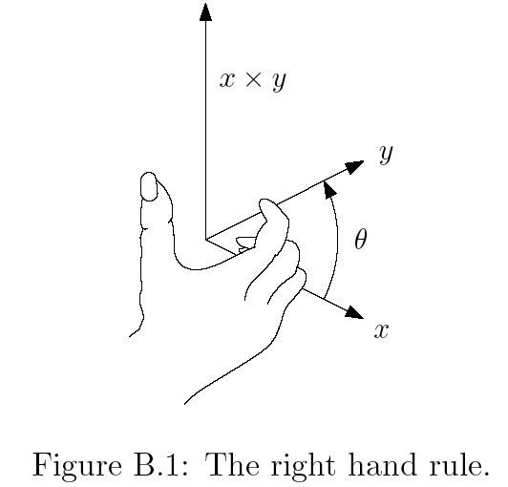If $x^{T}y=\left\|x\right\|\left\|y\right\|\cos{(θ)}$, what is $θ$?

Shortest angle between $x$ and $y$.

1. Assume $x$ and $y$ are 2D vectors that are not parallel. Draw $x,y,θ$ if $x^{T}y=\left\|x\right\|\left\|y\right\|\cos{(θ)}$
2. Again let $x={\left[\begin{matrix}a & b & c\end{matrix}\right]}^{T}$ and $y={\left[\begin{matrix}d & e & f\end{matrix}\right]}^{T}$. What is $Tr\left(xy^{T}\right)$, where $Tr\left(∙\right)$ is the **trace** of a matrix?
$$Tr\left(xy^{T}\right)=〈x,y〉=x^{T}y=ad+be+cf$$

3. What is the **determinant** of $A=\left[\begin{matrix}a & b \\ c & d\end{matrix}\right]?$

$$\det\left(A\right)=ad-bc$$

1. Give the **vector product** (the **cross product**) $x × y$ of two vectors $x={\left[\begin{matrix}x_{1} & x_{2} & x_{3}\end{matrix}\right]}^{T}$ and $y={\left[\begin{matrix}y_{1} & y_{2} & y_{3}\end{matrix}\right]}^{T}$ that belong to $R^{3}$ as the vector $c:$



*-y*

*-y* x *x*

$$c= x × y=\det\left[\begin{matrix}i & j & k \\ x_{1} & x_{2} & x_{3} \\ y_{1} & y_{2} & y_{3}\end{matrix}\right]$$

$$=\left(x_{2}y_{3}-x_{3}y_{2}\right)i+\left(x_{3}y_{1}-x_{1}y_{3}\right)j+\left(x_{1}y_{2}-x_{2}y_{1}\right)k$$

1. What is $-y × x$? (**anticommutative**) Draw it on image B.1:
2. Apply distributive rule: $x × (y+z)$ = $x × y+x × z$
3. Apply distributive rule: $α\left(x × y\right)=\left(αx\right) × y=x × \left(αy\right)$



**ECE 5397/6397: Intro to Robotics**

**Class Worksheet – Preparation for Lecture 3**

1. Show that the length of a free vector is not changed by rotation, that is, that $\left\|v\right\|=\left\|Rv\right\|$.
2. Show that the distance between points is not changed by rotation, that is $\left\|p_{1}-p_{2}\right\|=\left\|{Rp}_{1}-{Rp}_{2}\right\|$.
3. Show that $R_{z,0}=I$, $R_{a}{\left(R_{a}\right)}^{-1}=I$, and $R_{z,θ}R_{z,ϕ}=R_{z,θ+ϕ}$ imply $R_{z,-θ}={\left(R_{z,θ+ϕ}\right)}^{-1}$
4. Suppose $A$ is a $2 × 2$ rotation matrix. In other words, $A^{T}A=I$ and $\det\left(A\right)= 1$. Show that there exits a unique $θ$ such that $A$ is of the form $A=\left[\begin{matrix}\cos{θ} & -\sin{θ} \\ \sin{θ} & \cos{θ}\end{matrix}\right]$
5. Implement the swarmrobot outreach code at <http://www.cs.unm.edu/~elizabeth/mars_robots.zip>. You must install NetLogo on your computer: <https://ccl.northwestern.edu/netlogo/> Make a copy of the file with _ice in the name. Create an additional global variable **numberOfIce**. Create clusters in blue to represent ice. The singly placed yellow patches will still represent rocks. You must then change the **pcolor** tests to look for both blue and yellow patches. Create separate monitors for the ice and rocks remaining to be collected. Email this file to the TA.