

**ECE 5397/6397: Intro to Robotics**

**Class Worksheet – Lecture 4:** Coordinate transformation, Parameterizations of SO(3), Euler angles

Constraints on $R∈SO\left(3\right), r_{ij}=r_{row,column}$ How many DOF?

$R=\left[\begin{matrix}r_{11} & r_{12} & r_{13} \\ r_{21} & r_{22} & r_{23} \\ r_{31} & r_{32} & r_{33}\end{matrix}\right]$

1. column vectors in $SO\left(3\right)$ are unit vectors:

$r_{11}^{2}$ + $r_{21}^{2}+r_{31}^{2}$ =1, $r_{12}^{2}$ + $r_{22}^{2}+r_{32}^{2}$ =1, $r_{13}^{2}$ + $r_{23}^{2}+r_{33}^{2}$ =1

$$\sum_{i}{r_{ij}^{2}}=1, j∈\{1,2,3\}$$

1. Columns in $SO\left(3\right)$ are mutually orthogonal:

${\left[\begin{matrix}r_{11} \\ r_{21} \\ r_{31}\end{matrix}\right]}^{T}\left[\begin{matrix}r_{12} \\ r_{22} \\ r_{32}\end{matrix}\right]$, ${\left[\begin{matrix}r_{11} \\ r_{21} \\ r_{31}\end{matrix}\right]}^{T}\left[\begin{matrix}r_{13} \\ r_{23} \\ r_{33}\end{matrix}\right], {\left[\begin{matrix}r_{12} \\ r_{22} \\ r_{32}\end{matrix}\right]}^{T}\left[\begin{matrix}r_{13} \\ r_{23} \\ r_{33}\end{matrix}\right]$

Two-argument arctangent function is the unique angle $θ∈(-π,π)$ such that

$\cos\left(θ\right)=\frac{x}{\sqrt{x^{2}+y^{2}}}$ and $\sin\left(θ\right)=\frac{y}{\sqrt{x^{2}+y^{2}}}$

What is and $\tan^{-1}(\frac{x}{y})$ and $arctan2(x,y)$

for $\left(x,y\right)=\left(2,2\right)$, $\tan^{-1}\left(\frac{x}{y}\right)=$ $arctan2\left(x,y\right)=$

for $\left(x,y\right)=\left(-2,-2\right)$, $\tan^{-1}\left(\frac{x}{y}\right)=$ $arctan2\left(x,y\right)=$

**ZYZ Euler Angles:** specify the orientation of frame $o_{1}x_{1}y_{1}z_{1}$ relative to frame $o_{0}x_{0}y_{0}z_{0}$

1. Rotate about *z*-axis by $ϕ$
2. Rotate about current y-axis by $θ$
3. Rotate about current z-axis by $ψ$

$$R_{ZYZ}=R_{z,ϕ}R_{y,θ}R_{z,ψ}=\left[\begin{matrix}c_{ϕ} & -s_{ϕ} & 0 \\ s_{ϕ} & c_{ϕ} & 0 \\ 0 & 0 & 1\end{matrix}\right]\left[\begin{matrix}c_{θ} & 0 & s_{θ} \\ 0 & 1 & 0 \\ -s_{θ} & 0 & c_{θ}\end{matrix}\right]\left[\begin{matrix}c_{ψ} & -s_{ψ} & 0 \\ s_{ψ} & c_{ψ} & 0 \\ 0 & 0 & 1\end{matrix}\right]$$

For a given $R_{ZYZ}$, how do we determine $ϕ,θ,ψ$? Why do we need to?

Solving for angles necessary for the inverse kinematics problem in Section 3.3

$R_{ZYZ}$ = $\left[\begin{matrix}c_{ϕ}c_{θ}c_{ψ}-s_{ϕ}s_{ψ} & -c_{ϕ}c_{θ}s_{ψ}-s_{ϕ}c_{ψ} & {c_{ϕ}s}_{θ} \\ s_{ϕ}c_{θ}c_{ψ}+c_{ϕ}s_{ψ} & -s_{ϕ}c_{θ}s_{ψ}+c_{ϕ}c_{ψ} & {s_{ϕ}s}_{θ} \\ -s_{θ}c_{ψ} & s_{θ}s_{ψ} & c_{θ}\end{matrix}\right]=\left[\begin{matrix}r_{11} & r_{12} & r_{13} \\ r_{21} & r_{22} & r_{23} \\ r_{31} & r_{32} & r_{33}\end{matrix}\right]$

1. If $r_{13}$ and $r_{23}$ are not both zero, then $r_{33}≠±1$, $c_{θ}=r_{33}$ and $s_{θ}=±\sqrt{1-r_{33}^{2}}$
2. If $s_{θ}$ >0, If $s_{θ}$ <0
$θ=Atan2(r_{33},-\sqrt{1-r_{33}^{2}})$

$ϕ=Atan2({-r}_{13},{-r}_{23})$

$ψ=Atan2(r_{31},{-r}_{32})$

$θ=Atan2(r_{33},\sqrt{1-r_{33}^{2}})$

$ϕ=Atan2(r_{13},r_{23})$

$ψ=Atan2({-r}_{31},r_{32})$

3. If $r_{13}=r_{23}=0$, then $r_{33}=±1$ and $r_{31}=r_{32}=0$. Thus $s_{θ}$ =0

$R_{ZYZ}$ = $\left[\begin{matrix}c_{ϕ}c_{θ}c_{ψ}-s_{ϕ}s_{ψ} & -c_{ϕ}c_{θ}s_{ψ}-s_{ϕ}c_{ψ} & {c_{ϕ}s}_{θ} \\ s_{ϕ}c_{θ}c_{ψ}+c_{ϕ}s_{ψ} & -s_{ϕ}c_{θ}s_{ψ}+c_{ϕ}c_{ψ} & {s_{ϕ}s}_{θ} \\ -s_{θ}c_{ψ} & s_{θ}s_{ψ} & c_{θ}\end{matrix}\right]=\left[\begin{matrix}r_{11} & r_{12} & 0 \\ r_{21} & r_{22} & 0 \\ 0 & 0 & ±1\end{matrix}\right]$

1. If $r_{33}=1$, $c_{θ}$ =1, ­­­­and $s_{θ}$ =0 so $θ=$ 0

*remember the sine and cosine of sum identities:*

$$\sin\left(α±β\right)=\sin\left(α\right)cos⁡(β)±cos⁡(α)sin⁡(β)$$

$$\cos\left(α±β\right)=\cos\left(α\right)cos⁡(β)∓sin⁡(α)sin⁡(β)$$

$R_{ZYZ}$ = $\left[\begin{matrix}c_{ϕ}c_{ψ}-s_{ϕ}s_{ψ} & -c_{ϕ}s_{ψ}-s_{ϕ}c_{ψ} & 0 \\ s_{ϕ}c_{ψ}+c_{ϕ}s_{ψ} & -s_{ϕ}s_{ψ}+c_{ϕ}c_{ψ} & 0 \\ 0 & 0 & 1\end{matrix}\right]$ = $\left[\begin{matrix}c_{ϕ+ψ} & -s_{ϕ+ψ} & 0 \\ s_{ϕ+ψ} & c_{ϕ+ψ} & 0 \\ 0 & 0 & 1\end{matrix}\right]$

$$ϕ+ψ=Atan2(r_{11},r_{21})=Atan2(r_{22},r_{21})=Atan2(r_{22},{-r}_{12})$$

1. If $r_{33}=-1$, $c_{θ}$ = $-1$, ­­­­and $s_{θ}$ =0 so $θ=π$

$R_{ZYZ}$ = $\left[\begin{matrix}{-c}_{ϕ}c_{ψ}-s_{ϕ}s_{ψ} & c_{ϕ}s_{ψ}-s_{ϕ}c_{ψ} & 0 \\ {-s}_{ϕ}c_{ψ}+c_{ϕ}s_{ψ} & s_{ϕ}s_{ψ}+c_{ϕ}c_{ψ} & 0 \\ 0 & 0 & -1\end{matrix}\right]$ = $\left[\begin{matrix}{-c}_{ϕ-ψ} & -s_{ϕ-ψ} & 0 \\ s_{ϕ-ψ} & c_{ϕ-ψ} & 0 \\ 0 & 0 & -1\end{matrix}\right]$

$$ϕ-ψ=Atan2({-r}_{11},-r_{12})$$

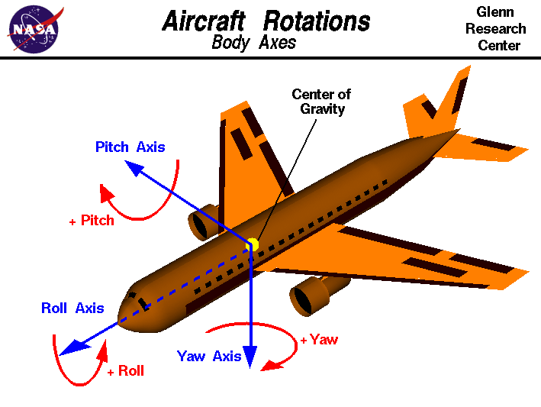**Roll,Pitch, Yaw Angles:** specify the orientation of frame $o_{1}x_{1}y_{1}z_{1}$ relative to frame $o_{0}x_{0}y_{0}z_{0}$

1. Yaw about world *x*-axis by $ψ$
2. Pitch about world *y*-axis by $θ$
3. Roll about world z-axis by $ϕ$

(draw on image. This image is wrong?)

$$R_{rollPitchYaw}=R_{z,ϕ}R_{y,θ}R_{x,ψ}=\left[\begin{matrix}c_{ϕ} & -s_{ϕ} & 0 \\ s_{ϕ} & c_{ϕ} & 0 \\ 0 & 0 & 1\end{matrix}\right]\left[\begin{matrix}c_{θ} & 0 & s_{θ} \\ 0 & 1 & 0 \\ -s_{θ} & 0 & c_{θ}\end{matrix}\right]\left[\begin{matrix}1 & 0 & 0 \\ 0 & c_{ψ} & -s_{ψ} \\ 0 & s_{ψ} & c_{ψ}\end{matrix}\right]$$

$$R_{rollPitchYaw}=\left[\begin{matrix}c_{θ}c_{ϕ} & -c_{ψ}s_{ϕ}+c_{ϕ}s_{θ}s_{ψ} & c_{ϕ}c_{ψ}s_{θ}+s_{ϕ}s_{ψ} \\ c_{θ}c_{ϕ} & c_{ϕ}c_{ψ}+s_{θ}s_{ϕ}s_{ψ} & c_{ψ}s_{θ}s_{ϕ}-c_{ϕ}s_{ψ} \\ -s_{θ} & c_{θ}s_{ψ} & c_{θ}c_{ψ}\end{matrix}\right]$$

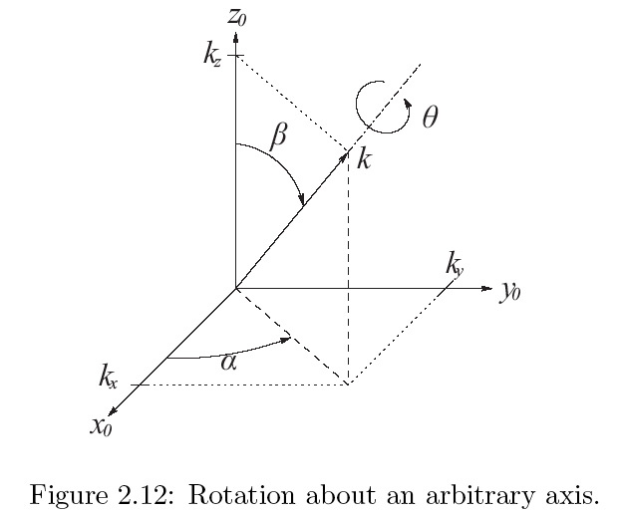

**Axis/Angle Representation:**

rotation about an arbitrary axis in space: $k,θ$

1. Define axis as unit vector in $o_{0}x_{0}y_{0}z_{0}$.

$k={\left[\begin{matrix}k_{x} & k_{y} & k_{z}\end{matrix}\right]}^{T}$

1. Rotate world *z*-axis to align with vector *k*:
   1. Rotate $α$ about world z-axis,
 $$\sin\left(α\right)=\frac{k_{y}}{\sqrt{k_{x}^{2}+k_{y}^{2}}}, \cos\left(α\right)=\frac{k_{x}}{\sqrt{k_{x}^{2}+k_{y}^{2}}}$$

  2. then $β$ about current *y-*axis

$$\sin\left(β\right)=\sqrt{k_{x}^{2}+k_{y}^{2}}, \cos\left(β\right)=k_{z}$$

$$R=R_{z,α}R_{y,β}, R_{k,θ}={R_{z,α}R}_{z,θ}{(R_{z,α})}^{-1}$$

$$R_{k,θ}=R_{z,α}R_{y,β}R_{z,θ}R_{y,-β}R_{z,-α}$$

$R_{k,θ}=\left[\begin{matrix}k_{x}^{2}v_{θ}+c_{θ} & k_{x}k_{y}v_{θ}-k_{z}s_{θ} & k_{x}k_{z}v_{θ}-k_{y}s_{θ} \\ k_{x}k_{y}v_{θ}+k_{z}s_{θ} & k_{y}^{2}v_{θ}+c_{θ} & k_{y}k_{z}v_{θ}-k_{x}s_{θ} \\ k_{x}k_{z}v_{θ}-k_{y}s_{θ} & k_{y}k_{z}v_{θ}+k_{x}s_{θ} & k_{z}^{2}v_{θ}+c_{θ}\end{matrix}\right]$, where $v_{θ}=(1-c_{θ})$

Solving:

What is the trace of $R_{k,θ}$? $r_{11}+r_{22}+r_{33}=\left(1-c_{θ}\right)+3c_{θ}$

Then $θ=\cos^{-1}\left(\frac{r_{11}+r_{22}+r_{33}-1}{2}\right)$

How can you isolate $k_{x}s_{θ}?$ $r_{32}-r_{23}=k_{x}2s_{θ}$

Thus $k=\frac{1}{2\sin{θ}}\left[\begin{matrix}r_{32}-r_{23} \\ r_{13}-r_{31} \\ r_{21}-r_{12}\end{matrix}\right]$

Problem: *If $k= \frac{1}{\sqrt{3}}{\left[\begin{matrix}1 & 1 & 1\end{matrix}\right]}^{T}, θ={90}^{∘}$* , $R_{k,θ}$ = $\left[\begin{matrix}1/3 & \frac{1}{3}-\frac{1}{\sqrt{3}} & \frac{1}{3}+\frac{1}{\sqrt{3}} \\ \frac{1}{3}+\frac{1}{\sqrt{3}} & 1/3 & \frac{1}{3}-\frac{1}{\sqrt{3}} \\ \frac{1}{3}-\frac{1}{\sqrt{3}} & \frac{1}{3}+\frac{1}{\sqrt{3}} & 1/3\end{matrix}\right]$,

**Rigid Motions**

A rigid motion is an ordered pair $(d,R)$, where $d∈R^{3}, R∈SO\left(3\right)$. It is a pure translation together with a pure rotation

The group of all rigid motions is known as the **Special Euclidean Group** and is denoted $SE(3)$.

$SE(3)∈R^{3}×SO\left(3\right)$.

Let $R_{1}^{0}$ be the orientation of frame $o_{1}x_{1}y_{1}z_{1}$ with respect to $o_{0}x_{0}y_{0}z_{0}$. Let $d_{1}$ be the vector from frame 0 to 1 and $d_{2}$ be the vector from frame 0 to 2. Suppose $p$ is rigidly attached to frame 2 with local coordinates $p^{2}$

Draw $o_{1}x_{1}y_{1}z_{1}$, $o_{0}x_{0}y_{0}z_{0}, d_{1},$ and $p$:

$p^{1}=R_{2}^{1} p^{2}+d_{2}^{1}$ $p^{0}=R_{1}^{0} p^{1}+d_{1}^{0}$

$$p^{0}=R_{1}^{0} (R_{2}^{1} p^{2}+d_{2}^{1})+d_{1}^{0}$$

$$p^{0}=R_{2}^{0} p^{2}+d_{2}^{1}$$

Solve for $R_{2}^{0}=R_{1}^{0}R_{2}^{1}$ $d_{2}^{1}=R_{1}^{0}d_{2}^{1}$