

**ECE 5397/6397: Intro to Robotics**

**Class Worksheet – Lecture 5:** Forward kinematics: Denavit-Hartenberg convention and the derivation of D-H transformation matrix, assigning link frames using the DH convention.

Constraints on $R∈SO\left(3\right), r_{ij}=r_{row,column}$ How many DOF?

$$A_{i}= Rot_{z,θ_{i}}{Trans}_{z,d_{i}}{Trans}_{x,a_{i}}Rot_{x,α_{i}}$$

$$Rot_{x,α_{i}}=\left[\begin{matrix}c_{θ_{i}} & -s_{θ_{i}} & 0 & 0 \\ s_{θ_{i}} & c_{θ_{i}} & 0 & 0 \\ 0 & 0 & 1 & 0 \\ 0 & 0 & 0 & 1\end{matrix}\right]{Trans}_{z,d_{i}}=\left[\begin{matrix}1 & 0 & 0 & 0 \\ 0 & 1 & 0 & 0 \\ 0 & 0 & 1 & d_{i} \\ 0 & 0 & 0 & 1\end{matrix}\right]$$

$${Trans}_{x,a_{i}}=\left[\begin{matrix}1 & 0 & 0 & a_{i} \\ 0 & 1 & 0 & 0 \\ 0 & 0 & 1 & 0 \\ 0 & 0 & 0 & 1\end{matrix}\right] Rot_{x,α_{i}}=\left[\begin{matrix}1 & 0 & 0 & 0 \\ 0 & c_{α_{i}} & -s_{α_{i}} & 0 \\ 0 & s_{α_{i}} & c_{α_{i}} & 0 \\ 0 & 0 & 0 & 1\end{matrix}\right]$$

$$A_{i}= \left[\begin{matrix}c_{θ_{i}} & -s_{θ_{i}} & 0 & 0 \\ s_{θ_{i}} & c_{θ_{i}} & 0 & 0 \\ 0 & 0 & 1 & 0 \\ 0 & 0 & 0 & 1\end{matrix}\right]\left[\begin{matrix}1 & 0 & 0 & 0 \\ 0 & 1 & 0 & 0 \\ 0 & 0 & 1 & d_{i} \\ 0 & 0 & 0 & 1\end{matrix}\right]\left[\begin{matrix}1 & 0 & 0 & a_{i} \\ 0 & 1 & 0 & 0 \\ 0 & 0 & 1 & 0 \\ 0 & 0 & 0 & 1\end{matrix}\right]\left[\begin{matrix}1 & 0 & 0 & 0 \\ 0 & c_{α_{i}} & -s_{α_{i}} & 0 \\ 0 & s_{α_{i}} & c_{α_{i}} & 0 \\ 0 & 0 & 0 & 1\end{matrix}\right]$$

$$A_{i}= \left[\begin{matrix}c_{θ_{i}} & -s_{θ_{i}}c_{α_{i}} & s_{θ_{i}}s_{α_{i}} & a_{i}c_{θ_{i}} \\ s_{θ_{i}} & {c_{θ_{i}}c}_{α_{i}} & -c_{θ_{i}}s_{α_{i}} & a_{i}s_{θ_{i}} \\ 0 & s_{α_{i}} & c_{α_{i}} & d_{i} \\ 0 & 0 & 0 & 1\end{matrix}\right]$$

**DH1:**

**DH2:**

**Step 1:** locate and label the joint axis $z_{0}, …, z_{n-1}$

**Step 2:** Establish the base frame. Set the origin anywhere on the $z_{0}$-axis. The $x_{0}$ and $z_{0}$ axes are chosen conveniently to form a right-handed frame.

**For $i=1,…,n-1$** perform steps 3 to 5:

**Step 3:** Locate the origin $o_{i}$ where the common normal to $z_{i}$ and $z_{i-1}$ intersects $z_{i}.$ If $z_{i}$ intersects $z_{i-1}$, locate $o_{i}$ at this intersection. If $z_{i}$ and $z_{i-1}$ are parallel, locate $o_{i}$ in any convenient position along $z_{i}$.

**Step 4:** Establish $x_{i}$ along the common normal between $z_{i-1}$ and $z_{i}$ through $o_{i}$,

or in the direction normal to the $z_{i-1}$ $- z_{i}$ plane if $z_{i-1}$ and $z_{i}$ intersect.

**Step 5:** Establish $y_{i}$ to complete a right-handed frame

**Step 6:** Establish the end-effector frame $o_{n}x_{n}y_{n}z_{n}$. Assume the $n^{th}$ joint is revolute, set $z_{n}=a$ parallel to $z_{n-1}$. Establish the origin $o_{n}$ conveniently along $z_{n}$, preferably at the center of the gripper or at the tip of any tool that the manipulator may be carrying. Set $y_{n}=s$ in the direction of the gripper closure and set $x_{n}=n$ as $s×a$. If the tool is not a simple gripper, set $x_{n}$ and $y_{n}$ conveniently to form a right-handed frame

**Step 7:** Create a table of DH parameters $a_{i}, d_{i}, α_{i}, θ_{i}$.

$a_{i}=$ distance along $x_{i}$ from the intersection of the $x_{i}$ and $z_{i-1}$ axes to $o_{i}$

$d_{i}=$ distance along $z_{i-1}$ from $o_{i-1}$ to the intersection of the $x_{i}$ and $z_{i-1}$ axes. If joint $x_{i}$ and $i$ is prismatic, $d_{i}$ is variable.

$a_{i}=$ the angle from $z_{i-1}$ to $z_{i}$ measured about $x_{i}$

$θ_{i}=$ the angle from $x_{i-1}$ to $x_{i}$ measured about $z_{i-1}.$ If joint $i$ is revolute, $θ_{i}$ is variable.

**Step 8:** Form the homogenous transformation matrices $A_{i},$ by substituting the above parameters into $A_{i}= Rot_{z,θ_{i}}{Trans}_{z,d_{i}}{Trans}_{x,a_{i}}Rot_{x,α_{i}}$

**Step 9:** Form $T_{n}^{0}=A_{1}…A_{n}$. This then fixes the position and orientation of the tool frame expressed in base coordinates.

* indicates variable

|  |  |  |  |  |
| --- | --- | --- | --- | --- |
| Link | $$a_{i}$$ | $$α_{i}$$ | $$d_{i}$$ | $$θ_{i}$$ |
|  |  |  |  |  |
|  |  |  |  |  |

* indicates variable

|  |  |  |  |  |
| --- | --- | --- | --- | --- |
| Link | $$a_{i}$$ | $$α_{i}$$ | $$d_{i}$$ | $$θ_{i}$$ |
|  |  |  |  |  |
|  |  |  |  |  |
|  |  |  |  |  |

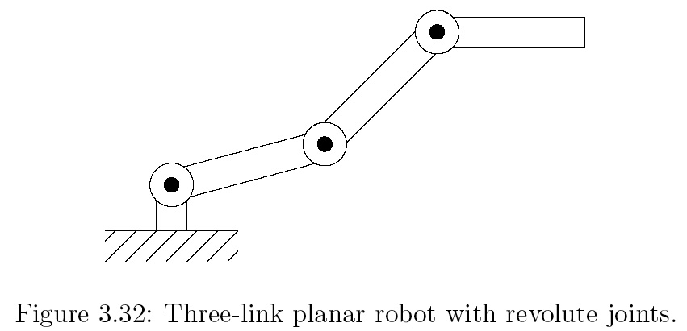

* indicates variable

|  |  |  |  |  |
| --- | --- | --- | --- | --- |
| Link | $$a_{i}$$ | $$α_{i}$$ | $$d_{i}$$ | $$θ_{i}$$ |
|  |  |  |  |  |
|  |  |  |  |  |
|  |  |  |  |  |



**ECE 5397/6397: Intro to Robotics**

**Class Worksheet – Preparation for Lecture 6**

For each: draw the coordinate frames, determine the DH parameters, and give the transformation matrix *Ai* and *T*

|  |  |  |  |  |
| --- | --- | --- | --- | --- |
| Link |  |  |  |  |
|  |  |  |  |  |
|  |  |  |  |  |

|  |  |  |  |  |
| --- | --- | --- | --- | --- |
| Link |  |  |  |  |
|  |  |  |  |  |
|  |  |  |  |  |
|  |  |  |  |  |

|  |  |  |  |  |
| --- | --- | --- | --- | --- |
| Link | $$a_{i}$$ | $$α_{i}$$ | $$d_{i}$$ | $$θ_{i}$$ |
|  |  |  |  |  |
|  |  |  |  |  |
|  |  |  |  |  |

