

**ECE 5397/6397: Intro to Robotics**

**Class Worksheet – Lecture 9** Inverse kinematics

Given a homogenous transformation: All solutions are in the powerpoint

$$H=$$

Find the solution of:

$$H=T_{n}^{0}\left(q_{1},…,q_{n}\right)=$$

Why is inverse kinematics hard?

1. May or may not have ____________________
2. Even if solution exists, may or may not _____________
3. Because forward kinematics is generally _____________________, solutions can be hard to obtain even if they exist

Why close form?

1. Much ___________
2. Iterative search _____________
3. Kinematics has

$o=o_{c}^{0}+d_{6}R\left[\begin{matrix}0 \\ 0 \\ 1\end{matrix}\right]$ ___________

, **solve for $o_{c}^{0}$**

$o={\left[o_{x},o_{y},o_{z}\right]}^{T},o_{c}={\left[x_{c},y_{c},z_c\right]}^{T},$**solve $o_{c}$**

If $R=R_{3}^{0}R_{6}^{3}$, **Solve $R_{6}^{3}=$**

**General idea to solve for $q_{i}$:**

1. Project manipulator onto________________
2. Solve a ‘simple’ _______________

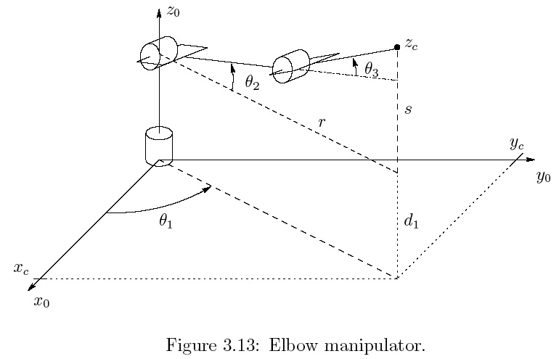



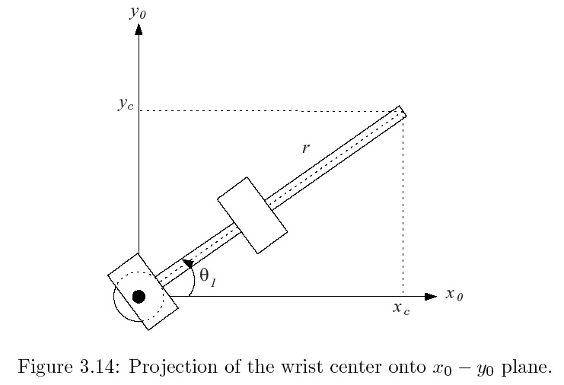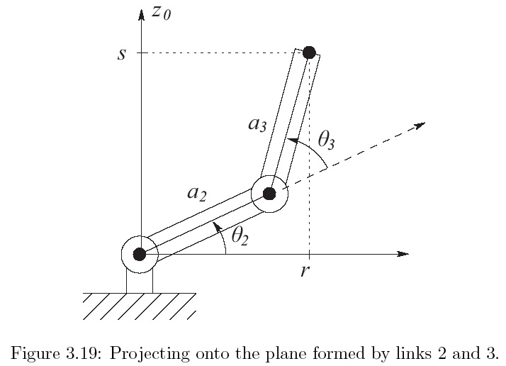

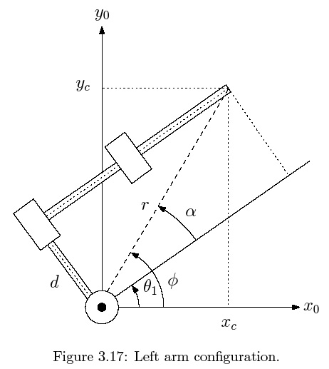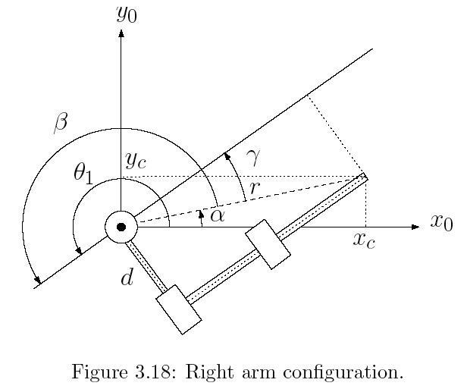



**ECE 5397/6397: Intro to Robotics**

**Class Worksheet – Preparation for Lecture 10**

­ 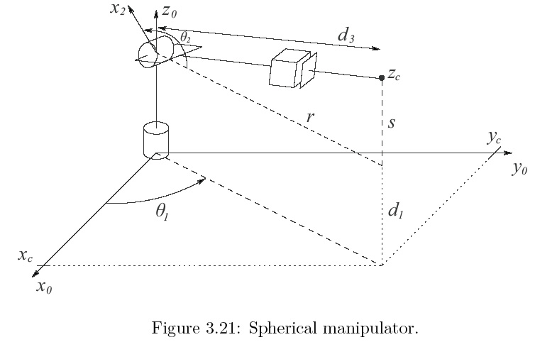

1. **Solve** for the following quantities. Draw them on the image above

$$r =\sqrt{x_{c}^{2}+y_{c}^{2}}$$

$$s =z_{c}-d_{1}$$

$$θ_{1}=Atan2(x_{c}, y_{c})$$

Alternate solution, $θ_{1}=π+Atan2(x_{c}, y_{c})$

$$d_{3}=\sqrt{r^{2}+s^{2}}$$

1. [due later] **Implement forward kinematics** on your MeARM robots. Try to pick something up. Take a video – (or image) and post it to #controlSwarm. If you can’t get twitter, upload to YouTube

Sign when completed _________________________________________________________