

**ECE 5397/6397: Intro to Robotics**

**Class Worksheet – Lecture 12** The manipulator Jacobian

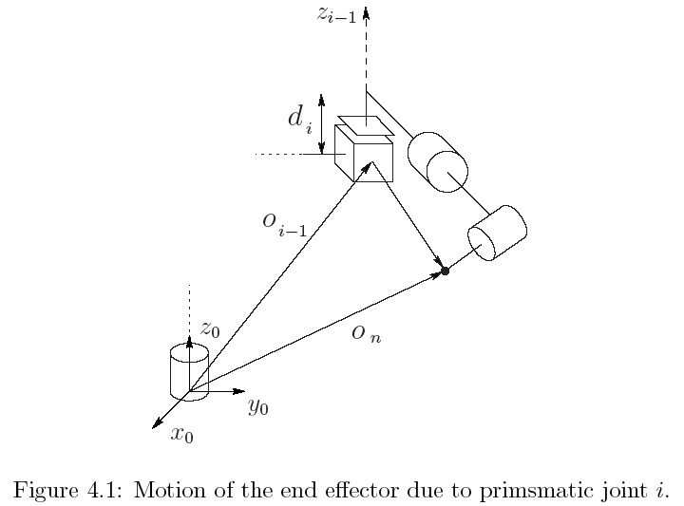

$ξ=J(q)\dot{q}$ note: $z_{i}$ implies $z_{i}^{0}$

$$\left[\begin{matrix}v_{n}^{0} \\ ω_{n}^{0}\end{matrix}\right]=\left[\begin{matrix}J_{v}(q) \\ J_{ω}(q)\end{matrix}\right]\left[\begin{matrix}{\dot{q}}_{1} \\ ⋮ \\ {\dot{q}}_{n}\end{matrix}\right]$$

upper half: $J_{v}=\left[\begin{matrix}J_{v_{1 }} & … & J_{v_{n }}\end{matrix}\right]$

$$J_{v_{i}}=\left\{\begin{matrix}z_{i-1}×\left(o_{n}-o_{i-1}\right) & for revolute joint i \\ z_{i-1} & for prismatic joint i\end{matrix}\right.$$

lower half:

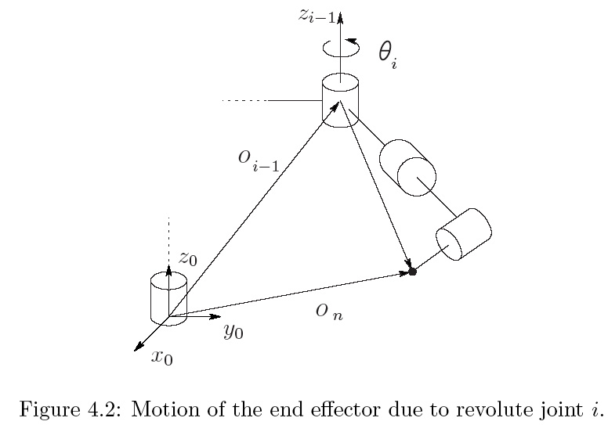

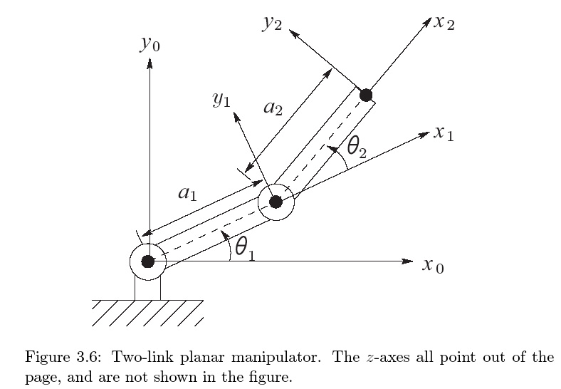

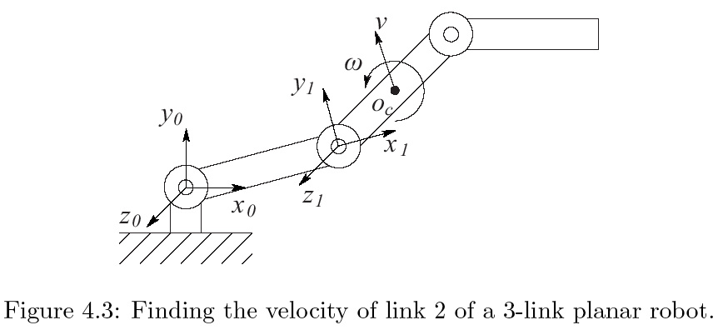

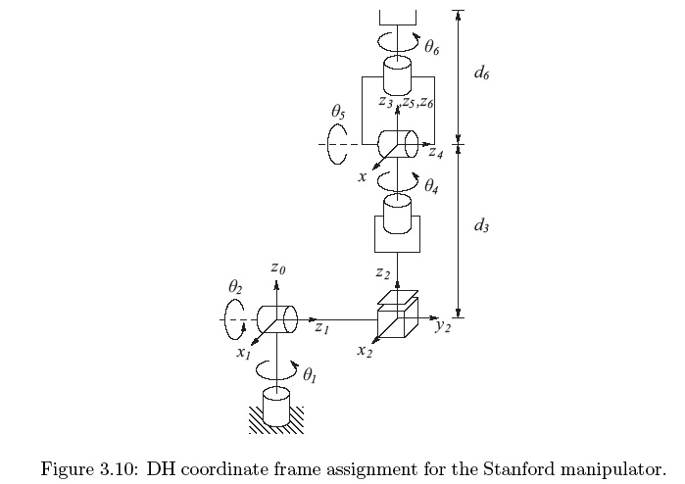

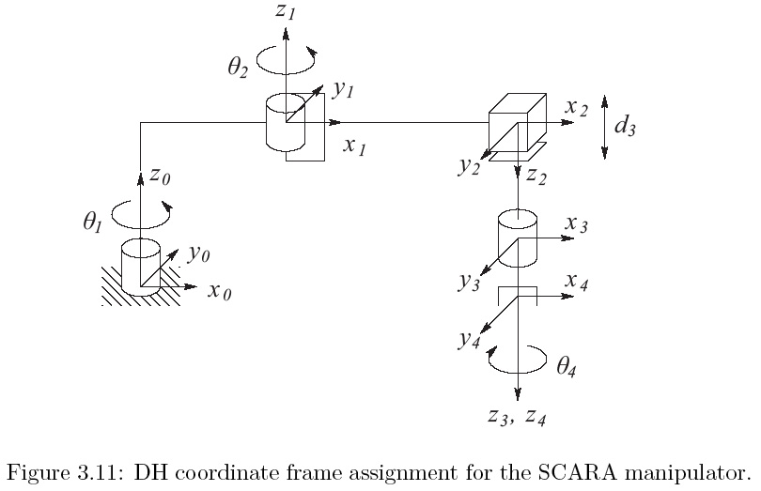



**ECE 5397/6397: Intro to Robotics**

**Class Worksheet – Preparation for Lecture 13**

­

1. **For the three-link planar manipulator of Example 4-6, compute the vector oc and derive the manipulator Jacobian matrix**

$T_{1}^{0}=\left[\text{⁠}\begin{matrix}c_{1} & -s_{1} & 0 & a_{1}c_{1} \\ s_{1} & c_{1} & 0 & a_{1}s_{1} \\ 0 & 0 & 1 & 0 \\ 0 & 0 & 0 & 1\end{matrix}\right]$ $T_{2}^{0}=\left[\text{⁠⁠}\begin{matrix}c_{12} & -s_{12} & 0 & a_{1}c_{1}+a_{2}c_{12} \\ s_{12} & c_{12} & 0 & a_{1}s_{1}+a_{2}s_{12} \\ 0 & 0 & 1 & 0 \\ 0 & 0 & 0 & 1\end{matrix}\right]$

$$T_{3}^{0}=\left[\text{⁠⁠}\begin{matrix}c_{123} & -s_{123} & 0 & a_{1}c_{1}+a_{2}c_{12}+a_{3}c_{123} \\ s_{123} & c_{123} & 0 & a_{1}s_{1}+a_{2}s_{12}+a_{3}s_{123} \\ 0 & 0 & 1 & 0 \\ 0 & 0 & 0 & 1\end{matrix}\right]$$

$$a_{2}$$

$$a_{1}$$

$$J=\left[\text{⁠⁠}\begin{matrix}z_{0}×(o_{c}-o_{0}) & z_{1}×(o_{c}-o_{1}) & 0 \\ z_{0} & z_{1} & 0\end{matrix}\right]$$

$$z_{0}=z_{1}=\left[\begin{matrix}0 \\ 0 \\ 1\end{matrix}\right],o_{0}=\left[\begin{matrix}0 \\ 0 \\ 0\end{matrix}\right],o_{0}=\left[\begin{matrix}a_{1}c_{1} \\ a_{1}s_{1} \\ 0\end{matrix}\right],o_{c}=\left[\begin{matrix}a_{1}c_{1}+a_{2}c_{12} \\ a_{1}s_{1}+a_{2}s_{12} \\ 0\end{matrix}\right]$$

$$J=\left[\text{⁠⁠}\begin{matrix}-a1s_{1}-a2s_{12} & -a2s_{12} & 0 & \\ a1c_{1}+a2c_{12} & a2c_{12} & 0 & \\ 0 & 0 & 0 & \\ 0 & 0 & 0 & \\ 0 & 0 & 0 & \\ 1 & 1 & 0 & \end{matrix}\right]$$