

**ECE 5397/6397: Intro to Robotics**

**Class Worksheet – Preparation for Lecture 20**

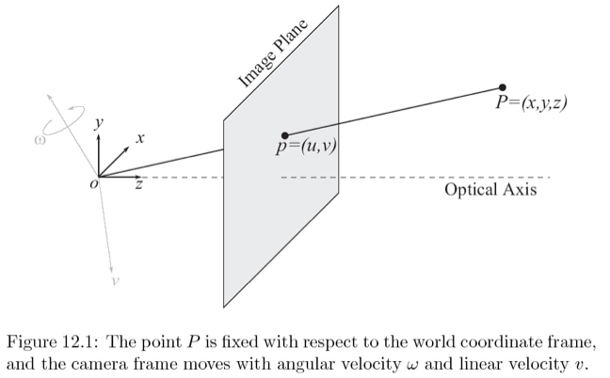

Give an expression for the interaction matrix for two points, $p_{1}$ and $p_{2}$ that satisfies $\left[\begin{matrix}u_{1} \\ v_{1} \\ u_{2} \\ v_{2}\end{matrix}\right]=Lξ$

in which $\left(u_{1},v_{1}\right)$ and $\left(u_{2},v_{2}\right)$ are the image coordinates of the projection of $p_{1}$ and $p_{2}$, respectively, and $ξ$ is the velocity of the moving camera.