

**ECE 5397/6397: Intro to Robotics**

**Class Worksheet – Preparation for Lecture 22**

Describe the configuration space for the robots below:

1. Robot that can translate and rotate in the plane

2.

3.

4. ­

5.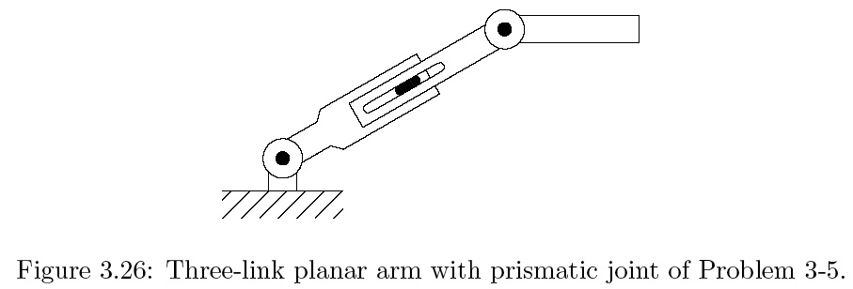

6. 