

**ECE 5397/6397: Intro to Robotics**

**In-Class Handout –Lecture 21: “The Sweetest Lecture”**

Define a square:

To a classmate, explain the difference between a square and a rectangle. (use the word subset)

Draw a sphere.

Add lines of latitude and longitude

Draw a torus. Draw lines, like latitude

and longitude, that assign a tuple (θ,φ)

to a coordinate on the torus

What is the configuration space of a spherical manipulator?

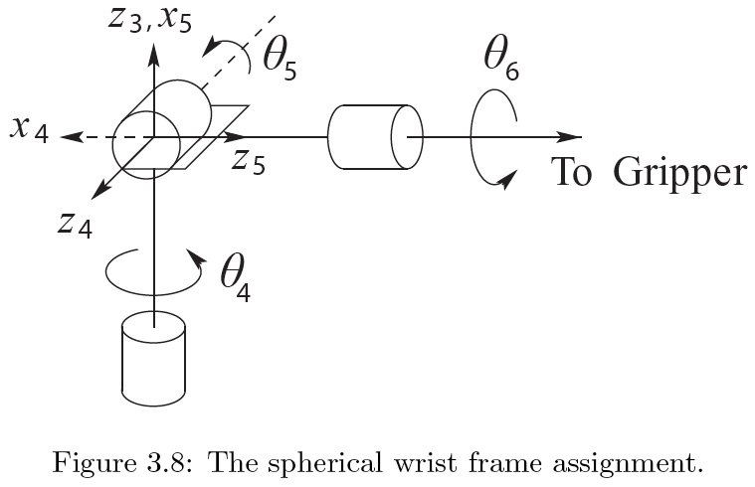



**ECE 5397/6397: Intro to Robotics**

**Class Worksheet – Preparation for Lecture 22**

Derive the equations needed to compute the shortest distance from a point *p* to the line segment in the plane with vertices v1 and v2. Remember there are 3 cases!



**ECE 5397/6397: Intro to Robotics**

**Anonymous feedback form**

1. Was the exam fair?  If not, what could be improved?
2. Was the test too long?
3. Were any questions ‘trick’ questions?
4. Should a different type of question be used?
5. How could the review session have helped more?
6. How could the assignments be improved?
7. How can the class material be improved?

* {Lecture slides,
* Blackboard,
* Homework solutions,
* Quizzes,
* Online Videos}

1. How could the lectures be improved?  Be specific.  Would an emailed outline before class help?  Should homework solutions be reserved for office hours? Are any current techniques working and should be continued?