

**ECE 5397/6397: Intro to Robotics**

**Class Worksheet – Preparation for Lecture 23**

Go to:

<http://demonstrations.wolfram.com/preview.html?draft/54742/000053/RobotConfigurationSpaceObstacles>

you may need to download a plugin, but this can work in your browser or you can download mathematica and run the source: <http://demonstrations.wolfram.com/data/draft/54742/000053/RobotConfigurationSpaceObstacles/RobotConfigurationSpaceObstacles-source.nb>

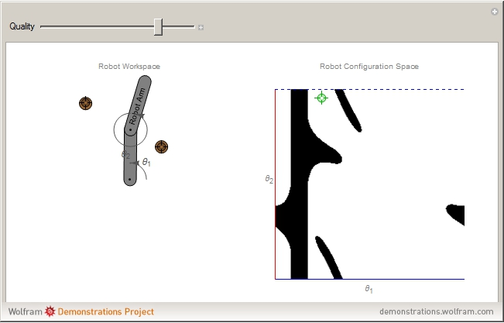

1. Setup the obstacles to trap the manipulator in part of the configuration space (an island of white). Print a screen shot.
2. Try to make the longest narrow passage possible (a thin sliver of white). Center this nicely in the configuration space. Print a screen shot.
3. Download the Matlab code for potential fields, PotentialFieldNavigation.m. Set the parameters so it does not converge. Print a screen shot.

<https://github.com/UH-ECE6397/Assignments/blob/master/PotentialFieldNavigation.m>