

Community Education

2015 UTICA CHIEFTAIN

YOUTH BASEBALL
TRYOUT PREPERATION SKILLS CAMP

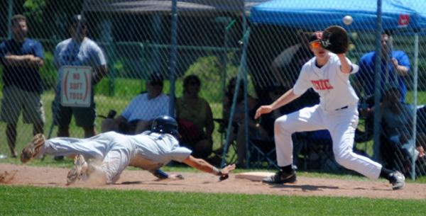
Date: | Friday, August 7, 2015
Location: | Utica High Baseball Field
Time: | 9:00 am-1:00 pm  #6097
Grades: | 4-9 (fall 2014)
Coaches: | Utica Baseball Staff
Fee: | $30

The Utica Chieftain baseball program is offering a one day skills camp to help players prepare for their upcoming travel baseball tryout. Details of the game will be taught to help them gain the edge and make the team! Skill sets in hitting, fielding, base-running and pitching will be covered. Skills sets ranging from beginner to expert are welcome.

To register by phone with a Visa, MasterCard or Discover, please call UCS Community Education at (586) 797- 6900, OR mail the completed application below (with your check payable to UCS) to Utica Community Schools, Community Education, 38901 Dodge Park Rd., Sterling Hts., MI 48312.
To register online visit www.ucscommunityeducation.com. NO REFUNDS

2015 UTICA YOUTH BASEBALL CAMP - #6097

Name

Address_____________________________City___________________________Zip

Home Phone _________________________ Work/Cell Phone

Shirt Size: YOUTH _____Large ADULT _____Small _____Medium _____ Large

E-mail address:

Last Grade Completed _____School__________________________ CASH___CHECK#

Visa/MC/Discover #_________________________________________________ EXP.DATE

CARDHOLDER’S NAME

CARDHOLDER’S ADDRESS

