DSE Notes
目录
38, Patterns in chemical world 2
Physical periodicity 2
General 2
Gradual change 2
Melting point 2
Electrical conductivity 3
Oxides of period III 3
Electronegativity 3
Period III oxides 4
Basic Oxides 4
Amphoteric oxide 4
Acidic oxides 4
Transition metals 5
Transition metals vs main group metals 5
colored ions 5
Variable oxidation states 6
Vanadium 7
Chromium 8
Catalytic property of transition metal 8
39, Chemical Kinetic 10
Rate Equations 10
Order of Reaction 10
Energy Profile 11
Arrhenius Equation 13

38, Patterns in chemical world

Physical periodicity

General
periodic table | arranged in | increasing atomic number
Group no | == | no. of OUTERMOST Shell electrons
period no. | == | no. of OCCUPIED electron shell

Gradual change
Metallic character ++ from left to right
Metals-> | semi-metals-> | non-metals-> | noble gases
giant metallic structure -> | giant covalent structure -> | simple molecular structure
metallic bond-> | covalent bond-> | covalent bond with van der Walls' force

Melting point
Li<Be, Na<Mg<Al
no. of delocalized electron | ++ | -> | metallic bond strength | ++
Li>Na, Be>Mg
size of metal cation | ++ | -> | metallic bond strength | --
Group 4 giant covalent structure |  | -> | strong covalent bond
group 5-0 simple molecular structure |  | -> | weak van der Waals' force
P4<S8>Cl2>Ar
Molecular size ++ | no. of electrons ++ | van der Waals’ force ++ | melting point ++

To melt an element with giant metallic structure
-> a lot of heat is needed to overcome attractive force between metal ions and 'sea of delocalized electrons
To melt an element with giant covalent structure
-> a lot of heat is need to break the covalent bonds between atoms
To melt an element with simple molecular structure
-> very little heat is needed to overcome the van der Waals’ forces and separate the molecules apart

Electrical conductivity
only group I - III | are conductors | giant metallic structure  has delocalized electrons for conducting electricity
Li<Be, Na<Mg<Al | no. of delocalized e-++ | electrical conductivity ++
B and Si | non-conductors at normal conditions | conductor when added with another element
graphite | is conductor | has delocalized e-
group 5-0 | are insulators | None delocalized e-

Oxides of period III

Electronegativity
power of the atom to attract bonding electrons in a covalent bond
Electronegativity | ++ across period | -- down a group
++ electronegativity diff | -> | ionic bond
-- electronegativity diff | -> | covalent bond

Period III oxides
Acidic | amphoteric | basic
giant ionic | giant covalent | simple molecular
++ no. of mole of oxygen combining with one mole of atom across the period

Basic Oxides
Na2O(s) + H2O(l) | -> | 2NaOH(aq) | vigorous reaction
Na2O(s) + 2HCl(aq) | -> | 2NaCl(aq) + H2O(l) | vigorous reaction
MgO(s) + H2O(l) | -> | Mg(OH)2(s) | react slightly and slowly
MgO(s) + 2HCl(aq) | -> | MgCl2(aq) + H2O(l)

Amphoteric oxide
Al2O3(s) + 3H2SO4(aq) | -> | Al2(SO4)3(aq) + 3H2O(l)
Al2O3(s) + 2NaOH(aq) + 3H2O(l) | -> | 2NaAl(OH)4(aq)

Acidic oxides
SiO2(s) + 2NaOH(aq) | -> | Na2SiO3(aq) + H2O(l) | SiO2 is insoluble in water but react slowly to form silicate
P4O10(s) + 6H2O(l) | -> | 4H3PO4(aq) | vigorous
P4O10(s) + CH3CONH2 | -> | CH3CN + H2O | P4O10 is a drying and dehydrating agent
SO2(g) + H2O(l) | -> | H2SO3(aq) | <--> | 2(H)+(aq) + (SO3)2-(aq)
SO2(g) + 2NaOH(aq) | -> | Na2SO3(aq) + H2O(l)
Cl2O(g) + H2O(l) | -> | 2HOCl(aq) | <--> | 2(H)+(aq) + 2(OCl)-(aq) | orange Cl2O react with water to give hypochlorous acid HOCl
NaOH(aq) + HOCl(aq) | -> | NaOCl(aq) + H2O(l) | NaOCl is hypochlorite salt, which are major ingredient in domestic bleach
Ca(OH)2(s) + 2HOCl(aq) | -> | Ca(OCl)2(aq) + 2H2O(l)

Transition metals

Transition metals vs main group metals
Located between group II and III
1 or 2 outermost shell electrons | -> | similar chemical properties with main group metal
e- in next inner shell contribute to sea of delocalized e- | -> | stronger metallic bond |  | higher melting point
 |  | harder |  | Higher conductivity
Properties: |  | exhibit variable oxidation states | act as catalysts | form coloured compounds

colored ions
Mn2+ | pale pink | V2+ | purple | Cr3+ | green
Mn3+ | red | V3+ | green | (CrO4)2- | yellow
(MnO4)2- | green | Co2+ | pink | (Cr2O7)2- | orange
(MnO4)- | purple | Cu2+ | blue | Ti3+ | purple
Fe2+ | pale green | Cu+ | red | Ni3+ | green
Fe3+ | yellow

Variable oxidation states

both outermost and next inner shell e- can be involved in bonding |  |  |  |  | -> | variable oxidation states
Element | Sc | Ti | V | Cr | Mn | Fe | Co | Ni | Cu | Zn
O.N. |  | +1 | +1 | +1 | +1 | +1 | +1 | +1 | +1
 |  | +2 | +2 | [+2] | [+2] | [+2] | [+2] | [+2] | [+2]
 | [+3] | [+3] | [+3] | [+3] | +3 | [+3] | +3 | +3 | +3
 |  | [+4] | +4 | [+4] | +4 | +4 | +4 | +4
 |  |  | [+5] | +5 | +5 | +5 | +5 | +5
 |  |  |  | [+6] | +6 | +6
 |  |  |  |  | [+7]

element at end of above figure | have only one oxidation state
element in middle of above figure | have multiple oxidation states
+2 is the main oxidation state for second half of the series
+3 is the main oxidation state for first half of the series
lower oxidation state is found in: | simple ions
higher oxidation state is found in: | Covalent compounds | polyatomic ions
transition metal at highest oxidation state is a strong oxidizing agent
38,3,4,,Fe2+(aq) & Fe3+(aq)
Fe3+(aq) + e- | -> | Fe2+(aq)
Fe2+(aq) - e- | -> | Fe3+(aq)
38,3,5,,Mn2+(aq) & MnO2(s) & MnO4-(aq)
MnO4-(aq) + 8H+(aq) + 5e- | -> | Mn2+(aq) + 4H2O(l)
 |  | colourless
MnO4-(aq) + 2H2O(l) + 3e- | -> | MnO2(s) + 4OH-(aq)
 |  | blackish brown

Vanadium
VOX2X+(aq)+VOX3X-(aq)+2 HX+(aq)→VOX2X+(aq)+HX2O(l)
In acidic condition, the metavanadate ion in converted into yellow dioxovandium(V) ion
This is not a redox reaction because vanadium is in the +5 oxidation state in both VOX3X-and VOX2X+ions.
Green colour may be observed temporarily when the oxidation state of vanadium decreases from +5 to +4. This is simply caused by a mixture of the yellow (+5) and blue (+4) colours of the vanadium ions.
ZnX2+aq+2 eX-⇌Zns
VX3+aq+eX-⇌VX2+aq
VX3+→ VX2+ | +3 → +2 | Green → Violet
VOX2+aq+2 HX+aq+eX-⇌VX3+aq+HX2Ol
VOX2+→ VX3+ | +4 → +3 | Blue → Green
VOX2X+(aq)+2 HX+(aq)+eX-⇌VOX2+(aq)+HX2O(l)
VOX2X+→ VOX2+ | +5 → +4 | Yellow → Blue

VOX2X+ | +5 | Yellow
VOX2+ | +4 | Blue
VX3+ | +3 | Green
VX2+ | +2 | Violet (purple)

Chromium
Chromium exists in three common oxidation states |  | +2, +3, +6
+6 in both chromate and dichromate |  | CrOX4X2-(chromate), CrX2OX7X2-(dichromate)
Equilibrium between dichromate and chromate |  | CrX2OX7X2-(aq)+HX2O(l)⇌2 CrOX4X2-(aq)+2 HX+(aq)
Alkali shifts equilibrium to right |  | Removes HX+→ orange to yellow
Acid shifts equilibrium to left |  | Adds HX+→ yellow to orange
Reduction of dichromate in acid |  | CrX2OX7X2-(aq)+14 HX+(aq)+6 eX-→2 CrX3+(aq)+7 HX2O(l)
chromate | yellow | dichromate | orange | Chromium (III) | green

Catalytic property of transition metal
Catalyst changes rate | Forms intermediate compounds |  | Regenerated at the end
2 IX-aq+SX2OX8X2-aq→IX2aq+2 SOX4X2-aq

Colorless + Colorless → Brown + Colorless
Reaction between IX- and SX2OX8X2- is slow, but with FeX3+ is fast:
2 FeX3+(aq)+2 IX-(aq)→2 FeX2+(aq)+IX2(aq)
Fe²⁺ reduces peroxydisulfate:
2 FeX2+(aq)+SX2OX8X2-(aq)→2 FeX3+(aq)+2 SOX4X2-(aq)
If Fe²⁺ used → same result |  | Reaction order changed
Fe in Haber Process |  | NX2(g)+3 HX2(g)→450°C,250 atmFe2 NHX3(g)

Uses | Equation | Catalyst
Haber Process | NX2(g)+3 HX2(g)⇌2 NHX3(g) | finely divided iron
Contact Process (making sulphuric acid) | 2 SOX2(g)+OX2(g)⇌2 SOX3(g) | vanadium(V) oxide (V₂O₅)
Catalytic converter | 2 NO(g)+2 CO(g)⇌2 NX2(g)+2 COX2(g) | platinum or rhodium (Rh)
Decomposition of H₂O₂ | 2 HX2OX2(aq)→2 HX2O(l)+OX2(g) | manganese(IV) oxide (MnO₂)
Ziegler-Natta polymerization | n CHX2=CHX2→[-CHX2-CHX2X-]Xn | titanium(IV) chloride (TiCl₄) triethylaluminium Al(C₂H₅)₃
Catalytic hydrogenation | CHX2=CHX2+HX2→CHX3-CHX3 | Pt, Pd or Ni
Fuel cells | electrode + catalyst | Pt, Pd, Ni, Ru

Transition Metal | Applications
Scandium (Sc) | • additive to strengthen Al alloy  • high intensity lamps  • crude oil analysis
Titanium (Ti) | • spacecraft, airship  • dye and pigment (TiO₂: white)  • catalyst for Ziegler-Natta polymerization (TiCl₄)
Vanadium (V) | • additive to strengthen steel  • aluminium-titanium-vanadium alloy • catalyst for Contact Process (V₂O₅)
Chromium (Cr) | • electroplating (e.g. car bumper)  • stainless steel (steel + Cr + Mn + Ni)  • as dye and pigment (PbCrO₄: yellow, Cr₂O₃: green)
Manganese (Mn) | • zinc-carbon cell (MnO₂)  • stainless steel (steel + Cr + Mn + Ni)  • duralumin (Al + Cu + Mg + Mn)
Iron (Fe) | • buildings and bridges  • steel (Fe + C)  • catalyst for Haber Process
Cobalt (Co) | • radiotherapy: γ ray source (Co-60)  • alloy for turbine blade  • positive electrode of Lithium-ion rechargeable cell (CoO₂)
Nickel (Ni) | • catalyst for hydrogenation  • stainless steel (steel + Cr + Mn + Ni)  • electrode for fuel cell  • Ni-MH rechargeable cell (or old Ni-Cd rechargeable cell)
Copper (Cu) | • electrical wires and cables  • water taps and pipes  Alloy, brass (Cu+Zn), bronze(Cu+Sn), cupronickel(Cu+Ni)
Zinc (Zn) | • galvanizing  • zinc-carbon cell  • alloy, brass (Cu+Zn)  • day and pigment

39, Chemical Kinetic

Rate Equations
Section | Key Words
1 Review | • average rate  • instantaneous rate  • initial rate (special case)  • measured by experiment only  • factors: temperature, concentration, surface area, catalyst, pressure
2 Differential Rate Equation | • reaction: aA + bB → cC + dD  • rate = k [A]ᵡ [B]ʸ  • k = rate constant, temperature dependent  • larger k → higher rate  • [A] = concentration of A  • x = order w.r.t. A  • y = order w.r.t. B  • x, y = 0, 1, 2 (DSE)  • x, y NOT related to a, b  • total order = x + y  • unit of k varies

Order of Reaction
Change in [A] | Effect on Rate | Order w.r.t. [A]
X2 | rate unchanged | 0
X2 | X2^1 | 1
X2 | X2^2 | 2

Energy Profile
• particles collide → react
• effective collision: correct orientation + enough speed
• only small fraction effective
• speed ∝ energy: ½mv²
• break old bonds → form new bonds
• minimum energy to start = activation energy (Eₐ)
• particles ≥ Eₐ → reaction starts
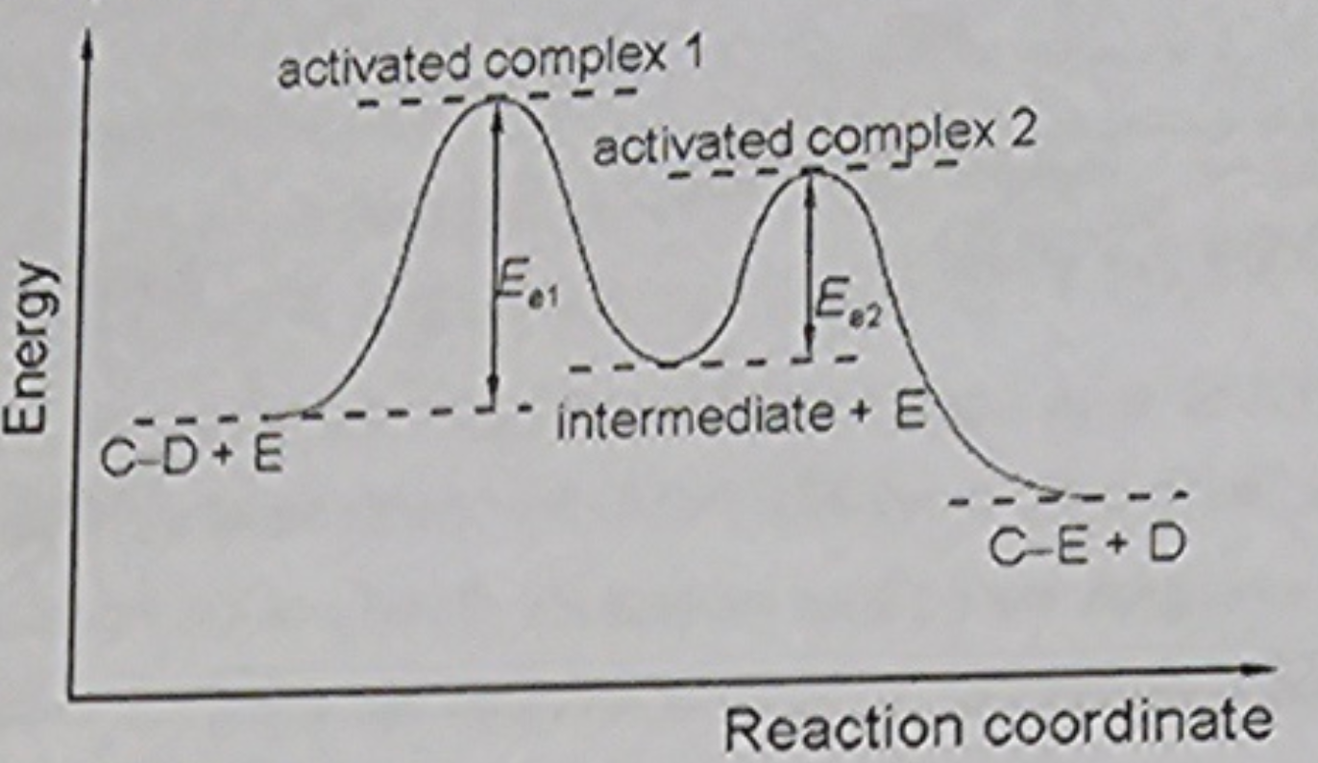
Rate-Determining Step
• highest Eₐ -> slowest step
• valley: intermediate (unstable)
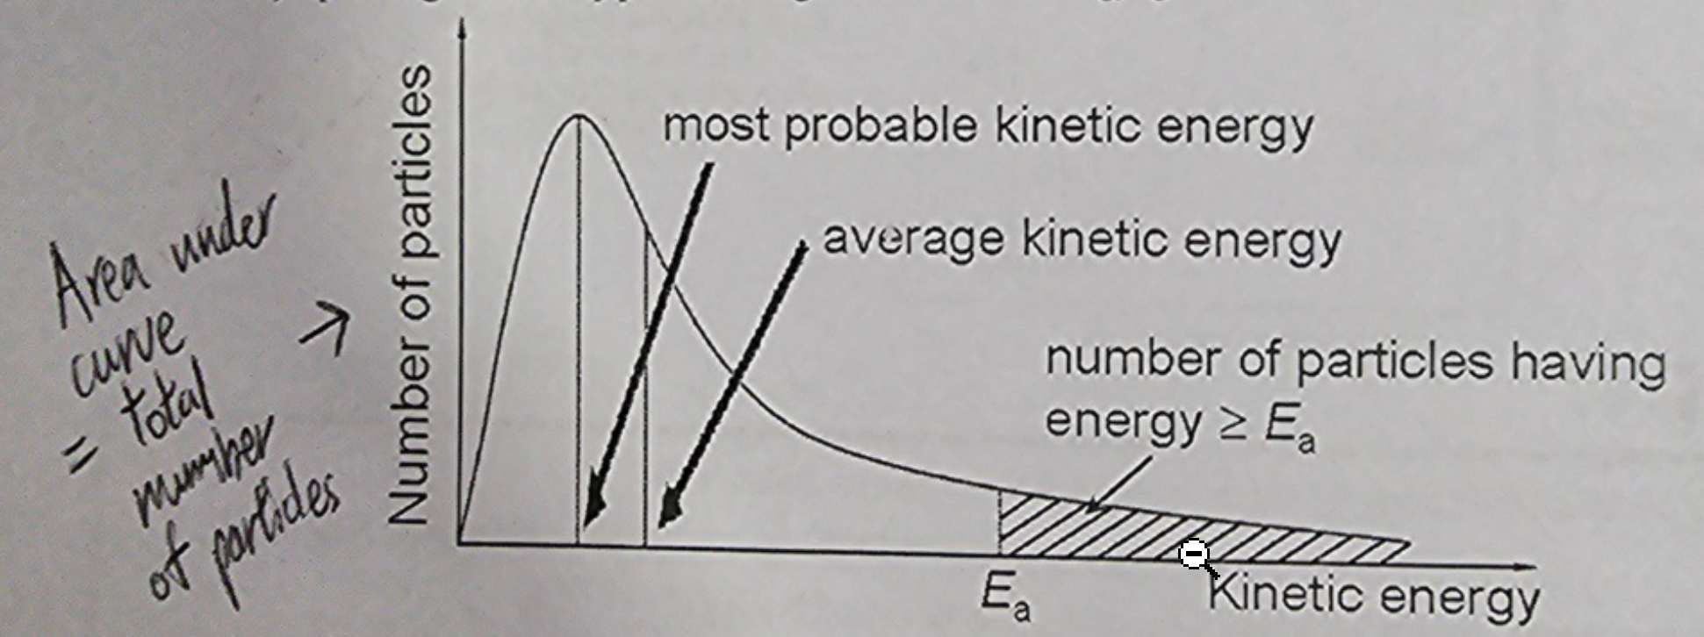
Maxwell-Boltzmann Distribution
• area = total particles
• continuous collision → energy transfer
• wide KE range
• plot: number vs KE → curve

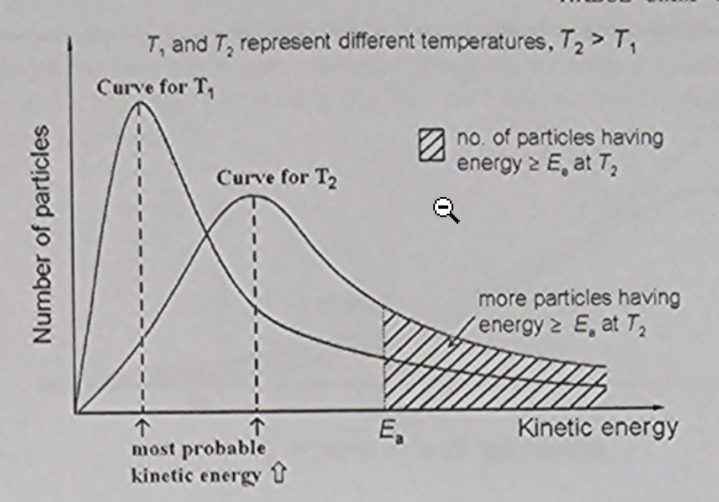
Temperature ↑
curve | shifts right, flattens
peak | lower, right
average KE | ↑
particles ≥ Eₐ | ↑ (shaded ↑)
effective collision | ↑
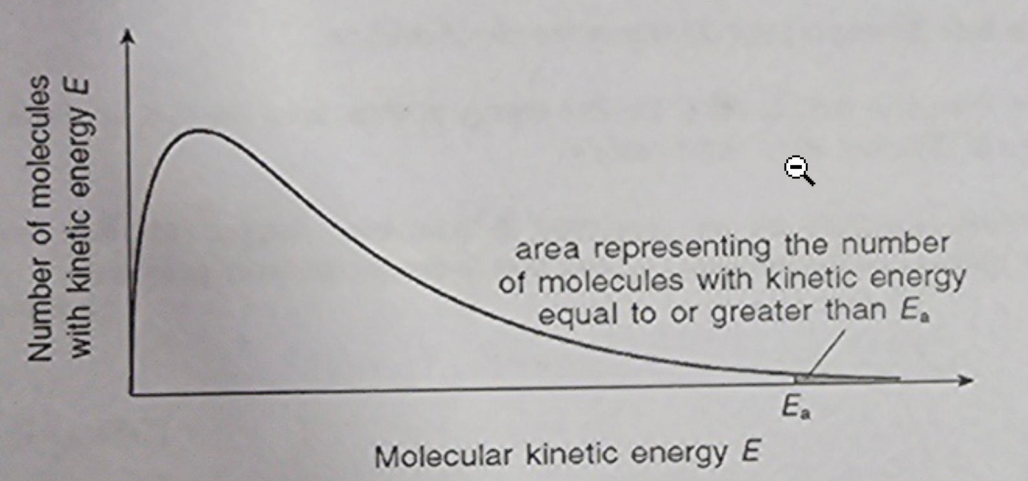
Temperature ↑
• average KE ↑
• molecules move faster
• collision frequency ↑
• effective collision ↑
• rate ↑

Arrhenius Equation
Equation
$$k=Ae^{-\frac{E_{a}}{RT}}$$
Log Form
$$ln⁡k=-\frac{E_{a}}{RT}+ln⁡A$$
$$log⁡k=-\frac{E_{a}}{2.3RT}+log⁡A$$
Symbol |  | Meaning
k |  | rate constant
A |  | collision factor
e |  | base of natural log
Eₐ |  | activation energy (J mol⁻¹)
R |  | 8.31 J K⁻¹ mol⁻¹
T |  | Kelvin
T ↑ | Eₐ/RT ↓ |  | e⁻(Eₐ/RT) ↑ | k ↑ | Rate ↑
T ↓ | Eₐ/RT ↑ |  | e⁻(Eₐ/RT) ↓ | k ↓ | Rate ↓
Numerical Method
• use two sets (k₁, T₁), (k₂, T₂)
• substitute → equations
• solve Eₐ
Formula
$$log⁡\frac{k_{2}}{k_{1}}=\frac{E_{a}}{2.3R}(\frac{1}{T_{1}}-\frac{1}{T_{2}})$$

Catalysis
• change rate
a) +ve: ↑ rate
b) –ve (inhibitor): ↓ rate
• unchanged at end
a) form unstable intermediate
b) regenerate
• small amount works
a) amount ↑ → rate ↑ → limit
b) solid: surface area ↑ → effect ↑ (e.g. porous Ni electrode)
• specific
a) MnO₂ > ZnO for H₂O₂(l)
• easily poisoned
a) Pb → Pt catalyst (converter)
b) S → hydrogenation catalyst
c) replaced often
Principle
+ catalyst: alternative pathway lower Eₐ
– catalyst: alternative pathway higher Eₐ
Reversible Reactions
• + catalyst ↑ forward & backward rates • shorter time to equilibrium • no effect on position • K unchanged (temperature fixed)
Homogeneous | Heterogeneous
reactants, products, catalyst same phase  e.g.  • Fe³⁺ / Fe²⁺: 2I⁻ + S₂O₈²⁻ → I₂ + 2SO₄²⁻  • 2Fe³⁺ + 2I⁻ → 2Fe²⁺ + I₂  • 2Fe²⁺ + S₂O₈²⁻ → 2Fe³⁺ + 2SO₄²⁻  • ions opposite charges react faster  • Fe³⁺ regenerated, not consumed | reactants, products, catalyst different phases (usually solid catalyst)  e.g.  • finely divided Fe: Haber (N₂ + 3H₂ ⇌ 2NH₃)  • V₂O₅: Contact (2SO₂ + O₂ ⇌ 2SO₃)  • Ni: alkene hydrogenation reactants adsorb on surface, weaken bonds

Industrial Applications
i Haber Process
• advantages: shorten time
• lower T & P → cut cost
ii Alcohol Production
• enzyme from yeast catalyst
• fermentation: fruits/crops (grapes, wheat, barley, maize)
• max [ ] ≤ 15% (yeast dies)
Equations
• sucrose: C₁₂H₂₂O₁₁ + H₂O → C₆H₁₂O₆ + C₆H₁₂O₆ (invertase in yeast)
• glucose: C₆H₁₂O₆ → 2C₂H₅OH + 2CO₂ (zymase in yeast)
d Enzyme pH
• sensitive to pH
• optimum ~7
• denature away from optimum
e Enzyme Temperature
• sensitive to T
• optimum body T
• denature 60–70°C

