“Detroit Capital Flows_Trends”

**Figures 4, 5, and 8:** I would add a white dropshadow to the neighborhood labels as they are hard to read, especially when the black text is over darker colored districts. I’d also make the font “Lato” to match urban styles, if possible.

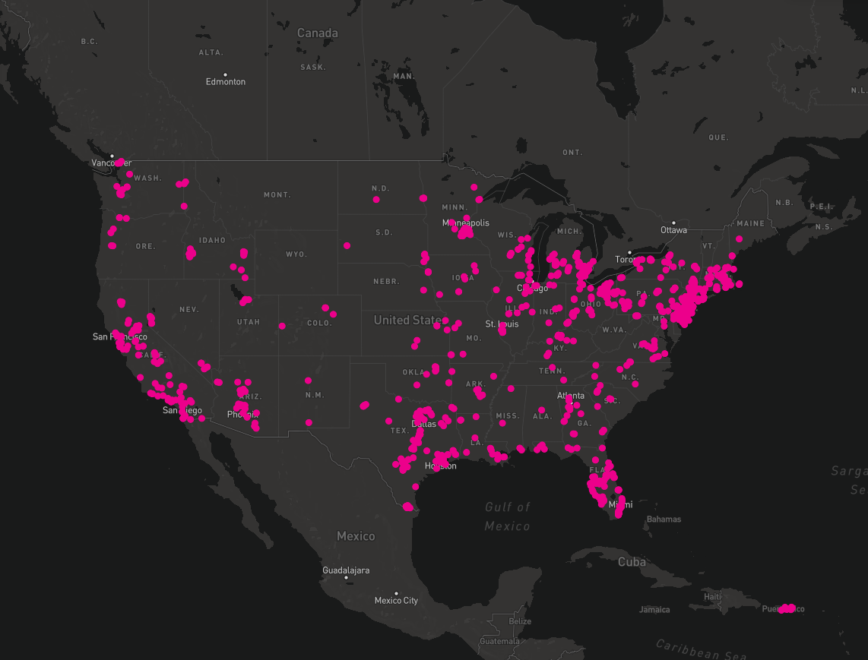**Figures 13, 15, and 17**: I’m wondering if you want to set the opacity to semi-opaque, or have the fill transparent but set a stroke to each circle, that way you can see where dots overlap. That might add some depth to your map whereas right now there are clusters of dots but we don’t see just how dense these clusters are. Here’s an example of something that I recently did, where the dots are set to 100% opaque in the first graph and 40% in the second. 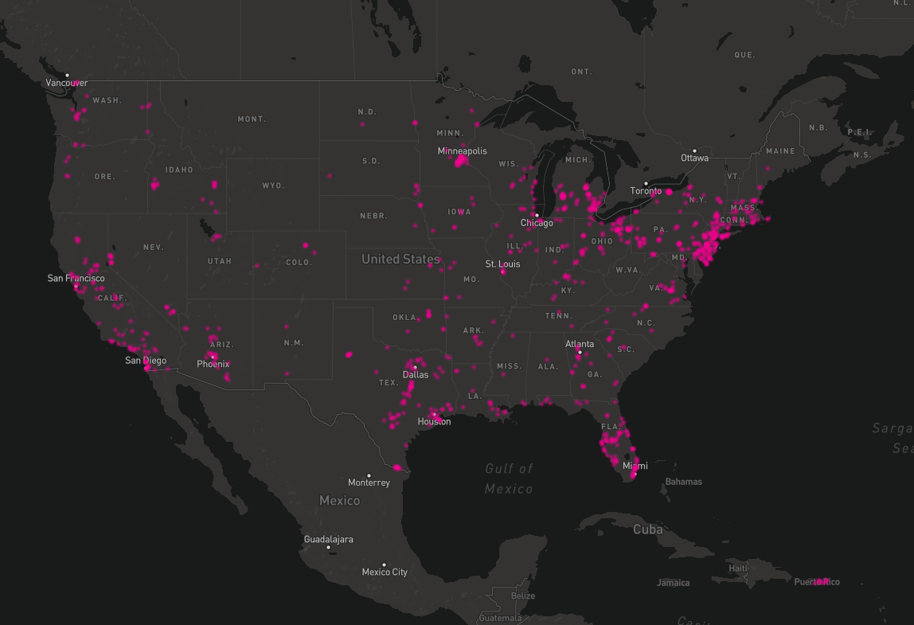It easier to see where clusters are forming if the dots are layered on top of each other.

“Detroit Capital Flows_Mission Capital”

**Figure 2:** Why is the Federal line running from 2005-2011 only? The text above the graph says that Federal government programs contributed $71 million from 2008-2015 so I’m wondering why the years don’t match up.

**Figure 4:** I would add a white dropshadow to the neighborhood labels

**Figure 6:** This graph seems a bit difficult to understand at first glance, it may be clearer to show the change in lending from 2004 to 2015 and have three bars total instead of 6. Also the description doesn’t seem to match up because it says “Whereas 34 percent of mainstream and private lending went to the Central Business District, Lower Woodward, and Middle Woodward in 2004 to 2006” but the figure says 32%.