DEDAN KIMATHI UNIVERSITY OF TECHNOLOGY
SCHOOL OF BUSINESS
BACHELOR OF BUSINESS INFORMATION TECHNOLOGY (BBIT)
USER INTERFACE DESIGN AND INTERACTION
GROUP 8
ADAPTIVE STUDY PLANNER
Group Project Report
Balsamiq Wireframing • GitHub Collaboration • Usability Review • Iterative Revision
Third Year BBIT
Academic Year: 2026

GROUP MEMBERS
1.Jason Kanango C027-01-08/24
2.Paul Oenga C027-01-0918/24
3.Michael Njenga Kariuki C027-01-0896/24
4.Chris Ndei C027-01-0898/24
5.Sylvia Lwaya C027-01-08/24
6.Gloria Shiru C027-01-0873/24
7.Bernice Gitonga C027-01-0846/24
8.Mitchelle Njeri C027-01-2287/24
9.Yvonne Patience C027-01-0869/24
10.Ivy Githinji C027-01-0883/24
Prepared for submission and presentation
Date: ______________________________

PROJECT AT A GLANCE
Item | Group 8 Project
Project | Adaptive Study Planner Mobile Application
Group | Group 8
Programme | Bachelor of Business Information Technology (BBIT)
Year | Third Year
Primary design tool | Balsamiq
Collaboration/documentation | GitHub
Prototype scope | 12 mobile screens
Development approach | Three-week group workflow: screens → linking → usability review → revision
Main HCI emphasis | Consistency, visibility, feedback, user control, personalization, error prevention and mobile usability
EXECUTIVE SUMMARY
Group 8 designed an Adaptive Study Planner mobile application prototype as a practical Human–Computer Interaction project. The work was completed collaboratively in three stages. Week One focused on creating the application screens in Balsamiq and uploading the wireframes to GitHub. Week Two focused on linking the screens into an interactive prototype so that the individual screens formed usable navigation flows. Week Three focused on usability reviews, recording findings in GitHub, developing hypotheses from identified problems, and revising the affected screens.
The supplied Balsamiq screen set contains twelve named screens: Splash Screen, Login Screen, Dashboard, Add Course, Add Task, Study Schedule/Calendar, Task Details, Progress, Reschedule Task, Notifications, Profile and Settings. These screens form the core of the report and are referenced throughout the design, interaction and evaluation discussion.
The project demonstrates an iterative user-centered process rather than treating the first prototype as the final design. Where the group identifies a problem—for example, inconsistent icons on the dashboard—the member responsible for the affected screen revises it, pushes the update to GitHub, and the prototype integrator links the revised screen into the updated project.
TABLE OF CONTENTS
1. Introduction
2. Project Background
3. Problem Statement
4. Aim and Objectives
5. Target Users
6. Proposed Adaptive Study Planner
7. Screen Inventory and Interface Description
8. HCI and Interaction Design Considerations
9. Tools and Collaboration
10. Group Work Allocation and Workflow
11. Week One: Screen Creation and GitHub Upload
12. Week Two: Wireframing and Prototype Linking
13. Week Three: Usability Review
14. Usability Testing Tasks and Evidence
15. Review, Hypothesis and Revision Process
16. GitHub Documentation and README
17. Challenges and Lessons Learned
18. Final Deliverables and Quality Checklist
19. Conclusion
20. Recommendations
References
Appendices

1. INTRODUCTION
Human–Computer Interaction (HCI) is concerned with how people interact with digital systems and how interfaces can be designed to make those interactions clear, efficient and satisfying. For this group project, Group 8 applied HCI and user interface design principles to a mobile study-planning problem.
The chosen solution was an Adaptive Study Planner. The prototype is designed around common university study activities such as managing courses, creating study tasks, scheduling study sessions, viewing task details, tracking progress, receiving notifications, rescheduling missed work, and managing personal reminder settings.
The project was carried out as a group. Individual members created assigned screens, a member integrated and linked the screens, other members reviewed the interactive prototype, and the group used the review results to guide hypotheses and revisions. GitHub was used to preserve the project's work and evidence throughout the process.
2. PROJECT BACKGROUND
University students frequently have several courses, assignments, study sessions and deadlines to manage at the same time. A study planner can help bring these activities into one organized mobile interface.
Group 8's prototype reflects this need through a sequence of twelve screens. The design begins with onboarding and authentication, moves to the student dashboard, supports course and task creation, provides a study calendar and task details, and then provides progress, rescheduling, notifications, profile and reminder settings.
The screen set supplied by the group shows a coherent mobile navigation concept with a repeated bottom navigation structure across the main application screens. This supports the project's goal of making the prototype understandable as a mobile application rather than as unrelated static wireframes.
3. PROBLEM STATEMENT
Students may find it difficult to keep track of courses, academic tasks, study sessions, deadlines and progress when these activities are managed separately. The project therefore addresses the problem of designing a mobile interface that brings these activities together while remaining simple enough for students to navigate and use.
Problem question: How can an adaptive mobile Study Planner help university students organize academic tasks, schedule study activities, monitor progress, and recover from missed study sessions through a clear and usable interface?
4. AIM AND OBJECTIVES
Aim: To design and evaluate an interactive Adaptive Study Planner mobile prototype using Balsamiq and an iterative HCI process.
Specific Objectives
- Create the required mobile interface screens in Balsamiq.
- Upload the screens and supporting evidence to GitHub.
- Link the screens into an interactive prototype.
- Demonstrate realistic navigation and task flows through the prototype.
- Conduct usability reviews using realistic mobile tasks.
- Record task completion, errors, difficulties and user comments.
- Document usability findings in the GitHub research directory.
- Develop hypotheses from the identified usability issues.
- Revise the responsible screens based on the hypotheses and review findings.
- Relink the revised screens into an updated prototype.
- Maintain a clear README and GitHub evidence of group contributions.
- Prepare a final report and presentation.
5. TARGET USERS
- University students managing several courses.
- Students who need to create and prioritize academic tasks.
- Students who need a calendar or schedule for study sessions.
- Students who want to monitor completed and pending work.
- Students who need reminders for academic activities.
- Students who occasionally miss study sessions and need to reschedule them.
6. PROPOSED ADAPTIVE STUDY PLANNER
The Adaptive Study Planner is represented as a mobile application that guides a student from entry into the application to day-to-day academic planning and monitoring.
Area | How it appears in the supplied prototype
Entry | Splash Screen followed by Login Screen.
Main workspace | Dashboard with a welcome area, study information and bottom navigation.
Course management | Add Course screen with Course Name, Course Code, Lecturer and Semester fields.
Study task management | New Study Task screen with Title, Course, Due Date, Priority and optional Notes.
Scheduling | Study Schedule/Calendar screen for date-based planning.
Task monitoring | Task Details screen with due date, priority, description and subtasks.
Progress | My Progress screen with overall progress, completed/pending tasks, study streak, hours studied and progress history.
Adaptation | Reschedule Task screen with current due date, new due date and optional reason.
Communication | Notifications screen with All/Unread filtering and notification entries.
Personalization | My Profile and Reminder Settings screens for personal and reminder preferences.
7. SCREEN INVENTORY AND INTERFACE DESCRIPTION
The following descriptions are based directly on the twelve screens supplied by Group 8. The figures are included later in this report so that the written analysis can be checked against the visual prototype.
No. | Screen | Visible content | Purpose in the interaction
1 | Splash Screen | StudyPlanner branding, short tagline, Get Started control and onboarding indicators. | Introduces the product and provides the entry point.
2 | Login Screen | Welcome back message, email and password fields, remember-me option, password recovery, Login and Create Account controls. | Provides user authentication and account entry.
3 | Dashboard | Student welcome area, upcoming study information and bottom navigation for Home, Calendar, Tasks, Progress and Profile. | Acts as the main navigation and overview screen.
4 | Add Course | Course Name, Course Code, Lecturer, Semester and Save Course. | Allows a student to create a course record.
5 | Add Task Screen | Title, Course, Due Date, Priority options, optional Notes and task submission control. | Allows creation of a new study task.
6 | Study Schedule/Calendar | Date navigation and time/date blocks, plus the application's bottom navigation. | Supports schedule viewing and study-session planning.
7 | Task Details Screen | Task title, due date, priority, description, subtasks and Mark as Completed control. | Allows the student to inspect and complete a task.
8 | Progress Screen | Overall Progress, Completed Tasks, Pending Tasks, Study Streak, Hours Studied and View Progress History. | Communicates study performance and progress.
9 | Reschedule Task Screen | Task title, current due date, new due date, optional reason and Reschedule Task control. | Supports adaptation when a planned task must be moved.
10 | Notifications Screen | Notifications heading, All/Unread filters and notification entries. | Presents study-related notifications.
11 | Profile Screen | My Profile, user name, My Courses, Study Preferences, Reminder Settings, Change Password, Help & Support, About App and Log Out. | Provides account and preference management.
12 | Settings / Reminder Settings | Enable Reminders, Reminder Time, Daily Study Reminder and Weekly Summary controls, plus Save Settings. | Allows reminder preferences to be customized.
7.1 Complete Balsamiq Screen Set
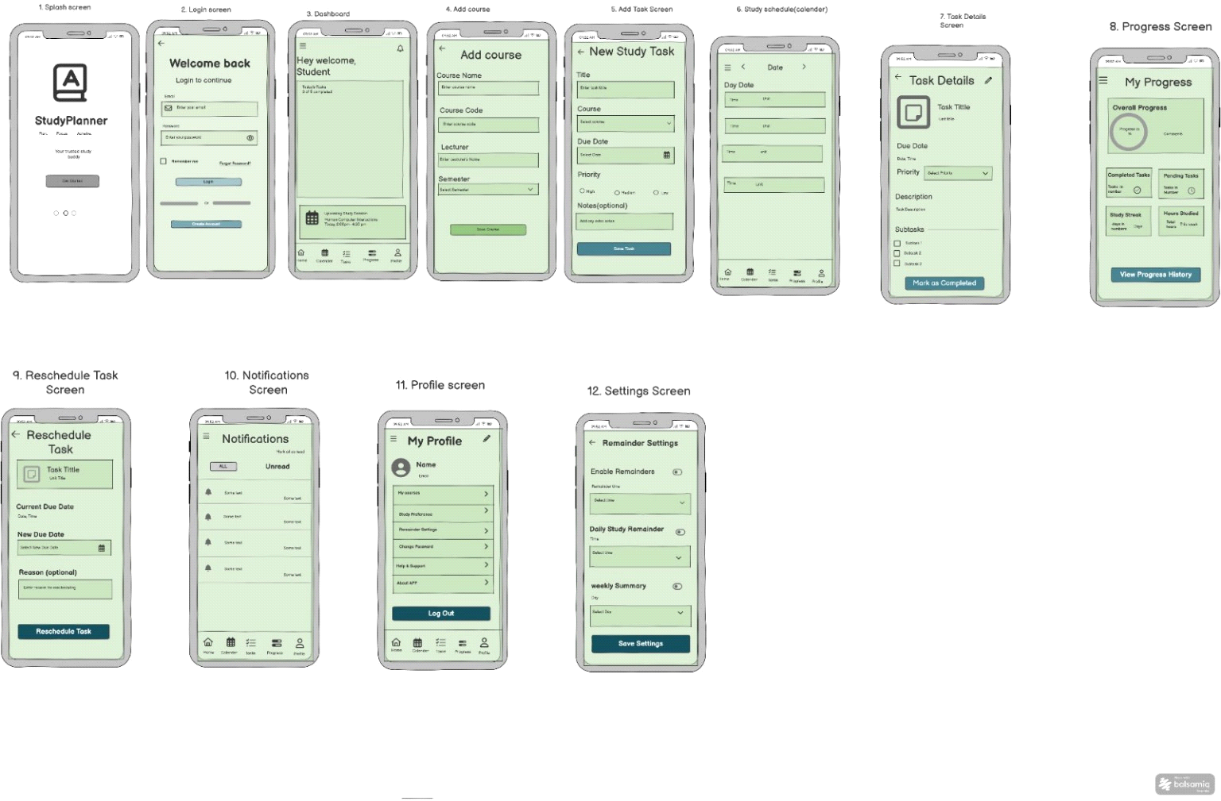
Figure 1. Group 8 Adaptive Study Planner – supplied Balsamiq screen compilation (12 screens).
Source: Balsamiq screen compilation supplied by Group 8 for this report.

7.2 Individual Screen Figures
- Splash Screen  - 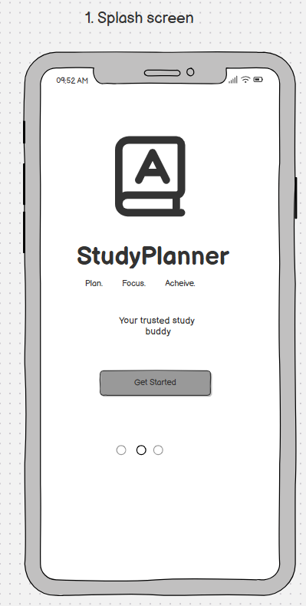 | - Login Screen  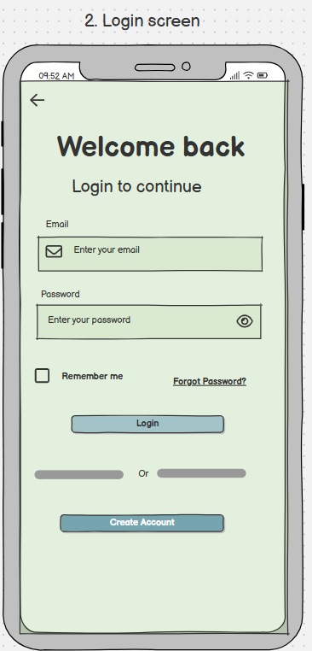

Entry and authentication establish the beginning of the user journey.

7.2 Individual Screen Figures
- Dashboard  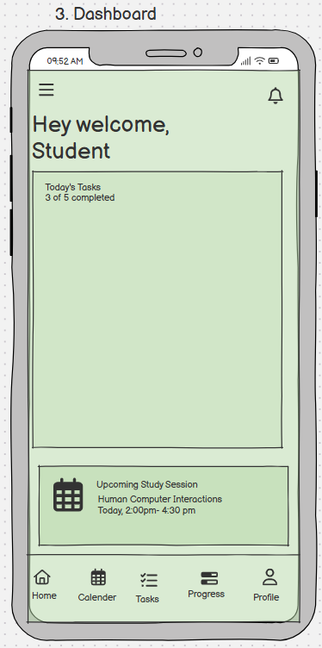 | - Add Course  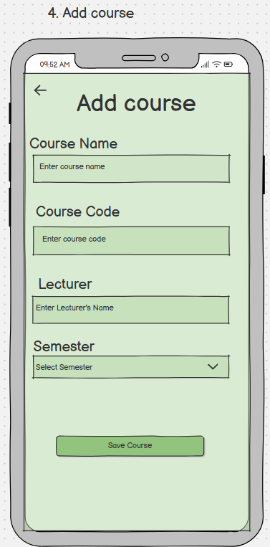

The dashboard becomes the central hub after login.

7.2 Individual Screen Figures
5. Add Task Screen  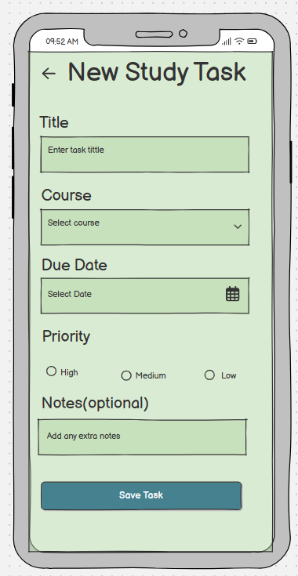 | 6. Study Schedule / Calendar  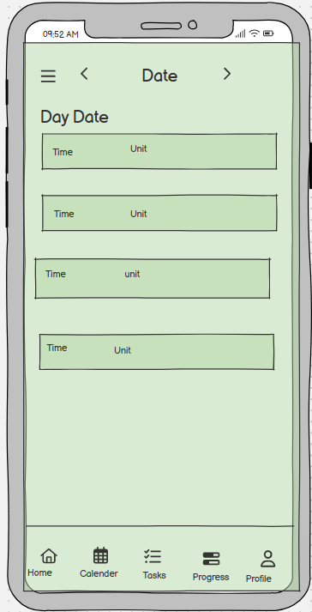

Course and task creation turn the planner into an actionable academic tool.

7.2 Individual Screen Figures
7. Task Details Screen  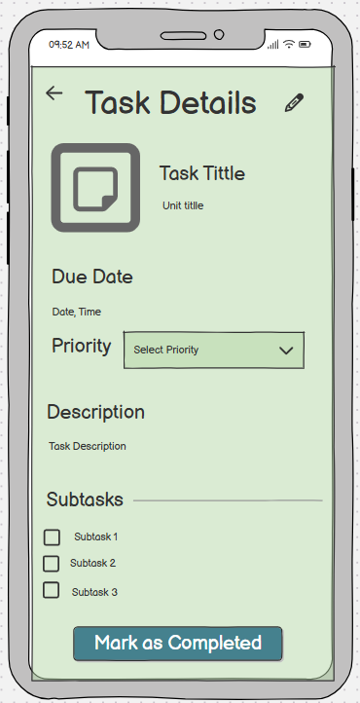 | 8. Progress Screen  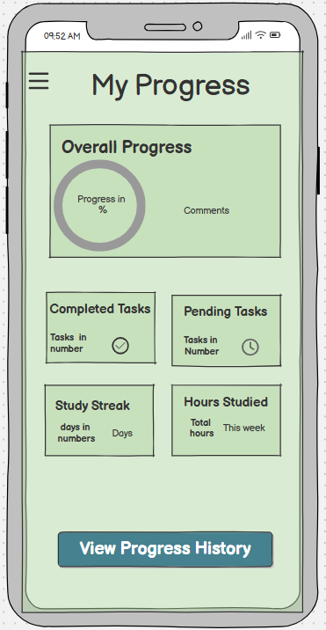

Scheduling and task details connect planning with day-to-day execution.

7.2 Individual Screen Figures
9. Reschedule Task Screen  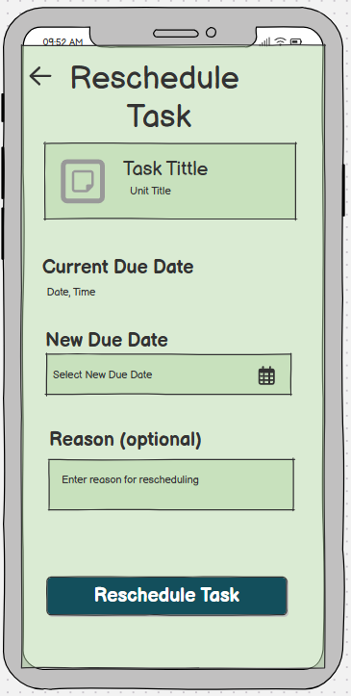 | 10. Notifications Screen  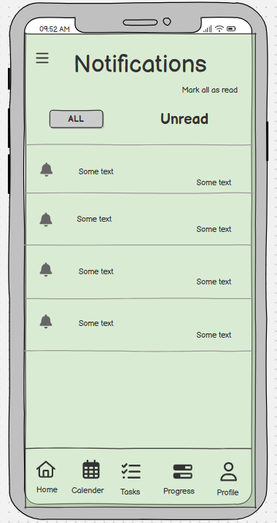

Progress and rescheduling support adaptation when study plans change.

7.2 Individual Screen Figures
11. Profile Screen  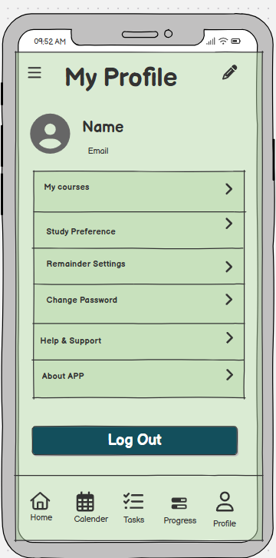 | 12. Settings / Reminder Settings  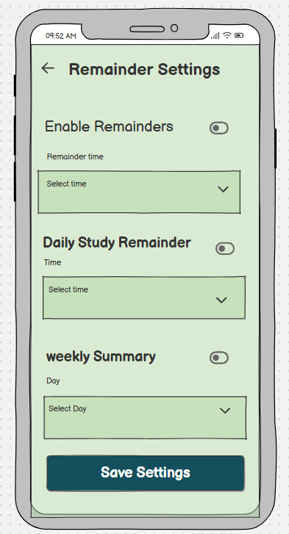

Notifications, profile and settings support communication and personalization.
8. HCI AND INTERACTION DESIGN CONSIDERATIONS
Consistency
The supplied screens use a repeated visual language, including light green interface areas, rectangular form controls, blue action buttons and recurring bottom navigation on main application screens. During review, the group should check that icons, button styles, spacing and labels remain consistent across all screens.
Visibility and recognition
Key actions such as Save Course, task submission, Mark as Completed, Reschedule Task and Save Settings are visually separated from the form fields. Usability review should confirm that users can identify these actions without assistance.
Navigation
The Dashboard and main screens use bottom navigation for Home, Calendar, Tasks, Progress and Profile. This creates a persistent navigation structure for core areas.
Feedback and system status
The Progress screen gives visual information about overall progress, completed and pending tasks, study streak and hours studied. Notifications also provide a communication mechanism.
User control and adaptation
The Reschedule Task screen provides a current due date, new due date and optional reason, allowing a planned activity to be changed when necessary.
Personalization
The Profile and Reminder Settings screens provide access to study preferences and reminder controls, supporting individual user needs.
Error prevention
Form fields and selectable controls should be reviewed for clear labels and appropriate defaults. The usability review should record any field that users misunderstand or any action they attempt incorrectly.
Mobile usability
The prototype uses a smartphone-sized interface and touch-oriented controls. During testing, users should be observed for small targets, unclear icons, excessive steps and difficult navigation.
9. TOOLS AND COLLABORATION
Balsamiq
Balsamiq was the primary interface design and wireframing tool. In Week One, it was used to create the twelve application screens. In Week Two, the screens were linked to produce an interactive prototype.
GitHub
GitHub was used to store and coordinate the group's work. Screens were pushed to the repository, the linked project was shared for review, usability findings were added to the research directory, hypotheses were documented, revised screens were pushed, and the README was maintained.

Suggested Repository Structure
GROUP-8-ADAPTIVE-STUDY-PLANNER/
├── README.md
├── wireframes/
├── research/
│ ├── review.md
│ └── hypothesis.md
├── usability-testing/
├── iterations/
├── docs/
└── final/
10. GROUP WORK ALLOCATION AND WORKFLOW
The group organized the work as a sequence in which each stage depended on the previous one.
Stage | Responsibility | Expected Output
1. Screen creation | Assigned screen designers | All Balsamiq wireframe screens pushed to GitHub.
2. Prototype linking | Member responsible for integration | Linked Balsamiq prototype for Task 1.
3. Prototype review | Group members | Usability observations for Tasks 2 and 3.
4. Hypothesis | Assigned documentation/research members and reviewers | Hypotheses pushed to GitHub as Task 4.
5. Screen revision | Members responsible for affected screens | Corrected screens based on identified issues.
6. Prototype update | Integration member | Updated and relinked Balsamiq prototype.
7. Final documentation | Report/README/presentation team | Final report, README and presentation.
The agreed group instruction was: members first push all wireframe screens; the integration member links them; the linked project is circulated for review; reviewers add findings to the GitHub research/review file; hypotheses are written and pushed; screen owners then address the issues; the integration member collects the updates and relinks the prototype.
The group also planned for six members to concentrate on updating their screens while four members worked on the final report, README updates and presentation planning. This division should remain visible in GitHub contributions.
11. WEEK ONE: SCREEN CREATION AND GITHUB UPLOAD
Week One focused on creating the screens shown in Figure 1. Each member was responsible for assigned screens. The objective was to produce a complete set of mobile interface wireframes before interaction linking began.
Week One Outputs
- Twelve Balsamiq mobile screens.
- Initial screen-level interface designs.
- Initial GitHub commits and uploaded wireframes.
- README project and member information.
- Preparation for prototype integration.
12. WEEK TWO: WIREFRAMING AND PROTOTYPE LINKING
Week Two focused on turning the individual screens into a connected prototype. The integration member linked the screens so that a reviewer could move through the intended user journey instead of viewing disconnected images.
The main interaction flow can be understood as: Splash → Login → Dashboard → Add Course / Add Task / Study Schedule → Task Details → Progress / Reschedule → Notifications / Profile → Reminder Settings. The actual Balsamiq links should be verified in the final prototype before submission.
Once the linked project was shared, reviewers were instructed to open the prototype, select the 'Interact' option, and perform the assigned tasks. This allowed the group to evaluate the usability of the interaction rather than only the appearance of individual screens.
13. WEEK THREE: USABILITY REVIEW
Week Three focused on checking whether users could understand and complete realistic tasks using the linked prototype. The findings were to be uploaded to the GitHub research directory, specifically the review documentation used by the group.
The purpose of this stage was to discover problems that might not be visible while designing individual screens. Examples include unclear icons, inconsistent controls, difficult navigation, missing feedback, confusing labels, or difficulty finding a required function.
14. USABILITY TESTING TASKS AND EVIDENCE
The following task set is aligned with the twelve screens in the supplied prototype. It should be used to guide the actual review. The report does not invent participant results; actual completion, errors and comments should be copied from the group's GitHub review once finalized.
ID | Task | Main Screen | What to Observe | Actual Result
T1 | Start the app | Splash → Login | Can the user identify how to begin? | Completion / errors / comments: __________
T2 | Log in | Login Screen | Can the user identify the email, password and Login action? | Completion / errors / comments: __________
T3 | Reach the main dashboard | Dashboard | Can the user understand the dashboard and main navigation? | Completion / errors / comments: __________
T4 | Add a course | Add Course | Can the user enter course name, code, lecturer and semester and save it? | Completion / errors / comments: __________
T5 | Create a study task | Add Task | Can the user select a course, due date, priority and save a task? | Completion / errors / comments: __________
T6 | Find a study date | Study Schedule | Can the user navigate the calendar/date view and locate the required study time? | Completion / errors / comments: __________
T7 | Complete a task | Task Details | Can the user review task information and mark it as completed? | Completion / errors / comments: __________
T8 | Check progress | Progress | Can the user find overall progress and completed/pending task information? | Completion / errors / comments: __________
T9 | Reschedule missed work | Reschedule Task | Can the user select a new due date and reschedule the task? | Completion / errors / comments: __________
T10 | Check notifications | Notifications | Can the user locate notifications and distinguish All from Unread? | Completion / errors / comments: __________
T11 | Open profile | Profile | Can the user find profile options and personal settings? | Completion / errors / comments: __________
T12 | Change reminder settings | Settings | Can the user enable reminders, choose times and save settings? | Completion / errors / comments: __________
15. REVIEW, HYPOTHESIS AND REVISION PROCESS
The group's review process connects the usability test to actual design changes. After a reviewer identifies a problem, the problem is described clearly in review.md, a hypothesis is written, and the member responsible for the affected screen makes the revision.
Step | Action | Evidence in GitHub
1 | Open and interact with the linked prototype. | Prototype link / project file.
2 | Perform realistic tasks. | Task review notes.
3 | Record task completion, errors, difficulties and comments. | research/review.md
4 | Identify repeated or important usability issues. | Findings section.
5 | Write a hypothesis explaining the expected improvement. | research/hypothesis.md
6 | Assign the issue to the responsible screen designer. | Issue/commit or review note.
7 | Revise the screen in Balsamiq. | Updated wireframe.
8 | Push the revision to GitHub. | New commit.
9 | Relink the updated screen into the prototype. | Updated prototype.
10 | Recheck the issue and document the outcome. | Iteration evidence.
Example Hypothesis
Example from the group's planned revision process: if the dashboard icons do not match the style of the icons on other screens, users may experience visual inconsistency or uncertainty. Therefore, standardizing the dashboard icons to match the rest of the application should improve consistency and recognition.
This is an example hypothesis supplied by the group and should not be presented as a measured usability result unless the actual reviewers recorded it in review.md.
16. GITHUB DOCUMENTATION AND README
The README is the front page of the group's project evidence. It should make it easy for a lecturer to understand the project, identify every member, find the prototype, and locate the usability and iteration evidence.
README Must Include
- Project title: Adaptive Study Planner.
- Group 8 identification.
- All group members' names and registration numbers.
- Problem statement and target users.
- Project objectives and key features.
- Links to the Balsamiq prototype and repository sections.
- Description of the three-week process.
- Usability testing method and findings.
- Hypotheses and revisions.
- Final prototype and presentation information.
Outstanding action: Three members still need to update their names and registration numbers in README.md. This must be completed before the final repository is submitted.
17. CHALLENGES AND LESSONS LEARNED
Challenges
- Coordinating multiple screen designers while maintaining one visual style.
- Ensuring that all screens were pushed before the linking stage.
- Making the links between screens form realistic and complete task flows.
- Finding usability problems that are only visible during interaction.
- Keeping review findings, hypotheses and revisions synchronized in GitHub.
- Ensuring every member's contribution is represented in the README and commit history.
Lessons Learned
- Wireframes are more useful when they are connected into a realistic interaction flow.
- Usability testing can reveal problems that are difficult to see during design.
- User feedback should lead to specific, traceable design changes.
- Consistency across screens is important when several people design one application.
- GitHub supports accountability by preserving project files, documentation and contribution history.
- Iteration is a core part of user-centered interface design.

18. FINAL DELIVERABLES AND QUALITY CHECKLIST
- ☐ Twelve Balsamiq screens are present and readable.
- ☐ All screens are pushed to the GitHub repository.
- ☐ The screens are linked into an interactive prototype.
- ☐ The main navigation is checked from start to finish.
- ☐ Realistic user tasks have been prepared and tested.
- ☐ At least five representative participants are documented if required by the assignment.
- ☐ Task completion, errors, difficulties and comments are recorded.
- ☐ review.md contains the group's actual findings.
- ☐ hypothesis.md or the agreed hypothesis file contains the identified hypotheses.
- ☐ Screen owners revise the affected screens.
- ☐ Updated screens are pushed to GitHub.
- ☐ The updated prototype is relinked.
- ☐ Iteration evidence shows what changed and why.
- ☐ README contains all members' names and registration numbers.
- ☐ The three outstanding members update their details.
- ☐ Final report and presentation are uploaded.
19. CONCLUSION
Group 8's Adaptive Study Planner project demonstrates the application of HCI concepts to a realistic student-centered mobile interface. The twelve supplied Balsamiq screens provide a complete design foundation covering entry, authentication, dashboard navigation, course management, study tasks, scheduling, task completion, progress, rescheduling, notifications, profile management and reminder settings.
The project was deliberately organized as an iterative group process. Week One established the screen designs and GitHub evidence. Week Two transformed the screens into an interactive prototype through wireframing and linking. Week Three moved the project from design assumptions to user-centered evaluation by asking reviewers to interact with the prototype and document usability observations.
The most important part of the workflow is the connection between review and revision. A usability problem is recorded, a hypothesis is developed, the responsible screen designer makes the correction, the updated work is pushed to GitHub, and the integration member relinks the prototype. This provides a traceable design cycle and demonstrates practical HCI skills beyond simply producing attractive screens.
With the completion of the usability evidence, actual review findings, final revisions and README updates, Group 8 will have a coherent record of the design, evaluation and improvement of its Adaptive Study Planner.
20. RECOMMENDATIONS
- Complete the missing three names and registration numbers in README.md immediately.
- Use the twelve supplied screens as the baseline when reviewing the linked prototype.
- Keep the visual style consistent across all screen revisions.
- Record actual usability results rather than relying on assumptions.
- Link every usability finding to a specific screen and a specific revision.
- Use clear GitHub commit messages such as 'Fix dashboard icon consistency' or 'Improve reschedule task form'.
- Re-test important issues after revisions to confirm that the change improves the interaction.
- Before presentation, demonstrate at least one complete user journey from task creation through scheduling, completion/progress and rescheduling.
- Ensure the final repository contains the prototype, review evidence, hypotheses, iterations, README, report and presentation.
REFERENCES
Balsamiq. Balsamiq Wireframes documentation and prototyping tools.
GitHub. GitHub documentation for repositories, commits and collaborative project management.
Group 8. Adaptive Study Planner Balsamiq wireframe compilation supplied for this report.
Group 8. Project workflow and usability-review instructions supplied for the Group 8 assignment.

APPENDIX A: GROUP TASK FLOW
Task | Group Action | Output
Task 1 | Push all wireframe screens. | Complete Balsamiq screen set in GitHub.
Task 2 | Review the linked project. | Usability observations.
Task 3 | Continue review using realistic tasks. | Task completion, errors, difficulties and comments.
Task 4 | Write and push hypotheses. | research/hypothesis.md or agreed file.
Revision | Screen owners correct identified issues. | Updated Balsamiq screens.
Integration | Collect updates and relink. | Updated interactive prototype.
Final | Four members update report/README and plan presentation. | Final submission package.

APPENDIX B: SCREEN-TO-TASK COVERAGE
Screen | Primary Task/Scenario | Evaluation Focus
Splash | Start the application | Discoverability of entry action.
Login | Authenticate | Form clarity and Login/Create Account visibility.
Dashboard | Understand the planner | Information hierarchy and navigation.
Add Course | Create a course | Form labels, fields and save action.
Add Task | Create academic work | Course selection, date, priority and notes.
Study Schedule | Plan a study session | Calendar/date navigation and readability.
Task Details | Review/complete work | Information clarity, subtasks and completion action.
Progress | Monitor study performance | Recognition of progress information.
Reschedule Task | Adapt a missed task | New date selection and confirmation.
Notifications | Check updates | Filtering and notification recognition.
Profile | Manage personal options | Navigation and organization of account options.
Settings | Customize reminders | Toggle/dropdown controls and save action.

APPENDIX D: GROUP MEMBER SIGN-OFF
No. | Name | Registration No. | Contribution / Role | Signature
1 | ________________________ | ________________ | ________________________ | ____________
2 | ________________________ | ________________ | ________________________ | ____________
3 | ________________________ | ________________ | ________________________ | ____________
4 | ________________________ | ________________ | ________________________ | ____________
5 | ________________________ | ________________ | ________________________ | ____________
6 | ________________________ | ________________ | ________________________ | ____________
7 | ________________________ | ________________ | ________________________ | ____________
8 | ________________________ | ________________ | ________________________ | ____________
9 | ________________________ | ________________ | ________________________ | ____________
10 | ________________________ | ________________ | ________________________ | ____________

END OF GROUP 8 REPORT

