**Project by (NAME):** Junaid Ahmed Khokhar 21-ARID-583, Mudassir Saleem 21-ARID-601

**Section :** BSCS 2-A (EVE)

**Metro-Bus Management System**

**Project Report**

**Planing:**

Now a day, data is everywhere. Each and every field is incomplete without data.

There is a lot of difficulties to manage all data. So we can establish such system

which can handle this bulk of data.

Metro Bus is a vast system. Many passengers travel within a day, different employees working in different stations, some are on leave due to any reason, many tokens used in a day, buses have different routes and many more. To handle this bulk of data I’ll try to establish a data base system to manage all the data.

* This system provides detail about the route of buses, time of departure and arrival, which bus drive by whom driver, related detail of driver.
* Firstly, assigning unique no to tokens. How many tokens used per day? Which token assign to whom user, time of scanning of token for entering and exiting are also stored.
* We can also manage the details about passengers. How many passengers each bus carry, time at which passenger scans token for entering with name of station and vice versa.
* Working employee details is necessary to store, timing and name of station at which they work, theirs ranks, salary, yearly bonus, casual and sick leaves etc.
* This system also manages detail about stations. Station location, opening and closing time, no of working employees per station, no of passengers goes inside and comes outside, no of tokens issue per day and many more.

This data base system provides following functionalities:

* Integration of all records of metro.
* Provides searching facilities.
* Editing, updating, deletion of records is improved which results in proper resource management.
* Increase efficiency of managing the routes.
* Deal with monitoring the information and transactions of booking counter.
* Manage the information of tokens.
* Shows the information and description of the employee, their ranks and salary.

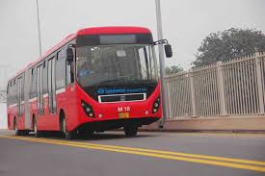

**Main Structure:**

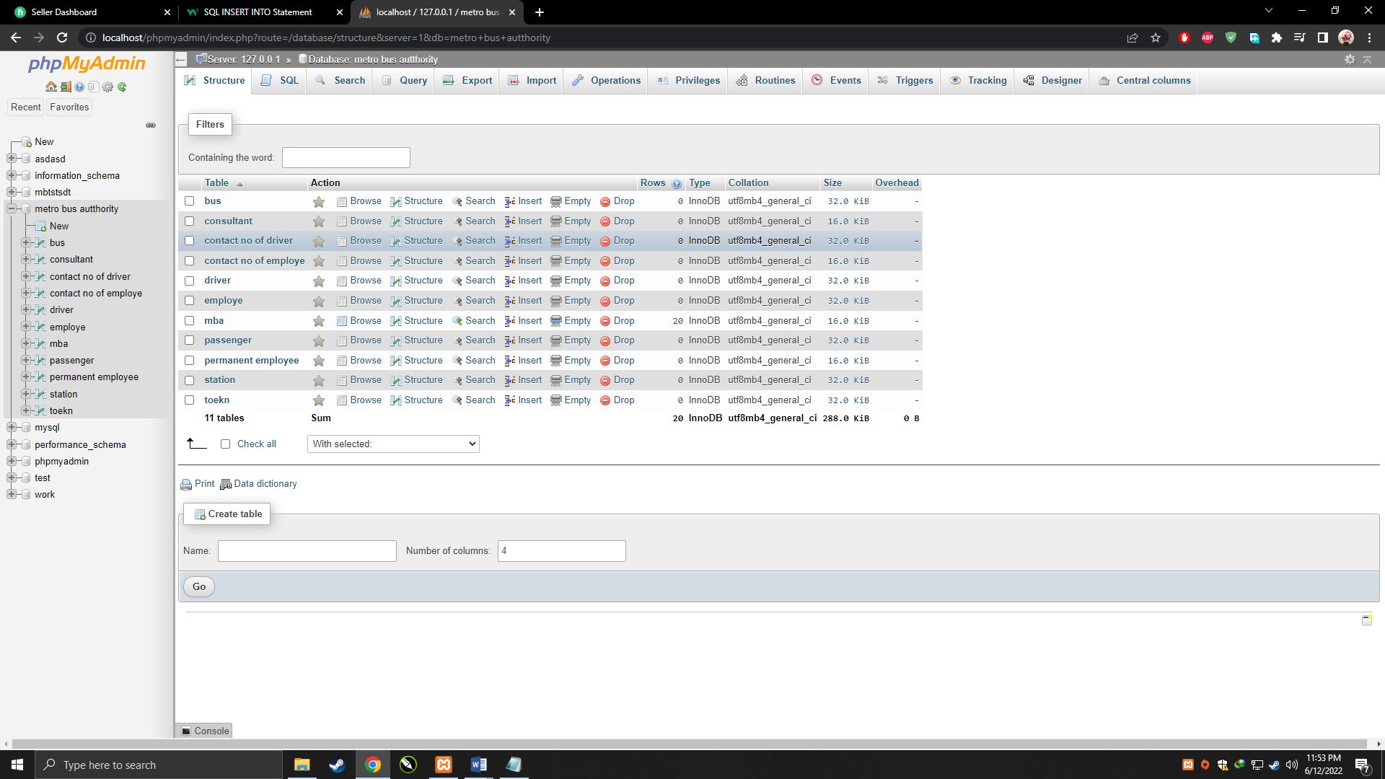

**Queries:**

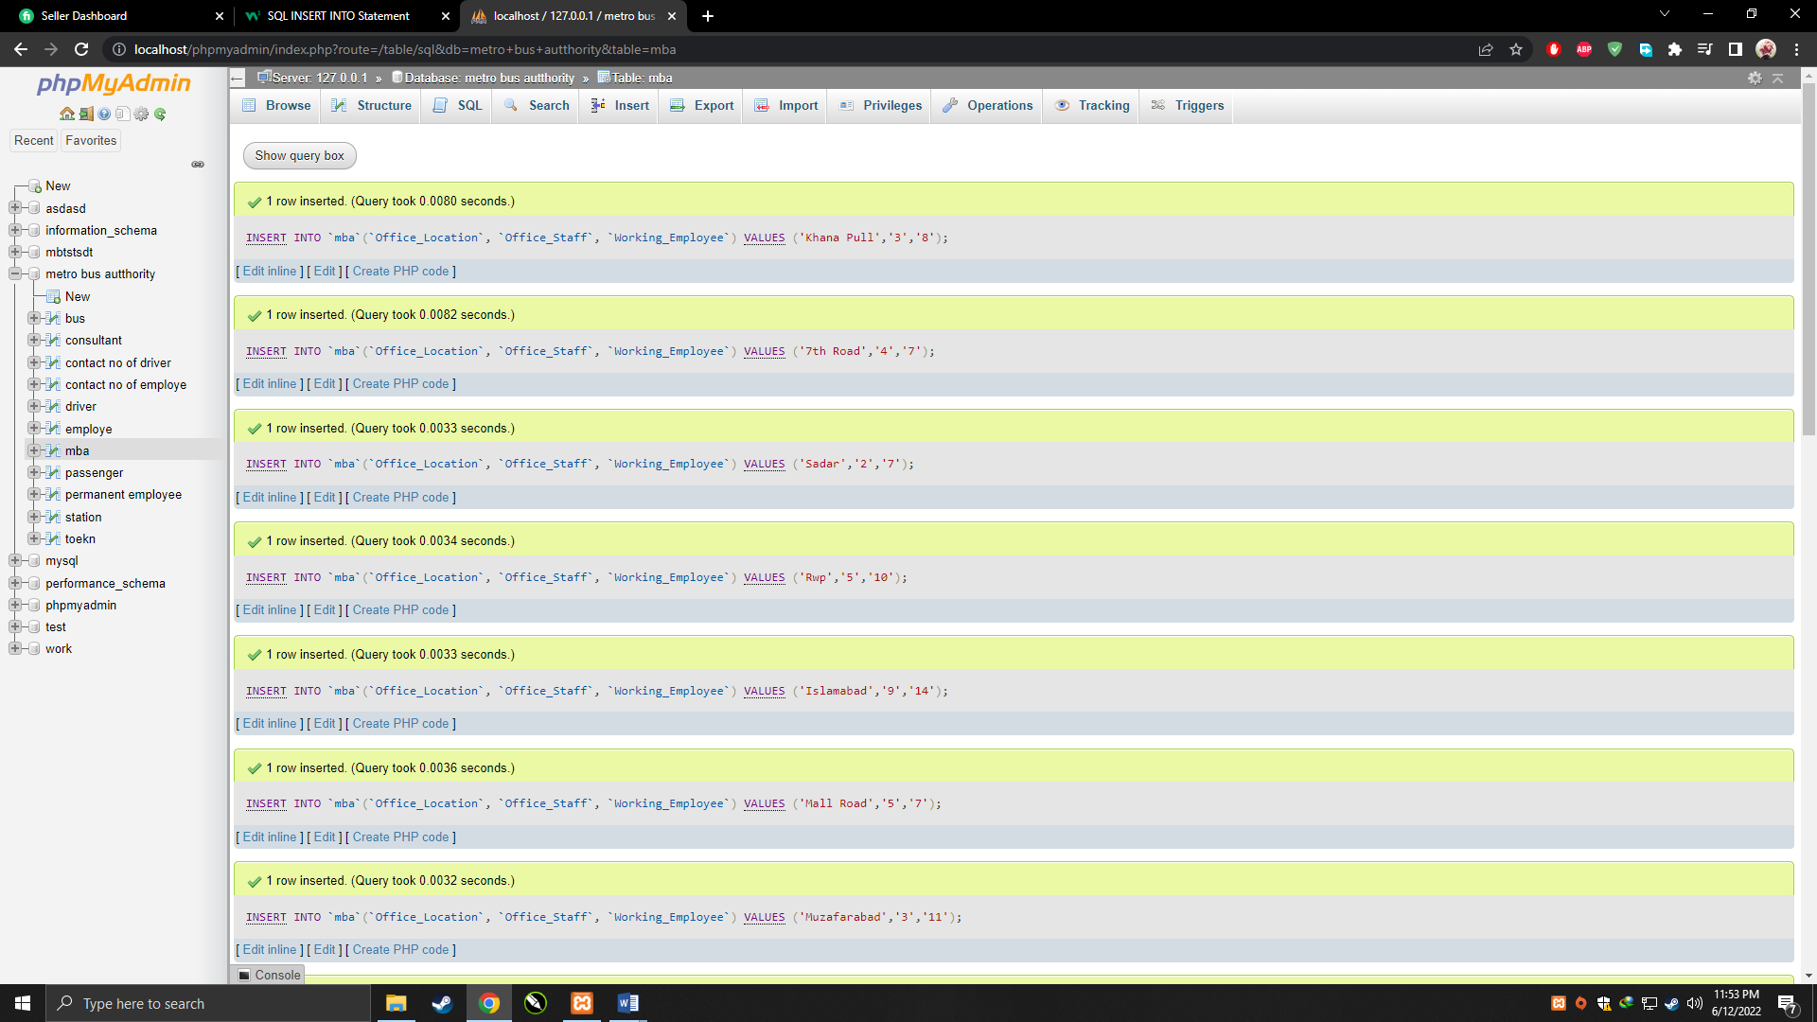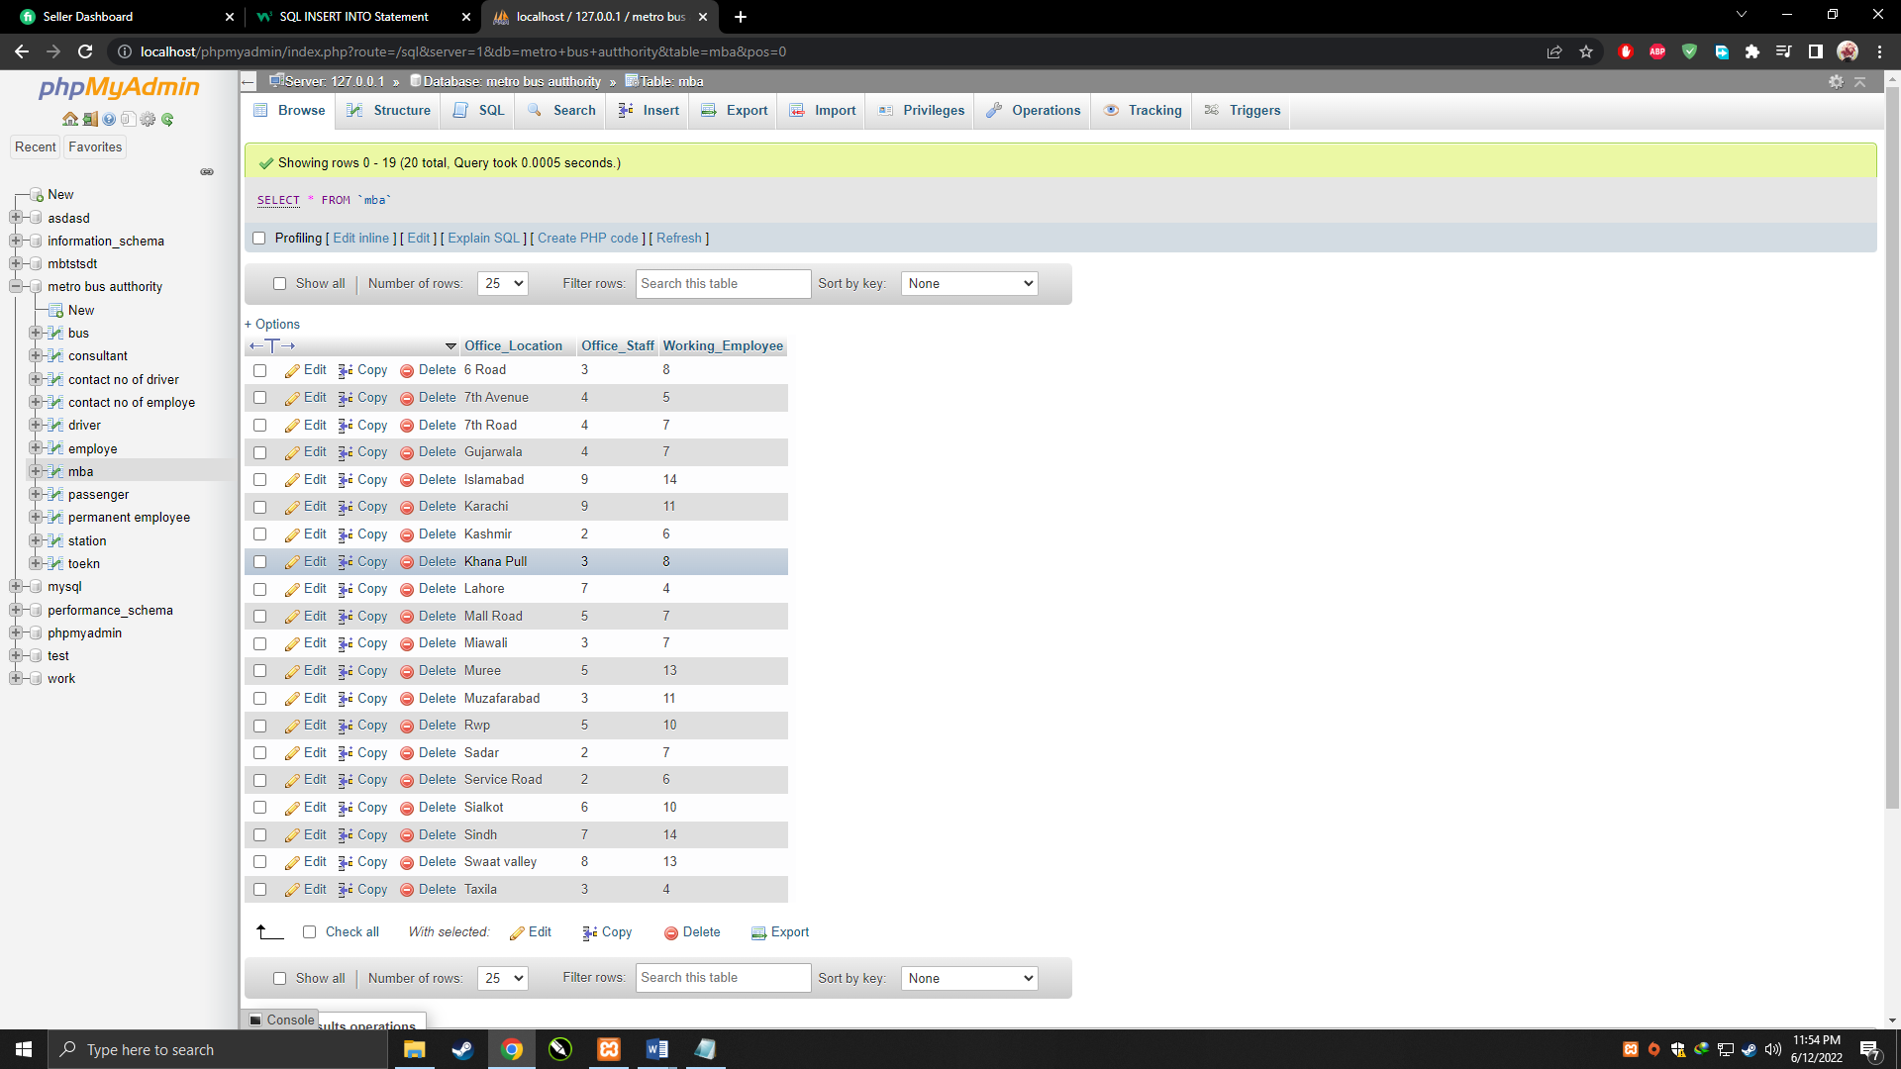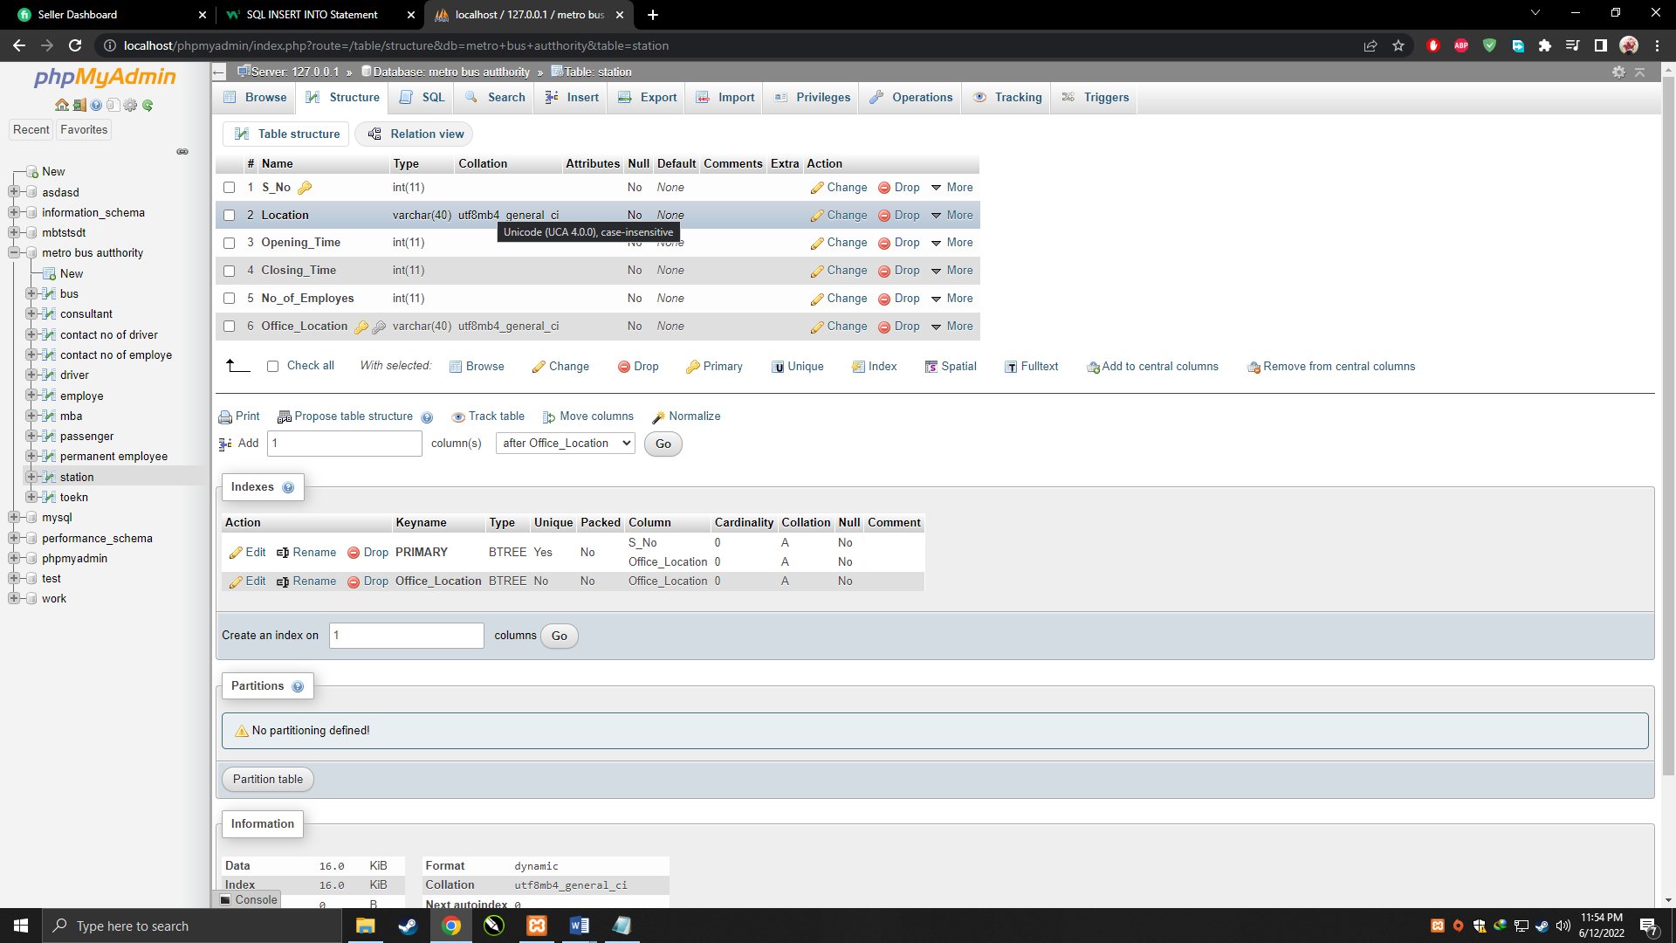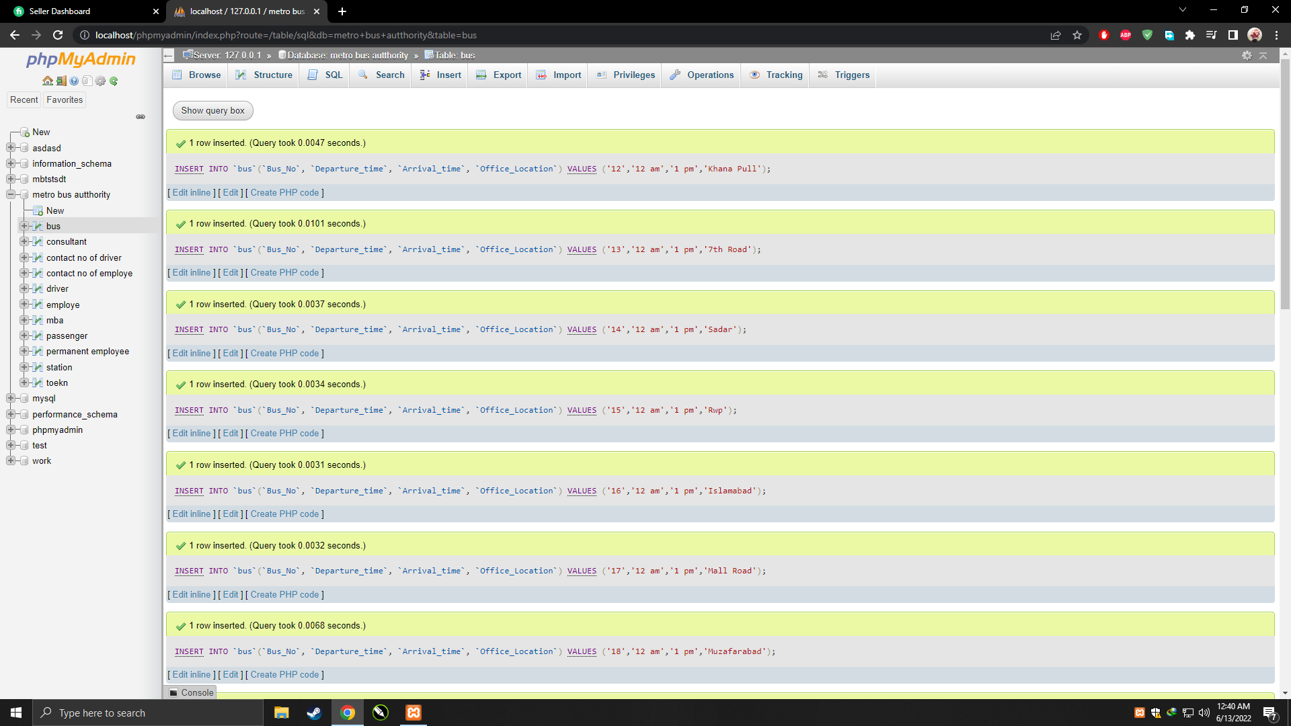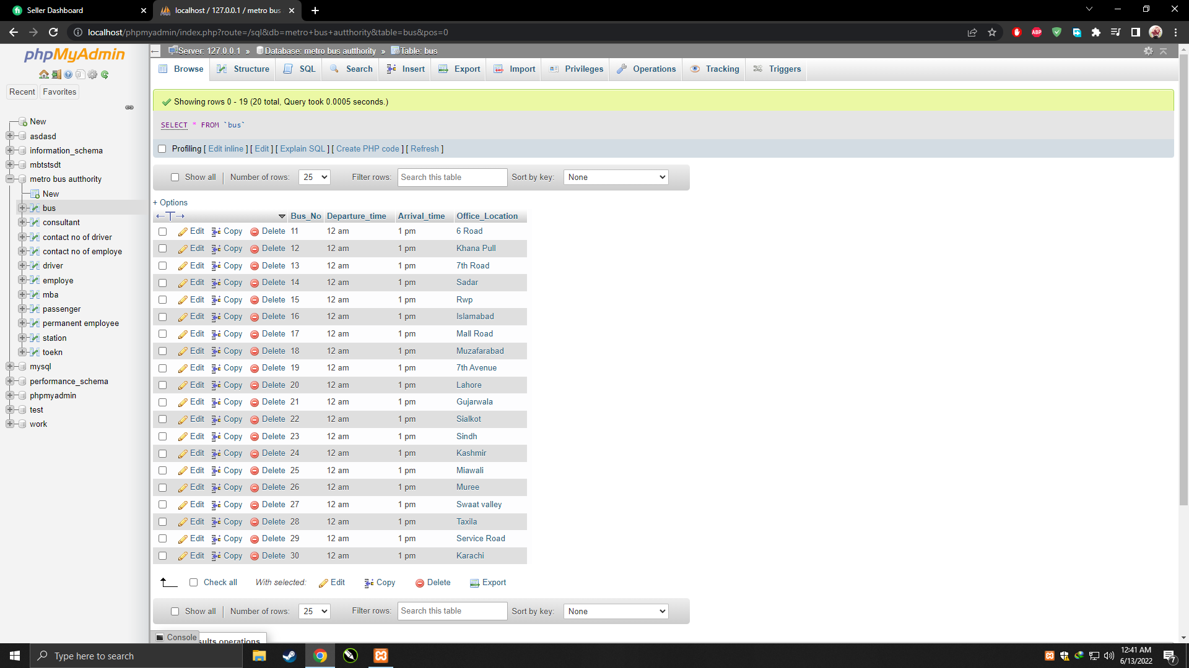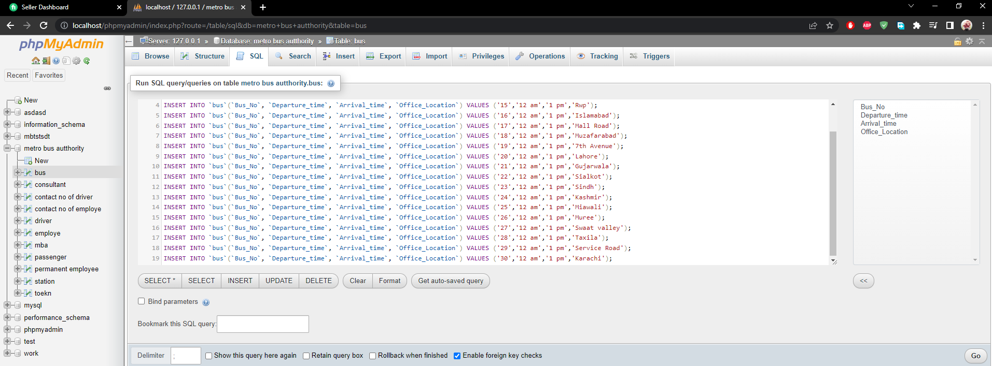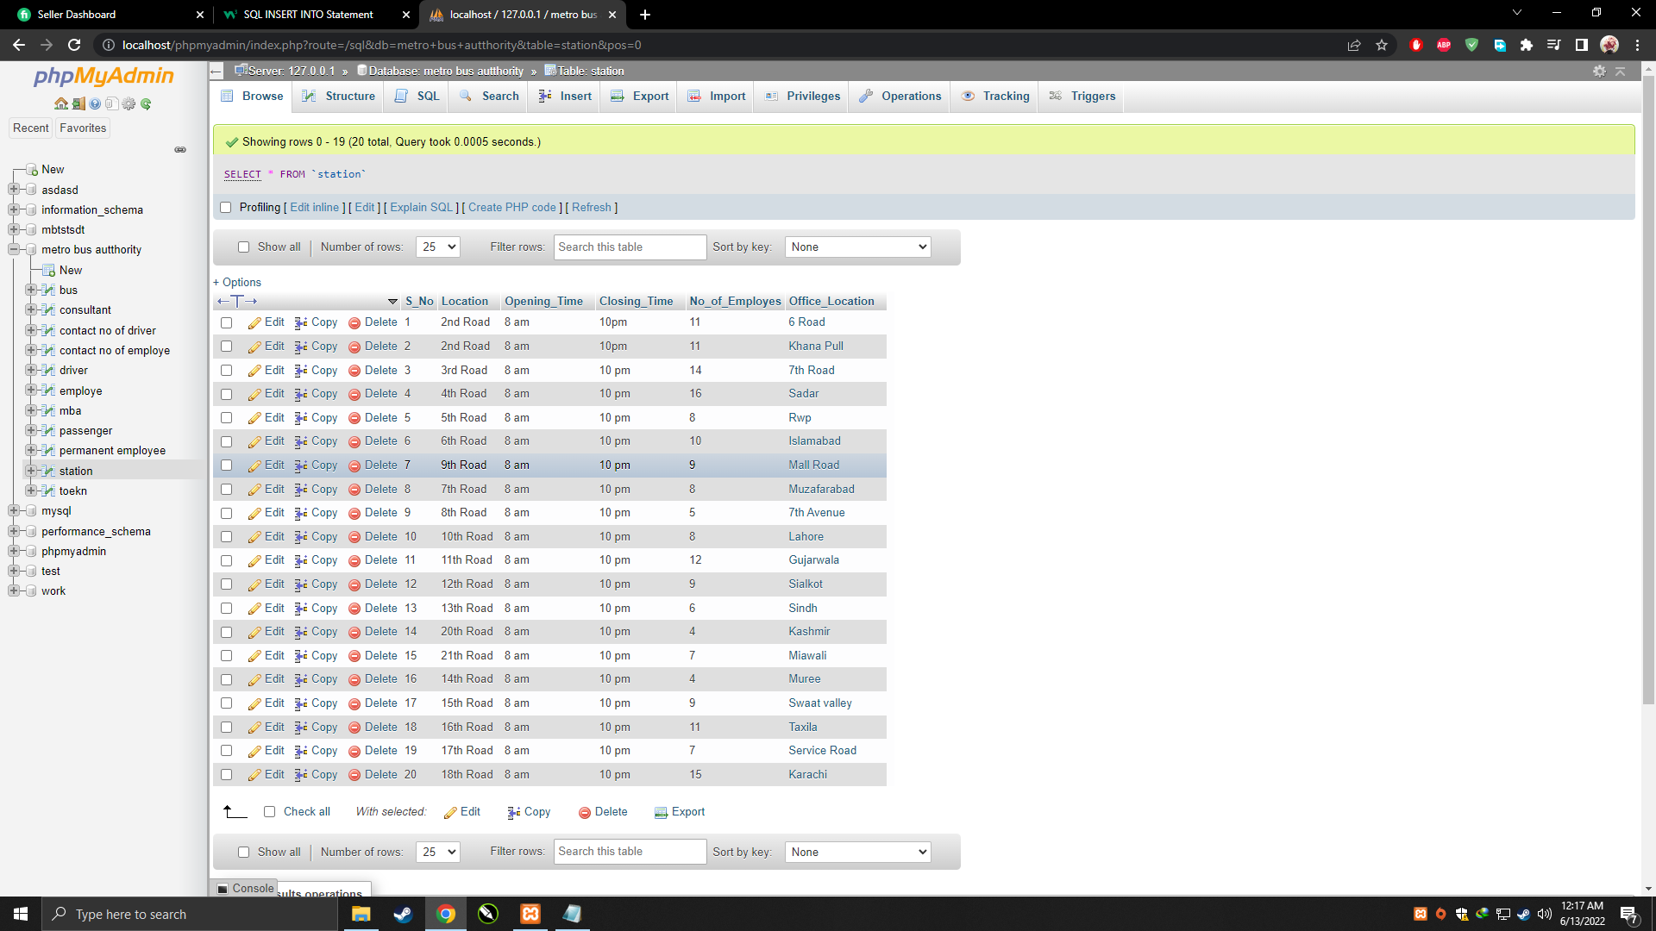

**Analysis:**

Metro bus is referred as a public rapid transit system. Metro bus authority system have at least 24 stations in twin cities. Metro bus have one or many stations and one station has one and only one management authority. For station: s.no, locations, opening and closing time, and no of working employees are to be stored. Station no uniquely identify every station. Different employees are working on different stations. Each station has one or many employees and one employees works in one and only station. For employee: e.id, name which is composed of first and last name, address which further decomposed into house no, street no and city, age and contact no are to be stored. Employee ID is used to uniquely identify each employee. Employees are of two types: Permanent and Consultant, these employees are distinguished on the basis of permanent salary and hourly rate respectively. Tokens are issued to stations to use by passengers. One token issued to one and only one station while one station has at least one or many tokens. For token: token no, no of tokens issued and no of tokens used are to be stored. Token no is used to identify uniquely any token. Tokens are assign to passengers. One passenger has only one token at a time while one token used by one and only one passenger. For passenger: entering time and exiting time are to be stored. Metro bus authority have buses. For bus: bus no which is referred as a primary key, departure time and arrival time are to be stored. Buses carry passengers. Buses have drivers. One bus only drive by one driver and one driver drives one bus only at a time. For driver: driver id, name, age, contact no and address are to be stored. For address we must know house no, street no, and city. Driver ID are uniquely identifying driver.

**ERD**

**Metro Bus Authority**

**Stations**

**has**

**have**

**Buses**

**Issued to**

**Have**

**Assign to**

**carry**

**have**

**Driver**

**Passengers**

**TOKEN**

*Consultant*

*Permanent*

**O**

**Employee**