# Developer’s Guide

This document describes the necessary steps to setup the developer’s environment in order to develop for the « kairos » project.

Requirements :

* MacOs >= Snow leopard
* XCode 3.x (XCode 4 is not completely supported yet)
* Cappuccino Starter Kit >= 0.9)
* Cappuccino XCode plugin
* Mysql5 >= 5.5.11 32 bits (optional for now)

HACKINTOSH : If you use a hackintosh system please unmount **ALL** windows filesystems because it prevents cappuccino to work properly (mdfind command runs in loop). Another fix (not tested) could be to add those filesystem in the Spotligt exclusion list)

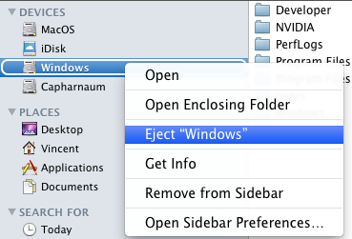

Please follow the installation order

Install XCode 3

Download Cappuccino Starter Kit : <http://cappuccino.org/starter> and unzip it.

Open a terminal and launch bootstrap.sh **as root**

$ sudo sh /Users/Vincent/Downloads/Starter/bootstrap.sh

You will be asked to answer some questions; generally you can just answer yes for the defaults values except if you have some good reasons not to do so.

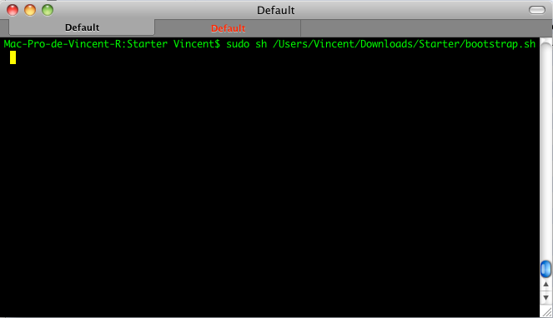

Download Cappuccino plug-in here:

<https://github.com/rbartolome/xcode-cappuccino/archives/master>

Unzip it

Open a terminal and go the folder

Enter the following command as your current user : rake install

Mac-Pro-de-Vincent-R:rbartolome-xcode-cappuccino-08d44fd Vincent$ rake install

(in /Users/Vincent/Downloads/rbartolome-xcode-cappuccino-08d44fd)

cp -r File Templates /Users/Vincent/Library/Application Support/Developer/Shared/Xcode/

cp -r Project Templates /Users/Vincent/Library/Application Support/Developer/Shared/Xcode/

cp -r Specifications /Users/Vincent/Library/Application Support/Developer/Shared/Xcode/

cp -r Target Templates /Users/Vincent/Library/Application Support/Developer/Shared/Xcode/

Now you can launch XCode to see if the plugin was installed properly and you should see a new kind of Project :

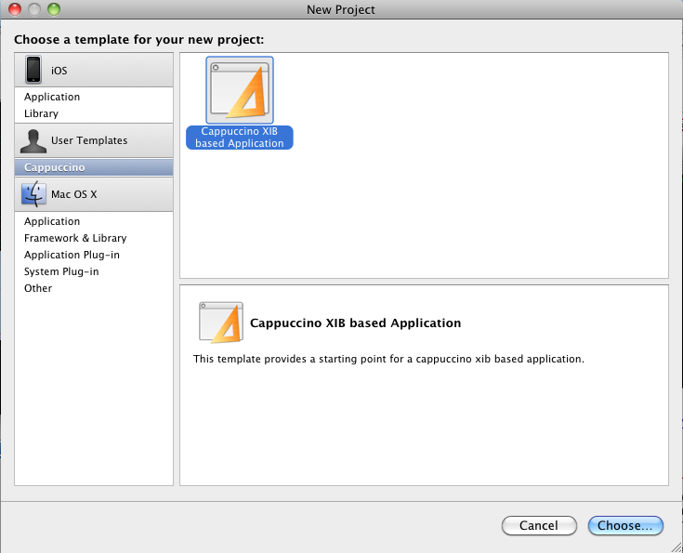

Select Cappuccino XIB based Application and choose a name for the project.

Try to build the sample project and normally you should see no errors.

If the compilation never ends check you have unmounted all windows filesystems.

**Apache Configuration**

Snow Leopard already comes with Apache, PHP and many other development tools, so we just need to configure them.

Look in /etc and find php.ini.default, open it up in your favorite editor.

Look for this line:

date.timezone =

Add your preferred timezone, like so:

date.timezone = "Europe/Berlin"

Read [this page](http://www.php.net/manual/en/timezones.php) in the PHP manual for supported zones and cities.   
  
After you're done with that, rename the file using sudo mv php.ini.default php.ini.

Restart apache : sudo apachectl restart

Warning : Check that you uncomment the date.timezone by removing the ; at the beginning of the line

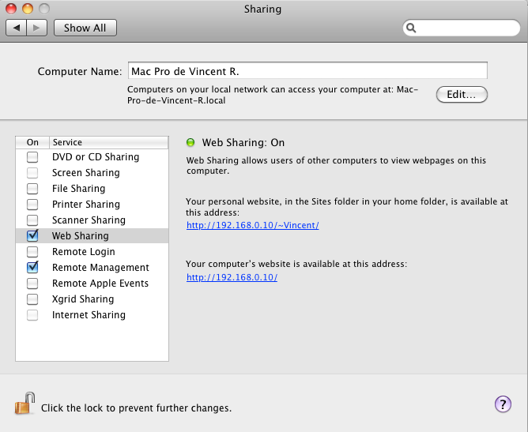

Click on your personal website and if it works it should display a welcome page.

Once you have been given the rights to access the source repository you can retrieve sources using git :

Since I am not using a standard port for ssh you need to create a ~/.ssh/config file with the following parameters :

Host smartmobili.com

Port 42

Then you can get sources :

* mkdir ~/Sites/objj; cd ~/Sites/objj
* git clone [gitosis@smartmobili.com:kairos.git](mailto:gitosis@smartmobili.com:kairos.git)
* cd kairos
* Modify in Imap.j the following line and replace by your account name

self.urlBase = @"http://localhost/~Vincent/objj/Mail/Webservice/";

Now you can launch project and run it (Build->Build and Run or Cmd+Enter).