Book Doctor Appointment
I have successfully developed the “Doctor Appointment” application using .NET MVC for the frontend and .NET Core API with Azure SQL Database for the backend –
Doctor appointment web site URL – Home Page - BookAppointmentMVC
Doctor appointment API URL – Swagger UI
Features that I Cover here:
1.Register (Admin And Patient but they should be hcl employee. )
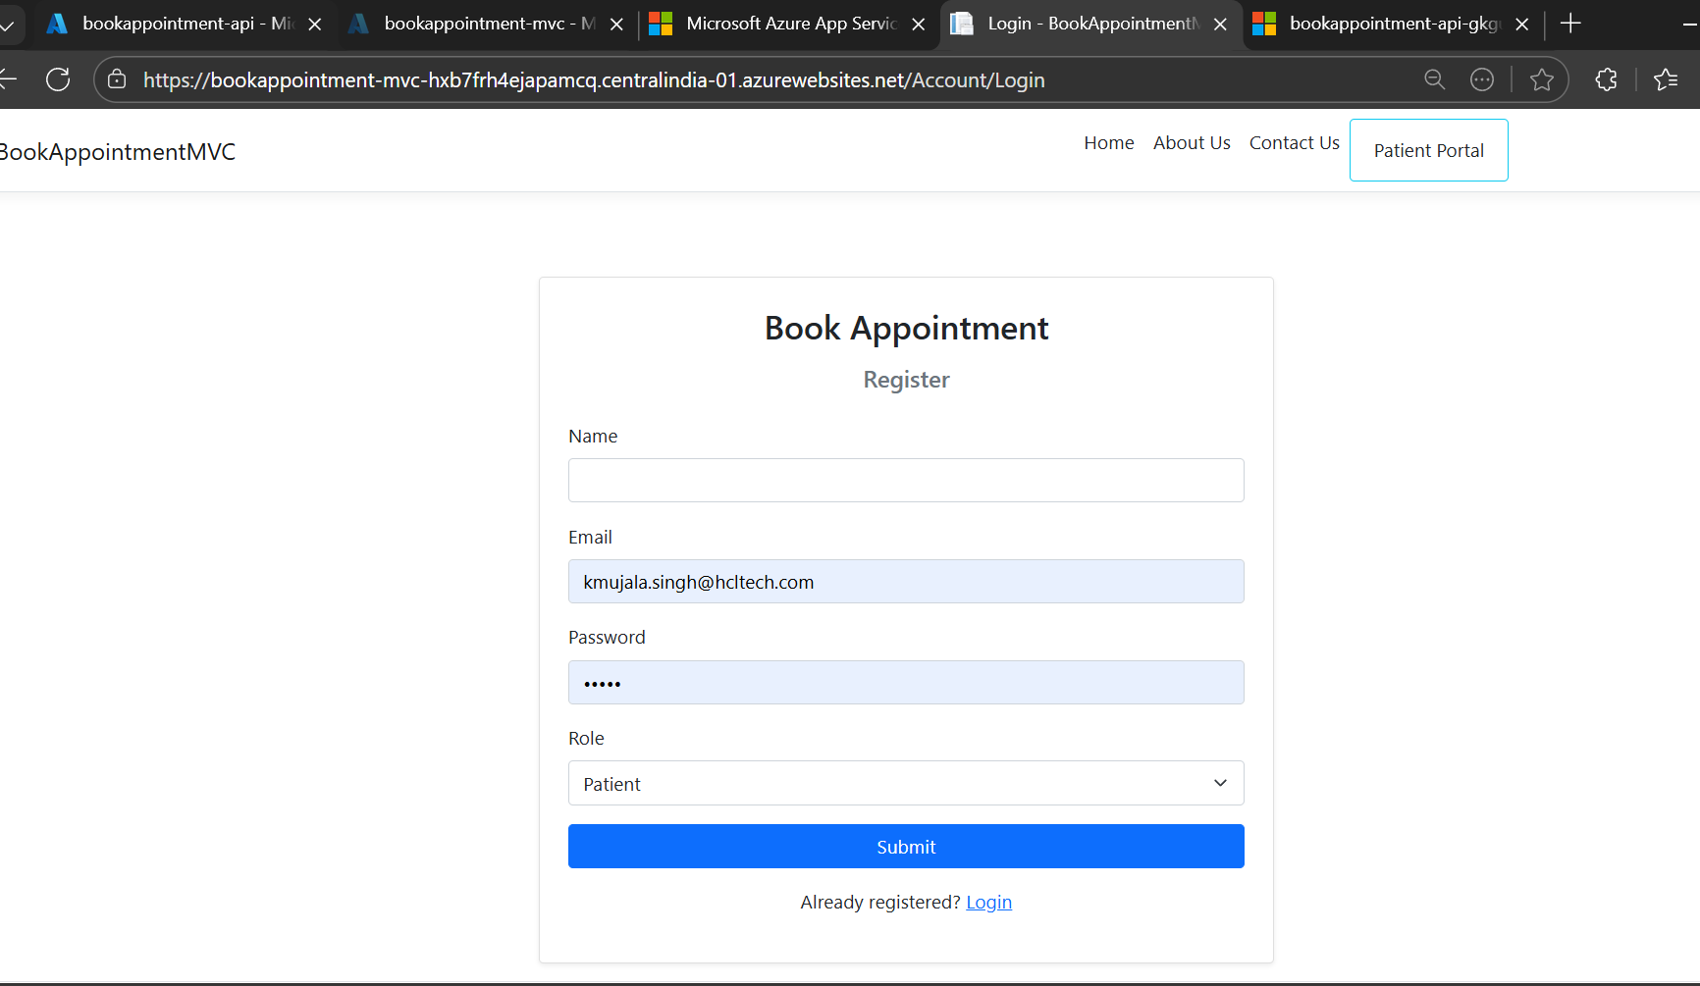
2.Login As Admin- Email : sudha.singh@hcltech.com Password: Sudha
As Patient- Email : kmujala.singh@hcltech.com Password : Ujala
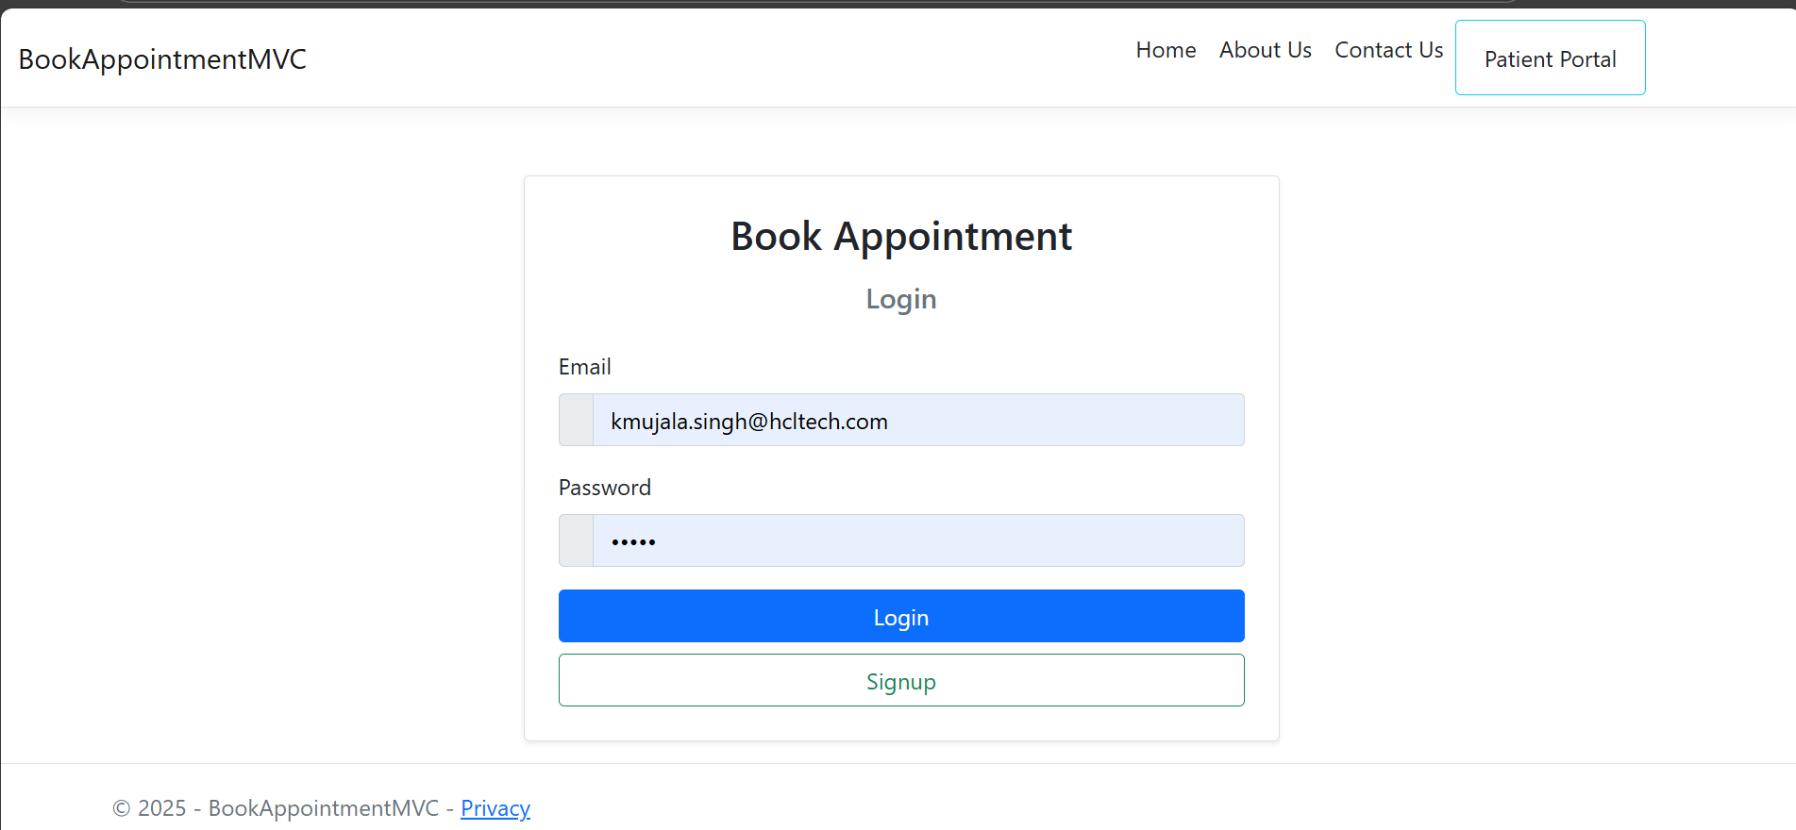
Admin Features
- Admin Can Add HealthCenter
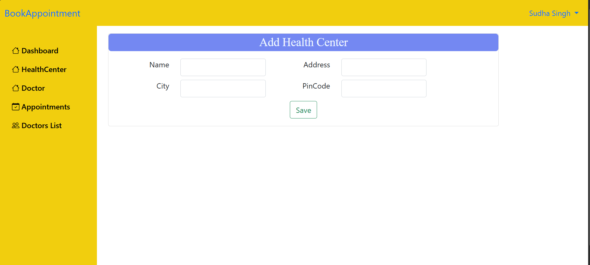
- Admin Can Add Doctor
Here I’m Using Blob Storage to Store Images.
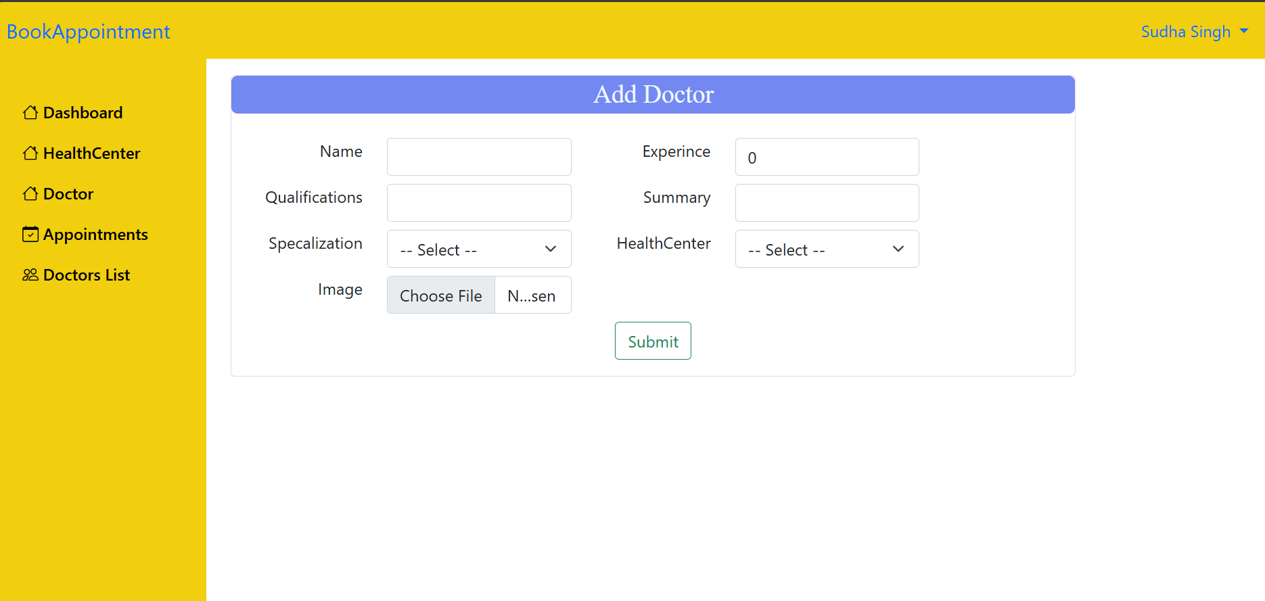
- From Appointments Admin can See all Appointments and their Status , he can Confirm and Reject Appointment, and User will get Email Notification About that. For that I used Logic App
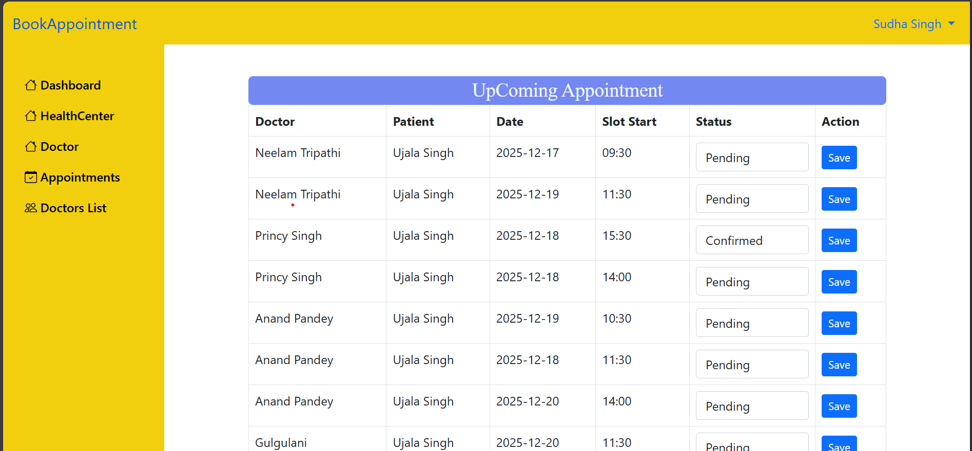
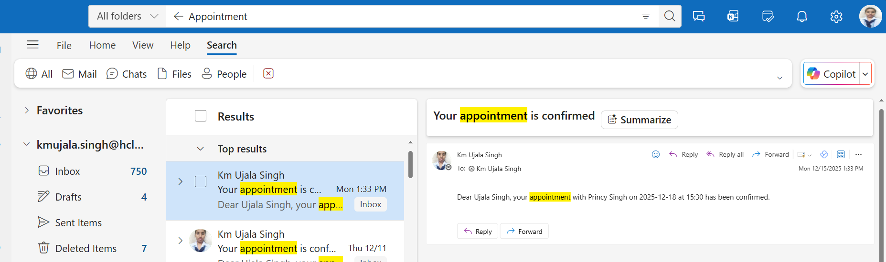

- In Doctor List , This is Details of all doctors, here we can search doctors by there Name, Health Canter and their specialization
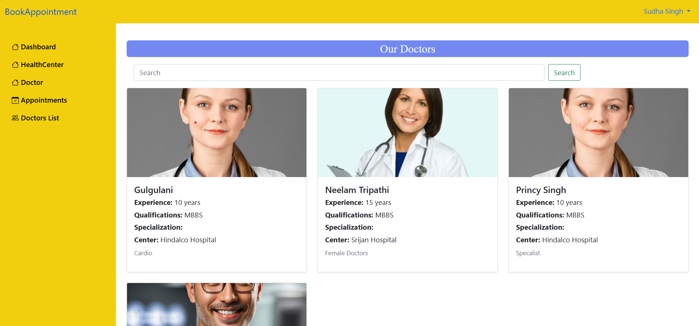

When Login As Patient-

- Dashboard where all Upcoming appointments of patient is listed.
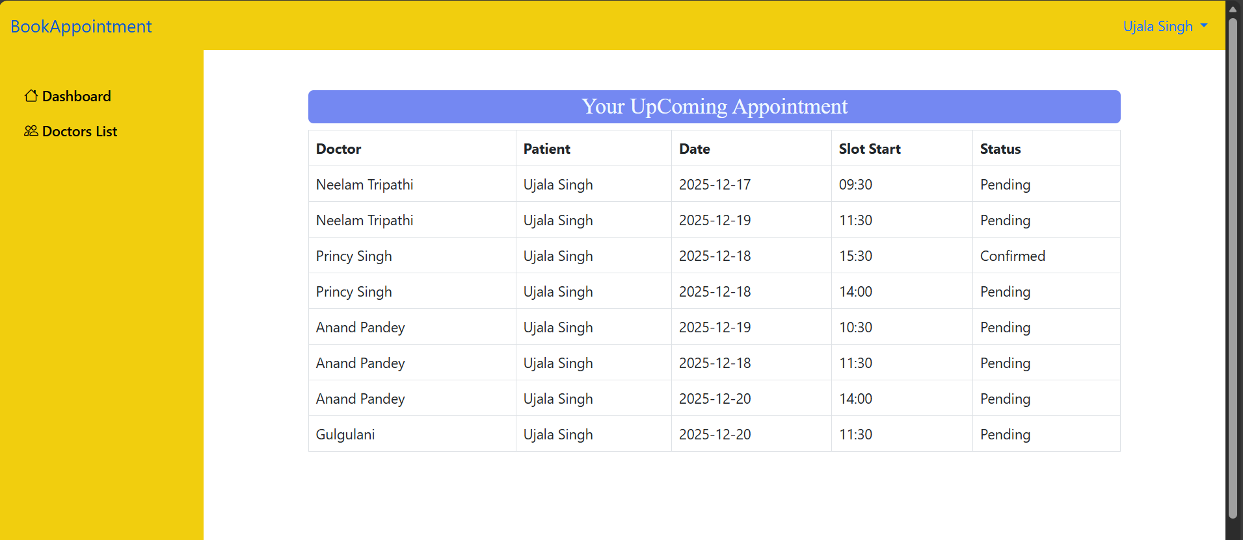

- In Doctor List , Patient can see all Doctors Search According to their requirements and take Appointments according to doctor’s Availability
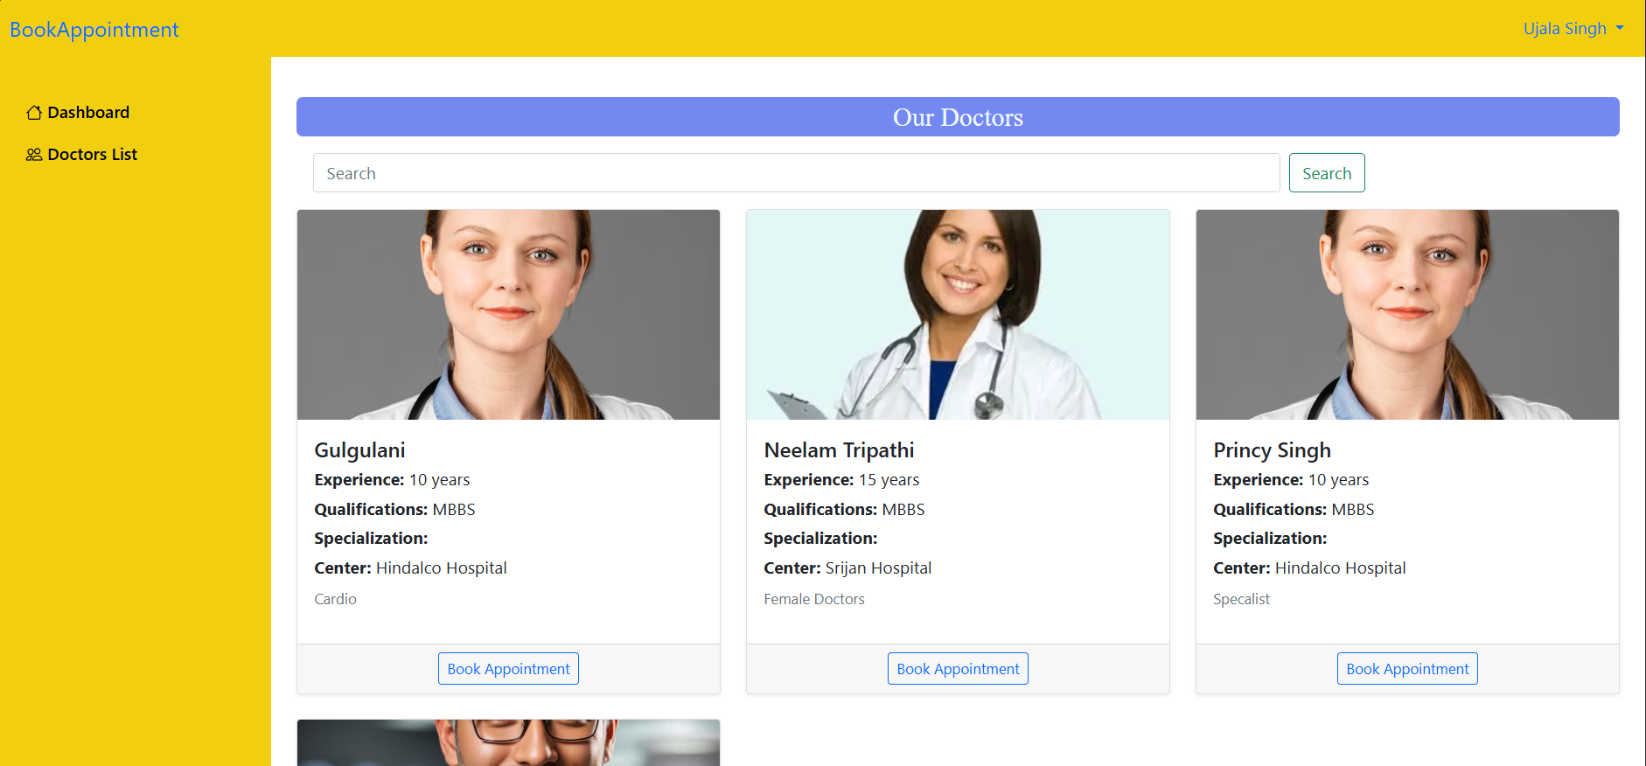

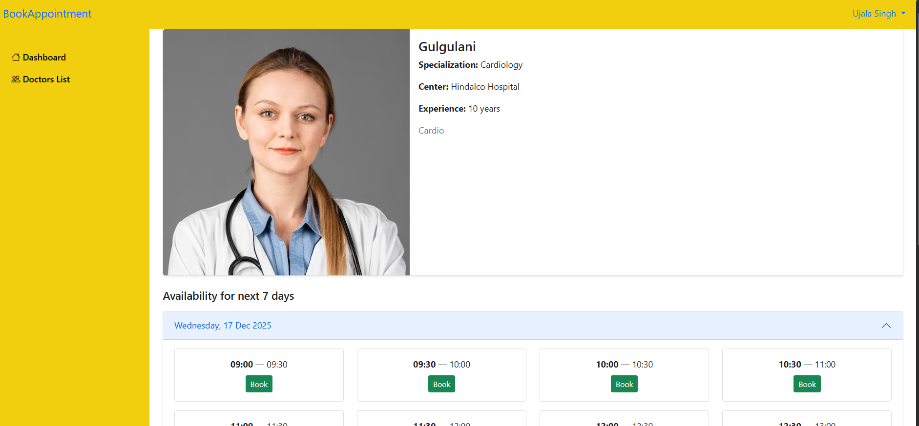
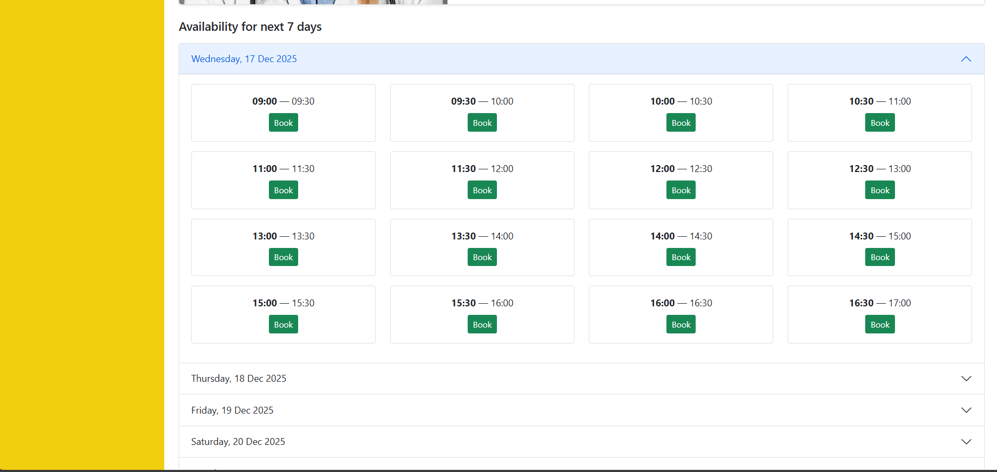

Now All Azure Services That I used for my Project:
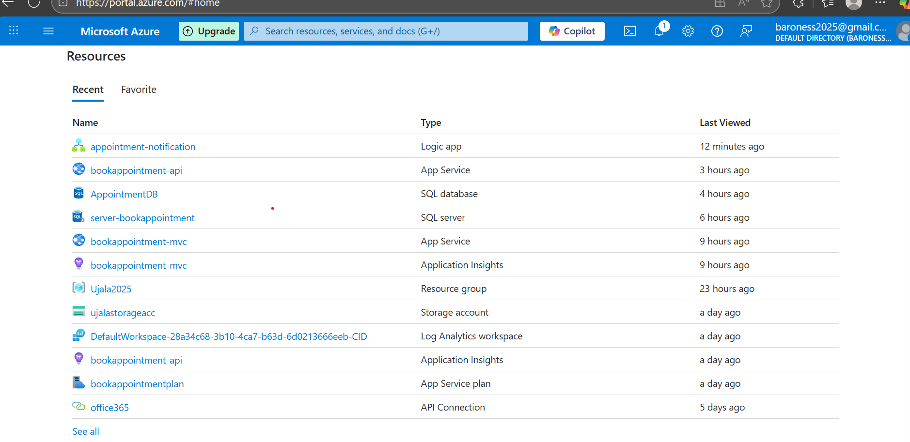
Using Web App for Frontend and Api
