**Task-2**

**Build a Reusable UI Component in React**

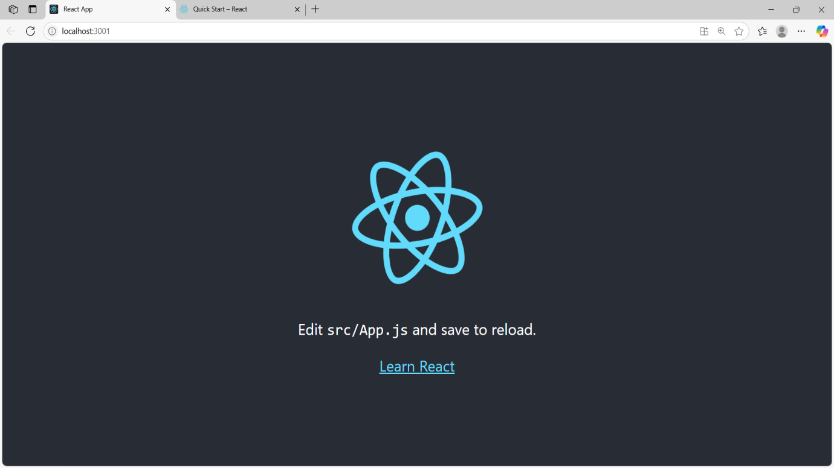

**Screen shorts 1**

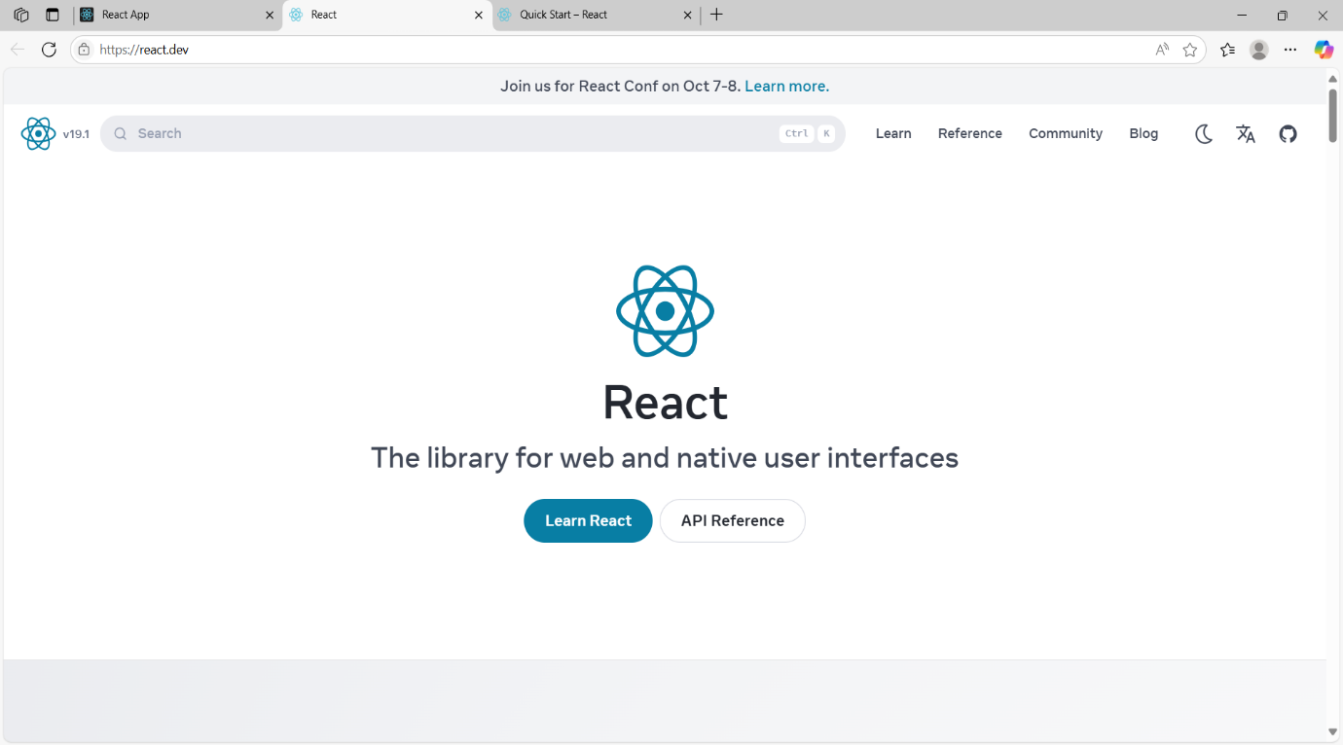

**Screen shorts 2**

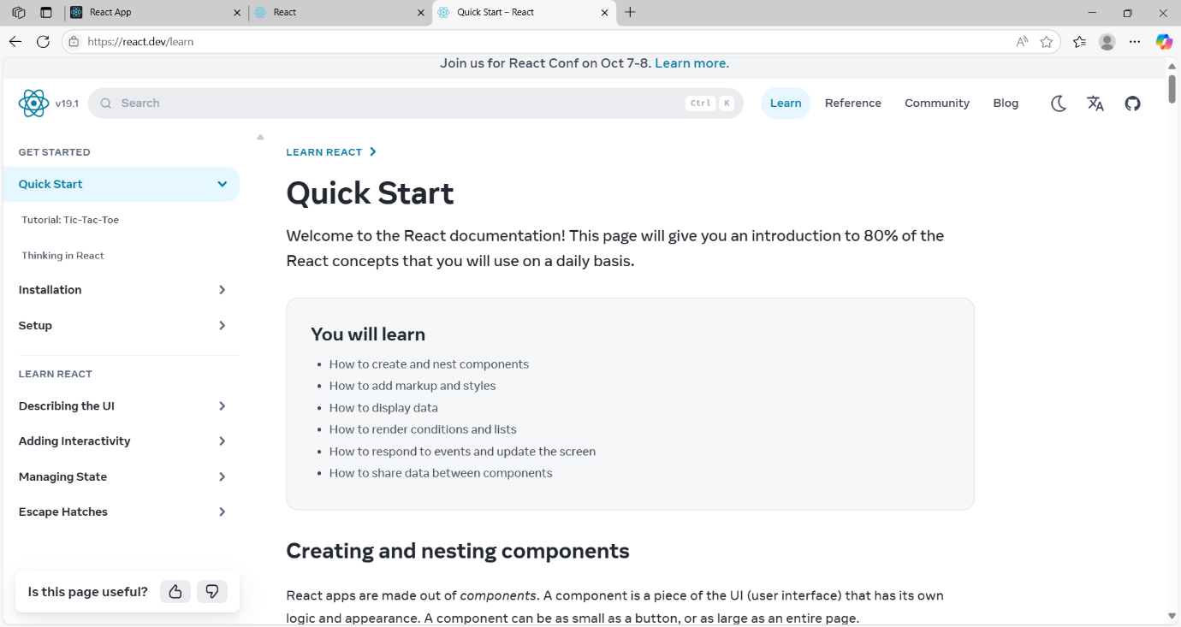

**Screen shorts 3**

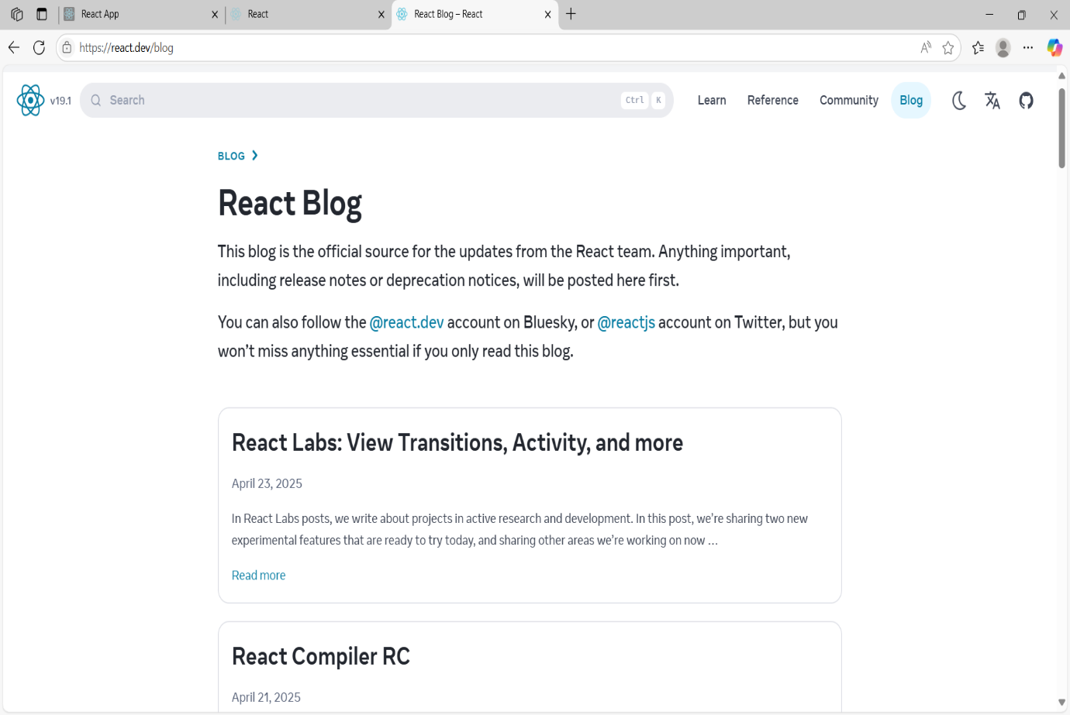

**Screen shorts 4**