What is time series analysis?

Time series analysis is a specific way of analyzing a sequence of data points collected over an interval of time. In time series analysis, analysts record data points at consistent intervals over a set period of time rather than just recording the data points intermittently or randomly. However, this type of analysis is not merely the act of collecting data over time.

What sets time series data apart from other data is that the analysis can show how variables change over time. In other words, time is a crucial variable because it shows how the data adjusts over the course of the data points as well as the final results. It provides an additional source of information and a set order of dependencies between the data.

Time series analysis typically requires a large number of data points to ensure consistency and reliability. An extensive data set ensures you have a representative sample size and that analysis can cut through noisy data. It also ensures that any trends or patterns discovered are not outliers and can account for seasonal variance. Additionally, time series data can be used for forecasting—predicting future data based on historical data.

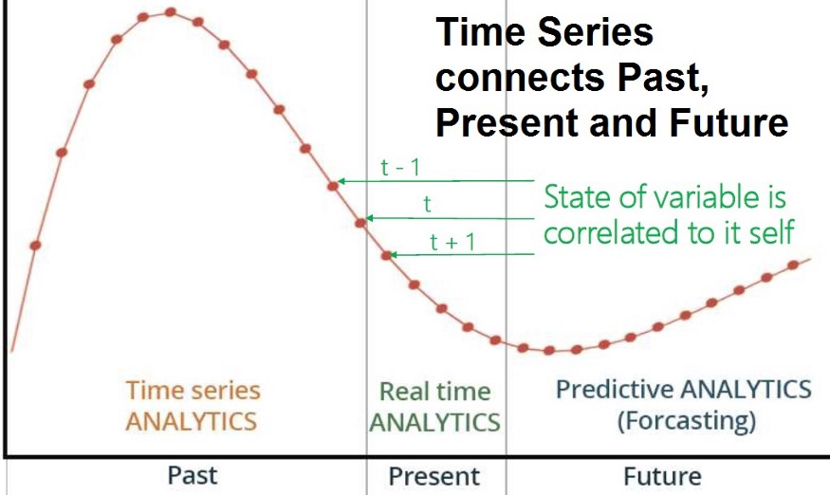

# **Time Series use cases and domains of applications:**

There are several applications of Time Series models:

* **Business:**Supply chain, booking, web traffic, …
* **Finance:** Stock option, Exchange, Econometrics, …
* **Science:**Astronomy, Weather, Earthquake prediction, …
* **Engineering:** Sensors & control Signal processing, …
* **Health:** Diagnosis, biomedical monitoring, …

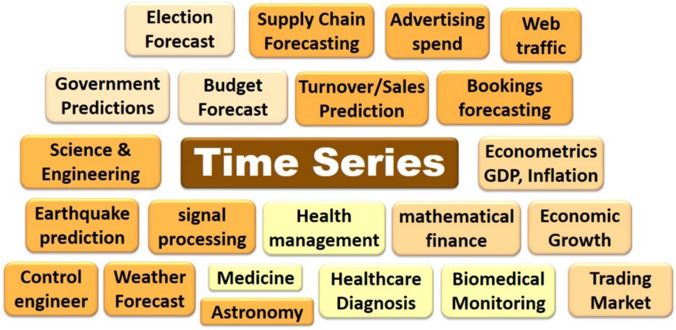

# **Times series types:**

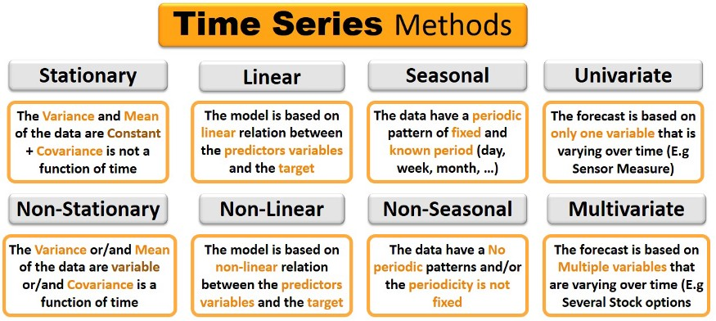

**TIME SERIES DATA**

Time series data, also referred to as time-stamped data, is a sequence of data points indexed in time order. Time-stamped is data collected at different points in time.

These data points typically consist of successive measurements made from the same source over a time interval and are used to track change over time.

**COMPONENTS OF TIME SERIES**

The components, by which time series is composed, are called the components of time series data. A time series is not necessarily composed of all these four components. There are four basic components of the time series data described below.

Different Sources of Variation are:

* **Seasonal effect (Seasonal Variation or Seasonal Fluctuations)**  
  Many of the time series data exhibits a seasonal variation which is the annual period, e.g., sales and temperature readings. Seasonal variations are easy to understand and can be easily measured or removed from the data to give deseasonalized data. Seasonal Fluctuations describes any regular variation with a period of less than one year. For example, the cost of various types of fruits and vegetables, clothes, unemployment figures, average daily rainfall, increase in the sale of tea in winter, increase in the sale of ice cream in summer, etc., all show seasonal variations. The changes which repeat themselves within a fixed period, are also called seasonal variations. For example, traffic on roads in the morning and evening hours, Sales at festivals like EID, etc., increase in the number of passengers at the weekend, etc. Seasonal variations are caused by climate, social customs, religious activities, etc. The main causes of seasonal variations are seasons, religious festivals, and social customs.
* **Other Cyclic Changes (Cyclical Variation or Cyclic Fluctuations)**  
  Time series exhibits Cyclical Variations at a fixed period due to some other physical cause, such as daily variation in temperature. Cyclical variation is a non-seasonal component that varies in a recognizable cycle. These variations are considered a more dangerous effect on business and economic activity. Sometimes series exhibits oscillation which does not have a fixed period but is predictable to some extent. For example, economic data affected by business cycles with a period varying between about 5 and 7 years. In weekly or monthly data, the cyclical component may describe any regular variation (fluctuations) in time series data. The cyclical variation is periodic in nature and repeats itself like a business cycle, which has four phases (i) Peak/Prosperity (ii) Recession (iii) Trough/Depression (iv) Expansion.
* **Trend (Secular Trend or Long Term Variation)**  
  It is a longer-term change. Here we take into account the number of observations available and make a subjective assessment of what is long term. It represents a relatively smooth, steady, and gradual movement of a time series in the same direction. To understand the meaning of the long term, consider the climate variables. These variables sometimes exhibit cyclic variation over a very long time period such as 50 years. If one just had 20 years of data, this long term oscillation would appear to be a trend, but if several hundreds of years of data are available, then long term oscillations would be visible. These movements are systematic in nature where the movements are broad, steady, showing a slow rise or fall in the same direction. The trend may be linear or non-linear (curvilinear). Some examples of secular trends are:
  + Increase in prices,
  + Increase in pollution,
  + an increase in the need for wheat,
  + an increase in literacy rate,
  + the decrease in deaths due to advances in science. Taking averages over a certain period is a simple way of detecting a trend in seasonal data. Change in averages with time is evidence of a trend in the given series. There are more formal tests for detecting a trend in time series.
* **Other Irregular Variation (Irregular Fluctuations)**  
  When trend and cyclical variations are removed from a set of time series data, the [residual](https://itfeature.com/glossary/residual) left, which may or may not be random. Various techniques for analyzing series of this type examine to see “if irregular variation may be explained in terms of probability models such as moving average or autoregressive models, i.e. we can see if any cyclical variation is still left in the residuals. These variations occur due to sudden causes are called [residual](https://itfeature.com/glossary/residual) variation (also called accidental or erratic fluctuations) and are unpredictable. For example, a rise in prices of steel due to strike in the factory, accident due to failure of the break, flood, earth quick, and war, etc.

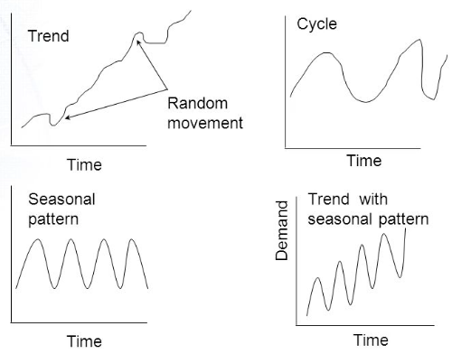

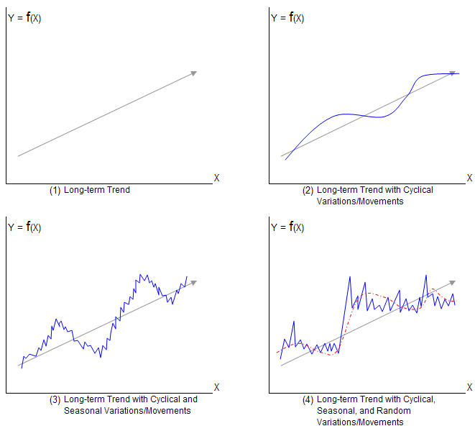

**ϖ Level: The average value in the series.**

**ϖ Trend: The increasing or decreasing value in the series.**

**ϖ Seasonality: The repeating short-term cycle in the series.**

**ϖ Cyclic: data exhibit rises and falls that are not of fixed period ϖ Noise: The random variation in the series.**

**USE OF TIME SERIES IN BUISNESS**

Time Series Analysis is used to determine a good model that can be used to forecast business metrics such as stock market price, sales, turnover, and more. It allows management to understand timely patterns in data and analyze trends in business metrics. By tracking past data, the forecaster hopes to get a better than average view of the future.

