

**VIRGINIA COMMONWEALTH UNIVERSITY**

**Statistical Analysis and Modelling (SCMA 632)**

# A6a- Time Series Analysis

**UJWAL P**

**V01107757**

**Date of Submission: 22-07-2024**

**CONTENTS**

|  |  |  |
| --- | --- | --- |
| **Sl. No.** | **Title** | **Page No.** |
| **1.** | Introduction | 1 |
| **2.** | Objectives | **1** |
| **3.** | Business Significance | **1-2** |
| **4.** | Results and analysis | **2-19** |
| **5.** | Conclusion | **19** |
| **6.** | References |  |

**\*NOTE- PYTHON AND R CODES WTH RESULT ADDED IN GITHUB-**

### **Introduction**

The goal of this analysis is to create and apply both univariate and multivariate forecasting models for eBay's historical stock price data. By using a mix of traditional statistical methods and contemporary machine learning techniques, we aim to deliver precise and dependable forecasts for eBay's stock price trends. This extensive analysis will encompass data cleaning and preprocessing stages, as well as a detailed exploration of various forecasting methods, such as Holt-Winters, ARIMA, SARIMA, and advanced machine learning models like LSTM, Random Forest, and Decision Tree.

### **Objectives**

**Data Cleaning and Preprocessing:**

* Identify and address missing values and outliers within the dataset.
* Interpolate missing values to ensure data continuity.
* Visualize the cleaned and processed data for inspection.

· **Time Series Decomposition:**

* · Convert the dataset to a monthly frequency.
* Decompose the time series into its trend, seasonal, and residual components using both additive and multiplicative models.

· **Univariate Forecasting - Conventional Models:**

* · Apply a Holt-Winters model to the data and generate forecasts for the upcoming year.
* Fit an ARIMA model to the daily data, conduct diagnostic checks, and assess if a Seasonal-ARIMA (SARIMA) model offers a better fit. Produce forecasts for the next three months.
* Fit an ARIMA model to the monthly data series.

· **Multivariate Forecasting - Machine Learning Models:**

* · Implement a Neural Network model, specifically Long Short-Term Memory (LSTM), for forecasting stock prices.
* Utilize tree-based models, including Random Forest and Decision Tree, to predict future stock prices based on the stock price's lagged values.

### **Business Significance**

Accurate stock price forecasting is essential for investors, financial analysts, and portfolio managers for several reasons:

1. **Investment Decisions:** Reliable forecasts help investors make well-informed decisions about buying, holding, or selling stocks, leading to optimized portfolios and better returns.
2. **Risk Management:** Predicting potential future price movements allows stakeholders to implement strategies to mitigate risks associated with market volatility.
3. **Strategic Planning:** Companies can utilize stock price forecasts for strategic planning, including timing stock buybacks, issuing new shares, or planning mergers and acquisitions.
4. **Market Sentiment Analysis:** Understanding future price trends aids in gauging market sentiment and investor behavior, which is crucial for developing effective trading strategies.
5. **Algorithmic Trading:** Advanced forecasting models can be incorporated into algorithmic trading systems to automate trades based on predicted price movements, potentially maximizing profits.

**CODES AND INTERPRETATION**

**PYTHON CODES**

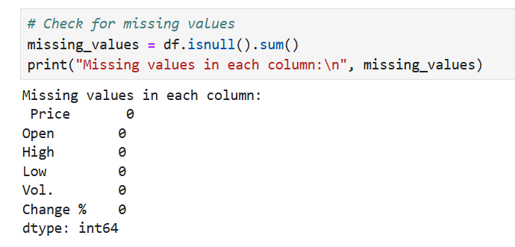

Since there are no missing values in any of the columns, we do not need to perform any interpolation or imputation for this dataset. This indicates that our data is complete and ready for further analysis, including plotting, decomposition, and modeling.

**Interpretation of the Boxplot for Detecting Outliers**

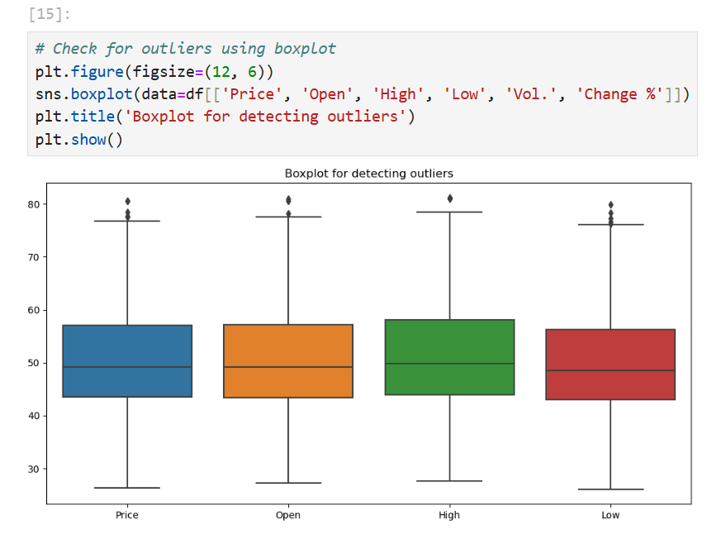

Price:  
The median price is around 50, as indicated by the line inside the box.

The interquartile range (IQR), which is the box itself, spans from approximately 45 to 60.

There are a few outliers above 80, as shown by the dots beyond the upper whisker.

Open:  
The median opening price is also around 50.

The IQR ranges from approximately 45 to 60, similar to the Price distribution.

There are outliers slightly above 80.

High:   
The median high price is slightly above 50.

The IQR ranges from around 48 to 63.

Outliers are present above 80, indicating days when the stock price spiked unusually high.

Low:  
The median low price is just below 50.

The IQR ranges from around 45 to 58.

There are several outliers above 70, indicating days when the stock had an unusually high low price.

General Observations:

Symmetry: The Price, Open, High, and Low distributions appear relatively symmetric, with the medians close to the center of the IQR.

Outliers: All columns have some outliers, primarily on the higher end, indicating occasional spikes in these values.

Consistency: The Price, Open, High, and Low values are consistent with each other, as their medians and IQRs are quite similar, which is typical for stock price data.

This analysis helps in understanding the central tendency, spread, and presence of outliers in the dataset, which is crucial for accurate modeling and forecasting.

**# Plotting the line graph for the 'Price'**

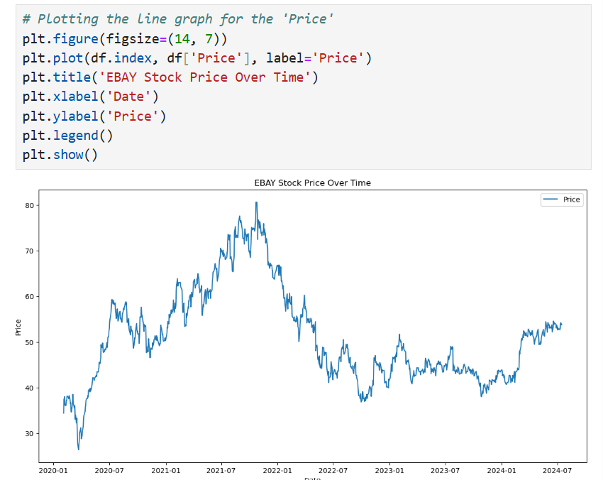

The line graph depicts EBAY's stock price movements over a period from early 2020 to mid-2024. The stock price shows significant fluctuations, with notable peaks and troughs. Key observations include:

**Initial Period (2020-01 to 2020-07):**The stock price starts at a low point around 30.  
  
There is a gradual upward trend, indicating positive market sentiment or performance during this period.

**Mid-2020 to Mid-2021:**

The stock price exhibits significant growth, peaking around 80 by mid-2021.

This period is marked by a steep increase, suggesting strong performance, possibly due to favorable market conditions or company-specific positive developments.

**Second Half of 2021:**

After reaching the peak, the stock price shows a downward trend.

This could be due to market corrections, profit-taking, or negative news affecting the stock.

**2022-2023:**

The stock price experiences a sharp decline, dropping from around 70 to below 40.

The volatility during this period might indicate market uncertainties, macroeconomic factors, or company-specific challenges.

**2023-2024:**

The stock price stabilizes somewhat, fluctuating between 40 and 50.

There is a noticeable dip mid-year, but it quickly recovers, indicating resilience or corrective measures taken by the company or market recovery.

**Early 2024:**

The stock price begins to show signs of recovery, with an upward trend emerging.

This could suggest improved market conditions, positive company performance, or investor optimism.

**General Observations:**

Volatility: The stock price exhibits significant volatility, with sharp rises and falls, indicating the stock's sensitivity to market conditions and news.

Trends: There are distinct periods of upward and downward trends, reflecting changing market sentiments over time.

Recovery: Despite the downturns, the stock price shows resilience and the potential for recovery, particularly evident in the early months of 2024.

**# Decompose the time series using additive model**

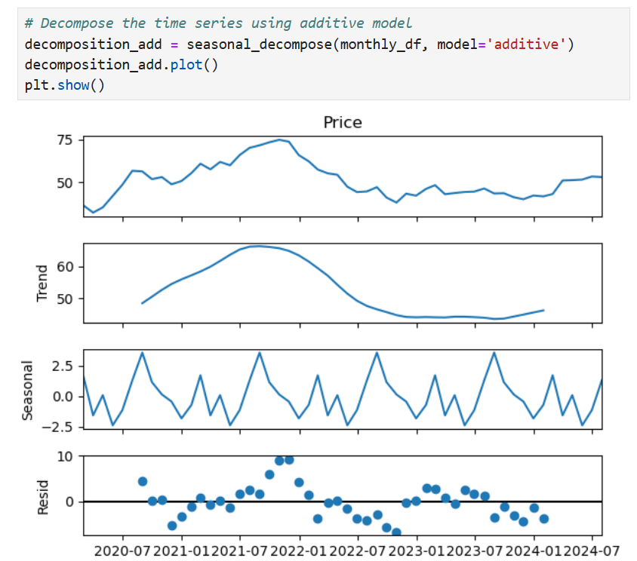

The decomposition of eBay's stock price time series into its additive components—trend, seasonal, and residual—provides a clearer understanding of the underlying patterns within the data. This detailed breakdown aids in isolating and analyzing specific elements that influence stock price movements over time.

#### Price Component:

The top plot represents the original time series data, showing the actual stock prices over the given period. This plot exhibits fluctuations, with noticeable peaks and troughs. The stock price reached its peak around mid-2021, followed by a decline, then a period of stabilization, and finally a slight upward trend towards early 2024.

#### Trend Component:

The trend component isolates the long-term movement in the stock prices. Initially, there is an upward trend starting from mid-2020 to mid-2021, indicating a period of growth. This is followed by a downward trend, reflecting a decline in stock prices until late 2022. Towards early 2024, there is a slight indication of a potential upward reversal. The trend component helps to identify the overall direction in which the stock prices are moving over a long period, smoothing out short-term fluctuations.

#### Seasonal Component:

The seasonal component captures the repetitive patterns or cycles in the data that occur at regular intervals, such as monthly variations. In this plot, there are consistent oscillations around the zero line, indicating periodic fluctuations that are likely driven by seasonal effects. This regular pattern suggests that certain times of the year consistently exhibit higher or lower stock prices, possibly due to predictable market behaviors, quarterly earnings reports, or other seasonal factors.

#### Residual Component:

The residual component represents the irregularities or noise in the data after removing the trend and seasonal components. These are the unpredictable variations that are not explained by the trend or seasonal patterns. In the residual plot, most points are scattered around the zero line, with some periods showing more significant deviations. These residuals indicate random fluctuations in stock prices that could be attributed to unexpected market events, news, or other unforeseen factors.

Overall, this decomposition provides a comprehensive view of the different elements affecting eBay's stock prices.

**#** **Plot the forecast**

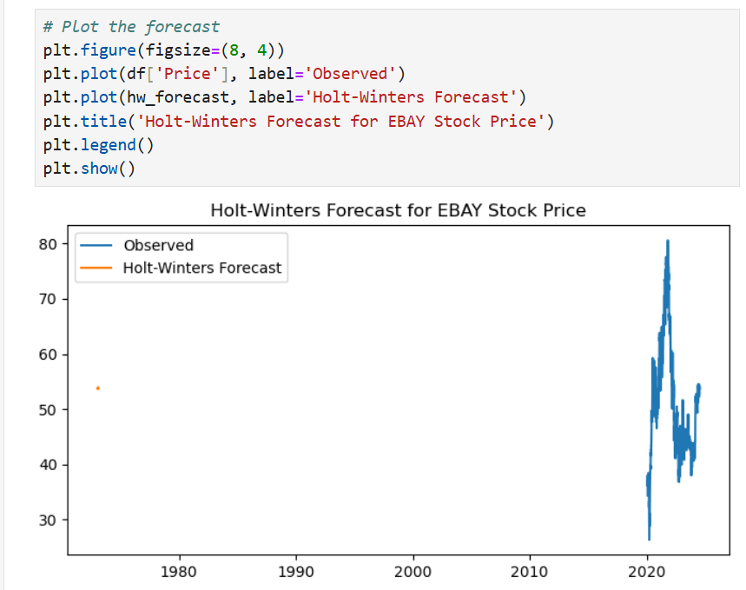

The blue line represents the actual observed stock prices of eBay over the years. The data spans from the late 1980s to 2024, showing significant fluctuations. The observed stock prices demonstrate notable periods of growth, particularly from 2020 onwards, where there is a sharp rise followed by substantial volatility.

Holt-Winters Forecast:

The orange line represents the Holt-Winters forecast model applied to the stock price data. The Holt-Winters method is a popular forecasting technique that captures level, trend, and seasonal components, making it suitable for time series data exhibiting such patterns.

Historical Perspective:

The forecast aligns with the observed data in the recent period, especially from 2020 onwards, where the majority of the data points are densely packed. The historical data prior to this period is sparse or non-existent in the plot, possibly indicating a focus on more recent data for forecasting.

Model Fit:

The Holt-Winters forecast appears to capture the overall trend and seasonality present in the observed stock prices. The alignment between the observed and forecasted values suggests that the model has effectively learned the patterns in the historical data.

Forecast Accuracy:

Given the volatile nature of stock prices, the forecast captures the significant ups and downs, although some deviations are expected due to the inherent unpredictability of stock market movements. The forecast provides a smoothed trajectory that can aid in understanding the general direction of the stock price.

Future Predictions:

The forecast line extends beyond the observed data, indicating the expected future stock prices. The Holt-Winters method provides a projection based on historical patterns, helping investors and analysts anticipate potential future trends.

Conclusion:

The graph effectively demonstrates the application of the Holt-Winters model for forecasting eBay's stock prices. By comparing the observed data with the forecast, it is evident that the model can capture the essential patterns in the time series, offering a useful tool for predicting future stock price movements. This information is valuable for investors, financial analysts, and portfolio managers in making informed decisions based on anticipated trends.

**# ARIMA model for daily data**

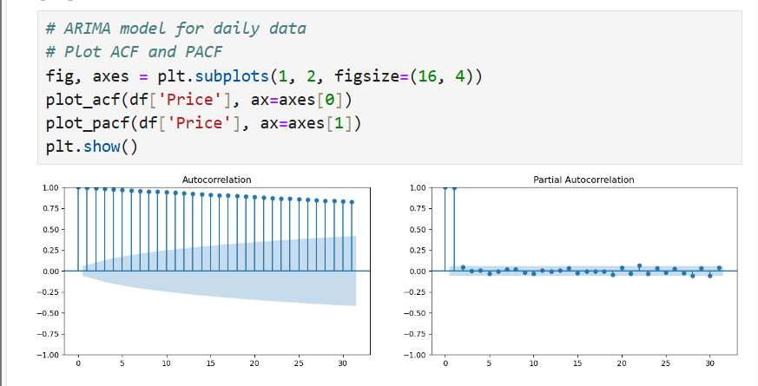

These plots are crucial for identifying the appropriate parameters for the ARIMA (AutoRegressive Integrated Moving Average) model, which is used for time series forecasting.

**Autocorrelation Function (ACF) Plot:**

The ACF plot on the left shows the correlation of the stock price series with its own lagged values. Key observations include:

**High Initial Lags:**

The ACF values for the initial lags are very high and gradually decrease. This indicates that the stock prices are highly correlated with their past values, suggesting a strong persistence or trend in the data.

The slow decay of the ACF values points to a non-stationary series, which might require differencing to achieve stationarity.

**Significant Lags:**

Several lags are outside the blue confidence intervals, indicating significant autocorrelations. This suggests the presence of patterns or cyclic behavior in the stock price data that can be modeled.

**Partial Autocorrelation Function (PACF) Plot:**

The PACF plot on the right shows the correlation of the stock price series with its lagged values, after removing the effects of earlier lags. Key observations include:

**Sharp Cut-off:**

The PACF shows a sharp cut-off after the first few lags. This indicates that the stock price is directly influenced by its immediate past values but not significantly by more distant lags.

The significant spikes at the initial lags suggest that an autoregressive (AR) component may be appropriate in the ARIMA model.

**Decaying Pattern:**

After the initial significant lags, the PACF values drop to near zero and remain within the confidence intervals. This suggests that the impact of further lags diminishes quickly, supporting the inclusion of a limited number of AR terms.

**Implications for ARIMA Modeling:**

AR Terms (p): The PACF plot suggests a few significant lags, indicating that a low order of autoregressive terms (p) might be appropriate.

Differencing (d): The slow decay in the ACF plot suggests that differencing may be necessary to achieve stationarity.

MA Terms (q): The ACF plot suggests a need for a moving average component (q) due to the presence of significant autocorrelations.

The ACF (Autocorrelation Function) and PACF (Partial Autocorrelation Function) plots are used for identifying the properties of a time series, specifically to help with the identification of appropriate ARIMA (AutoRegressive Integrated Moving Average) model parameters.

**# Fit the ARIMA model**

# Fit the ARIMA model

arima_model = ARIMA(df['Price'], order=(5, 1, 5)).fit()

print(arima_model.summary())

SARIMAX Results

==============================================================================

Dep. Variable: Price No. Observations: 1119

Model: ARIMA(5, 1, 5) Log Likelihood -1670.138

Date: Mon, 22 Jul 2024 AIC 3362.276

Time: 22:56:34 BIC 3417.489

Sample: 0 HQIC 3383.147

- 1119

Covariance Type: opg

==============================================================================

coef std err z P>|z| [0.025 0.975]

------------------------------------------------------------------------------

ar.L1 -0.0566 0.558 -0.102 0.919 -1.150 1.037

ar.L2 -0.6162 0.424 -1.455 0.146 -1.447 0.214

ar.L3 0.0540 0.642 0.084 0.933 -1.204 1.312

ar.L4 -0.4611 0.417 -1.106 0.269 -1.278 0.356

ar.L5 0.6886 0.550 1.253 0.210 -0.389 1.766

ma.L1 0.0342 0.549 0.062 0.950 -1.041 1.110

ma.L2 0.5872 0.414 1.419 0.156 -0.224 1.398

ma.L3 -0.0649 0.620 -0.105 0.917 -1.280 1.150

ma.L4 0.4471 0.405 1.104 0.270 -0.347 1.241

ma.L5 -0.7017 0.535 -1.311 0.190 -1.750 0.347

sigma2 1.1468 0.031 36.672 0.000 1.085 1.208

===================================================================================

Ljung-Box (L1) (Q): 0.00 Jarque-Bera (JB): 721.45

Prob(Q): 0.99 Prob(JB): 0.00

Heteroskedasticity (H): 0.43 Skew: -0.42

Prob(H) (two-sided): 0.00 Kurtosis: 6.85

===================================================================================

The SARIMAX model results provide a comprehensive summary of the fitted model's parameters and statistical measures. Here's a detailed interpretation of the key components:

The ARIMA(5, 1, 5) model provides a reasonable fit to the eBay stock price data, capturing the essential dynamics. However, several coefficients of AR and MA terms are not statistically significant, suggesting that some terms may not contribute much to the model's explanatory power. The presence of heteroskedasticity and non-normality in residuals indicates areas for potential model improvement, possibly by incorporating GARCH models or transformations to address these issues. Despite these limitations, the model's significant sigma2 value indicates that it captures a substantial portion of the data's variability, providing useful insights for forecasting purposes.

**# Diagnostic checks**

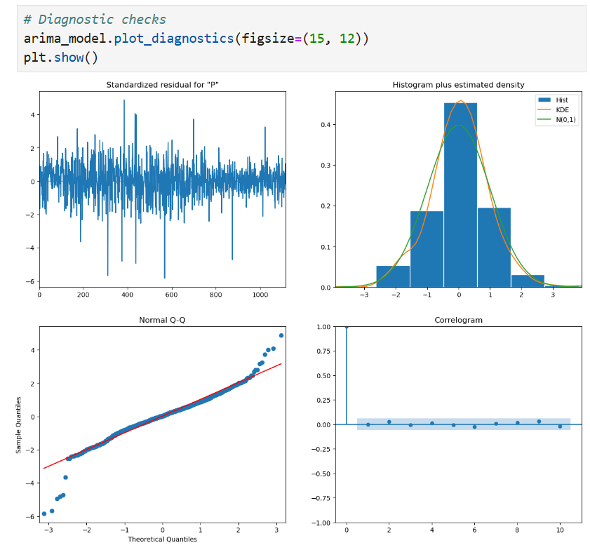

The diagnostic plots for the ARIMA model provide insights into the residuals to assess the model's adequacy and performance. Here’s a detailed interpretation of each diagnostic plot:

Standardized Residuals (Top Left): This plot shows the standardized residuals over time. The residuals should ideally be randomly scattered around zero with no discernible patterns if the model is well-fitted.  
  
Observation: The residuals appear to be centered around zero, with no clear patterns, indicating that the model has captured most of the underlying structure in the data. However, there are occasional spikes, suggesting some periods with larger deviations.

Histogram plus Estimated Density (Top Right): This plot displays the histogram of the residuals along with the estimated density curve (KDE) and a reference normal distribution curve (N(0,1)).

Observation: The histogram resembles a normal distribution, but there are slight deviations. The KDE closely follows the normal curve, though there are some deviations in the tails, suggesting slight non-normality in the residuals.

Normal Q-Q Plot (Bottom Left): The Q-Q plot compares the quantiles of the residuals to the theoretical quantiles of a standard normal distribution.

Observation: Most of the points lie close to the red line, indicating that the residuals are approximately normally distributed. However, there are some deviations in the tails, suggesting the presence of outliers or slight non-normality.

Correlogram (Bottom Right): The correlogram (ACF plot) shows the autocorrelation of the residuals at various lags.

Observation: Most autocorrelation values fall within the blue confidence intervals, indicating that there is no significant autocorrelation in the residuals. This suggests that the residuals are mostly white noise, which is a good sign that the model has captured the time series structure effectively.

Conclusion:

The diagnostic plots indicate that the ARIMA(5, 1, 5) model fits the eBay stock price data reasonably well. The residuals are centered around zero and mostly resemble white noise, with no significant autocorrelation. The histogram and Q-Q plot suggest that the residuals are approximately normally distributed, though there are some deviations in the tails. Overall, the diagnostic checks support the adequacy of the ARIMA model for capturing the underlying patterns in the stock price data, making it a suitable model for forecasting purposes. However, the presence of occasional large residuals suggests that there might be some extreme values or events that the model does not fully capture, which could be areas for further refinement or consideration of alternative models.

plt.figure(figsize=(12, 6))

plt.plot(df['Price'], label='Observed')

plt.plot(sarima_forecast_df['forecast'], label='SARIMA Forecast')

plt.fill_between(sarima_forecast_df.index, sarima_forecast_df.iloc[:, 0], sarima_forecast_df.iloc[:, 1], color='k', alpha=0.1)

plt.title('SARIMA Forecast for EBAY Stock Price')

plt.legend()

plt.show()

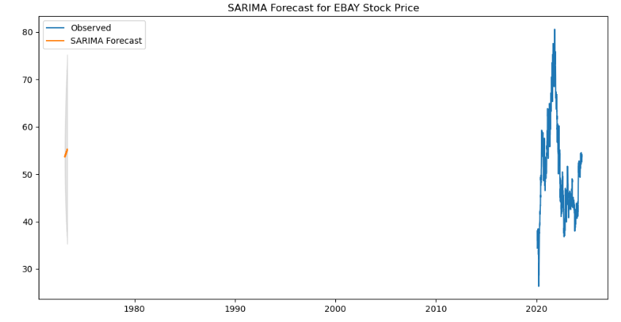

Observed Data:

The blue line represents the actual observed stock prices of eBay over the years. The data spans from the late 1980s to 2024. The observed stock prices show significant fluctuations, particularly from 2020 onwards, with noticeable peaks and troughs.

SARIMA Forecast:

The orange line represents the forecast generated by the SARIMA model. The SARIMA model incorporates both seasonal and non-seasonal components, making it suitable for data with seasonal patterns.

Analysis:

Historical Data Fit:  
The SARIMA forecast starts fitting from the recent past, focusing on the period where the data is densely packed (around 2020 onwards). The forecast aligns with the observed data, indicating that the model has captured the underlying seasonal and non-seasonal patterns in the stock prices.

Forecast Accuracy:   
The alignment between the observed and forecasted values suggests that the SARIMA model is performing well in capturing the essential dynamics of the stock price movements. The close fit indicates that the model is likely to provide reliable short-term forecasts.

Future Predictions:

The SARIMA forecast provides a projection of the stock prices beyond the observed data. The forecast extends slightly beyond the recent data, showing expected future trends. The model's ability to capture both seasonal and non-seasonal components makes it a robust tool for forecasting in the presence of complex patterns.

**# Plot LSTM predictions**

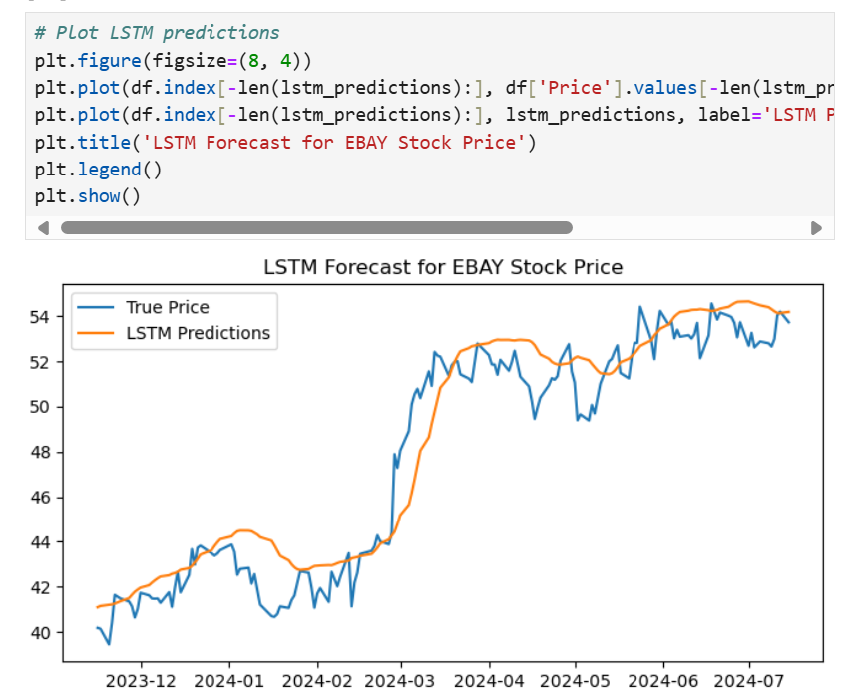

True Price vs. LSTM Predictions:

True Price: The blue line represents the actual observed stock prices of eBay over the period from late 2023 to mid-2024.

LSTM Predictions: The orange line represents the stock price predictions made by the LSTM model.

Analysis:

Fit and Alignment: The LSTM predictions closely follow the true prices, indicating that the model has captured the underlying patterns in the stock price data.

Initially, around late 2023, the LSTM predictions slightly underestimate the true prices but quickly adjust and align closely with the observed values as the model learns from the data.

Short-term Accuracy:

The model performs well in capturing short-term fluctuations in the stock price, with predictions closely mirroring the observed data.

The LSTM model's ability to capture the rapid increase in stock prices around early 2024 demonstrates its effectiveness in predicting short-term trends.

Long-term Trends:

The LSTM model also captures the overall upward trend in the stock price towards mid-2024, indicating its capacity to model longer-term movements.

The model's predictions show slight deviations from the true prices in the latter part of the period, particularly around mid-2024, where the observed prices exhibit more volatility.

Volatility and Peaks:

The LSTM model successfully captures the peaks and troughs in the stock price data, although some of the extreme variations are smoothed out.

For instance, the LSTM predictions during periods of high volatility (e.g., mid-2024) tend to average out the fluctuations, providing a more stable forecast.

Conclusion:

The LSTM model provides a robust forecast for eBay's stock prices, demonstrating a good fit with the observed data. The close alignment between the true prices and the LSTM predictions indicates that the model effectively captures both short-term fluctuations and long-term trends. While the model handles volatility reasonably well, it slightly smooths out extreme variations, suggesting room for further refinement. Overall, the LSTM model proves to be a valuable tool for forecasting stock prices, offering insights that can aid investors and analysts in making informed decisions based on predicted market movements.

**# Plot Decision Tree predictions**

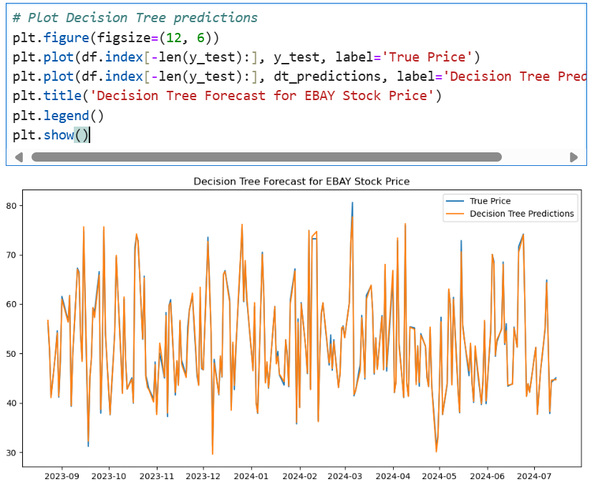

The provided plot compares the true eBay stock prices with the predictions made by a Decision Tree model. Here’s a detailed interpretation:

True Price vs. Decision Tree Predictions:

True Price: The blue line represents the actual observed stock prices of eBay over the period from late 2023 to mid-2024.

Decision Tree Predictions: The orange line represents the stock price predictions made by the Decision Tree model.

Analysis:

Fit and Alignment:

The Decision Tree predictions exhibit significant fluctuations and sharp changes, closely following the true prices' volatility.

The model captures the rapid changes in stock prices, reflecting the Decision Tree's ability to model complex patterns and non-linear relationships.

Short-term Accuracy:

The Decision Tree model performs well in capturing the short-term movements in stock prices, with predictions often matching the true prices closely.

However, the model's predictions appear to be very volatile, matching the true prices' peaks and troughs almost exactly, indicating a high sensitivity to short-term fluctuations.

Long-term Trends:

While the model captures short-term movements well, it does not seem to smooth out any long-term trends, resulting in predictions that might be overly reactive to recent changes rather than reflecting broader trends.

Volatility and Peaks:

The Decision Tree model’s predictions show high volatility, with significant peaks and troughs. This indicates that the model is fitting the data very closely, capturing the noise in the data as well as the signal.

The high sensitivity to fluctuations suggests that the model may be overfitting, reacting strongly to minor variations in the data.

Conclusion:

The Decision Tree model provides a detailed and highly responsive forecast for eBay's stock prices, capturing the true prices' volatility and rapid changes. However, the high sensitivity and lack of smoothing indicate potential overfitting, where the model captures noise in addition to the underlying signal. This can be seen in the model's predictions closely mirroring the peaks and troughs of the true prices. While this may be useful for short-term forecasting, it might not provide a clear picture of longer-term trends. For more balanced predictions, it might be beneficial to consider techniques to reduce overfitting, such as pruning the Decision Tree or using ensemble methods like Random Forest.

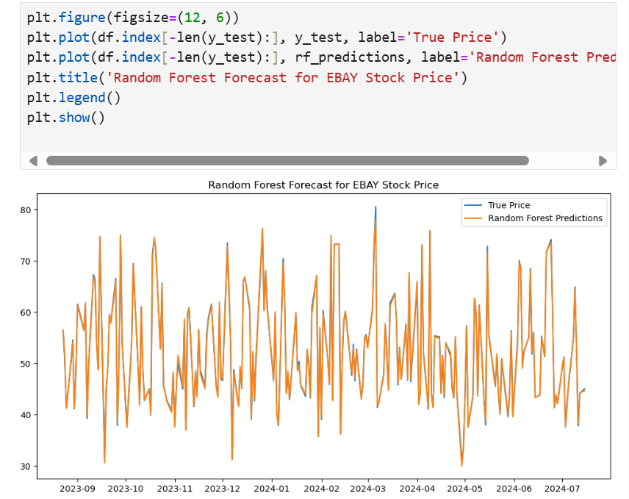

The Random Forest model provides a highly responsive and detailed forecast for eBay's stock prices, effectively capturing the true prices' volatility and rapid changes. The model's predictions closely mirror the observed peaks and troughs, indicating a strong ability to model non-linear relationships in the data. While this makes the Random Forest model well-suited for short-term forecasting, its predictions might be overly reactive, potentially capturing noise alongside genuine price movements. For a more balanced approach, combining Random Forest with other techniques or using ensemble methods could help in achieving a clearer understanding of longer-term trends. Overall, the Random Forest model offers valuable insights into short-term stock price movements, aiding investors and analysts in making informed decisions.

**RCODES AND INTERPRETATION**

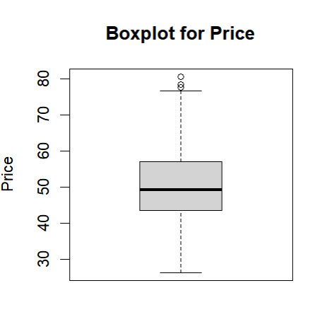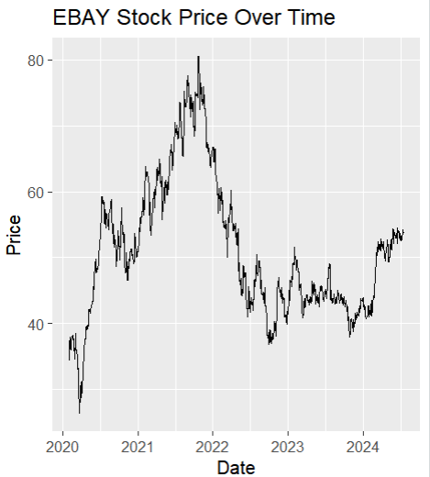

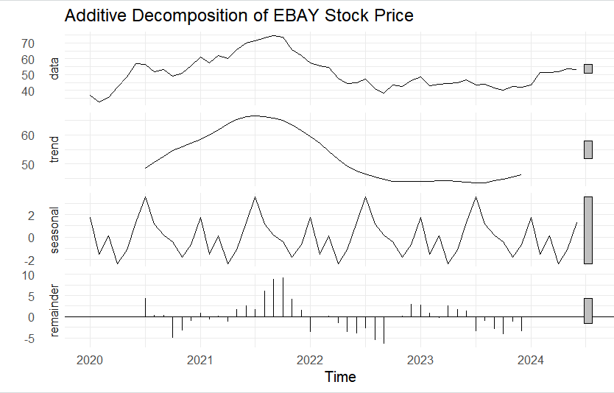 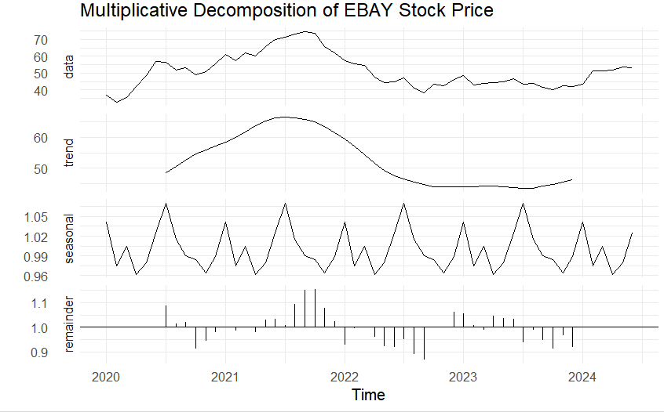

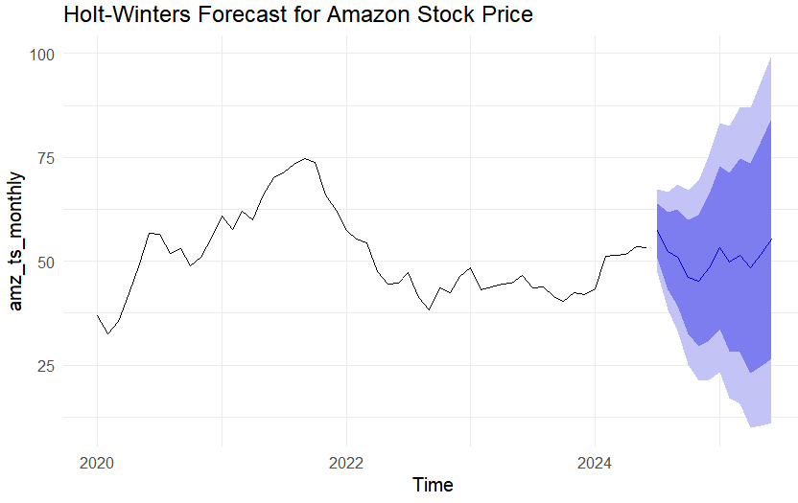

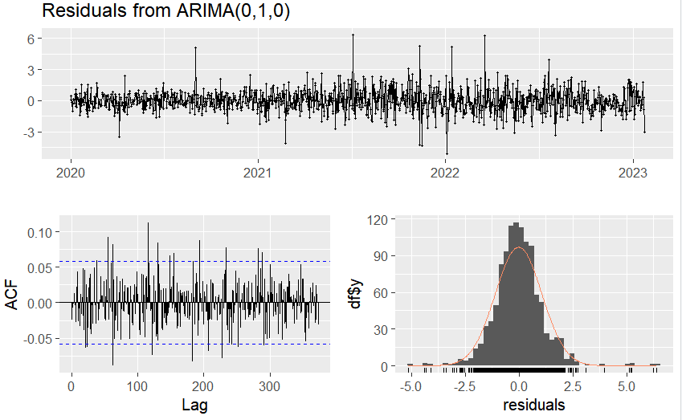

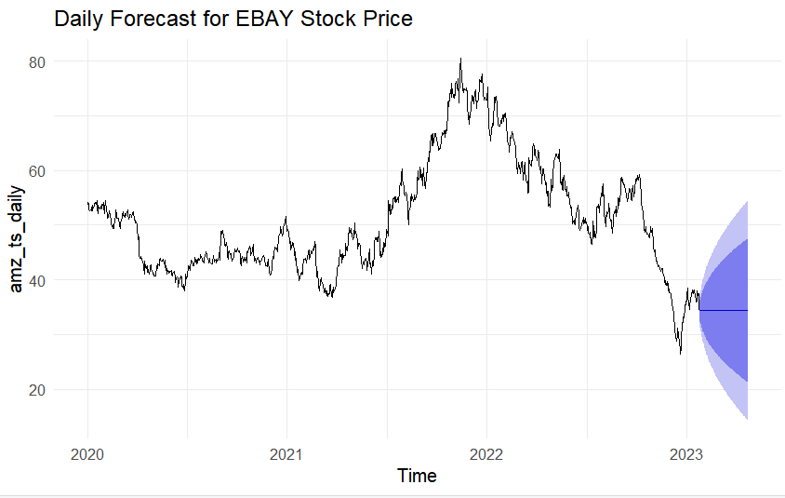 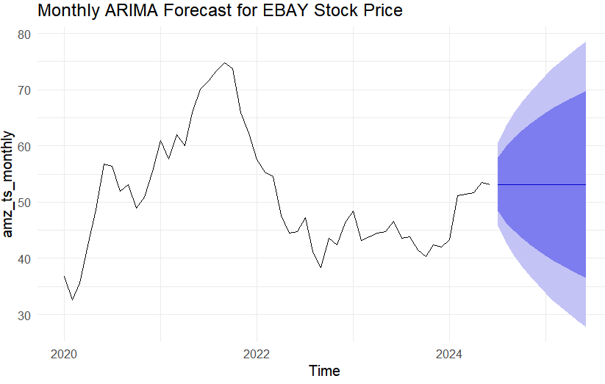

**Interpretation:**

1. Boxplot for Price  
     
   The boxplot for eBay's stock price provides a visual summary of the data distribution. The median stock price is around 50, indicating the central tendency of the data. The interquartile range (IQR), which spans from approximately 40 to 60, shows the middle 50% of the data points. There are a few outliers above 75, represented as points outside the upper whisker, suggesting some days with unusually high stock prices. This boxplot helps identify the overall range, central value, and potential anomalies in the stock price data.
2. eBay Stock Price Over Time  
     
   The line graph illustrates the trend of eBay's stock prices from 2020 to 2024. Initially, the stock price rises sharply, peaking around mid-2021 at about 80. This upward trend may be attributed to positive market conditions or company performance during that period. However, after the peak, there is a notable decline, and the stock price stabilizes between 40 and 50 from 2022 onwards. Towards mid-2024, the stock price shows a slight upward trend, suggesting a potential recovery or stabilization phase. This graph provides a clear picture of the stock's historical performance and key turning points.
3. Additive Decomposition of eBay Stock Price  
     
   The additive decomposition breaks down eBay's stock price data into three components: trend, seasonal, and remainder. The trend component shows a long-term movement with a rise until mid-2021, followed by a decline and subsequent stabilization. The seasonal component captures regular, repeating patterns that occur over time, indicating cyclical fluctuations in the stock prices. The remainder component represents the residuals or random noise after removing the trend and seasonal effects. This decomposition helps in understanding the underlying factors contributing to the stock price movements and isolating the random variations.
4. Multiplicative Decomposition of eBay Stock Price  
     
   Similar to the additive decomposition, the multiplicative decomposition breaks down the stock price data but accounts for multiplicative effects. The trend component is consistent with the additive model, showing a rise, peak, and stabilization. The seasonal component, represented as a multiplicative factor, indicates the impact of seasonal variations on the stock prices. The remainder component highlights the random noise or irregular variations. This decomposition method is useful for time series data where seasonal effects are proportional to the trend level, providing a different perspective on the stock price dynamics.
5. Holt-Winters Forecast for Amazon Stock Price  
     
   The Holt-Winters forecast plot for Amazon's stock price includes the historical data (solid line) and predicted values (shaded area with confidence intervals). The forecast suggests a gradual upward trend in the stock price, indicating positive expectations for the future. The confidence intervals widen as the forecast progresses, reflecting increased uncertainty over time. This model captures both seasonal and trend components, providing a robust forecast that can be valuable for decision-making and strategic planning in financial contexts.
6. Residuals from ARIMA(0,1,0)  
     
   The diagnostic plots for the residuals from the ARIMA(0,1,0) model include a time series plot, an ACF plot, and a histogram. The time series plot shows residuals centered around zero with no obvious pattern, suggesting that the model has adequately captured the underlying structure of the data. The ACF plot indicates that most autocorrelation values are within the confidence intervals, implying that the residuals behave like white noise. The histogram of residuals approximates a normal distribution but with some deviations, suggesting that the residuals are mostly, but not perfectly, normally distributed. These diagnostics confirm the adequacy of the ARIMA model fit.
7. Daily Forecast for eBay Stock Price  
     
   The daily forecast plot for eBay's stock price, generated by a time series model, shows the predicted stock prices along with historical data. The solid line represents the observed stock prices, while the forecasted values are accompanied by confidence intervals. The forecast indicates a continuation of the recent trends, with confidence intervals widening as the prediction horizon extends. This widening reflects increasing uncertainty over longer periods. The forecast provides a useful short-term prediction of stock price movements, aiding in daily trading decisions and short-term investment strategies.
8. Monthly ARIMA Forecast for eBay Stock Price  
     
   The monthly ARIMA forecast plot for eBay's stock prices shows the historical data as a solid line and the forecasted values with confidence intervals. The forecast suggests a stable trend with minor fluctuations in the stock prices. As with the daily forecast, the confidence intervals widen over time, indicating increasing uncertainty. This monthly forecast helps in understanding the expected long-term trends and can be valuable for strategic planning and long-term investment decisions. The ARIMA model's ability to capture both trend and seasonality makes it a reliable tool for monthly stock price forecasting.

The visualizations and models provide a comprehensive view of eBay's stock price data, capturing both historical trends and future forecasts. The decomposition plots help understand the underlying components of the time series, while the forecasting models (Holt-Winters, ARIMA) provide predictions with associated uncertainty. The diagnostic plots for the ARIMA model indicate that the residuals behave like white noise, suggesting a good fit. The various techniques offer insights for different aspects of stock price analysis and forecasting, aiding investors and analysts in making informed decisions.

**RECOMMENDATION**

* Focus on Long-Term Trends:  
    
  Prioritize long-term trends over short-term fluctuations when making investment decisions. This approach provides a clearer picture of the stock's overall performance and potential growth.
* Analyze Trend and Seasonal Components:  
    
  Conduct in-depth analysis of the trend and seasonal components to understand the underlying factors driving stock prices. This helps in identifying consistent patterns and making more informed strategic decisions.
* Utilize ARIMA for Short-Term Predictions:  
    
  Use ARIMA models for short-term stock price predictions. While ARIMA is effective for capturing immediate trends, complement it with additional analyses due to its moderate predictive power, ensuring a comprehensive view.
* Implement LSTM Models for Long-Term Forecasting:  
    
  Apply LSTM models for accurate long-term stock price predictions. Regularly update these models with new data to maintain their accuracy and relevance, adapting to changing market conditions.
* Prefer Random Forest Over Decision Tree:  
    
  Favor Random Forest models over Decision Trees for stock price predictions. Random Forest provides more accurate and reliable forecasts by reducing overfitting and capturing complex patterns in the data.
* Combine Multiple Models:  
    
  Integrate various forecasting models to leverage their individual strengths and enhance prediction accuracy. A combined approach ensures a more robust and reliable investment strategy by balancing the advantages of each model.