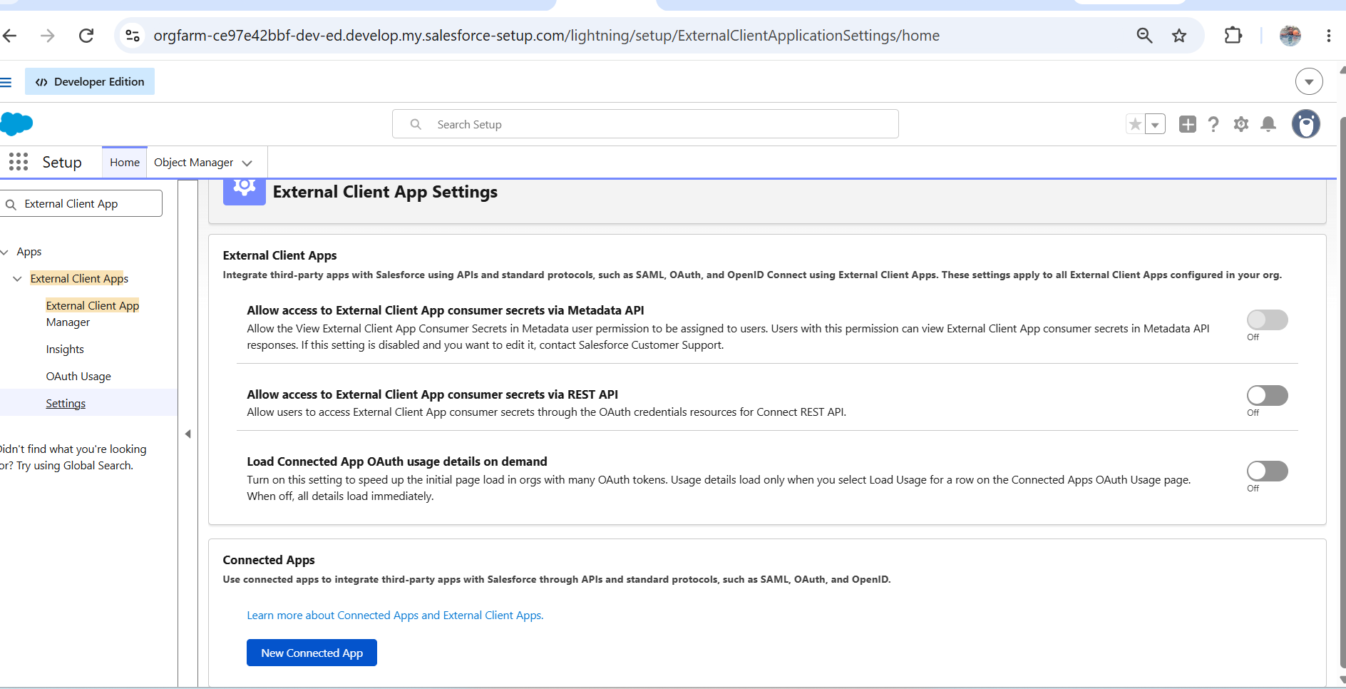

Set up -my domain -get domain name

$body = @{
grant_type = "client_credentials"
client_id = "3MVG9HtWXcDGV.nFEJFFrjTQVA2noJ7D38pR4QVRY6_sZjbxfv8KV9fsdMmEjzIOon3Is4G2zKAWk3l_pQhkY"
client_secret = "748B46F552C4A556AA61C52B0E5568CD07EF1AF926D0AD93980CA8573E8E31A0"
}

Invoke-RestMethod `
-Method Post `
-Uri "https://orgfarm-ce97e42bbf-dev-ed.develop.my.salesforce.com/services/oauth2/token" `
-ContentType "application/x-www-form-urlencoded" `
-Body $bod

https://github.com/forcedotcom/pub-sub-api/blob/main/pubsub_api.proto?utm_source=chatgpt.com

dotnet user-secrets init
dotnet user-secrets set "Salesforce:ClientId" "3MVG9HtWXcDGV.nFEJFFrjTQVA2noJ7D38pR4QVRY6_sZjbxfv8KV9fsdMmEjzIOon3Is4G2zKAWk3l_pQhkY"

dotnet user-secrets set "Salesforce:ClientSecret" "748B46F552C4A556AA61C52B0E5568CD07EF1AF926D0AD93980CA8573E8E31A0"
dotnet user-secrets list

