BBB in AD
Gabriel Mateus Bernardo Harrington
Jimena Monzon Sandoval
Michal Rokicki
Zameel Cader
Caleb Webber
2024-07-11
Abstract
The blood brain barrier, it’s important, probably in AD even
Note that I’ll add a skeleton of all the sections Cell outlines

1 Summary
The neurovascular unit (NVU) is crucial for brain homeostasis and is implicated in Alzheimer’s disease (AD) pathogenesis. We developed a method to isolate the NVU from parenchymal tissue in post-mortem human brains, achieving over 90% vascular cell enrichment. Using single-nuclei sequencing from 40 samples (20 control and 20 AD cases), we identified risk associations with AD in pericyte and perivascular fibroblast subtypes, as well as in activated microglia. These cells have unique risk signatures linked to amyloid, suggesting a collaborative role in AD risk. Additionally, we discovered EndoMT cells, transitioning from endothelial to mural cells, not previously documented in vascular atlases. This study provides a valuable resource for understanding NVU composition and dynamics in AD, highlighting potential cellular targets for therapeutic intervention and offering new insights into the cellular interactions associated with amyloid and AD risk.

2 Introduction
- Role of BBB in AD
- Prior vascular atlases (Yang), their methods, shortcomings and how our method addresses them

3 Results

3.1 Isolating the neurovascular unit
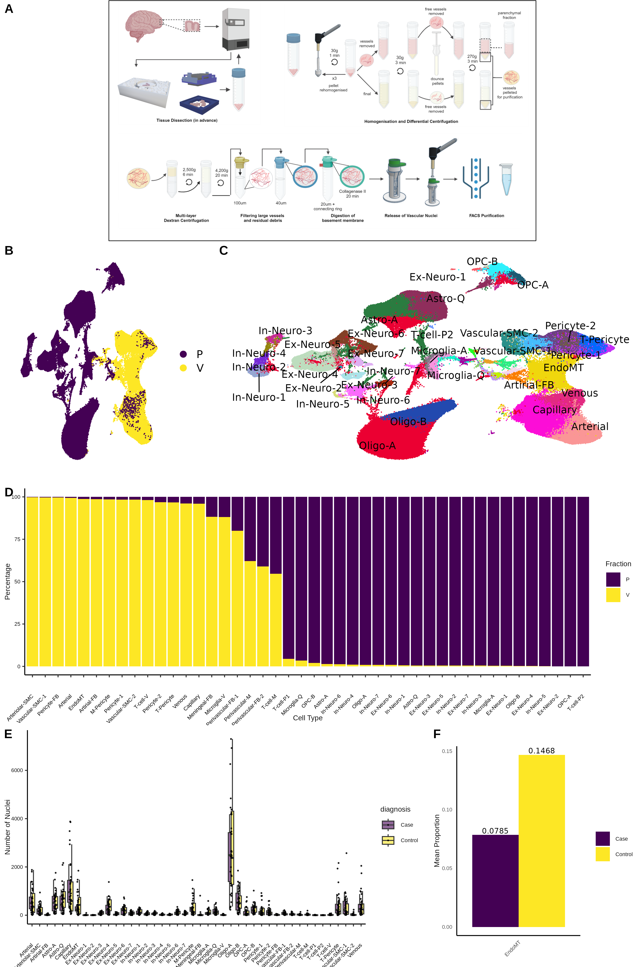
Figure 1
- Explain isolation (or refer to pre-print if it’s ready?)
- The quality/purity of the enrichment
- The cohort details/summary?
- Celltype annotation?

3.2 Risk section summary
- TODO:
- Run the level 1 celltypes through the PPI/GO/MPO analysis
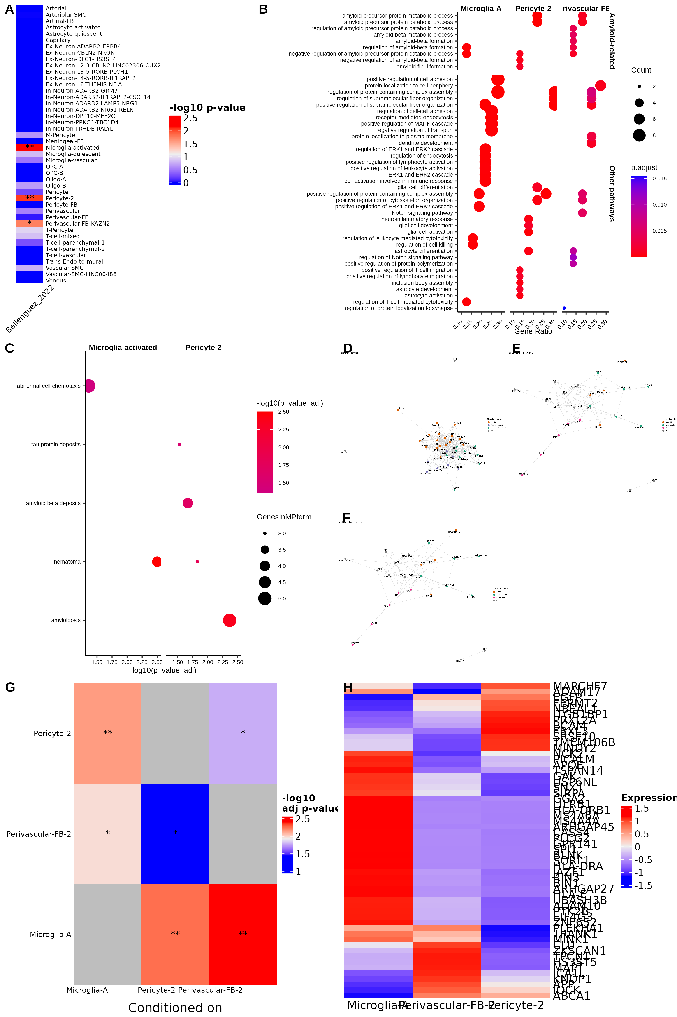
Figure 2
- Analysing Alzheimer’s disease celltype-specific risk with the latest Bellenguez AD GWAS shows a significant enrichment of activated microglia, a pericyte subtype and a perivascular fibroblast subtype.(Bellenguez et al. 2022)
- The prior Kunkle GWAS and Bellenguez without the UKBioBank proxy cases (note in the case of the Bellenguez I lost over half the SNPs in the translation to dbSNP rs IDs, dunno what effect keeping them would have…) do not show the same enrichment.(Kunkle et al. 2019)
- GO terms: running GO on the sig magma genes shows amyloid pathways in all three celltypes and regulation of t-cells in microglia/perictye2

3.3 Identification of Risk Associations in Specific Cell Types
We sought to understand what celltype-specific AD risk associations would emerge with a fuller representation of celltypes in the brain. Using single-nuclei sequencing data, we investigated the association of gene expression profiles in various cell types with Alzheimer’s disease (AD) risk. Our analysis identified significant risk associations in three specific cell types: microglia-A, pericyte-2, and perivascular-FB-2.

3.4 MAGMA Analysis
To determine these associations, we employed Multi-marker Analysis of GenoMic Annotation (MAGMA) against the latest Bellenguez AD Genome-Wide Association Study (GWAS).(Bellenguez et al. 2022) The results revealed significant associations for activated microglia (microglia-A), pericyte-2, and perivascular-FB-2. Microglia-A, which play a crucial role in immune response within the brain, exhibited a pronounced association with AD risk. pericyte-2, involved in blood-brain barrier maintenance and cerebral blood flow regulation, also showed significant associations. Similarly, perivascular-FB-2, essential for the structural integrity of the blood-brain barrier and extracellular matrix composition, were identified as significantly associated with AD risk.

3.4.1 Conditional Analysis
We conducted conditional analysis to assess the independence of the risk signals. The results showed significant enrichment for each of the three cell types even when conditioned on the other two cell types, indicating that the observed signals are unique and not confounded by the other cell types.

3.4.2 Gene Ontology (GO) Enrichment Analysis
To further understand the biological implications of these associations, we performed Gene Ontology (GO) enrichment analysis on the significant genes identified by MAGMA for each of the aforementioned cell types. The GO analysis revealed several enriched pathways, prominently featuring amyloid-related processes. The enrichment of genes involved in amyloid precursor protein (APP) processing, amyloid-beta (Aβ) formation, and amyloid plaque clearance was particularly notable. This finding aligns with the well-established role of amyloid pathology in AD. Additionally, for microglia-A and pericyte-2 cell types, significant GO terms related to T-cell and lymphocyte regulation were identified, suggesting an immune regulatory component in AD risk.

3.4.3 Protein-Protein Interaction (PPI) Networks
We constructed protein-protein interaction networks for the significant genes identified in each cell type. The PPI networks were significant, and subsequent Louvain clustering of these networks revealed modules associated with amyloid-related processes across all three cell types. This suggests a coordinated risk association involving amyloid processing among microglia-A, pericyte-2, and perivascular-FB-2.

3.4.4 Mouse Ontology Data Analysis
To further validate our findings, we used mouse ontology data to investigate the functional implications of the significant genes. For microglia-A, significant associations were found with abnormal cell chemotaxis and hematoma. pericyte-2 showed significant associations with amyloidosis and tau protein deposits. However, no significant associations were identified for perivascular-FB-2.

3.4.5 Interpretation
The identification of these specific cell types and the enrichment of amyloid-related processes underscore the complex interplay between various cellular components in the brain and AD pathology. Microglia-A, pericyte-2, and perivascular-FB-2 may contribute to disease mechanisms through their roles in immune response, vascular integrity, and amyloid processing, respectively. The independence of these signals, as shown by conditional analysis, highlights the unique contributions of each cell type. Additionally, the PPI network analysis suggests a coordinated risk association involving amyloid-related processes across these cell types. Mouse ontology data further supports these findings, particularly highlighting the roles of microglia-A and pericyte-2 cells in AD-related pathologies.
These findings provide new insights into potential cellular targets for therapeutic intervention in Alzheimer’s disease.

This version is more in line with the conventions of scientific writing, avoiding bullet points and providing a more continuous narrative. Adjust the specific details and gene lists as needed based on your actual data.

3.5 DEGs
- ex-neuron 5 - interesting DEGs and sig proportion difference

4 Discussion

5 Acknowledgments

6 Author contributions

7 Declaration of interests

8 Figure titles and legends

9 Tables with title and legends

10 STAR Methods
Link to info on this here: https://www.cell.com/star-authors-guide
And a pdf guide here
- Plan to make the code available on GitHub and make a docker image with the R environment for all the downstream processing - The seurat object from scflow could be included in this image - This could go on ADDI as well?
- Raw data will go on GEO I guess

10.1 Key resoures table

10.2 Resource availability

10.2.1 Lead contact
Further information and requests for resources and reagents should be directed to and will be fulfilled by the lead contact, name here (email here).

10.2.2 Materials availability
No unique reagents were generated for this study.

10.2.3 Data and code availability
- All raw data are available in the GEO database under the accession number GEO:
- The Seurat object generated from the scFlow pipeline is included in the Docker image with the R environment used for analysis here:
- All original code has been deposited at Zenodo and is publicly available as of the date of publication. DOIs are listed in the key resources table.

10.3 Experimental model and study participant details

10.3.1 Post-mortem tissue donors
- Need to add sex info
Post-mortem pre-frontal cortex from 20 controls and 20 AD brain donors were collected from brain bank here under ethics details here. The clinicopathological parameters were collected and summarized in Table 1, including gender, age, diagnosis, APOE status, ethnicity and Braak stage. 3 donors where excluded in QC and of the remaining 37 donors, 23 were female and 14 were male with a median age of 87 (range 48-101). Sex and age were included as a covariates in pseudobulk differential gene expression analysis.

10.4 Method details

10.4.1 Sample prep/neurovascular unit isolation

10.4.2 RNA sequencing

10.5 Quantification and statistical analysis

10.5.1 Data Processing
The raw sequencing data was processed using CellRanger (version 7.1.0, 10X Genomics), which performed initial alignment, filtering, barcode counting, and UMI counting. An updated reference genome (Ensembl version 109 and Gencode version 43 annotations for GRCh38) was generated for use with CellRanger. The resulting gene-barcode matrices were then further processed using the scFlow pipeline implemented in Nextflow.(Khozoie et al. 2021 ; Di Tommaso et al. 2017)

10.5.2 Quality Control
The processed data were read into R (version 4.4.0) using the Seurat package (version 5.1.0).(base?; Seurat?) Basic quality control (QC) measures were applied to ensure data integrity and reliability. Specifically, cells with low feature counts were filtered out, and donors with an insufficient number of high-quality cells were excluded from further analysis, resulting in 3 donors being excluded (both fractions). The criteria for low feature counts and donor exclusion were determined based on established thresholds in the literature and empirical distributions observed in the data.

10.5.3 Cell Type Annotation
Cell types were annotated based on canonical marker genes identified from the literature, (yang2022?) in particular. The expression levels of these marker genes were used to classify cells into distinct cell types. This annotation process was validated by comparing the identified cell types to known cell type distributions in similar datasets.

11 Supplemental information titles and legends
Table 1: Clinical Information. Clinical characteristics of the cohort and samples included in the multi-omics analysis.
donor_id | sex | age | diagnosis | braak_tangle | pH_cerebellum | ethnicity | brain_weight | diagnosis_details | apoe_status
NP011/2019 | M | 94 | Control | II | 6.04 | White (European) | 1386 | Low level AD Braak II, Abnormal deposition of pTDP-43 in medial temporal lobe | 2/4
NP041/2019 | F | 87 | Case | V | 5.57 | Black Caribbean | 1034 | AD, LATE | 3/4
NP067/2018 | M | 81 | Case | VI | 6.43 | unknown | 1172 | AD, LBD, CVD, Hippocampal sclerosis | 4/4
NP076/2014 | F | 95 | Case | V | 5.94 | unknown | 934 | AD | 3/4
NP032/2018 | F | 86 | Control | III | 5.62 | unknown | 1330 | Abnormal deposition of tau protein | 2/3
NP150/2014 | F | 95 | Control | II | 5.17 | unknown | 1317 | Normal aged brain | 3/3
NP077/2018 | M | 82 | Control | II | 5.90 | unknown | 1400 | Normal aged control, low level AD change | 3/4
NP090/17 | M | 70 | Control | II | NA | NA | NA | Aged brain Braak II | 3/3
NP102/17 | F | 81 | Control | II | NA | NA | NA | Normal aged Brain Braak II | 3/3
NP093/13 | F | 90 | Case | V | NA | NA | NA | Alzheimer's disease, Braak V, CVD | 3/3
NP018/14 | F | 85 | Case | VI | NA | NA | NA | AD Braak VI | 3/4
NP406/16 | F | 81 | Case | VI | NA | NA | NA | AD Braak VI | 2/4
NP096/13 | F | 92 | Control | II | NA | NA | NA | Normal aged brain Braak II | 3/3
NP127/14 | F | 89 | Case | IV | NA | NA | NA | AD Braak IV | 4/4
NP080/15 | M | 71 | Control | I | NA | NA | NA | Normal aged brain Braak I | 3/3
NP054/17 | F | 73 | Case | VI | NA | NA | NA | AD Braak VI | 3/4
NP109/17 | F | 77 | Control | I | NA | NA | NA | Normal aged brain Braak I | 3/3
NP048/19 | M | 71 | Control | I | NA | NA | NA | Aged brain Braak I | 3/3
NP011/14 | F | 93 | Control | III | NA | NA | NA | Normal aged brain . Braak III | 3/3
NP160/13 | F | 88 | Case | IV | NA | NA | NA | AD Braak IV, CVD | 3/4
NP024/17 | M | 74 | Control | II | NA | NA | NA | Control with low level AD Braak II | 3/3
NP092/19 | M | 98 | Case | IV | NA | NA | NA | AD, LATE, CVD Braak IV | 3/4
NP103/13 | F | 48 | Control | NA | NA | NA | NA | Control | 3/3
NP037/18 | F | 101 | Case | V | NA | NA | NA | AD, CVD Braak V | 3/4
NP016/2017 | F | 89 | Control | II | 5.67 | unknown | 1366 | Aged brain, CVD | 3/3
NP163/13 | F | 89 | Case | IV | NA | NA | NA | AD Braak IV, CVD | 3/4
NP034/2014 | F | 87 | Case | VI | 5.95 | unknown | 1060 | AD | 2/4
NP008/2015 | F | 87 | Control | II | 6.86 | unknown | 1101 | Normal aged brain | 3/3
NP002/2019 | M | 88 | Case | VI | 5.63 | unknown | 1151 | AD, CVD | 4/4
NP070/2019 | M | 85 | Control | II | 6.03 | unknown | 1367 | Control with low level AD change Braak II | 3/3
NP128/2017 | M | 87 | Control | I | 6.10 | unknown | 1368 | Control, CVD | 3/3
NP080/2014 | F | 89 | Case | V | 6.67 | unknown | 1101 | AD, LBD, CVD | 3/3
NP018/2019 | M | 87 | Case | V | 5.93 | unknown | 1154 | AD Braak V | 3/4
NP142/2014 | M | 85 | Case | VI | 6.22 | unknown | 1372 | AD Braak VI | 3/3
NP058/2019 | M | 89 | Control | II | 5.58 | unknown | 1141 | Low level AD | 3/3
NP177/2013 | F | 90 | Case | V | 5.58 | unknown | 1153 | AD, LBD | 3/3
NP063/2019 | F | 89 | Control | II | 5.69 | White (European) | 1280 | Aged brainLow level AD | 3/3
package | loadedversion
Bioconductor 3.19 (R 4.4.0)
AnnotationDbi | 1.66.0
AnnotationFilter | 1.28.0
AnnotationHub | 3.12.0
BSgenome | 1.72.0
Biobase | 2.64.0
BiocFileCache | 2.12.0
BiocGenerics | 0.50.0
BiocIO | 1.14.0
BiocNeighbors | 1.22.0
BiocParallel | 1.38.0
BiocSingular | 1.20.0
BiocVersion | 3.19.1
ComplexHeatmap | 2.20.0
DESeq2 | 1.44.0
DelayedArray | 0.30.1
DelayedMatrixStats | 1.26.0
DropletUtils | 1.24.0
EWCE | 1.12.0
ExperimentHub | 2.12.0
GEOquery | 2.72.0
GOSemSim | 2.30.0
GenomicAlignments | 1.40.0
GenomicFeatures | 1.56.0
GenomicFiles | 1.40.0
HDF5Array | 1.32.0
KEGGgraph | 1.64.0
MAST | 1.30.0
MatrixGenerics | 1.16.0
MungeSumstats | 1.12.0
PCAtools | 2.16.0
ProtGenerics | 1.36.0
Rgraphviz | 2.48.0
Rhdf5lib | 1.26.0
Rsamtools | 2.20.0
SC3 | 1.32.0
ScaledMatrix | 1.12.0
SingleCellExperiment | 1.26.0
SummarizedExperiment | 1.34.0
UCSC.utils | 1.0.0
VariantAnnotation | 1.50.0
XVector | 0.44.0
alabaster.sce | 1.4.0
alabaster.schemas | 1.4.0
batchelor | 1.20.0
beachmat | 2.20.0
bluster | 1.14.0
cellity | 1.32.0
clusterProfiler | 4.12.0
edgeR | 4.2.0
enrichplot | 1.24.0
ensembldb | 2.28.0
ewceData | 1.12.0
fgsea | 1.30.0
gage | 2.54.0
gageData | 2.42.0
ggtree | 3.12.0
graph | 1.82.0
gypsum | 1.0.1
metapod | 1.12.0
orthogene | 1.10.0
pathview | 1.44.0
preprocessCore | 1.66.0
qusage | 2.38.0
qvalue | 2.36.0
rhdf5 | 2.48.0
rhdf5filters | 1.16.0
rrvgo | 1.16.0
rtracklayer | 1.64.0
scRNAseq | 2.18.0
scater | 1.32.0
scran | 1.32.0
scuttle | 1.14.0
simona | 1.2.0
sparseMatrixStats | 1.16.0
speckle | 1.4.0
topGO | 2.56.0
treeio | 1.28.0
zlibbioc | 1.50.0
Bioconductor
BSgenome.Hsapiens.1000genomes.hs37d5 | 0.99.1
BSgenome.Hsapiens.NCBI.GRCh38 | 1.3.1000
EnsDb.Hsapiens.v79 | 2.99.0
GO.db | 3.19.1
GenomeInfoDbData | 1.2.12
HDO.db | 0.99.1
SNPlocs.Hsapiens.dbSNP155.GRCh37 | 0.99.24
SNPlocs.Hsapiens.dbSNP155.GRCh38 | 0.99.24
org.Hs.eg.db | 3.19.1
org.Mm.eg.db | 3.19.1
RSPM (R 4.4.0)
BiocManager | 1.30.23
DirichletReg | 0.7-1
Formula | 1.2-5
HGNChelper | 0.8.14
NMF | 0.27
RApiSerialize | 0.1.3
RNOmni | 1.0.1.2
RSQLite | 2.3.7
Seurat | 5.1.0
SeuratObject | 5.0.2
UpSetR | 1.4.0
WebGestaltR | 0.4.6
apcluster | 1.4.13
babelgene | 22.9
backports | 1.5.0
base64url | 1.4
broom | 1.0.6
coda | 0.19-4.1
dqrng | 0.4.1
english | 1.2-6
enrichR | 3.2
estimability | 1.5.1
fastmap | 1.2.0
formattable | 0.2.1
ggdendro | 0.2.0
ggfun | 0.1.5
ggnetwork | 0.5.13
googleAuthR | 2.0.2
gprofiler2 | 0.2.3
grr | 0.9.5
homologene | 1.4.68.19.3.27
humaniformat | 0.6.0
leaflet | 2.2.2
maxLik | 1.5-2.1
minqa | 1.2.7
miscTools | 0.6-28
mvtnorm | 1.2-5
network | 1.18.2
openssl | 2.2.0
paletteer | 1.6.0
rliger | 2.0.1
rmarkdown | 2.27
sandwich | 3.1-0
sessioninfo | 1.2.2
sna | 2.7-2
splitstackshape | 1.4.8
statnet.common | 4.9.0
stringfish | 0.16.0
stringi | 1.8.4
systemfonts | 1.1.0
threejs | 0.3.3
uwot | 0.2.2
whisker | 0.4.1
Bioconductor 3.19 (R 4.4.1)
Biostrings | 2.72.1
DOSE | 3.30.1
GenomeInfoDb | 1.40.1
GenomicRanges | 1.56.1
IRanges | 2.38.1
KEGGREST | 1.44.1
ResidualMatrix | 1.14.1
S4Arrays | 1.4.1
S4Vectors | 0.42.1
SparseArray | 1.4.8
alabaster.base | 1.4.2
alabaster.matrix | 1.4.2
alabaster.ranges | 1.4.2
alabaster.se | 1.4.1
biomaRt | 2.60.1
limma | 3.60.3
Github (jinworks/CellChat@862ab34277942ca26dad41ed2d168fcbdf952950)
CellChat | 2.1.2
RSPM (R 4.4.1)
DBI | 1.2.3
RcppParallel | 5.1.8
SparseM | 1.84
XML | 3.99-0.17
aplot | 0.2.3
cli | 3.6.3
crayon | 1.5.3
digest | 0.6.36
downlit | 0.4.4
emmeans | 1.10.3
evaluate | 0.24.0
ggsci | 3.2.0
knitr | 1.48
lme4 | 1.1-35.5
locfit | 1.5-9.10
nloptr | 2.1.1
ps | 1.7.7
reticulate | 1.38.0
rlang | 1.1.4
robustbase | 0.99-3
scatterpie | 0.2.3
secretbase | 1.0.0
spatstat.data | 3.1-2
spatstat.sparse | 3.1-0
spatstat.utils | 3.0-5
targets | 1.7.1
xfun | 0.45
yaml | 2.3.9
CRAN (R 4.4.0)
DEoptimR | 1.1-3
DT | 0.33
FNN | 1.1.4
GetoptLong | 1.0.5
GlobalOptions | 0.1.2
KernSmooth | 2.23-24
NLP | 0.2-1
Polychrome | 1.5.1
R.methodsS3 | 1.8.2
R.oo | 1.26.0
R.utils | 2.12.3
R6 | 2.5.1
RANN | 2.6.1
RColorBrewer | 1.1-3
RCurl | 1.98-1.14
ROCR | 1.0-11
RSpectra | 0.16-1
RcppAnnoy | 0.0.22
RcppHNSW | 0.6.0
Rtsne | 0.17
SnowballC | 0.7.1
WriteXLS | 6.6.0
abind | 1.4-5
ape | 5.8
askpass | 1.2.0
assertthat | 0.2.1
base64enc | 0.1-3
beeswarm | 0.4.0
bit | 4.0.5
bit64 | 4.0.5
bitops | 1.0-7
blob | 1.2.4
bslib | 0.7.0
cachem | 1.1.0
callr | 3.7.6
car | 3.1-2
carData | 3.0-5
cellranger | 1.1.0
circlize | 0.4.16
clue | 0.3-65
colorspace | 2.1-0
corrgram | 1.14
cowplot | 1.1.3
crosstalk | 1.2.1
curl | 5.2.1
data.table | 1.15.4
dbplyr | 2.5.0
deldir | 2.0-4
dichromat | 2.0-0.1
doParallel | 1.0.17
doRNG | 1.8.6
dotCall64 | 1.1-1
dplyr | 1.1.4
e1071 | 1.7-14
europepmc | 0.4.3
fansi | 1.0.6
farver | 2.1.2
fastDummies | 1.7.3
fastmatch | 1.1-4
fftw | 1.0-8
filelock | 1.0.3
fitdistrplus | 1.1-11
forcats | 1.0.0
foreach | 1.5.2
fs | 1.6.4
furrr | 0.3.1
future | 1.33.2
future.apply | 1.11.2
gargle | 1.5.2
generics | 0.1.3
ggalluvial | 0.12.5
ggbeeswarm | 0.7.2
ggforce | 0.4.2
ggplot2 | 3.5.1
ggplotify | 0.1.2
ggpubr | 0.6.0
ggraph | 2.2.1
ggrepel | 0.9.5
ggridges | 0.5.6
ggsignif | 0.6.4
ggvenn | 0.1.10
globals | 0.16.3
glue | 1.7.0
goftest | 1.2-3
graphlayouts | 1.1.1
gridBase | 0.4-7
gridExtra | 2.3
gridGraphics | 0.5-1
gson | 0.1.0
gt | 0.10.1
gtable | 0.3.5
haven | 2.5.4
here | 1.0.1
hms | 1.1.3
htmltools | 0.5.8.1
htmlwidgets | 1.6.4
httpuv | 1.6.15
httr | 1.4.7
httr2 | 1.0.1
ica | 1.0-3
igraph | 2.0.3
irlba | 2.3.5.1
iterators | 1.0.14
janeaustenr | 1.0.0
janitor | 2.2.0
jquerylib | 0.1.4
jsonlite | 1.8.8
kableExtra | 1.4.0
labelled | 2.13.0
later | 1.3.2
lazyeval | 0.2.2
leiden | 0.4.3.1
lifecycle | 1.0.4
listenv | 0.9.1
lmtest | 0.9-40
lubridate | 1.9.3
magrittr | 2.0.3
mapproj | 1.2.11
maps | 3.4.2
matrixStats | 1.3.0
memoise | 2.0.1
mime | 0.12
miniUI | 0.1.1.1
munsell | 0.5.1
mvoutlier | 2.1.1
nlme | 3.1-165
pals | 1.8
parallelly | 1.37.1
patchwork | 1.2.0
pbapply | 1.7-2
pcaPP | 2.0-4
pheatmap | 1.0.12
pillar | 1.9.0
pkgconfig | 2.0.3
plyr | 1.8.9
png | 0.1-8
polyclip | 1.10-6
prettyunits | 1.2.0
processx | 3.8.4
progress | 1.2.3
progressr | 0.14.0
promises | 1.3.0
proxy | 0.4-27
purrr | 1.0.2
qs | 0.26.3
rappdirs | 0.3.3
readr | 2.1.5
readxl | 1.4.3
registry | 0.5-1
rematch2 | 2.1.2
remotes | 2.5.0
reshape | 0.8.9
reshape2 | 1.4.4
restfulr | 0.0.15
rjson | 0.2.21
rngtools | 1.5.2
rprojroot | 2.0.4
rrcov | 1.7-5
rstatix | 0.7.2
rstudioapi | 0.16.0
rsvd | 1.0.5
sass | 0.4.9
scales | 1.3.0
scattermore | 1.2
scatterplot3d | 0.3-44
sctransform | 0.4.1
sgeostat | 1.0-27
shadowtext | 0.1.3
shape | 1.4.6.1
shiny | 1.8.1.1
slam | 0.1-50
snakecase | 0.11.1
sp | 2.1-4
spam | 2.10-0
spatstat.explore | 3.2-7
spatstat.geom | 3.2-9
spatstat.random | 3.2-3
statmod | 1.5.0
stringr | 1.5.1
survival | 3.7-0
svglite | 2.1.3
tensor | 1.5
tibble | 3.2.1
tidygraph | 1.3.1
tidyr | 1.3.1
tidyselect | 1.2.1
tidytext | 0.4.2
tidytree | 0.4.6
timechange | 0.3.0
tm | 0.7-13
tokenizers | 0.3.0
treemap | 2.4-4
triebeard | 0.4.1
tweenr | 2.0.3
tzdb | 0.4.0
umap | 0.2.10.0
urltools | 1.7.3
utf8 | 1.2.4
vctrs | 0.6.5
vipor | 0.4.7
viridis | 0.6.5
viridisLite | 0.4.2
vroom | 1.6.5
wesanderson | 0.3.7
withr | 3.0.0
wordcloud | 2.6
xml2 | 1.3.6
xtable | 1.8-4
yulab.utils | 0.1.4
zoo | 1.8-12
Github (chris-mcginnis-ucsf/DoubletFinder@03e9f37f891ef76a23cc55ea69f940c536ae8f9f)
DoubletFinder | 2.0.4
CRAN (R 4.4.1)
MASS | 7.3-61
CRAN (R 4.3.3)
Matrix | 1.6-5
boot | 1.3-30
CRAN (R 4.3.2)
Rcpp | 1.0.12
cluster | 2.1.6
Github (satijalab/seurat-wrappers@8d46d6c47c089e193fe5c02a8c23970715918aa9)
SeuratWrappers | 0.3.5
Github (ropensci/bib2df@de0838da561544361d9be6ff20192d0d1c794cde)
bib2df | 1.1.2.0
CRAN (R 4.3.1)
class | 7.3-22
lattice | 0.22-5
CRAN (R 4.2.2)
codetools | 0.2-19
Github (theislab/kBET@afc5f431bcbefd73267acc066a0f2e4eaa10a355)
kBET | 0.99.6
Github (cole-trapnell-lab/monocle3@98402ed0c10cac020524bebbb9300614a799f6d1)
monocle3 | 1.3.7
Github (ropensci/plotly@963b9143ba4102eca8edbd4750d4c85541ddd0f5)
plotly | 4.10.4.9000
Github (immunogenomics/presto@7636b3d0465c468c35853f82f1717d3a64b3c8f6)
presto | 1.0.0
Github (neurogenomics/scFlow@065bc13dacee707a0437fb65e006647660fc13c7)
scFlow | 0.7.4
Github (rpolicastro/scProportionTest@37a04900be1c991428da15af7f9aa7b0ad84661e)
scProportionTest | 0.0.0.9000

12 References
Bellenguez, Céline, Fahri Küçükali, Iris E. Jansen, Luca Kleineidam, Sonia Moreno-Grau, Najaf Amin, Adam C. Naj, et al. 2022. “New Insights into the Genetic Etiology of Alzheimer’s Disease and Related Dementias.” Nature Genetics 54 (4): 412–36. https://doi.org/10.1038/s41588-022-01024-z.
Di Tommaso, Paolo, Maria Chatzou, Evan W. Floden, Pablo Prieto Barja, Emilio Palumbo, and Cedric Notredame. 2017. “Nextflow Enables Reproducible Computational Workflows.” Nature Biotechnology 35 (4): 316–19. https://doi.org/10.1038/nbt.3820.
Khozoie, Combiz, Nurun Fancy, Mahdi Marjaneh, Alan Murphy, Paul Matthews, and Nathan Skene. 2021. “scFlow: A Scalable and Reproducible Analysis Pipeline for Single-Cell RNA Sequencing Dat.” https://doi.org/10.22541/au.162912533.38489960/v2.
Kunkle, Brian W., Benjamin Grenier-Boley, Rebecca Sims, Joshua C. Bis, Vincent Damotte, Adam C. Naj, Anne Boland, et al. 2019. “Genetic Meta-Analysis of Diagnosed Alzheimer’s Disease Identifies New Risk Loci and Implicates Aβ, Tau, Immunity and Lipid Processing.” Nature Genetics 51 (3): 414–30. https://doi.org/10.1038/s41588-019-0358-2.

