Prize sponsored by:



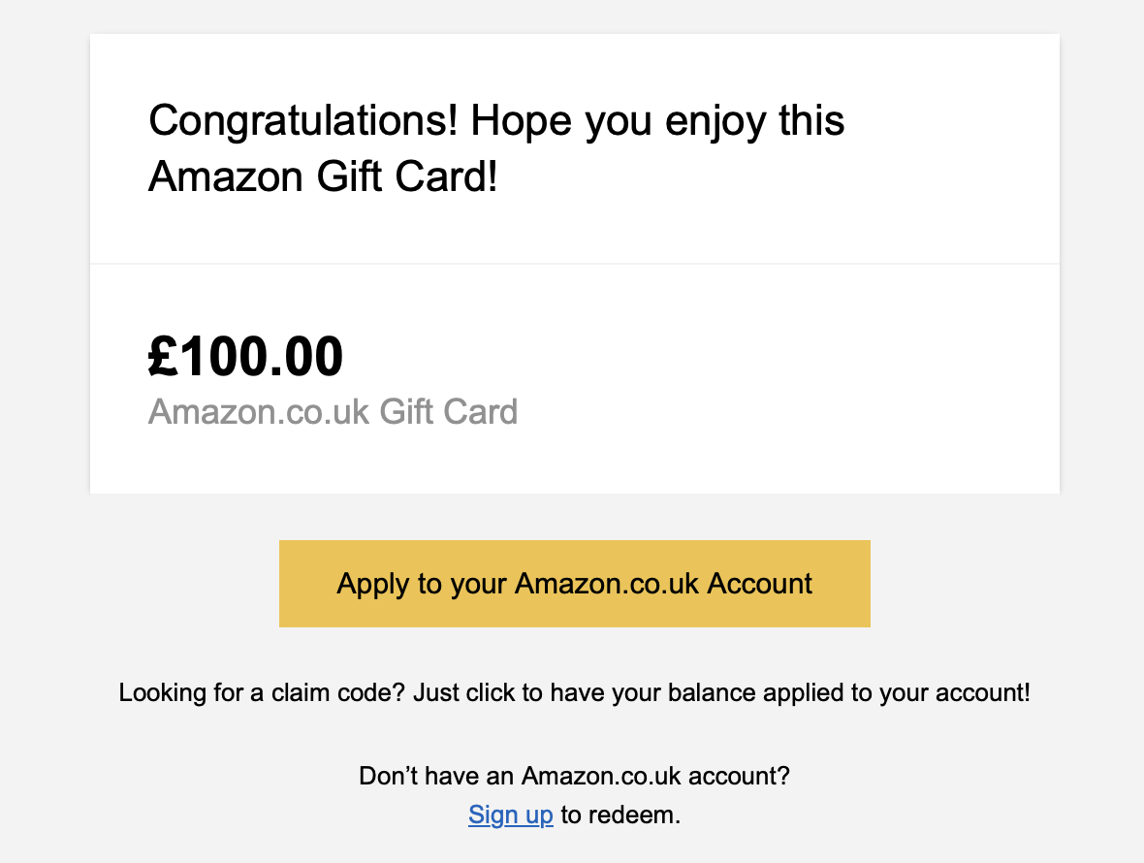

How to redeem the E-voucher?

1. Communicate your email address to Christina Maat ([christina.maat@ukdri.ac.uk](mailto:christina.maat@ukdri.ac.uk))
2. The gift card will be transferred to your email address; you should receive an email within 24 hours after transfer

**Congratulations again!!**