UKDS_quarto

## Running Code

x <- seq(-4, 4, length=100)  
y <- dnorm(x)  
plot(x,y, type = "l", lwd = 2, axes = FALSE, xlab = "", ylab = "")  
axis(1, at = -3:3, labels = c("-3s", "-2s", "-1s", "mean", "1s", "2s", "3s"))

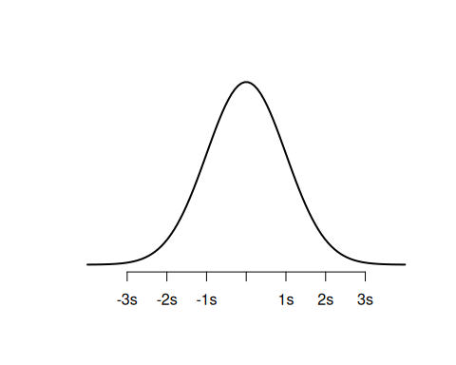

## Running Code

We can choose to display or hide the code: below is the same plot with the R code hidden



## Stata Code

sysuse auto, clear  
describe

Running /usr/local/stata16/profile.do . sysuse auto, clear  
(1978 Automobile Data)  
  
. describe  
  
Contains data from /usr/local/stata16/ado/base/a/auto.dta  
 obs: 74 1978 Automobile Data  
 vars: 12 13 Apr 2018 17:45  
 (_dta has notes)  
-------------------------------------------------------------------------------  
 storage display value  
variable name type format label variable label  
-------------------------------------------------------------------------------  
make str18 %-18s Make and Model  
price int %8.0gc Price  
mpg int %8.0g Mileage (mpg)  
rep78 int %8.0g Repair Record 1978  
headroom float %6.1f Headroom (in.)  
trunk int %8.0g Trunk space (cu. ft.)  
weight int %8.0gc Weight (lbs.)  
length int %8.0g Length (in.)  
turn int %8.0g Turn Circle (ft.)  
displacement int %8.0g Displacement (cu. in.)  
gear_ratio float %6.2f Gear Ratio  
foreign byte %8.0g origin Car type  
-------------------------------------------------------------------------------  
Sorted by: foreign

… And Python

import numpy as np  
import matplotlib.pyplot as plt  
from scipy.stats import norm  
  
#x-axis ranges from -3 and 3 with .001 steps  
x = np.arange(-3, 3, 0.001)  
  
#plot normal distribution with mean 0 and standard deviation 1  
plt.plot(x, norm.pdf(x, 0, 1))

