MEMORANDUM OF ACCOUNTS: Payment for CCA Annual Charge(s)

Payee:  The Environment Agency | VAT: Outside Scope
Payee Address:  Shared Services Connected Ltd  Sortation Ref 601  Phoenix House  Newport  NP10 8FZ | Payment Reference: «${params.moaData.transactionId}»
Issue date: «${currentDate» | Due Date: Immediate

«${params.sectorContactFullName}»  «${params.sectorAssociationName}»  «${params.sectorContactAddress}» |  | CCA Sector Identifier:  Due Date:  Amount:  GB Pounds Sterling | «${params.sectorId}»  Immediate  «${(params.moaData.moaAmount)?string["#,#»

Memorandum of Account (MoA) for payment in respect of the Climate Change Agreement Scheme Annual Charge
The charge for the sector covers the following target units and facilities:
Item | Description |  |  | GB Pounds Sterling
«@before-row[#list params.lineItems as it»«${(item.groupId)!}»«@after-row[/#list]» | «${item.id}» | «${item.name}» | «${(item.period)!}» | «[#if (item.amount)??]${(item.amount)?str»
 | VAT: Outside Scope |  |  | 0.00
 | Total (GB Pounds Sterling) |  |  | «${(params.moaData.moaAmount)?string["#,#»

PTO
Payment Methods

Annual charge payments must be paid in full to the Environment Agency in Pound Sterling using one of the methods below.

Direct Debit
We can only accept payment by Direct Debit if this MoA was issued in April. (If this MoA has another issue date you will need to make payment by another approved method.)

Please complete the attached Direct Debit mandate form and return the completed form to the following address:
Shared Services Connected Ltd
Sortation Ref 601
Phoenix House
Newport
NP10 8FZ

BACS/CHAPS
Please use the bank account details below, together with your unique Payment Reference (on the front page of the MoA) when setting up your BACS/CHAPS transfer. This will help us to identify your payment and avoids any delay in confirming receipt. (If your payment system does not allow you to use the payment reference in full, please ensure you include at least the letters and the final three digits.)

Account Holder Name: | The Environment Agency
Account Name: | EA RECEIPTS
Bank: | RBS
Address: | Royal Bank of Scotland plc, London Corporate Service Centre, CPB Services 2nd Floor, 280 Bishopsgate, London, EC2M 4RB
Sort Code: | 60-70-80
Account Number: | 10014411
IBAN: | GB23NWBK60708010014411
SWIFTBIC: | NWBKGB2L

Credit/Debit Card
You should pay by Direct Debit or BACS/CHAPS transfer if have means to do so. If you have no other option you may pay using a corporate credit/debit card from the list below. To make a card payment please call us on 03708 506 506 between 9am and 5pm, Monday to Friday.

Mark X in the appropriate box:

MasterCard
Visa
Maestro UK

Please send your payment remittance advice by email to: ea_fsc_ar@gov.sscl.com with a copy to ccapayments@environment-agency.gov.uk

If you have any queries about this MoA please email cca-help@environment-agency.gov.uk in the first instance, or alternatively call us on 03708 506 506.

Guidance about the CCA Scheme can be found at https://www.gov.uk/guidance/climate-change-agreements--2

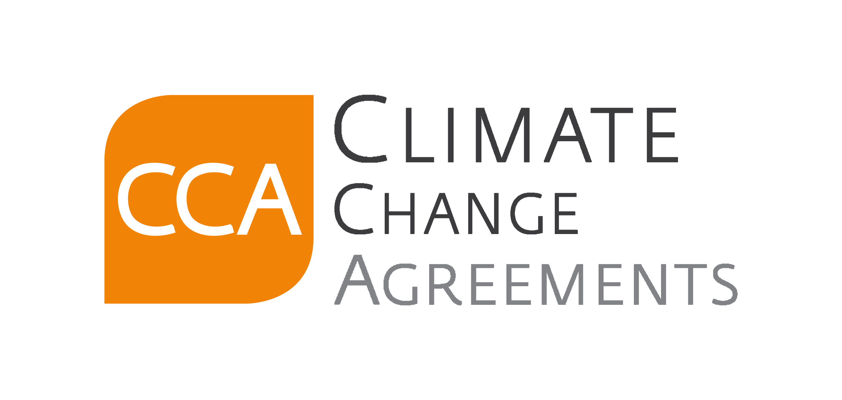

Application to pay your annual charge by Direct Debit

Please fill in the whole form using a black ball point pen and send the completed form to the following address:

SSCL (Environment Agency), PO Box 797, Newport, Gwent NP10 8FZ

Your Name:
Your Address:
Post Code:
Email Address:
Contact Number:
Please indicate your preferred payment plan to us by ticking one of the boxes below.
If you fail to make a selection, or your preference is unclear, then the Environment Agency will take one payment from your bank account.

◻ | One Payment
◻ | Two Payments
◻ | Three Payments

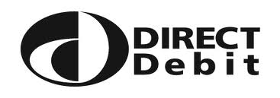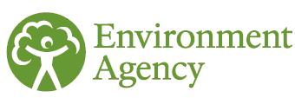Instruction to your Bank or Building

Society to pay by Direct Debit

Please complete this section using a black ball point pen:

Name(s) of Account Holder(s):
Bank/Building Society account number

Branch Sort Code

Name and full postal address of your Bank or Building Society
To: The Manager | Bank/Building Society

Service User Number:
4 | 1 | 1 | 0 | 0 | 2

Reference:

Please pay Environment Agency Direct Debits from the account detailed in this Instruction subject to the safeguards assured by the Direct Debit Guarantee. I understand that this Instruction may remain with Environment Agency and, if so, details will be passed electronically to my Bank/Building Society.

Signature(s)
Date

Banks and Building Societies may not accept Direct Debit instructions for some types of account
Direct Debit Guarantee
This guarantee should be detached and retained by the payer.

The Direct Debit Guarantee 

This Guarantee is offered by all banks and building societies that accept instructions to pay Direct Debits.

If there are any changes to the amount, date or frequency of your Direct Debit, the Environment Agency will notify you 10 working days in advance of your account being debited or as otherwise agreed. If you request the Environment Agency to collect a payment, confirmation of the amount and date will be given to you at the time of your request.

If an error is made in the payment of your Direct Debit, by Environment Agency or your bank or building society you are entitled to a full and immediate refund of the amount paid from your bank or building society – if you receive a refund you are not entitled to, you must pay it back when Environment Agency asks you to.

You can cancel a Direct Debit at any time by simply contacting your bank or building society. Written confirmation may be required. Please also notify us.

