«${currentDate?date?string('dd MMMM yyyy'»
CCA Register Ref: «${workflow.requestId}»

Sector Identifier: «${account.sectorIdentifier}»
Operator name: «${params.targetUnitDetails.name}»
Company registration number: «${(params.targetUnitDetails.companyRegis»

«${account.sectorContactLocation}»
«${account.sectorContactEmail}»

CLIMATE CHANGE AGREEMENTS SCHEME

UNDERLYING AGREEMENT APPLICATION REFUSAL
Dear «${account.sectorContactFullName}»
We are writing to inform «${account.sectorIdentifier}» ("you") that the application from «${params.targetUnitDetails.name}» to setup an underlying agreement ("the agreement") within the Climate Change Agreement scheme to qualify for the Climate Change Levy discount under Part IV of Schedule 6 to the Finance Act 2000 (as amended), has been refused. This refusal applies to the following target unit:

Target Unit: | «${account.targetUnitIdentifier}» – «${params.targetUnitDetails.name}»
 | «${params.targetUnitDetails.location}»
This is following the information you have provided us from the target unit during the application process. We have considered this carefully and deemed that the information provided has been either insufficient or energy processes are not eligible. The specific comments relating to this refusal are shown below:
«${params.reason}»
If you require any clarification of the above, please contact a member of the CCA Operations team at cca-help@environment-agency.gov.uk or consult the Climate Change Agreement guidance on-line at http://www.environment-agency.gov.uk/CCA.

Yours faithfully
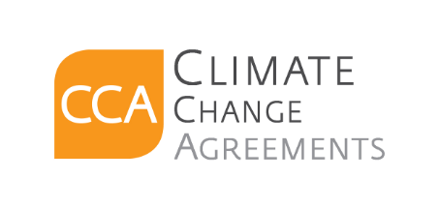
CCA Team

c.c. «[#list email.ccRecipients as cc]»«${cc}[#sep], [/#sep]»«[/#list]»

