«${currentDate?date?string('dd MMMM yyyy'»
CCA Register Ref: «${workflow.requestId}»

Sector identifier: «${account.sectorIdentifier}»
Operator name: «${params.targetUnitDetails.name}»
Company registration number: «${(params.targetUnitDetails.companyRegis»
TU Identifier: «${account.targetUnitIdentifier}»

«${params.targetUnitDetails.location}»
«${params.targetUnitDetails.primaryContac»

CLIMATE CHANGE AGREEMENTS SCHEME

UNDERLYING AGREEMENT ACTIVATED

Dear «${params.targetUnitDetails.primaryContac»,

We are writing to inform «${params.targetUnitDetails.name}» (“you”) that your underlying agreement (“the agreement”) for the Climate Change Agreement scheme (“the scheme”) has been activated. This will now allow your target unit and the facilities listed within your agreement to qualify for the Climate Change Levy discount under Part IV of Schedule 6 to the Finance Act 2000 (as amended). The details below confirm the target unit and agreement to which this letter relates.

Target Unit: | «${account.targetUnitIdentifier}» – «${params.targetUnitDetails.name}»
 | «${params.targetUnitDetails.targetUnitAdd»
Agreement Identifier: | «${account.targetUnitIdentifier}» «${params.version}»

We will notify HMRC that this agreement has been activated for your target unit and the facilities named within it.

You need to notify HMRC and your energy supplier(s) using the PP10 and PP11 forms to enable you to begin claiming the CCA relief on the Climate Change Levy.

If you require any clarification of the above, please contact your sector association.

If you need to contact the Administrator for any supporting information, please use the following email: cca-help@environment-agency.gov.uk.

Yours faithfully
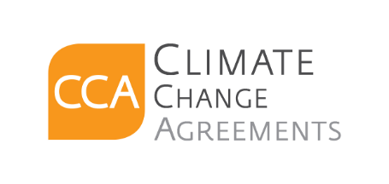
CCA Team

c.c. «[#list email.ccRecipients as cc]»«${cc}[#sep], [/#sep]»«[/#list]»

