«${currentDate?date?string('dd MMMM yyyy'»
CCA Register Ref: «${workflow.requestId}»

Sector Identifier: «${account.sectorIdentifier}»
«${account.name}»
Company Registration Number: «${(account.companyRegistrationNumber)!}»
TU Identifier: «${account.targetUnitIdentifier}»

«${account.location}»
«${account.primaryContactEmail}»

CLIMATE CHANGE AGREEMENTS SCHEME
UNDERLYING AGREEMENT TERMINATED (REGULATORY) RIGHT OF APPEAL

Dear «${account.primaryContact}»

We are writing to inform «${account.name}» (“you”) that your underlying agreement to the Climate Change Agreements scheme is due to be terminated on «${(params.terminationDate.format('dd MMM». This termination relates to the following agreement and target unit which will include all facilities listed within that agreement.

Underlying Agreement Identifier: | «${account.targetUnitIdentifier}» «${params.version}»
Target Unit: | «${account.targetUnitIdentifier}» – «${account.name}»

We have initiated this termination for the following reason:
«[#if params.reasonDetails.reason== 'FAIL»
- pay the financial penalty by the date specified in the notice or
- take the steps to remedy the contravention specified in that notice by the date so specified
«[#else]»
«${params.reasonDetails.reason.descriptio»
«[/#if]»

If you wish to appeal this decision you can do so via a first-tier tribunal process. If you wish to make an appeal, please do so by «${(params.terminationDate.format('dd MMM». For further information and guidance on the first-tier tribunal process please refer to the relevant guidance located on the EA/CCA guidance web page (link below):

http://www.environment-agency.gov.uk/CCA

If you require any clarification of the above, please contact your Sector Association in the first instance. If you need to contact the Administrator for any supporting information, please use the following link:

cca-help@environment-agency.gov.uk

Yours faithfully
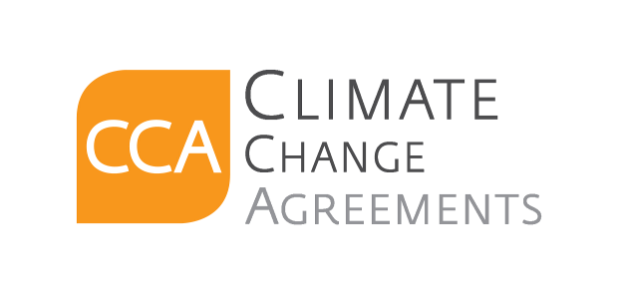
CCA Team

c.c. . «[#list email.ccRecipients as cc]»«${cc}[#sep], [/#sep]»«[/#list]»

