
«${currentDate?date?string('dd MMMM yyyy'»
CCA Register Ref: «${workflow.requestId}»
Sector Identifier: «${account.sectorIdentifier}»

TU Identifier: «${account.targetUnitIdentifier}»
«${account.name}»
Company Registration Number: «${(account.companyRegistrationNumber)!}»

«${account.location}»
«${account.primaryContactEmail}»

CLIMATE CHANGE AGREEMENTS SCHEME

UNDERLYING AGREEMENT TERMINATED (REGULATORY)

Dear «${account.primaryContact}»

We are writing to inform «${account.name}» (“you”) that your underlying agreement to the Climate Change Agreements scheme has been terminated. This termination relates to the following agreement and target unit which will include all facilities listed within that agreement.

Agreement Identifier: | «${account.targetUnitIdentifier}» «${params.version}»
Target Unit: | «${account.targetUnitIdentifier}» – «${account.name}»

We have proceeded with this termination for the following reasons:
«[#if params.reasonDetails.reason== 'FAIL»
- pay the financial penalty by the date specified in the notice or
- take the steps to remedy the contravention specified in that notice by the date so specified
«[#else]»
«${params.reasonDetails.reason.descriptio»
«[/#if]»

This termination of your agreement means all facilities within the target unit will no longer be able to claim their discount to the Climate Change Levy. We will notify HMRC of this termination. It is your responsibility to notify your energy provider of this termination to ensure these facilities do not claim a discount where they are no longer eligible.

If you require any clarification of the above, please contact your Sector Association in the first instance. If you need to contact the Administrator for any supporting information, please use the following link:

cca-help@environment-agency.gov.uk

Yours faithfully
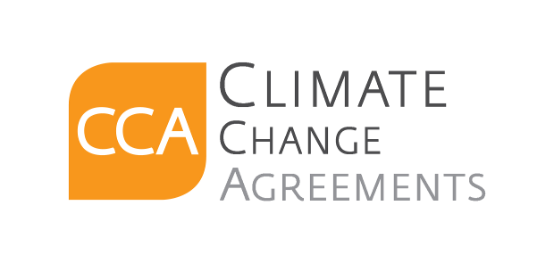
CCA Team

c.c. . «[#list email.ccRecipients as cc]»«${cc}[#sep], [/#sep]»«[/#list]»

