«${currentDate?date?string('dd MMMM yyyy'»
CCA Register Ref: «${workflow.requestId}»

Sector identifier: «${account.sectorIdentifier}»
Operator name: «${params.targetUnitDetails.name}»
Company registration number: «${(params.targetUnitDetails.companyRegis»
TU Identifier: «${account.targetUnitIdentifier}»

«${params.targetUnitDetails.location}»
«${params.targetUnitDetails.primaryContac»

CLIMATE CHANGE AGREEMENTS SCHEME
UNDERLYING AGREEMENT VARIATION REFUSAL
Dear «${params.targetUnitDetails.primaryContac»
We are writing to inform «${params.targetUnitDetails.name}» (“you”) that the recent request to vary your underlying agreement has been refused. This relates to the following target unit, agreement and variation:
Current Underlying Agreement Identifier: | «${account.targetUnitIdentifier}» «${params.version}»
Target Unit: | «${account.targetUnitIdentifier}» – «${params.targetUnitDetails.name}»
The reason(s) for this refusal are listed below:
«${params.reason}»
If you require any clarification of the above, please contact your Sector Association in the first instance.
If you need to contact the Administrator for any supporting information, please use the following email: cca-help@environment-agency.gov.uk.
Yours faithfully
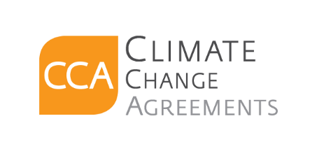
CCA Team
c.c. «[#list email.ccRecipients as cc]»«${cc}[#sep], [/#sep]»«[/#list]»

