«${currentDate?date?string('dd MMMM yyyy'»
CCA Register Ref: «${workflow.requestId}»

Sector Identifier: «${account.sectorIdentifier}»
Operator name: «${params.targetUnitDetails.name}»
Company registration number: «${(params.targetUnitDetails.companyRegis»
TU Identifier: «TargetUnitID»

«${params.targetUnitDetails.location}»
«${params.targetUnitDetails.primaryContac»

CLIMATE CHANGE AGREEMENTS SCHEME

UNDERLYING AGREEMENT VARIATION APPROVAL

Dear «${params.targetUnitDetails.primaryContac»

We are writing to inform «${params.targetUnitDetails.name}» (“you”) that the recent request to vary your underlying agreement was approved on «${currentDate?date?string('dd MMMM yyyy'». This relates to the following target unit, agreement and variation:

Current Underlying Agreement Identifier: | «${account.targetUnitIdentifier}» «${params.version}»
Target Unit: | «${account.targetUnitIdentifier}» – «${params.targetUnitDetails.name}»  «${params.targetUnitDetails.targetUnitAdd»

Please note that a draft version of your agreement, incorporating the changes you requested, will be sent to you in a separate email. Your previous agreement will remain in effect until you provide your assent to the new agreement.

If you require any clarification of the above, please contact your Sector Association in the first instance.

If you need to contact the Administrator for any supporting information, please use the following email address: cca-help@environment-agency.gov.uk.

Yours faithfully
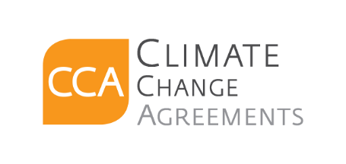
CCA Team

c.c. «[#list email.ccRecipients as cc]»«${cc}[#sep], [/#sep]»«[/#list]»

