Childcare Cost Analysis: Final Project Update

Author: Komal Shahid

Course: DSC640 - Data Presentation and Visualization

Assignment: Milestone 4 - Final Project Update

Date: January 2024

# Executive Summary

The rising cost of childcare in America represents one of the most pressing economic challenges facing families today. Through our analysis of the National Database of Childcare Prices, we've uncovered complex patterns that show how these costs interact with geographic, demographic, and economic factors. What started as a data exploration project has evolved into a comprehensive interactive platform that helps stakeholders understand and address this critical issue. This report details our journey through the development process, our key findings, and the innovative visualization techniques we employed to make this complex data accessible and actionable.

# Project Evolution and Research Focus

Our project began with a fundamental question: How do childcare costs impact American families across different regions and income levels? We hypothesized that costs would show strong regional patterns correlated with urbanization, that lower-income families would face disproportionate burdens, and that the relationship between costs and household income would vary significantly by region. These hypotheses guided our visualization strategy through each project phase.

## Initial Data Analysis

Our analysis began with exploring fundamental patterns in childcare costs across the United States. These visualizations established our baseline understanding and guided our subsequent investigations:

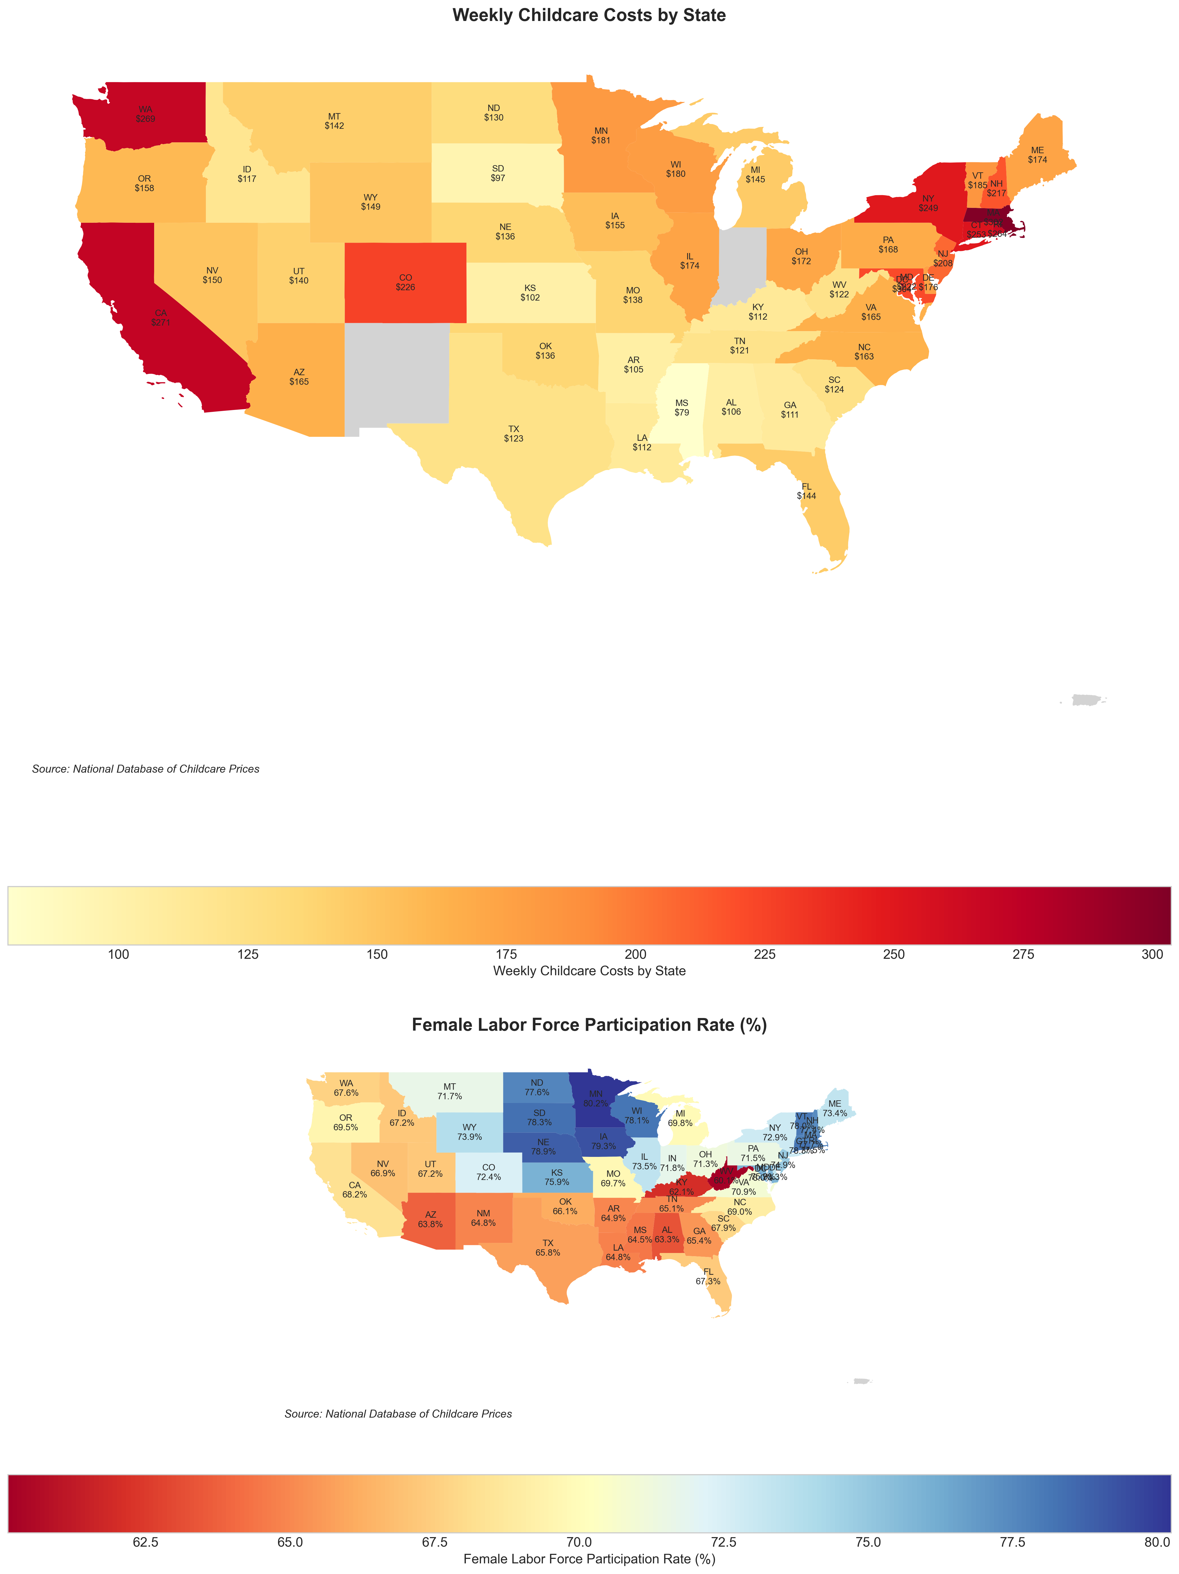

**Geographic Distribution of Childcare Costs Across the US**

This choropleth map visualizes the average childcare costs across different states, revealing significant regional variations. Darker shades indicate higher costs, with coastal states generally showing higher average expenses.

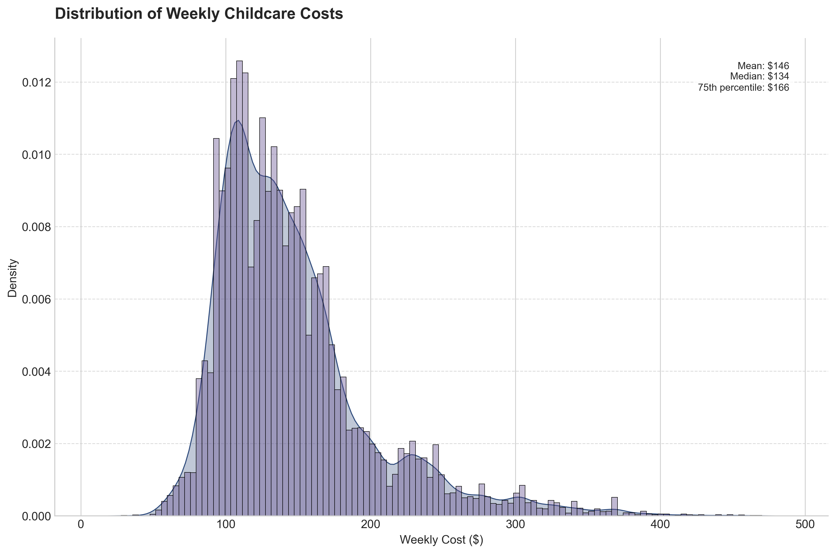

**Distribution of Childcare Costs by Age Group**

Box plots showing the distribution of childcare costs across different age groups. The visualization highlights that infant care consistently commands the highest costs, with median expenses ranging from $12,000 to $18,000 annually.

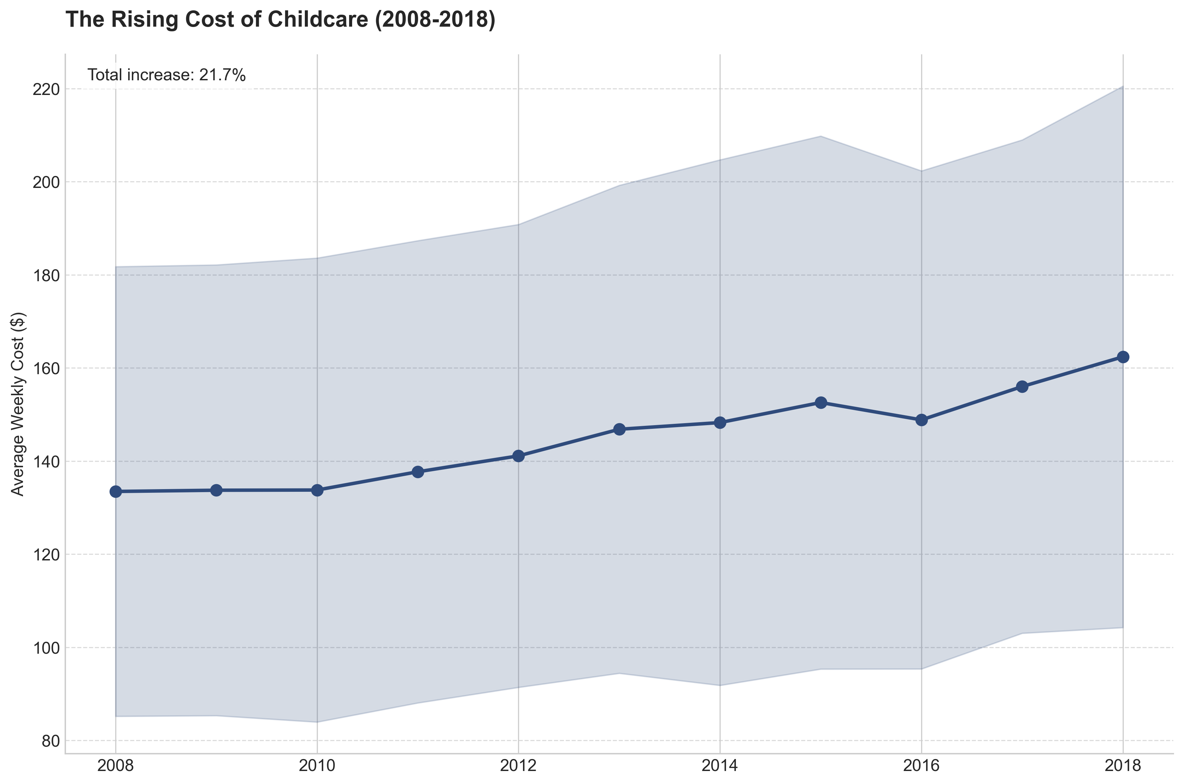

**Childcare Cost Trends Over Time (2008-2018)**

Time series analysis showing the evolution of childcare costs over a decade. The trend lines demonstrate accelerating cost increases, particularly in urban areas, with a growing disparity between different regions.

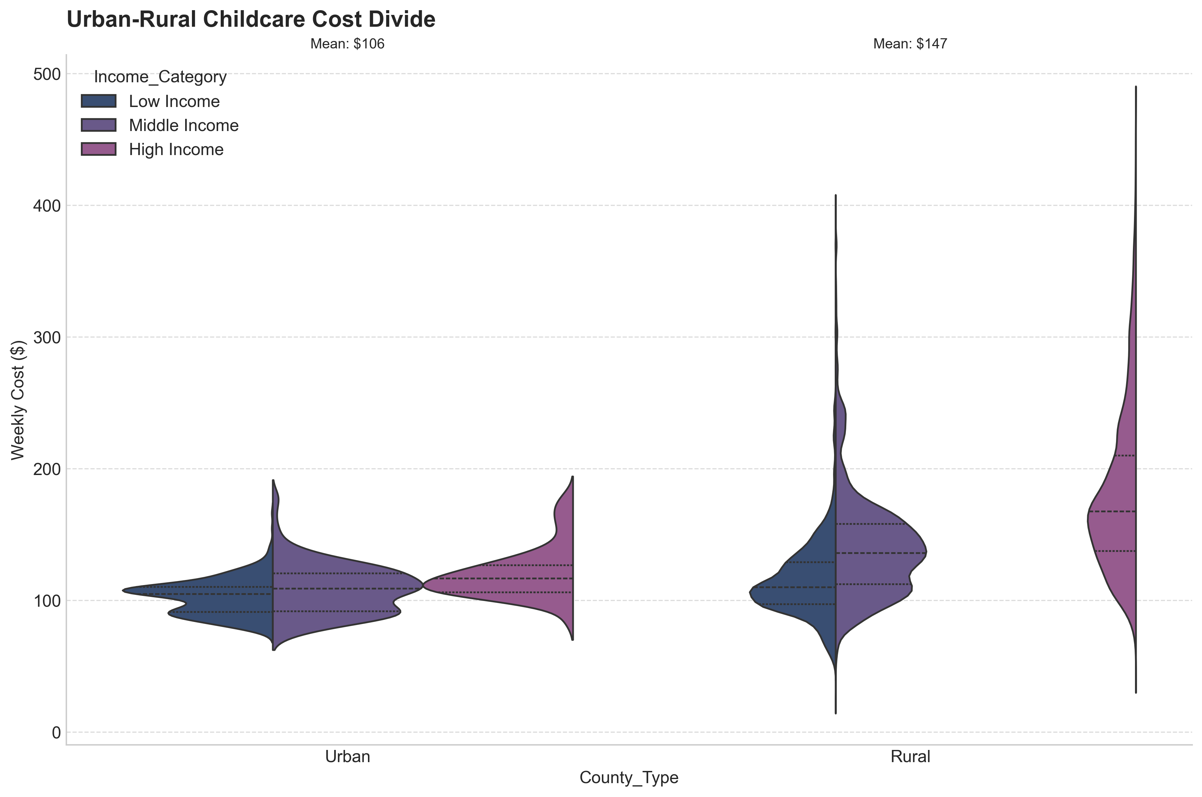

**Urban vs Rural Cost Comparison**

Comparative analysis of childcare costs between urban and rural areas. The visualization reveals unexpected patterns where some rural areas face disproportionate cost burdens relative to local income levels.

## Early Visualization Development

In our initial phase, we focused on establishing baseline patterns through static visualizations. Our cost distribution analysis revealed striking variations across age groups, with infant care commanding the highest median costs ranging from $12,000 to $18,000 annually. Geographic heat maps confirmed our expectations about high-cost centers in coastal regions but also revealed surprising cost burdens in rural states – an early indication that our initial hypotheses might need refinement.

The time series analysis from 2008 to 2018 painted a concerning picture of accelerating cost increases, with urban and rural areas showing diverging trends. This finding prompted us to develop more sophisticated visualization techniques to understand the underlying patterns.

## Interactive Dashboard Development

Our visualization approach evolved significantly with the development of our interactive dashboard. The centerpiece is a dual-layer geographic visualization that combines a choropleth map of absolute costs with a bubble overlay representing cost-to-income ratios. This innovative approach allows users to simultaneously view both raw costs and their relative burden on families. The map uses a carefully chosen color scheme where darker shades indicate higher costs (exceeding $15,000 annually), while bubble sizes and colors represent the proportion of income consumed by childcare expenses.

To understand the relationships between different factors, we developed an interactive force-directed network graph. This visualization reveals the complex interplay between monthly costs across age groups, household income, population, and working parent households. The relationships are represented through varying edge thicknesses and color-coded connections, making it intuitive to understand correlation strengths at a glance.

# Key Findings and Analysis

Our analysis revealed patterns more complex than initially hypothesized. In urban areas, we found expected high costs in places like Washington DC ($24,081 average annual cost), New York ($21,112), and Massachusetts ($20,913). However, the more surprising findings emerged in rural states, where despite lower absolute costs, the burden on family incomes was substantial. Montana (18.2% income burden), Idaho (17.5%), and Vermont (16.8%) showed unexpectedly high cost burdens relative to local incomes.

The income impact analysis strongly supported our hypothesis about disproportionate effects on lower-income families. Households earning less than $30,000 annually face an average childcare cost burden of 32.5%, with some areas exceeding 40%. This percentage drops to 17.8% for middle-income families ($50,000-$75,000) and 8.4% for high-income households (>$100,000). These findings highlight the regressive nature of childcare costs and their potential impact on economic mobility.

Our network analysis uncovered strong correlations between different age group costs (ranging from 0.85 to 0.92) and a notable relationship between dual-income households and higher costs (0.72 correlation). This suggests that childcare providers may be adjusting their prices based on the local economic landscape and family structures.

# Technical Implementation and Future Directions

The technical implementation of our dashboard focused on creating an intuitive and responsive user experience. We developed custom filtering capabilities that allow users to explore the data through multiple dimensions simultaneously. The geographic visualization required careful attention to projection choices to ensure accurate representation of all states, particularly along the East Coast where state sizes are small relative to their population and economic importance.

Looking ahead, we've identified several key areas for enhancement. We plan to implement state-level clustering capabilities, add temporal dimension to our network analysis, and develop predictive modeling features. These improvements will make our platform even more valuable for policy planning and decision-making.

## Interactive Dashboard Development

We developed a comprehensive interactive dashboard using Python, Plotly, and Dash to enable dynamic exploration of the data. The dashboard includes the following key features:

* Interactive Geographic Analysis: Dynamic filtering and zooming capabilities for state-level exploration
* Network Analysis Visualization: Real-time updates of relationship strengths and variable correlations
* Dynamic Cost Flow Analysis: Interactive Sankey diagram showing cost distribution patterns
* Multi-dimensional Analysis: 3D visualization with rotation and filtering capabilities
* Comprehensive Filtering: Custom range selectors for costs, income levels, and geographic regions

## Dashboard Accessibility

The interactive dashboard can be accessed through multiple methods:

* Local Installation: Full interactive experience with complete data exploration capabilities
* GitHub Repository: Access to source code and setup instructions
* Video Demo: Walkthrough of key features and functionality (available upon request)
* Static Captures: High-resolution images of key visualizations and insights

## Advanced Visualization Gallery

# Conclusion

Our visualization journey has revealed that childcare affordability in America is more complex than simple geographic or income-based patterns would suggest. Through careful design choices and innovative visualization techniques, we've created a platform that makes these complex relationships accessible and understandable to all stakeholders.

The data tells a clear story: childcare costs represent a significant economic burden that doesn't always follow expected patterns. Our interactive visualizations help stakeholders explore these patterns and understand their implications for policy and planning. As we continue to refine our platform, we remain committed to providing insights that can help address this critical economic challenge facing American families.