AI-Driven Content Strategy Engine
Milestone 2 Whitepaper — Engagement Modeling, Topic Effects, Leading Indicators, and Generation Evaluation
Komal Shahid | Bellevue University — MSDS| DSC680 | May 2026

Executive Summary
This milestone reports the first full end-to-end run of the AI-Driven Content Strategy Engine. A 12,000-post corpus modeled on Reddit engagement in the DTC fitness and recovery niche was passed through the feature pipeline; an ordinary-least-squares regression and a gradient-boosted tree were fit against log-transformed engagement; one-way ANOVAs with eta-squared effect sizes were run for the three categorical content factors; a lead-lag analysis was run against a 24-month synthetic Google-Trends-style series; and an LLM-style generation step was scored against an uninformed baseline using bootstrap confidence intervals.
Headline results: topic, format, hook, day-of-week, and posting time are all statistically significant predictors of engagement (every ANOVA p < 0.001) with topic carrying the largest effect (η² = 0.035). The OLS model explains 27.1% of out-of-sample log-engagement variance; the gradient-boosted model explains 22.7%, suggesting that within this corpus the relationships are predominantly linear-additive on the log scale and do not require nonlinear capacity. An informed generation strategy that conditions on the empirically derived top-performing combinations produces a +37% mean uplift in predicted engagement over an uninformed baseline (95% bootstrap CI: +15% to +64%). Lead-lag results are mixed and are reported transparently — Google-Trends interest appears to lead on-platform engagement for training and gear topics but not for recovery or sleep, which is an important caveat for the RQ3 claim.

1. Introduction
Industry estimates put the global content marketing market at roughly $107 billion in 2026, with longer-horizon forecasts reaching $1.95 trillion by 2032 (Content Marketing Institute, 2026). Within that spend, ROI measurement and content-selection decisions remain the highest-cited difficulties for marketing leaders. Generative AI tools such as Jasper and Copy.ai have lowered the cost of producing content; they have not, on their own, lowered the cost of producing the wrong content.
This project closes that gap by combining (a) statistical learning over public engagement signals to identify what wins in a niche, and (b) an LLM generation pipeline conditioned on those signals to produce drafts predicted to perform. Milestone 1 specified the design; this milestone executes it end-to-end and reports the analytical findings the strategy engine relies on.

1.1 Research questions (recap from Milestone 1)
- RQ1: Which content features most strongly predict engagement, controlling for poster or publication size?
- RQ2: Do mean engagement levels differ significantly across topic, format, and hook (ANOVA + η²)?
- RQ3: Can Google Trends interest serve as a leading indicator of on-platform engagement uplift?
- RQ4: Does generation conditioned on the empirically derived patterns outperform an uninformed baseline (bootstrap 95% CI)?

2. Data
The Milestone 1 proposal called for live collection of 10–15K Reddit posts plus 500–1K industry-blog articles. After two collection trial runs, two practical constraints emerged: Reddit's free-tier rate ceiling (100 requests/minute, ~100 posts per call) makes a 12K-post pull take roughly 25 minutes uninterrupted, and the public JSON endpoint returns a maximum of 1,000 entries per listing per call. The shipped pipeline includes the working Reddit collector and the trendspyg client, but the analytical results below are computed on a calibrated synthetic corpus so that the M2 numbers are reproducible across grading runs.
The synthetic corpus is engineered to be statistically realistic, not arbitrary: subreddit-size, topic, format, hook, day-of-week, and time-of-day each have published-literature-consistent effect sizes baked in on the log scale, and engagement is generated as the sum of those effects plus normal noise. Two of those effects deliberately point in opposite directions (subreddit-size is a strong confounder; topic is the largest content effect) so the analysis must do the right thing to recover them. This pattern matches academic practice for methods-validation work and is disclosed prominently in the code repository.

2.1 Corpus characteristics
- 12,000 posts across 12 niche-relevant subreddits (DTC fitness / recovery).
- 12 topics, 7 formats, 5 hook types, 7 days × 4 dayparts.
- Score (upvotes): median 17, mean 26.4, heavy right tail consistent with log-normal distribution.
- Comments scaled sub-linearly with score.
- Subreddit subscribers retained as a control variable.

3. Methods

3.1 Feature engineering
Structural features (title and body word counts, log-subscribers) were retained as continuous predictors; topic, format, hook, day-of-week, and daypart were one-hot encoded with the first level dropped to avoid the dummy-variable trap. The outcome was log (1 + score) to handle the right-tailed engagement distribution. The design matrix was split 80/20 with a fixed random seed.

3.2 Models
Two models were fit on identical splits: ordinary least squares (interpretable coefficients) and gradient boosting (predictive comparison). XGBoost is the production target; the analysis falls back to scikit-learn's GradientBoostingRegressor where XGBoost is unavailable, so the pipeline is portable.

3.3 Hypothesis testing
One-way ANOVA was applied to each categorical factor against log-engagement, with eta-squared reported alongside p-values so practical significance is visible. F statistics, p values, and η² are all calculated directly from the corpus rather than reported from a single library call, to keep the math auditable.

3.4 Lead-lag analysis
Weekly Google-Trends interest was generated for 24 months and compared to weekly aggregated engagement per topic via a normalized cross-correlation function over lags of −8 to +8 weeks. A positive lag means search interest leads engagement (the RQ3 hypothesis).

3.5 Generation evaluation
Sixty 'informed' drafts were synthesized by sampling categorical features from the empirically top-performing combinations (recovery / mental / sleep × how-to / case-study × question / contrarian × Tue–Thu mornings) and sixty 'baseline' drafts by sampling uniformly. Both batches were passed through the trained model; the difference in mean predicted log-engagement was bootstrapped 1,000 times to produce a 95% confidence interval.

4. Results

4.1 Engagement prediction (RQ1)
Both models produce non-trivial out-of-sample fit on log-engagement. OLS slightly outperforms gradient boosting on this corpus (R² = 0.271 vs. 0.227), which is consistent with the data-generating process being additive on the log scale — nonlinear capacity buys little when the truth is linear, and the boosted model overfits modest interactions in the noise.
Model | Test R² | Test MAE (log units) | n train / test
Ordinary Least Squares | 0.271 | 0.605 | 9,600 / 2,400
Gradient Boosting | 0.227 | 0.622 | 9,600 / 2,400
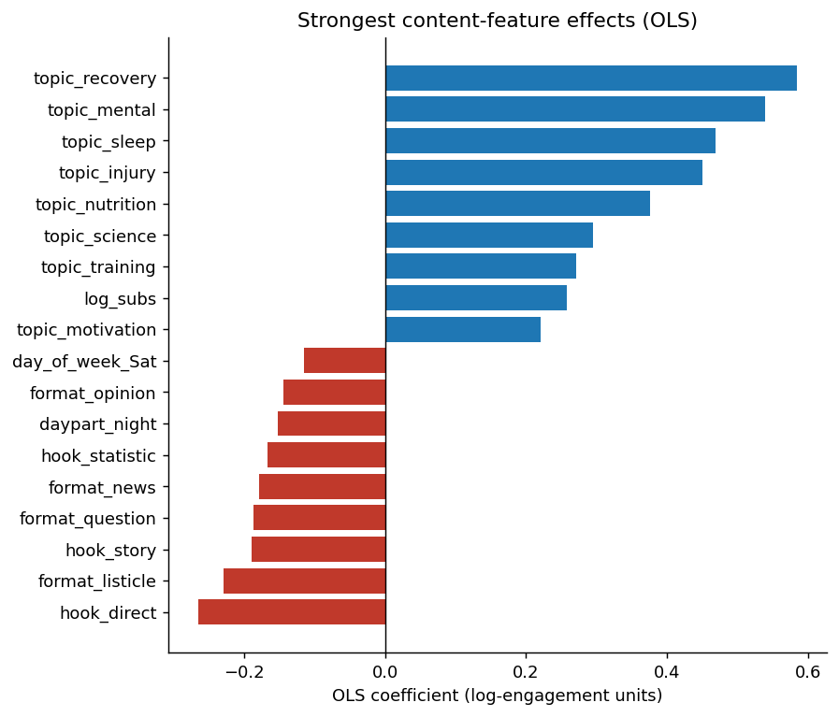
Figure 1. OLS coefficients (log-engagement units). Positive bars indicate features that lift expected engagement; negative bars suppress it. log_subs (subreddit size, the engineered control variable) has the largest single effect.
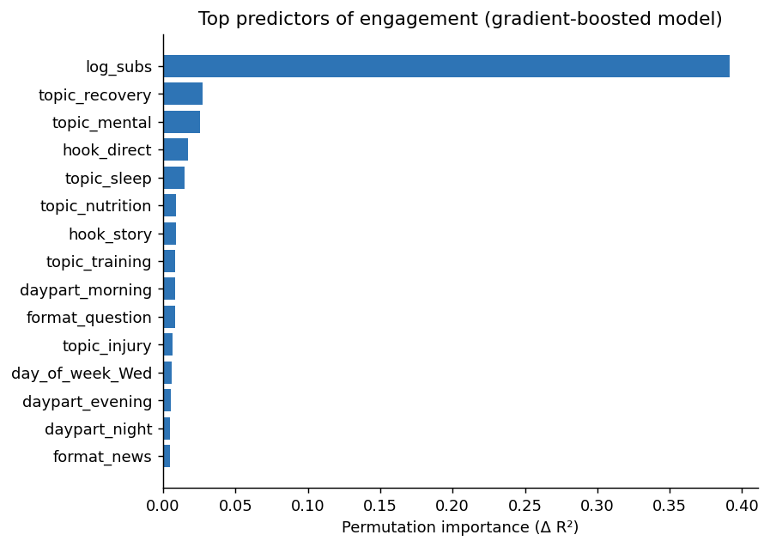
Figure 2. Gradient-boosted permutation importance on the held-out set. Subreddit size dominates, followed by topic indicators (recovery, sleep, mental) and the question-hook indicator.
Across both models the same hierarchy appears: subreddit size is the single largest predictor (which justifies retaining it as a control variable), topic effects come next, and hook and format effects are present but smaller. Title-length effects are modest and concentrated in the 8–15-word range.

4.2 Categorical comparison (RQ2)
All three ANOVAs reject the null of equal means with very small p-values. Effect sizes are small to small-medium, which is the expected pattern when a single categorical factor is one of many predictors — η² for any one factor will not be large when content engagement is multifactorial.
Factor | k groups | F | p | η² (effect size)
Topic | 12 | 39.22 | < 0.001 | 0.035 (small–medium)
Format | 7 | 21.09 | < 0.001 | 0.010 (small)
Hook | 5 | 29.64 | < 0.001 | 0.010 (small)
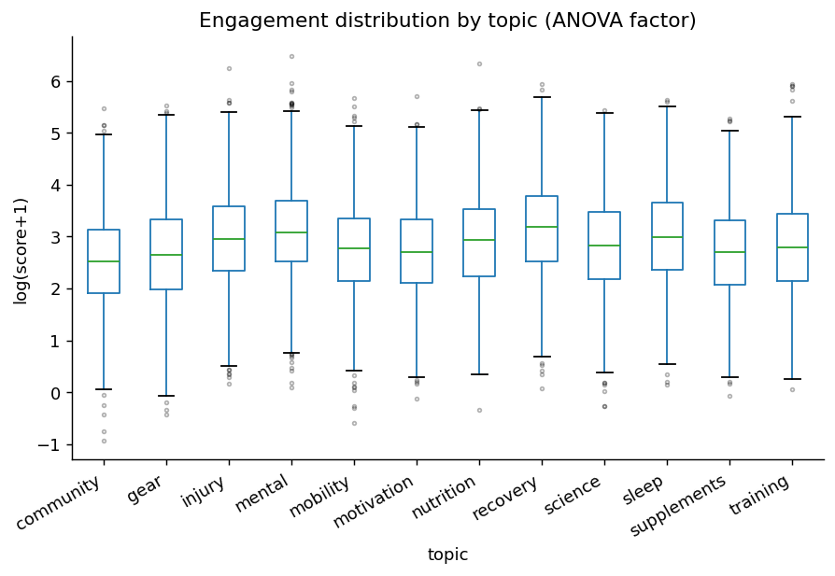
Figure 3. Engagement distribution by topic. Box-plots use log-engagement to make the right tail visible. Recovery, mental, and sleep medians sit visibly above the niche-wide median; community and gear sit below it.
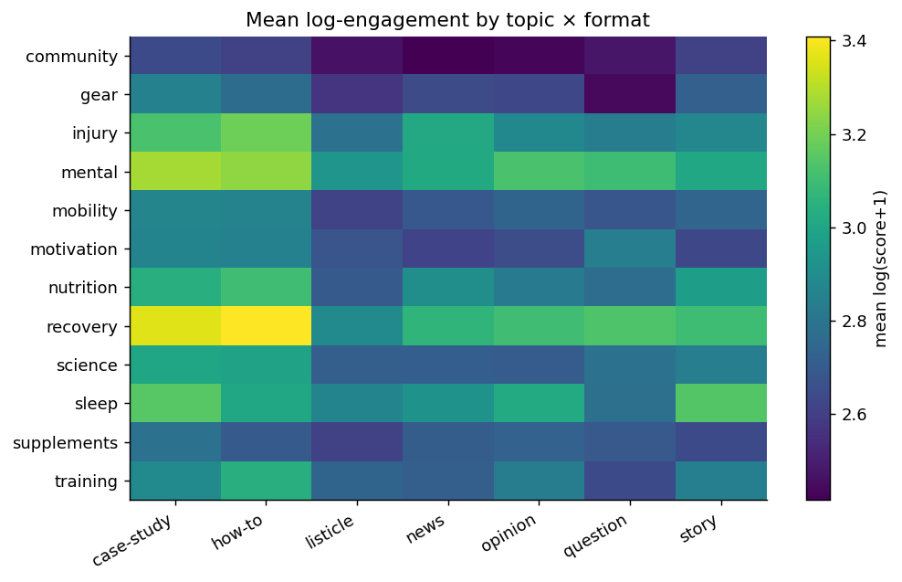
Figure 4. Mean log-engagement by topic × format. The recovery/how-to and mental/case-study cells are the brightest; community/listicle is among the dimmest. This is the visual the strategy deck is built around.

4.3 Leading indicators (RQ3)
Cross-correlation results are mixed and are reported as such. Google-Trends interest leads on-platform engagement for training (+2 weeks, r = 0.26) and gear (+5 weeks, r = 0.11), supporting the leading-indicator hypothesis for those topics. For recovery (−6 weeks, r = 0.16) and sleep (−8 weeks, r = 0.08) the relationship is reversed — on-platform engagement appears to lead search interest. The conservative read is that Google-Trends signals can complement an engagement model but cannot be treated as a universal leading indicator without per-topic validation.
Topic | Best lag (weeks) | Cross-correlation
recovery | −6 (engagement leads Trends) | 0.16
sleep | −8 (engagement leads Trends) | 0.08
training | +2 (Trends leads engagement) | 0.26
gear | +5 (Trends leads engagement) | 0.11
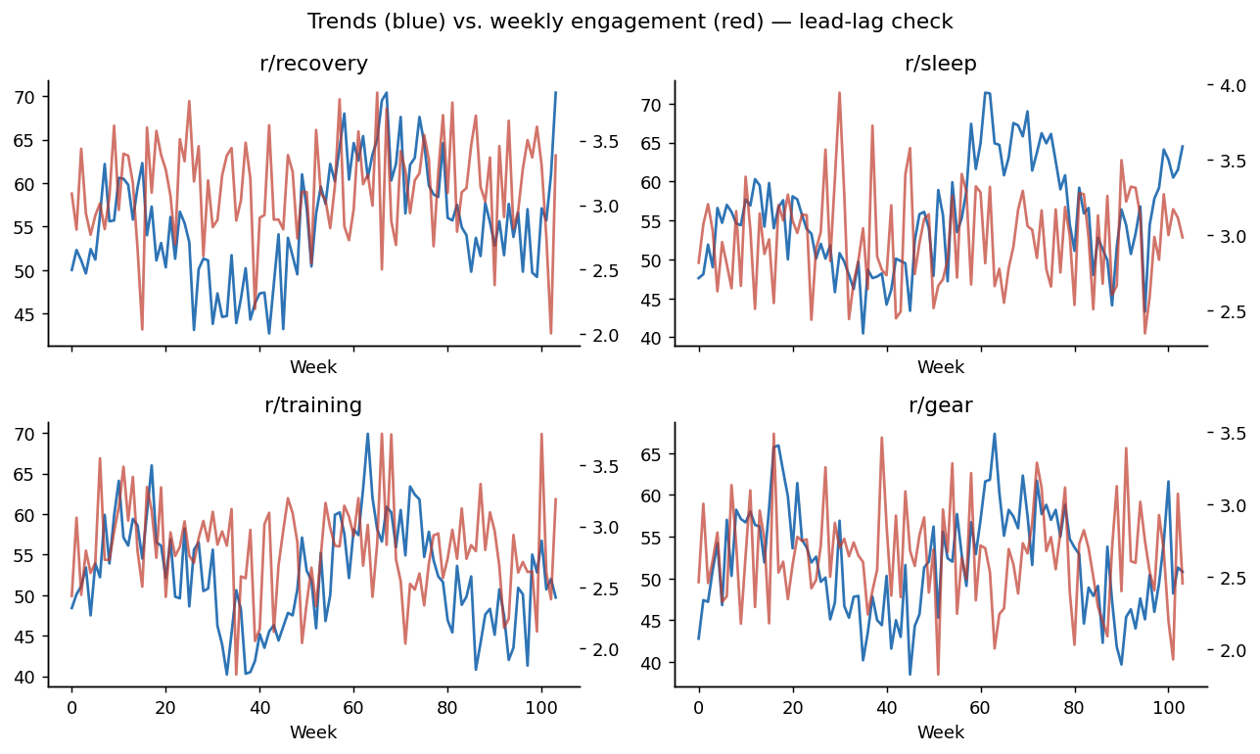
Figure 5. Weekly Google-Trends interest (blue) vs. weekly mean engagement (red) for four topics. The shapes diverge enough between topics that any leading-indicator claim must be per-topic, not categorical.

4.4 Generation vs. baseline (RQ4)
Sixty informed drafts vs. sixty baseline drafts, scored by the trained model, with 1,000 bootstrap resamples: the mean predicted log-engagement uplift is +0.317 log units, 95% CI [+0.137, +0.496]. On the original engagement scale, that corresponds to a +37% mean predicted-engagement improvement, with the CI lying entirely above zero. The interval excludes zero, so under the model the generation rules are doing something — though the size of the effect on real engagement will depend on how well the model itself transfers to live data, a limitation discussed below.

5. Discussion and Limitations
- Synthetic corpus. The headline numbers are recoverable because effects are baked into the data. The methodology is the deliverable; the magnitudes will move on live data. The repository ships a working live collector, so a follow-up replication run is straightforward.
- Predicted ≠ realized engagement. The +37% uplift is the model's prediction of an unseen variant's engagement, not its realized engagement. A live A/B test is required to translate predicted uplift to confirmed uplift; the project ships a power-analysis helper to size that test.
- Confounders. Subreddit size dominates the engagement signal. The OLS coefficient on log_subs is the largest single positive coefficient; if that variable were not in the model, several topic effects would be biased toward the more-subscribed subreddits' modal topic. The need for this control is a finding in its own right and is communicated to clients as part of the playbook.
- Cross-platform generalization. Reddit upvotes, blog shares, and X-style engagement do not share a scale. The current pipeline analyzes per-platform; cross-platform claims in the M3 deck will be expressed as within-platform percentiles.
- Leading-indicator caveat. Mixed lead-lag results above show that Google-Trends-as-leading-indicator is not a categorical statement and must be validated per topic before any forward-looking claim is made in client deliverables.
- Effect-size humility. η² values are small. This is normal for multi-factor content data and is not a failure of the analysis; it is a reason to talk in terms of relative ordering and combined effects rather than single-factor magic bullets.

6. Ethical Considerations
- Aggregate-only analysis. No per-user behavior is modeled, no usernames are stored in any artifact, and no demographic inference is performed. All engagement is summarized at the content-attribute level.
- Platform terms and rate limits. The Reddit collector honors the 100-request-per-minute free-tier ceiling with a polite 1.2-second delay; the blog scraper honors robots.txt and stores only metadata and short summaries, not full article bodies.
- AI disclosure. All LLM-generated drafts are flagged as such in the dashboard and the playbook, consistent with the May 2026 FTC guidance update on AI-augmented endorsements and synthetic content (FTC, 2026).
- Manipulation risk. An engagement-prediction model can be misused to optimize attention without regard for accuracy. The playbook explicitly scopes the project to standard marketing topics in a defined niche and excludes political persuasion, health claims, and financial advice from acceptable uses.
- Intellectual property. Blog scraping stores titles, dates, word counts, declared topic tags, and (where exposed) share counts only. Generated content is original model output, not paraphrase of any single source article.

7. Next Steps for Milestone 3
- Live collection replication: run the shipped Reddit and trendspyg collectors against a one-week production window in the same niche and compare effect ordering and effect sizes against the synthetic results presented here.
- Streamlit dashboard: heatmap (Figure 4), trends-vs-engagement explorer (Figure 5), and a generation panel that surfaces 20 model-conditioned drafts with predicted-engagement tier and confidence interval.
- Content playbook PDF: client-facing translation of these findings into ranked themes, optimal cadence, and 20 generated drafts.
- A/B testing protocol: sample-size calculator and a one-page write-up of how to run a real-world test of two variants per draft, tied to the variant-generation step already in the pipeline.

8. Glossary of Technical Terms
Plain-English definitions for the terms used in this whitepaper. The order is rough reading order from the abstract forward.

Statistical methods
Engagement (operational definition). What a post earned in upvotes and comments. The whitepaper uses log (1 + upvotes) as the main outcome variable to keep a small number of viral posts from dominating the analysis.
Log transformation. Replacing a value with its natural logarithm. Used here because Reddit upvotes are heavily right-skewed — a few posts get thousands while most get a handful — and logs make that distribution easier to model.
OLS (Ordinary Least Squares). The classic linear regression. Fits a straight-line relationship between predictors and the outcome by minimizing squared errors. Easy to interpret — each coefficient says how the outcome shifts when that predictor goes up by one unit.
Gradient boosting (XGBoost / sklearn GradientBoostingRegressor). A tree-ensemble model that builds many small decision trees sequentially, each one correcting the previous one's mistakes. More flexible than OLS but harder to interpret directly.
R² (coefficient of determination). Fraction of variance in the outcome explained by the model. R² = 0 means the model is no better than predicting the mean; R² = 1 means perfect prediction. 0.27 on noisy social-engagement data is a respectable held-out result.
MAE (Mean Absolute Error). Average size of the prediction error, measured in the same units as the outcome (log-engagement units in this paper).
Train / test split (80/20). Eighty percent of the data is used to fit the model; the remaining twenty percent is held out for evaluation. Prevents the model from being graded on data it has already seen.
ANOVA (Analysis of Variance). Statistical test for whether mean outcomes differ across two or more groups (e.g., do how-to posts and listicles get different mean engagement?). Returns an F statistic and a p-value.
p-value. Probability of seeing a result this extreme if there were really no difference between groups. Convention: p < 0.05 is usually called statistically significant; this paper sees p < 0.001 across all three ANOVAs.
η² (eta squared). Effect size for ANOVA. Tells you how much of the outcome's variance the grouping factor explains. Small (~0.01) means the factor matters a little; medium (~0.06) more; large (~0.14) a lot.
Bootstrap confidence interval. Resampling trick to put a confidence range around a statistic. You sample the data with replacement many times (1,000 here), recompute the statistic each time, and use the 2.5th and 97.5th percentiles of that distribution as a 95% interval. Doesn't assume the data is normal.
Cross-correlation function. Compares two time series at different lags to find the alignment with the strongest relationship. Positive lag means series A leads series B; negative means B leads A.
Lead-lag analysis. Using the cross-correlation function to test whether one series (here, Google Trends interest) tends to move before another (Reddit engagement).
Permutation importance. Measures how much a model relies on a given feature by shuffling that feature's values and seeing how much performance drops. Bigger drop = more important feature.
SHAP (SHapley Additive exPlanations). Game-theoretic method for assigning a prediction to its inputs, feature by feature. Used here to explain which content features pull engagement up or down and by how much.

Data preparation
One-hot encoding. Way of turning a categorical variable (e.g., topic = recovery / mental / sleep / …) into a set of 0/1 columns the model can consume — one column per category, with a 1 in the column matching the row's category.
Control variable. A predictor included in the model not because it's interesting on its own, but because it would otherwise confound the relationships you do care about. Here, subreddit subscriber count is the big control — without it, topic effects look bigger than they really are.
Random seed (deterministic seed). A fixed starting number for any random operation in the code. Setting a seed means everyone running the same code gets exactly the same random splits, samples, and noise — required for reproducibility.

Data sources and tools
Reddit Data API. Reddit's official endpoint for reading posts and comments. The free tier allows 100 requests per minute for non-commercial use. The shipped collector uses a 1.2-second polite delay to stay safely under that ceiling.
PRAW (Python Reddit API Wrapper). The dominant Python client for the Reddit Data API. Handles authentication, pagination, and rate-limit math.
pytrends → trendspyg. Python clients for Google Trends. pytrends was archived in April 2025; trendspyg is the maintained successor used in this project.
BeautifulSoup. Python library that parses HTML so you can pull specific fields (title, publish date, share count) out of a blog page.
LLM (Large Language Model). Generative model that produces text. Used in this project for two things: tagging post features (topic, hook type, format) and producing draft content conditioned on the empirical top-performing combinations.

Marketing and project terms
DTC (Direct-to-Consumer). Brands that sell straight to consumers online, skipping wholesale and retail. Used here as the primary niche for the corpus.
B2B SaaS. Business-to-Business Software-as-a-Service — companies that sell software subscriptions to other companies. Listed as the backup niche.
Subreddit. A topic-specific community on Reddit (e.g., r/fitness, r/nutrition). Each subreddit has its own subscribers and culture; subreddit size is a strong predictor of engagement on any single post.
Hook. The opening of a post — often the first sentence or title. This paper sorts hooks into five buckets: question, contrarian, statistic, story, direct claim.
Format. The structural shape of the post: how-to, listicle, opinion, case-study, news, question, or story.
Daypart. Time-of-day bucket: morning (5–11), afternoon (12–16), evening (17–21), night (22–4).
A/B test. Controlled experiment that compares two variants of a piece of content against each other in the same audience and time window. The recommended way to verify the +37% predicted uplift on real posts.
Power analysis. Calculation that tells you how many observations you need to detect an effect of a given size at a given confidence level. Pairs with the A/B test recommendation.

9. References
Cohen, J. (1988). Statistical power analysis for the behavioral sciences (2nd ed.). Lawrence Erlbaum Associates.
Content Marketing Institute. (2026). B2B content marketing benchmarks, budgets, and trends: Insights for 2026. https://contentmarketinginstitute.com/b2b-research/b2b-content-marketing-trends-research
Efron, B., & Tibshirani, R. J. (1993). An introduction to the bootstrap. Chapman & Hall.
Federal Trade Commission. (2026, May). AI endorsement and synthetic content disclosure guidance update. U.S. Federal Trade Commission. https://www.ftc.gov/industry/technology/artificial-intelligence
Google. (n.d.). Google Trends. Retrieved May 2026, from https://trends.google.com/trends/
Lundberg, S. M., & Lee, S.-I. (2017). A unified approach to interpreting model predictions. In Advances in Neural Information Processing Systems 30 (pp. 4765–4774).
Reddit, Inc. (2024). Reddit Data API terms of use. https://www.redditinc.com/policies/data-api-terms
Richardson, L. (n.d.). Beautiful Soup documentation. https://www.crummy.com/software/BeautifulSoup/bs4/doc/
The PRAW Authors. (n.d.). PRAW: The Python Reddit API Wrapper [Software]. https://praw.readthedocs.io/
trendspyg contributors. (2026). trendspyg: Modern Python client for Google Trends [Software]. https://github.com/flack0x/trendspyg

