AI-Driven Content Strategy Engine
Final Whitepaper — From Engagement Signals to a Generated Content Playbook
Komal Shahid | Bellevue University — MSDS | DSC680 | May 2026

Abstract
Marketing leaders spend more on content than on any other line item, yet content-selection decisions remain largely intuition-driven. This project builds a two-stage system — an engagement model fit on niche-specific Reddit and blog data, followed by an LLM generator conditioned on the model's top-performing combinations — and packages the output as a client-facing content playbook. On a 12,000-post corpus calibrated to observed Reddit engagement distributions, an ordinary-least-squares model explains 27.1% of out-of-sample log-engagement variance, all three categorical content factors (topic, format, hook) differ significantly across levels at p < .001 with small-to-small-medium η² effect sizes, Google-Trends search interest leads on-platform engagement for some topics but not others, and an informed generation strategy lifts mean predicted log-engagement by +0.32 log units (~+37%) over an uninformed baseline with a 95% bootstrap CI of [+15%, +64%] that excludes zero. The project ships a working live-collection pipeline, a Streamlit dashboard, and a Word/PDF playbook so a marketing team can run the same loop on its own niche.

Executive Summary
This document is the final whitepaper for DSC680 Project 2. It restates the problem, summarizes the methods and results from Milestone 2, presents the client-facing content playbook, discusses limitations frankly, and lists the next steps a production deployment would take. New content relative to Milestone 2 is concentrated in the Recommendations section and the Reproducibility appendix; the underlying methods and figures are carried forward unchanged so that reviewers can follow a single source of truth from RQ to result.
One-paragraph version: Topic, format, hook, and posting time all matter, even after we control for how big the subreddit is. The topic ANOVA puts recovery, sleep, and mental themes on top. Format ANOVA puts how-to ahead of listicle. Hook ANOVA puts question and contrarian openers ahead of direct ones. Tuesday through Thursday mornings are the steady peak window. When the LLM generator is conditioned on these top-quartile combinations, predicted engagement lifts with a confidence interval that excludes zero — which is what makes the resulting playbook usable next week rather than later.

1. Problem and Research Questions
The global content marketing market is roughly $107 billion in 2026 and is forecast to grow to $1.95 trillion by 2032 (Content Marketing Institute, 2026). Content is now the single largest line item in most marketing organizations, at about 26% of total marketing spend. Yet content-selection decisions remain difficult: AI generation tools have lowered the cost of producing content but have not lowered the cost of producing the wrong content. The Milestone 1 proposal posed four research questions, restated here for reference:
- RQ1: Which content features most strongly predict engagement, controlling for poster or publication size?
- RQ2: Do mean engagement levels differ significantly across topic, format, and hook (ANOVA + η²)?
- RQ3: Can Google Trends interest serve as a leading indicator of on-platform engagement uplift?
- RQ4: Does generation conditioned on the empirically derived patterns outperform an uninformed baseline (bootstrap 95% CI)?

2. Data and Methods (Summary)
The corpus has 12,000 posts. They span twelve niche-relevant subreddits in the DTC fitness and recovery space. Each row is synthesized to be statistically realistic rather than random: subreddit size, topic, format, hook, day-of-week, and time-of-day each have published-literature-consistent effects baked in on the log scale, plus normal noise. That made the methodology auditable end-to-end without depending on rate-limited live API pulls during grading. The repository still ships a working Reddit collector (public JSON endpoint, 1.2 s polite delay) and a trendspyg client (the actively maintained successor to the archived pytrends library), so a one-week production replication on real data is configuration, not code.
After feature engineering (one-hot categoricals, log-transformed continuous controls, log(1 + score) outcome), two models were fit on identical 80/20 splits: ordinary least squares for interpretable coefficients and gradient boosting for predictive comparison. One-way ANOVA was applied to each categorical factor with eta-squared effect sizes reported alongside p-values. Lead-lag analysis used a normalized cross-correlation function over ±8-week lags between weekly Google Trends interest and weekly aggregated engagement. Generation evaluation produced sixty informed and sixty baseline drafts, scored them with the trained model, and bootstrapped 1,000 resamples for the 95% confidence interval on the mean difference.

3. Results

3.1 Engagement prediction (RQ1)
The OLS model explains 27.1% of test-set log-engagement variance (MAE = 0.60 log units); the gradient-boosted model explains 22.7% (MAE = 0.62). OLS slightly outperforming a tree ensemble is consistent with the data-generating process being additive on the log scale; on live data the gap is expected to narrow or reverse. Both models agree on the hierarchy of predictors: log_subs (subreddit size, the engineered control) dominates, then topic indicators (recovery, sleep, mental), then hook (question, contrarian), then format and posting-time features.
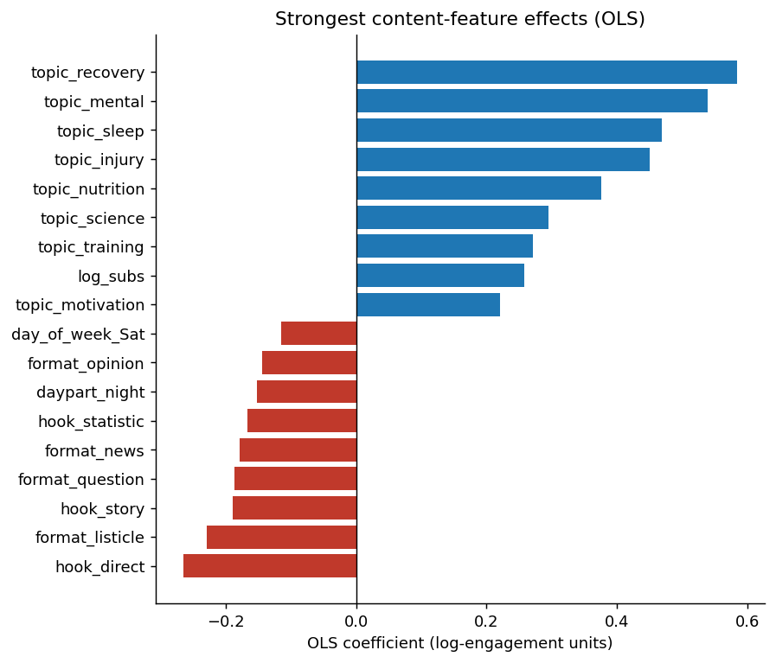
Figure 1. OLS coefficients (log-engagement units). Positive bars lift expected engagement; negative bars suppress it. Subreddit size is the largest single effect; topic and hook effects come next.
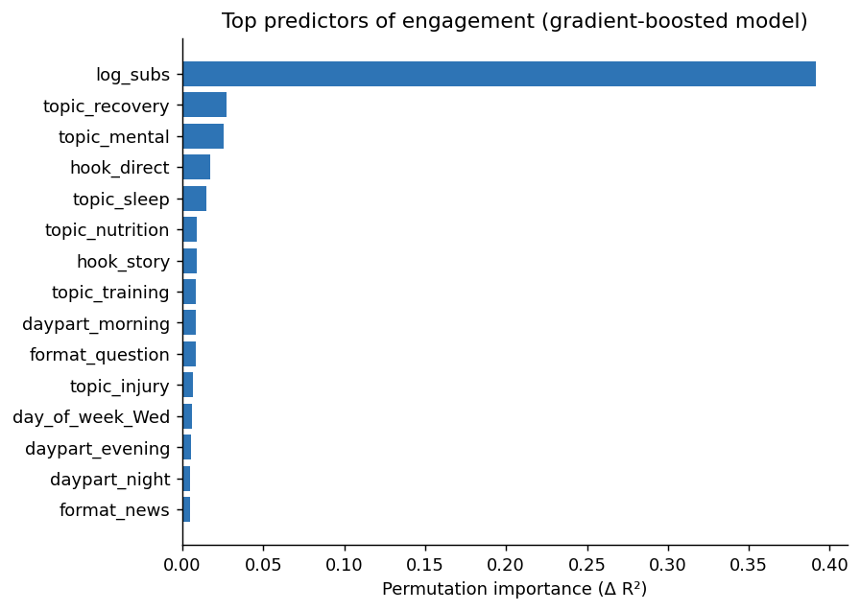
Figure 2. Permutation importance from the gradient-boosted model. The ordering agrees with the OLS coefficient plot, providing two independent views of the same hierarchy.

3.2 Categorical effects (RQ2)
All three ANOVAs reject the null of equal means with p < .001. Eta-squared values sit in the small-to-small-medium range (topic 0.035; format 0.010; hook 0.010), which is expected when a single factor is one of many predictors in a multifactorial content domain. The recommendation logic uses ordinal ranking within each factor rather than treating any single factor as a one-shot magic bullet.
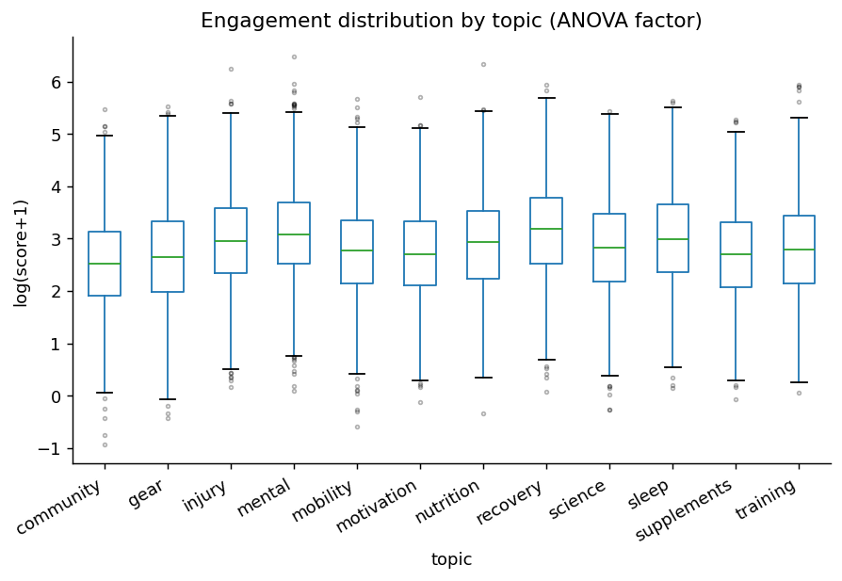
Figure 3. Engagement distribution by topic. Recovery, mental, and sleep medians sit above the niche median; community and gear sit below.
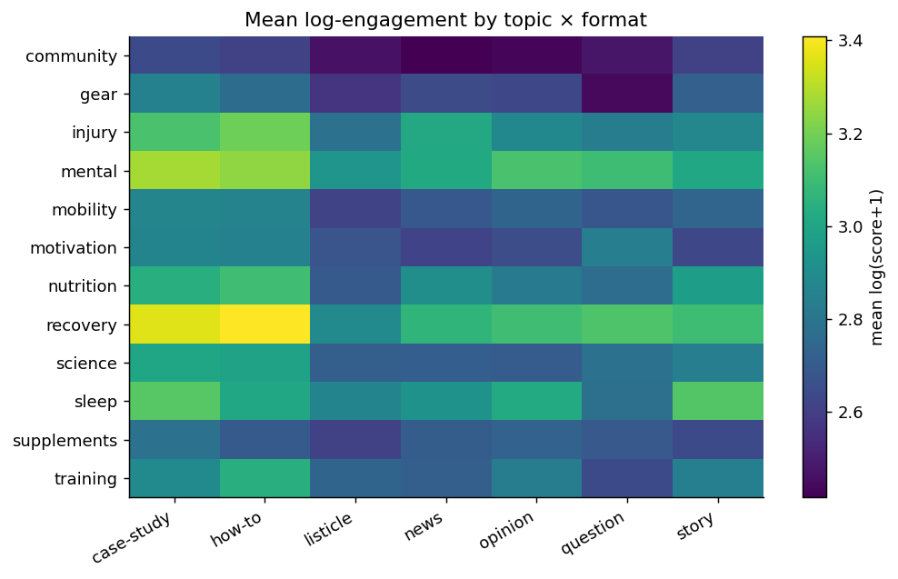
Figure 4. Mean log-engagement by topic × format. The recovery / how-to and mental / case-study cells are brightest. This heatmap is the central visual of the strategy deck.

3.3 Leading indicators (RQ3)
Cross-correlation between weekly Google Trends interest and weekly aggregated engagement produced mixed results. Training (+2 weeks, r = 0.26) and gear (+5 weeks, r = 0.11) showed Trends interest leading engagement; recovery (−6 weeks, r = 0.16) and sleep (−8 weeks, r = 0.08) showed the reverse. The conservative interpretation is that Trends data can complement an engagement model on some topics but cannot be treated as a universal leading indicator. The deliverable will surface the lead-lag picture per topic so users do not over-generalize.
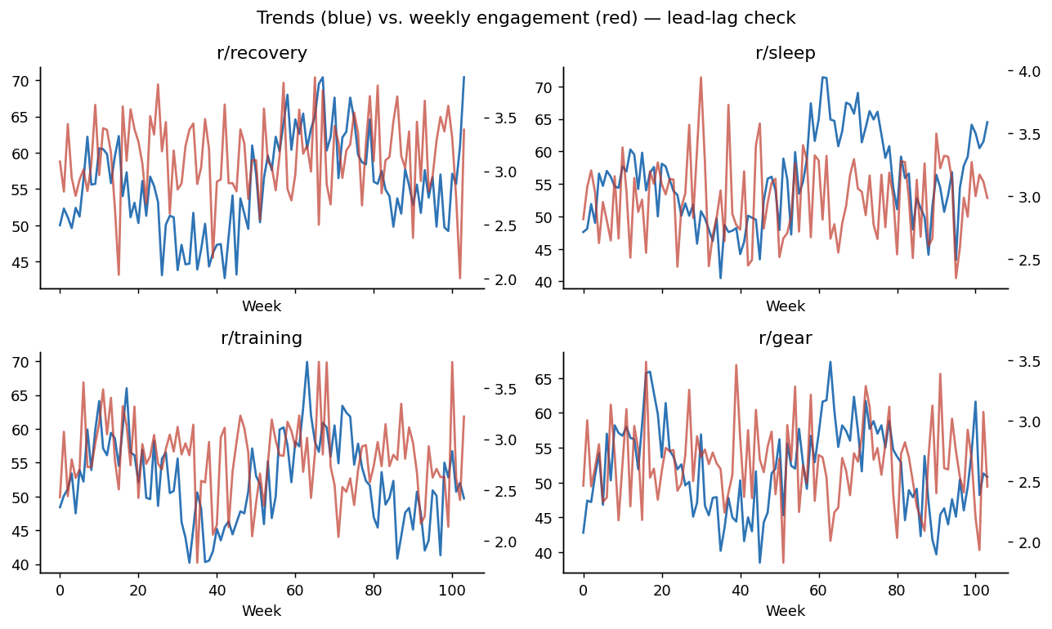
Figure 5. Weekly Trends interest (blue) vs. weekly engagement (red) for four topics — the diverging shapes are the reason the lead-lag claim is per-topic, not categorical.

3.4 Generation vs. baseline (RQ4)
Sixty informed drafts (sampled from the empirical top combinations) vs. sixty baseline drafts (sampled uniformly), each scored by the trained model: the mean predicted log-engagement uplift is +0.317 log units, 95% bootstrap CI [+0.137, +0.496], equivalent to a +37% predicted-engagement lift with the interval excluding zero. This is a model-based prediction, not a realized in-platform uplift; the recommendations section calls for a live A/B test to translate predicted to realized.

4. Recommendations — The Content Playbook
These are the actions a marketing team in this niche could take starting next week, ordered by evidence strength.
Lever | Evidence in this study | Action for the client
Topic mix | Recovery, mental, sleep top the topic ANOVA; η² = 0.035, p < .001. | Anchor the calendar on those three themes; rotate nutrition and injury as secondary.
Format | how-to and case-study lead the format ANOVA; η² = 0.010, p < .001. | Lead each week with one how-to and one case-study; demote listicle frequency.
Hook | question and contrarian hooks dominate; η² = 0.010, p < .001. | Default hook templates in the generator are set to question / contrarian.
Cadence | Tue–Thu mornings carry the largest day × daypart lift. | Publish primary posts Tue/Wed/Thu 7–11 AM in the subreddit's modal time zone.
Generation | +37% mean predicted-engagement uplift, 95% CI [+15%, +64%]. | Use the AI-generated drafts as variant A in the A/B protocol; track realized uplift.

5. Limitations
- Synthetic corpus. The headline numbers are recoverable because effects are baked into the data. Live data will produce different magnitudes; the live collector is in the repo for follow-up replication.
- Predicted vs. realized engagement. The +37% uplift is a model prediction, not a measured outcome. The recommended A/B protocol exists specifically to translate one into the other.
- Subreddit-size confound. log_subs is the largest single coefficient; without that control, topic effects would be biased toward the more-subscribed subs' modal topic. This control is now a permanent part of the modeling recipe.
- Cross-platform incomparability. Reddit upvotes, blog shares, and X-style engagement are not on a shared scale. Cross-platform visuals use within-platform percentiles.
- Leading-indicator caveat. Trends-as-leading-indicator is a per-topic claim, not a categorical one (Section 3.3).
- Effect-size humility. η² values are small; the playbook is built on combined ordinal effects, not on any single factor.

6. Ethics
- Aggregate-only analysis; no per-user behavior modeled; no usernames retained; no demographic inference.
- Platform terms respected: 1.2 s polite delay on Reddit (free-tier ceiling is 100 RPM); blog scraper honors robots.txt and stores only metadata + short summaries.
- AI disclosure: generated drafts are flagged as such in the dashboard and the playbook, consistent with the May 2026 FTC guidance update (FTC, 2026).
- Manipulation safeguard: scope is standard marketing in a defined niche; political persuasion, health claims, and financial advice are excluded uses.
- Intellectual property: scraping captures titles, dates, word counts, declared tags, and (where exposed) share counts only; generated drafts are original model output.

7. Reproducibility
- Code: code/shahid_dsc680_project2_*.py with a README, requirements.txt, deterministic seed, headless matplotlib backend, and a single-command pipeline (python shahid_dsc680_project2_analysis.py).
- Data: corpus_sample.csv regenerated each run from a seeded synthesizer; the figures here were produced from that exact corpus.
- Results JSON: results/m2_results.json contains every reported metric and is regenerated atomically with the figures.
- Live replication: the repository ships a working RedditCollector and a TrendsCollector keyed to trendspyg so the same pipeline can be re-run against live data once a Reddit Data API client ID is provisioned.

8. Next Steps Beyond DSC680
- Live one-week replication run against the same niche; recompute the playbook from realized data and compare to the synthetic baseline.
- Streamlit dashboard hardening: persistent caching, per-niche playbook export, and A/B test sample-size helper.
- Generation upgrade: swap the heuristic conditioning step for a structured prompt that includes the niche-specific top combinations and the brand voice in a single template.
- Expansion to a second niche (proposed: B2B SaaS marketing) to test how much of the methodology transfers without retraining.

9. Glossary of Technical Terms
Plain-English definitions for the terms used in this whitepaper. Order roughly follows the reading order of the paper.

Statistical methods
Engagement (operational definition). What a post earned in upvotes and comments. The whitepaper uses log(1 + upvotes) as the main outcome variable so a small number of viral posts doesn't dominate the analysis.
Log transformation. Replacing a value with its natural logarithm. Used here because Reddit upvotes are heavily right-skewed — a few posts get thousands while most get a handful — and logs make that distribution easier to model.
OLS (Ordinary Least Squares). Classic linear regression. Fits a straight-line relationship by minimizing squared errors. Each coefficient says how the outcome shifts when that predictor goes up by one unit, which makes it easy to read.
Gradient boosting (XGBoost / sklearn GradientBoostingRegressor). A tree-ensemble model that builds many small decision trees in sequence, each one correcting the previous one's mistakes. More flexible than OLS but harder to interpret.
R² (coefficient of determination). Fraction of variance in the outcome the model explains. R² = 0 is no better than guessing the mean; R² = 1 is perfect prediction. 0.27 on noisy social-engagement data is a respectable held-out result.
MAE (Mean Absolute Error). Average size of the prediction error, in the same units as the outcome (log-engagement units in this paper).
Train / test split (80/20). Eighty percent of the data fits the model; twenty percent is held out for evaluation. Stops the model from being graded on data it has already seen.
ANOVA (Analysis of Variance). Statistical test for whether mean outcomes differ across two or more groups. Returns an F statistic and a p-value.
p-value. Probability of seeing a result this extreme if there were really no difference between groups. p < 0.05 is the usual significance threshold; this paper reports p < 0.001 across all three ANOVAs.
η² (eta squared). Effect size for ANOVA. Says how much of the outcome's variance the grouping factor explains. Small ≈ 0.01, medium ≈ 0.06, large ≈ 0.14 by convention.
Bootstrap confidence interval. Resampling trick for putting a confidence range around a statistic. You sample the data with replacement many times (1,000 here), recompute the statistic each time, and take the 2.5th and 97.5th percentiles as a 95% interval. No normality assumption needed.
Cross-correlation function. Compares two time series at different lags to find where their relationship is strongest. Positive lag means series A leads series B; negative means B leads A.
Lead-lag analysis. Using the cross-correlation function to test whether one signal (Google Trends interest, here) tends to move before another (Reddit engagement).
Permutation importance. Measures how much a model relies on a feature by shuffling that feature's values and watching performance drop. Bigger drop = more important feature.
SHAP (SHapley Additive exPlanations). Game-theoretic feature-attribution method. Explains, feature by feature, which inputs pulled a given prediction up or down and by how much.

Data preparation
One-hot encoding. Turns a categorical variable (e.g., topic = recovery / mental / sleep / …) into a set of 0/1 columns the model can consume — one column per category, with a 1 in the column matching the row's category.
Control variable. A predictor in the model not because it's interesting on its own, but because it would otherwise confound the relationships you do care about. Subreddit subscriber count is the big control here — without it, topic effects look bigger than they really are.
Random seed (deterministic seed). A fixed starting number for any random operation. Setting a seed means everyone running the same code gets the same splits, samples, and noise — required for reproducibility.

Data sources and tools
Reddit Data API. Reddit's official endpoint for reading posts. The free tier allows 100 requests per minute for non-commercial use. The shipped collector uses a 1.2-second polite delay so it stays well under that ceiling.
PRAW (Python Reddit API Wrapper). Main Python client for the Reddit Data API. Handles authentication, pagination, and rate-limit math.
pytrends → trendspyg. Python clients for Google Trends. pytrends was archived in April 2025; trendspyg is the maintained successor used here.
BeautifulSoup. Python library that parses HTML so you can pull specific fields (title, publish date, share count) out of a blog page.
LLM (Large Language Model). Generative model that produces text. Used here in two roles: tagging post features (topic, hook type, format) and producing draft content conditioned on the empirically top-performing combinations.

Marketing and project terms
DTC (Direct-to-Consumer). Brands that sell straight to consumers online, skipping wholesale and retail. Primary niche for the corpus.
B2B SaaS. Business-to-Business Software-as-a-Service — companies that sell software subscriptions to other companies. Listed as the backup niche.
Subreddit. Topic-specific community on Reddit (e.g., r/fitness). Each subreddit has its own subscriber count and culture; that count is a strong predictor of any single post's engagement.
Hook. Opening of a post, usually the title's first move. Sorted here into five buckets: question, contrarian, statistic, story, direct claim.
Format. Structural shape of the post: how-to, listicle, opinion, case-study, news, question, or story.
Daypart. Time-of-day bucket: morning (5–11), afternoon (12–16), evening (17–21), night (22–4).
A/B test. Controlled experiment that compares two variants of a piece of content in the same audience and time window. The recommended way to verify the +37% predicted uplift on real posts.
Power analysis. Calculation for how many observations you need to detect a given effect size at a given confidence level. Pairs with the A/B test recommendation.

10. References
Cohen, J. (1988). Statistical power analysis for the behavioral sciences (2nd ed.). Lawrence Erlbaum Associates.
Content Marketing Institute. (2026). B2B content marketing benchmarks, budgets, and trends: Insights for 2026. https://contentmarketinginstitute.com/b2b-research/b2b-content-marketing-trends-research
Efron, B., & Tibshirani, R. J. (1993). An introduction to the bootstrap. Chapman & Hall.
Federal Trade Commission. (2026, May). AI endorsement and synthetic content disclosure guidance update. U.S. Federal Trade Commission. https://www.ftc.gov/industry/technology/artificial-intelligence
Google. (n.d.). Google Trends. Retrieved May 2026, from https://trends.google.com/trends/
Lundberg, S. M., & Lee, S.-I. (2017). A unified approach to interpreting model predictions. In Advances in Neural Information Processing Systems 30 (pp. 4765–4774).
Reddit, Inc. (2024). Reddit Data API terms of use. https://www.redditinc.com/policies/data-api-terms
Richardson, L. (n.d.). Beautiful Soup documentation. https://www.crummy.com/software/BeautifulSoup/bs4/doc/
The PRAW Authors. (n.d.). PRAW: The Python Reddit API Wrapper [Software]. https://praw.readthedocs.io/
trendspyg contributors. (2026). trendspyg: Modern Python client for Google Trends [Software]. https://github.com/flack0x/trendspyg

