Remote vs. Hybrid Work: Which Is the Best Work Model?

Author: Komal Shahid
Course: DSC500
Instructor: Fadi Alsaleem
Bellevue University
July 23, 2023

Introduction

When COVID-19 happened, disrupting our lives, economies, and businesses completely, remote and hybrid models were developed by companies after the lockdown to combat the novelty of the situation. It is essential to examine how hybrid and remote work affect employee behavior. This paper talks about the efficacy and draw backs of each model and to understand which model the business should adapt to in the right way.

Keywords: Post-COVID-19, Hybrid work, remote work, work-life balance, and stress.

Overview

Now that we are in the post-pandemic era, many have wondered the implications of working remotely, hybrid, or on-site would affect employees’ behaviors and productivity as well as the employers adapting to an effective business model that would encourage a high level of work engagement and efficiency. One of the changes that COVID-19 inflicted was the work environment and the workplace itself. While initially, the lockdown had everyone working from home regardless of the proper equipment, remote working raised many concerns like establishing work-home boundaries, inadequate equipment, and poor domestic work environments. On the other hand, as part of the work-resources requirements, the following personal resources were characterized: self-esteem, self-efficacy, and optimism. However, these dimensions rely highly on the individual’s perception of their ability to meet the work requirements. Work engagement follows second especially seen in the on-site workers. One of the most critical factors of work engagement is interpersonal relationships that prevails within the organization. While some of the concerns highlighted in this study are due to organizations’ poor management and problem-solving, some were related to workers’ personal lives and their inability to balance work and personal lives. Some workers also felt isolated and disconnected, thus hindering their productivity and work satisfaction by working remotely.

Analysis

We are applying work engagement as our dependent variable and trying to find its determinants, for example, stress and attitude toward both work models. Here’s a real-time search trend for remote jobs and hybrid work. The red indicates remote jobs, and blue indicates hybrid work. And our initial hypothesis is that people prefer working remote.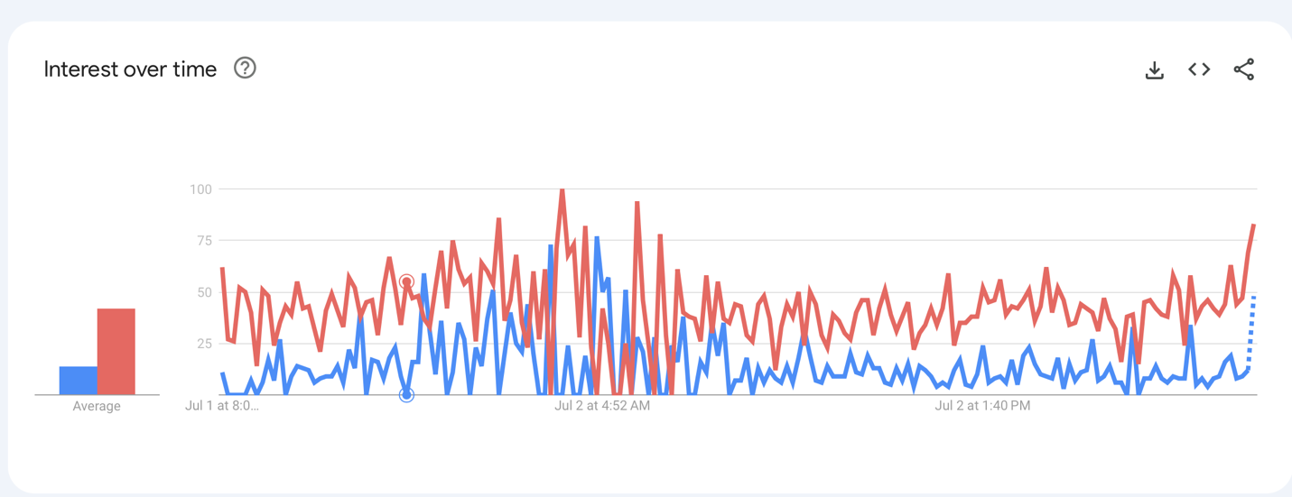
Remote
Hybrid
Figure 1: Time Series data for remote work vs hybrid work search

We are coming out of pandemic disciplinary and precautionary measures, many of the companies had adapted to remote work business model very quickly, and it provided flexibility for the employees to work from anywhere and had flexibly in the working hours as well. Even though many organizations are now preferring hybrid work arrangement that offers both remote and in-office working environment. Even at my workplace, the management had implemented a hybrid requirement after careful consideration, which had mixed responses from the people who were happy to engage and connect with coworkers again and others begrudgingly considering other companies because of their remote arrangements not allowing them to commute to work or their work-life balance drastically changing because of the new policy. However, they do provide flexibility within that policy to accommodate the employees, but the ones who have strong preferences towards remote work would have to seek work outside of the company. According to the study done by Forbes on the real reason to go back to the office, it states a study by McKinsey shows that 29% of people say they are likely to switch jobs if their employers require them to work exclusively on-site (Brower, 2022). Nonetheless, my company argued that a hybrid work environment would increase productivity and collaboration with the different business teams and encourage the employees to network and communicate with their colleagues. So, which one should you choose?

Even though the concept of working remote was developed in 1970s where they applied remote working mostly in IT. This was referred to as teleworking. “Teleworking is a method of organizing and performing work by which the employee works outside the employer’s workplace for a significant part of their working time, providing the employer with work outcomes (results) using information technology and data transfer technologies, especially the internet” (Wontorczyk, A., & Rożnowski, B). Teleworking can be referred to as remote working now.

As compelling as remote work can be, we all need forms of social interaction and connections. Even if we interact virtually frequently, the need to do face-to-face interaction can be refreshing and increase productivity. Adding a social component to the work setting can help us distinguish and draw boundaries between our personal and work life, which can be hard if we are working remotely.

To validate the working hypothesis, I studied several studies and journal articles that explain and dissect the factors that play a role in the work engagement of the workers and how they vary different on different work models and as well as the form of work. This way, the organizations can utilize the models that yields higher worker engagement and productivity.

Findings/Next Steps:

There is no significant difference between work engagement, or the work being performed by the remote and hybrid groups. Still, work engagement is different, explained by different variables between the studied groups. On-site workers had role definition as the important factor, whereas remote workers talked about work relationships as their most important factor being defined by work engagement.

Remote work has many benefits. Working remote, especially during Covid, was a privilege. A study conducted in Wuhan, China, shows that 30% of the covid infections were contracted in the workplace (Wontorczyk, A., & Rożnowski, B). Therefore, working from home was the way to self-isolate yourself and as well as to protect oneself from getting infected by following the rules of social distancing. Therefore, working remotely, in the beginning, was a requirement to contain COVID-19 in our fight against the novel virus.

The employees, overall, prefer to work remotely as you can work from home and collaborate with teams globally. This removes the geographical barrier that many companies face, and for the big companies working with different offices across the globe can be challenging. Hence, working remotely can give you more freedom to synchronize meetings and communication, which in return increases team productivity and promotes efficiency.

Remote work, however, added extra pressure and stress because the employees were concerned about the lack of job security and, therefore, adding the negative effects of working remotely to our hypothesis. In the Harvard Business article, Gratton shows the drift in employee preferences before and after COVID. In the article, she states that according to a study done in Fujitsu in Japan, a staggering 74% of the employees considered the office to be the best place to work which changed to only 15% after Covid. The employees said that they were wasting two hours of commute, and because of remote work, they could work effectively and got to spend time with their families and loved ones. Conversely, in some companies, the managers prefer face-to-face interactions and prefer the workers they have on-site interactions with, which helps to develop trust and communicate their ideas effectively. Also, the chances of being considered for future projects and offers by the leaders are higher than the remote workers.

The benefits of returning to the office are more significant to the employers than the employees. That’s why the companies are trying to come up with a hybrid model which will allow them to create a work environment more productive, agile, and purposeful. It is to be noted here that to work for a company that has a hybrid model deployed, “clarifying how often you’ll be allowed to work remotely and conveying your preferences is always a good idea before applying for any hybrid workplace” (Despande,2022). Our VP of Data Science at work once told me that when I come to the office, I should make it purposeful. It means connecting with colleagues and brainstorming ideas or striking up a conversation with the leadership over a quick coffee can be helpful along the way to understanding the business and, in return, providing value to the company.

Another positive factor to be considered in the hybrid model is that stress and occupational burnout increases while working remotely if an employee has conflicting job roles in the company and they end up fulfilling the job-related goals regardless of their role.

“An element of the fulfillment you get through community is a sense of belonging—feeling connected, united, and accepted by your people. But a sense of belonging doesn’t just come from being in a group. It arises from a shared sense of social identity” (Brower,2022).

Being on camera for hours can make us hyper-vigilant. Being in the office reduces our tech fatigue and boosts our emotional health. Being present together is linked to releasing oxytocin, which makes us feel good. Brower also mentioned that “interactions literally increased cognitive performance…because of the mental processes involved in listening, empathizing, thinking and responding which are elements of a discussion or conversation” (Forbes). Based on the analysis, it can be derived that remote workers have many positives and strong preferences for their work mode, and for hybrid workers, these positives are much less, although their cognitive representation of the work is influenced by many factors such as stress management, self, and relationships are far better than the remote workers.

Assumptions
To conduct research, we need to formulate a hypothesis. The research question is whether the groups (remote, hybrid, or on-site workers) differ in work engagement and how the businesses should adapt the model according to the form of work. We are checking the validity of the following hypothesis:
  - Perceptions of the remote work vary due to the form of work.
    - Employees that work remotely have the most significant number of observed effects (like stress, relationships, clear definitions of roles, etc.).
  - Remote workers have higher stress levels than others,
  - On-site work is preferred for a higher engagement at work and is observed more significantly in on-site groups than in remote or control groups.

Ethical Concerns
An ethical issue that might arise from this study would be the classification of work being perceived as a privilege. If multiple groups from different companies or fields perceive remote work as a privilege, then we are reinforcing human bias.

Challenges/Opportunities
The limitations and challenges of this study are that these studies have been conducted online. And therefore, many respondents can falsify the information or present false opinions for fear of being questioned by their management or misrepresenting their company. This study also depends on when it was conducted. If it was conducted when there was a surge in covid cases, then the results might be in favor of remote work. Also, the size of the group matters as we cannot assume the behavior of a whole subset of the population, or a region based on a tiny group. In the future, a larger surveyed audience would be better.

Conclusion:

In conclusion, hybrid and remote models depend on the company’s culture and the type of work you do. How does a company propel its’ workers towards that would make them work effectively and collaboratively at home and encourage creativity at work? Team leaders also need to provide flexibility to the workers who prefer remote and who work more productively while working from home. It might need some reengineering in the organization’s structure to support both models and how the effectiveness of each model plays a role in operational cost, effectiveness of operations, and compliance.

Sources/Citations:
- Deshpande, S. (2022, October 2). Remote vs. hybrid work: Which is the best work model for you?. MUO. https://www.makeuseof.com/remote-vs-hybrid-work/#:~:text=While%20remote%20work%20offers%20the,its%20own%20set%20of%20challenges.
- Google trends - google trends. Google Trends. (n.d.). https://trends.google.com/trends/explore?q=Google%20Trends&geo=US
- Gratton, L. (2023, January 19). How to do hybrid right. Harvard Business Review. https://hbr.org/2021/05/how-to-do-hybrid-right
- Tracy Brower, P. (2022, November 9). The real reason to go back to the Office (Hint: It’s not for your employer). Forbes. https://www.forbes.com/sites/tracybrower/2021/07/11/the-real-reason-to-go-back-to-the-office-hint-its-not-for-your-employer/?sh=4cce280717ca
- Wontorczyk, A., & Rożnowski, B. (2022, February 19). Remote, hybrid, and on-site work during the SARS-COV-2 pandemic and the consequences for stress and work engagement. MDPI. https://www.mdpi.com/1660-4601/19/4/2400

